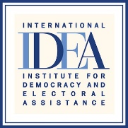
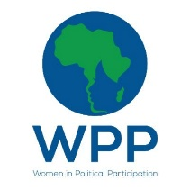

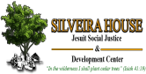


Zimbabwe Women’s Dialogue on the Local Government Women’s Quota
Report
20 October 2021
Crowne Plaza Hotel
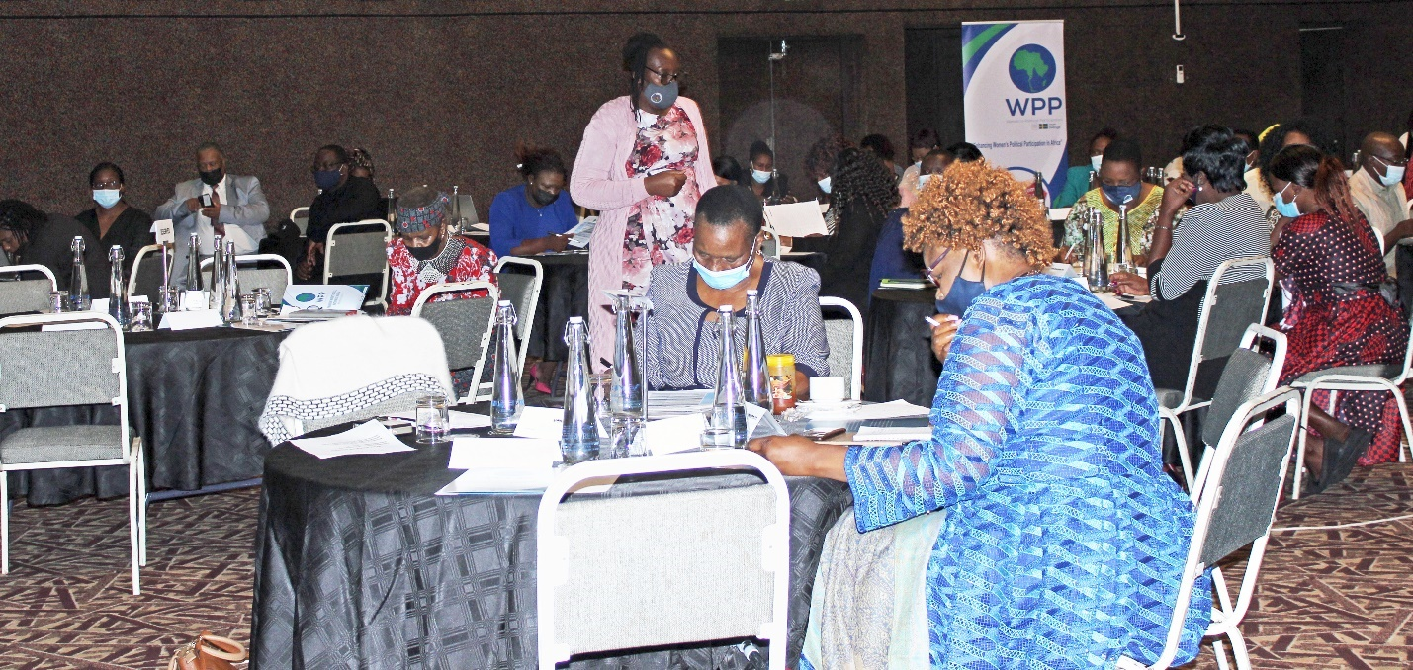
Zimbabwe Women’s Dialogue on the Local Government Women’s Quota in progress Photo: Loverage Nhamoyebonde
Contents
Executive summary 1
Background 1
Welcome Remarks, Introductions, and objectives 2
Remarks by the Ministry of Local Government and Public Works 3
Remarks from Minister of Women Affairs, Community, Small and Medium Enterprises Development 4
Remarks from the Embassy of Sweden 5
Keynote address 6
Unpacking the Local Government Women’s Quota 7
Overview of the Constitutional provision and implications for local government 7
Regional Perspective on Women’s Political Participation 8
Case study on how Mauritius trained councillors for the First Past the Post 8
Remarks from International Institute for Democracy and Electoral Assistance (IDEA) 9
Theological Perspectives on Women and Politics 9
Plenary discussion on the local government quota 9
Operationalising the Constitutional Amendment 10
Experiences with the Women’s Quota in Parliament 11
Plenary discussions on the electoral law 11
Strategies of Strengthening Women’s Representation in Local Government: Panel Discussion 11
Action Plan: 12
Closing remarks 12
Annexes 13
Annex A: Programme 13
Annex B: Registration list 16
Annex C: Evaluation 30
Annex D: Press Release 33

Executive summary
Gender Links Zimbabwe (GLZ) in partnership with the Parliament of Zimbabwe (POZ) and Silveira House conducted a Women’s dialogue between the Zimbabwe Women’s Parliamentary Caucus (ZWPC) and Women in Local Government Forum (WLGF) on the Local Government women’s quota the 20th of October 2021 at Crowne Plaza Hotel in Harare.
The dialogue was attended by female Members of Parliament from across the country appointed through the quota (60 reserved seats) at the national level, female councillors, Women in Local Government Forum (WLGF) members and the media. The Dialogue was attended by 100 people (84 females; 16 males). See Annex B for the detailed registration list.
Key partners who graced the event include the Ministry of Women Affairs, Community, Small and Medium Enterprises, Ministry of Local Government and Public Works, Embassy of Sweden, Silveira House, International Idea and the Zimbabwe Electoral Commission. The aim of the dialogue was to increase and strengthen representation of women in local government with a focus on developing a shared understanding of the Constitutional provisions of the local government women’s quota and its implications on local government. The dialogue, that served as a learning and sharing platform also sought to discuss the experiences of women on the women’s quota in Parliament particularly the challenges and lessons drawn from their experiences.

Background
Gender Links Zimbabwe in partnership with the Women in Local Government Forum (WLGF) successfully lobbied for a local government quota in December 2020, following years of sustained lobbying and advocacy for a quota at the local level. In December 2019, the Government of Zimbabwe sought to amend the 2013 Constitution through the Constitutional Amendment Bill no.2.
The 2013 Constitution of Zimbabwe has a provision for a quota system for women at the national level (60 reserved seats on proportional representation PR). The quota was due to expire after the 2023 elections. Section 124 of the Constitution sought to extend the quota for women at the national level by another 2 terms whilst excluding local government. The Constitutional Amendment Bill no.2 presented a window of opportunity for WLGF to lobby and advocate for the extension of the quota to local government.
WLGF made submissions to parliament and participated in the public hearings. However, the report of the public hearings still excluded local government. Considering this, WLGF sought the intervention of the President of Zimbabwe, His Excellency President E.D Mnangagwa to support their plea. At a landmark Women Councillors Indaba held in Victoria Falls in December 2020, the President supported the inclusion of a 30% quota for women in local government. The Cabinet of Zimbabwe promptly also endorsed the quota.
Following this the WLGF, strategically partnered with the ZWPC to lobby their support for the inclusion of the quota in the Constitutional Amendment Bill no.2. The ZWPC conducted a study visit to Murewa Rural District Council to understand the challenges affecting women at the local level. The ZWPC also supported the quota in parliament which was passed into law through the Constitutional Amendment Bill no.2 on Section 277 of the Constitutional Amendment which reads (“Elections to local authorities”) is amended by the insertion after subsection (3) of— “(4) An Act of Parliament may provide for the election, by a system of proportional representation referred to in subsection (5), of at least thirty per centum of the total members of the local council elected on ward basis as women).
Pursuant to the inclusion of the local government quota in the Constitutional Amendment Bill no.2 Gender Links in partnership with the Women in Local Government Forum, the Ministry of Local Government and Public Works engaged the Zimbabwe Electoral Commission and the Attorney General’s Office to explain the electoral and legal provisions for the quota (which will be an addition to the existing council seats on proportional representation). The Women’s Dialogue is a follow-up to these processes.

Welcome Remarks, Introductions, and objectives
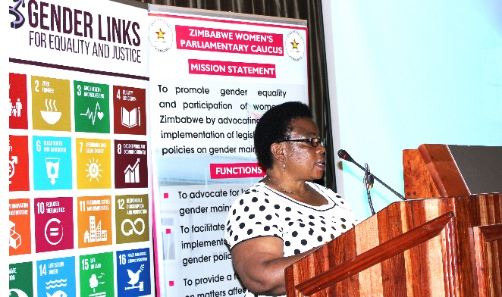
Zimbabwe Women’s Parliamentary Caucus Chairperson, Goodluck Kwaramba welcomed all participants to the dialogue. In her remarks she stated that the 30% quota for local government is a milestone achievement that must be celebrated. She stated that the Women’s Parliamentary Caucus worked hard to ensure that the 30% quota was enshrined in the Constitutional Amendment Bill No. 2. “The decision to support the quota at local government came after the ZWPC’s visit to Murehwa Rural District Council where we saw first-hand the challenges faced by women in local government”, she said.
Zimbabwe Women’s Parliamentary Caucus Chairperson, Hon. Kwaramba Photo: Loverage Nhamoyebonde

Kwaramba stated the objectives of the dialogue as follows:
- To develop a shared understanding of the women’s quota provision of the Constitution of Zimbabwe Amendment No 2 and its implications on local government.
- To understand the challenges and opportunities brought about by the Women’s Quota in Parliament and lessons from experience.
- To develop a clear road map towards the operationalisation of the Constitutional Amendment.
- To strengthen youth participation in governance processes

Kwaramba urged women to evaluate all the available modalities and ensure that the desired strategy is implemented during the 2023 elections.

Remarks by the Ministry of Local Government and Public Works

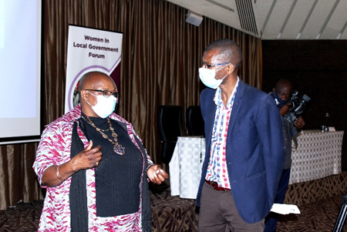
The deputy minister for Local Government and Public Works, Marian Chombo gave remarks in which she highlighted the efforts made towards the achievement of 50/50 representation. She stated that the constitutional amendment passed the 30% quota for women in local government into law. She highlighted that the quota promoted women’s participation and representation in decision making and play a role in matters that affects them at the local level. Women’s equal participation in decision- making is not only a demand for simple justice or democracy but a precondition for women’s empowerment”, she said.
Marian Chombo, Deputy Minister for Local Government and Public Works speaks to the media Photo: Loverage Nhamoyebonde

Chombo reiterated the importance of the local government sector because it is closest to the people and delivers basic services to the people. She applauded the passing of the local government quota into law, stating that it will improve the representation of women in local government which currently stands at 14%.

Chombo emphasised the need to ensure that development processes are inclusive to achieve sustainable development. She called upon women to make meaningful deliberations that will cultivate meaningful change in local authorities. She concluded by thanking the Parliament of Zimbabwe and the President for supporting the local government quota.

Remarks from Minister of Women Affairs, Community, Small and Medium Enterprises Development
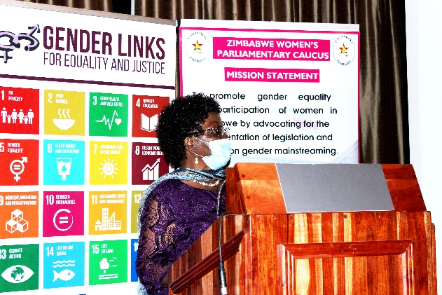
The Minister of Women Affairs, Community, Small and Enterprises Development, Sithembiso Nyoni gave remarks in which she reminded participants of the importance of dialogues that seek to strengthen women representation. She explained the implications of promoting equality and equity at local government level. She stated that it is pertinent for her ministry to address the challenges faced by women in public office. “Women’s presence at the decision-making tables results in positive impact in terms of development to families, communities and the nation”, she said.
Sithembiso Nyoni, Minister of Women Affairs, Community, Small and Medium Enterprises giving remarks Photo: Loverage Nhamoyebonde
Nyoni reminded participants that women constitute 52% of the total population hence the need to consider their views, aspirations, and concerns when national issues are discussed. She reiterated that her ministry will continue to measure women’s empowerment to inform policy and strategies at all levels.
On the legal framework, Minister Nyoni said that the 2013 Zimbabwean Constitution is a major milestone achievement in the lives of Zimbabwean women because of its progressive nature in advancing women’s rights through sections 17 and 56 specifically. “The National Gender Policy provides a framework for mainstreaming gender in all sectors”, she said. Nyoni added that the government of Zimbabwe has taken measures to enact and amend several laws that ensure that women’s rights are protected including the Electoral Act of 1990 which allows women to participate in general and by-elections for presidency, parliament or local government as voters or candidates without any discrimination.
She expressed her concern that women’s representation in politics has been declining at the local level. It was her firm belief that the 30% Local Government Quota will be a turning point in the representation of women in local government. Nyoni urged women to cease the opportunity offered by the 30% Local Government Quota and drive the nation forward. She reminded participants that meaningful women participation across all sectors and in decision making or leadership platforms is a key driver of development at local, national, regional, and global levels.
Nyoni challenged women to go back to their constituencies and mobilise other women so that they participate in decision-making. “If men can assist each other to get into decision making positions, then women can do it better”, she said. She called upon women to liberate themselves from the negative stereotypes attached to them. She urged women to start campaigning for the 50/50 because it will never come on a silver platter. “Politics is a game that our mothers never taught their daughters but it should now be a game for our daughters that we teach them how to play fairly, justly and with integrity”, she said.
In her concluding remarks Nyoni stated that her ministry is developing a national strategy to ensure that women’s participation and representation is meaningful. She further explained that the national strategy is key as it seeks to ensure gender equality in public and private spheres. She also urged women to work together to attain equality.

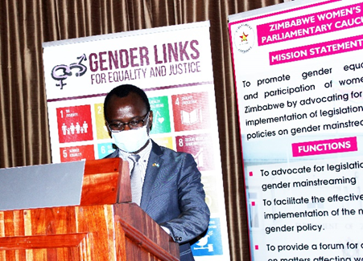
Remarks from the Embassy of Sweden
The Deputy Head of Mission and Head of Development Cooperation, for the Embassy of Sweden, Berthollet Kaboru gave a background of the relationship between Zimbabwe and Sweden. He mentioned that Sweden is the third largest bi-lateral donor to Zimbabwe. He further explained that Sweden is the only Nordic country remaining in the country and this shows great commitment in supporting the government and the entire population of Zimbabwe. “Gender equality is a profile question for Sweden driven by the feminist Swedish Foreign Policy which means all our activities abroad are mainstreaming gender equality”, he said.
Embassy of Sweden, Deputy Head of Mission and Head of Development Cooperation, Berthollet Kaboru Photo: Loverage Nhamoyebonde
Kaboru highlighted the key strategic areas where the Embassy of Sweden has been complementing Government of Zimbabwe’s efforts including democracy, human rights, gender equality, equitable health, climate change and agricultural livelihoods. He stated that the new Sweden strategy in Zimbabwe spanning from 2022-2026 will continue to focus on gender equality, democracy, and human rights. “We will continue supporting women’s movement and increase our support to women’s economic rights in Zimbabwe and multiply investment in supporting women’s political participation in local government”, he said. It was his hope that the outcomes of this meeting are included in the embassy’s operational plan.
He proposed a continuous engagement with Gender Links and the government for assessment of the progress made to in mainstreaming gender. “Gender Links are a critical partner to the Embassy of Sweden and we intend to follow-up on their achievements and come up with strategies to ensure women’s participation coupled with women’s empowerment”, he said. He concluded by stating the Embassy’s commitment to supporting gender mainstreaming and government initiatives.

Keynote address
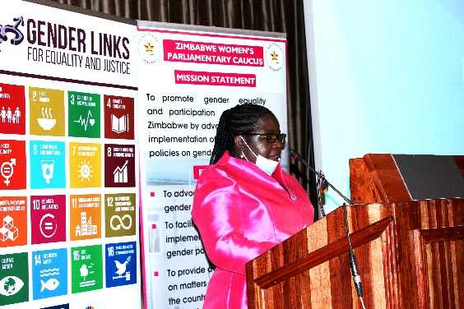
The Deputy Speaker of Parliament, Tsitsi Gezi gave the keynote address in which she thanked the Zimbabwe Women’s Parliamentary Caucus, Gender Links and Silveira House for supporting the local government quota. She stated that women vying for political office face numerous challenges that limit their roles in society including discrimination, harmful cultural beliefs, balancing family, and political life, lack of support from political parties and lack of campaign funding.
Deputy Speaker of Parliament, Tsitsi Gezi giving the keynote address Photo: Loverage Nhamoyebonde
Other challenges faced by women include violence and intimidation especially at family level and discouragement from family members and partners from participating in politics.
She stated that more women are being elected into parliaments across the world but equality is still beyond reach and current progress is very slow. She hinted that most parliaments are still heavily male dominated with women constituting only 24% of parliamentarians in Africa. “Even when women are greater in numbers, glass ceilings remain firmly in place”, she said.
Gezi highlighted the statistics of women’s participation in local government citing that at global level this figure stood at 21%, 35% in East Africa, 20% in Southern Africa, 27% in Central Africa and 2% in West Africa. She explained that the representation at local level has proven to be essential training grounds for long term political participation. She added that if women are left out at local level, representation of women at national level will also be affected.
Gezi bemoaned women’s representation at local government level in Zimbabwe, stating that the proportion of women declined with every election since 2008 when the representation of women stood at 18%. This declined to 16% in 2013 and to 14% in 2018. She explained that change is only possible through political commitment, adequate legal framework that will provide a level playing field for both women and men. Gezi applauded the local government quota which has been passed into law through the Constitutional Amendment Bill no.2, adding that the 30% quota is a stepping stone towards increasing the proportion of women in local government to attain gender parity. “It is important that women are equally involved in decision making to promote better local and national development outcomes. Women’s participation in local decision making is critical for disposing women’s needs and aspirations”, she said.
She highlighted that that one of the key result areas of the Zimbabwe Women’s Parliamentary Caucus is to increasing women’s participation at all levels, adding that the 30% Local Government Quota reflects the concerted effort of the Women’s Parliamentary Caucus and its key partners.
She urged participants to continue engaging and having dialogues in preparation for the 2023 elections. Gezi concluded by reiterating on the importance of collaboration and partnerships for the desired goals to be achieved.

Unpacking the Local Government Women’s Quota

Overview of the Constitutional provision and implications for local government

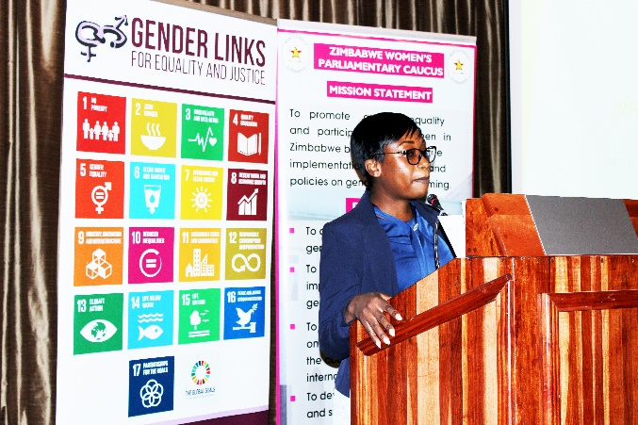
Ministry of Local Government and Public Works, Legal Advisor Karen Bopoto gave an overview of the constitutional provisions and the implications of the Constitutional Amendment Bill No. 2. She explained that the amendment has been inserted under Section 277 of the Constitution on Elections to Local Authorities.
Karen Bopoto, Legal Advisor in the Ministry of Local Government and Public Works Photo: Loverage Nhamoyebonde

Bopoto drew the attention of participants to Section 17 which provides for gender balance. She explained that the existence of these pieces of legislation show the government’s commitment to addressing gender imbalances.

Bopoto stated that the provisions of the local government quota will be an addition to the already existing 1958 local government seats. She reiterated that these seats will differ from each local authority depending on the size of the council. Bopoto reiterated that the 30% quota is a strategy to address historical imbalances that women have been experiencing. She concluded by highlighting the Ministry of Local Government and Public Works’ plans to amend pieces of legislation like the Provincial Councils and Administration Act, Urban Councils Act, Rural District Councils Act and Regional, Town and Planning Act to ensure that they are aligned to the electoral provisions.

Regional Perspective on Women’s Political Participation
Gender Links Special Advisor, Colleen Lowe Morna gave a regional perspective to draw important lessons. She focused on three electoral systems that is First Past the Post (FPTP), the Proportional Representation (PR) and mixed system. She explained the regional statistics on women representation. Statistics revealed that countries with proportional representation and mixed electoral systems tend to have more women’s representation than those using the first past the post.
Morna further explained that the regional perspective shows that electoral systems when combined with special measures makes a huge difference in women representation both at local and national level. She proceeded to cite Zimbabwe which has all systems in place, with the FPTP and PR used at national level in parliament. This has been extended for women at in local government.
While drawing lessons from Lesotho, she explained that the benefits of a gender quota that saw the proportion of women in that country rise to 58%, the highest representation of women in Southern Africa in 2011. She therefore explained that Zimbabwe must take lessons from the fact that in Lesotho women representation declined by the introduction of the mixed approach and there was also a serious decline of women participation in the FPTP system if the 30% quota is going to be effectively operationalised.
While unpacking the 30% quota for local government she reiterated that the PR seats constitute 30% of the current number of council seats (1958). However, 587 out of 2545 means women only have a guaranteed 23% of the total number of seats which is higher than the current level of 14% but still below 50%. “Women would have to win at least 27% of the FPTP seats, which is almost double the proportion of women who won through this system in the 2018 elections”, she said. Morna urged women to conduct more training and ensure that more women effectively participate in politics. It was her hope that this would change with the implementation of the Constitutional Amendment no. 2.

Case study on how Mauritius trained councillors for the First Past the Post
Former Gender Links Francophone Director, Loga Virahsawmy shared experiences on how Mauritius trained councillors to effectively participate in politics at the local level. She explained that women’s representation in Mauritius at local government level was at 6.4% and they came up with strategies which included the engagement of political parties and the training of aspiring or new female candidates. She concluded by reminding participants that training is key because if women lack skills, they will not be able to make use of the available pieces of legislation.

Remarks from International Institute for Democracy and Electoral Assistance (IDEA)
Sifisosami Dube the Programme Officer for International IDEA gave remarks in which she, applauded Zimbabwe’s adoption of the local government quota. She stated that other countries must draw lessons on what is important at local government level. She went on to explain that IDEA has been funding the programme which seeks to promote women political participation in Africa through the Enhancing the Inclusion of Women in Political Participation in Africa project. She said that the focus is not on numbers but on the quality of women who will occupy decision making platforms.
Dube concluded by stating that the organisation is proud of the political will displayed by Zimbabwe in supporting women political participation and she urged women to participate at regional political dialogues to ensure that they learn more.

Theological Perspectives on Women and Politics
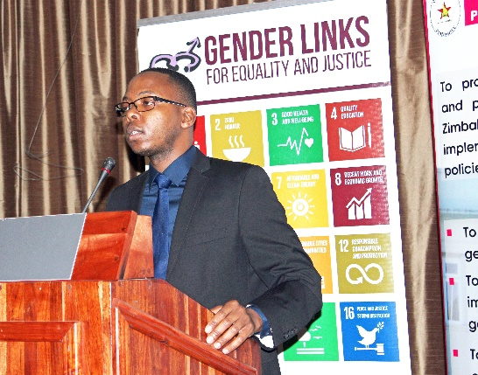
Silveira House Director, Father Arnold Moyo gave a presentation on the theological perspective of women in politics to deal with barriers inhibiting women from fully participating in politics. He said that the greatest weapon being used against women is dehumanising them through stripping them of their dignity.
Father Anorld Moyo making a presentation on theological perspectives of Women and Politics Photo: Loverage Nhamoyebonde
He encouraged women to draw inspiration from biblical stories that portray women as important. He urged women to support each another and be embodiments of justice. He concluded by quoting Pope Francis who said, that women in society should be involved in decision making is not only right for the reasons of equality but also for the specific insights that they may bring to the process. This will prove valuable as women increasingly play major roles in finding solutions for the challenges the world is facing. He added that unlike men, women are good for sacrificing themselves for the benefit of others. He said that the world needs leaders who sacrificial leaders and women must come in and teach the world how it is done.

Plenary discussion on the local government quota
Participants agreed that there is need to use 30% provision as a minimum number and work hard towards achieving 50/50 representation. There were concerns on the quota system whether it will lapse after two terms or remain in place until 50/50 is achieved. Participants were reminded that they are the ones who will decide what they want and lobby for its full implementation. Discussion also rose on the need for councillors and parliamentarians to groom young women to participate in governance processes. The Women in Local Government Forum (WLGF) was urged to put effective mechanisms in place to ensure that women fully participate in the FPTP system. Lastly, women were encouraged to effectively use Information Technology (IT) for mobilizing supporters.

Operationalising the Constitutional Amendment

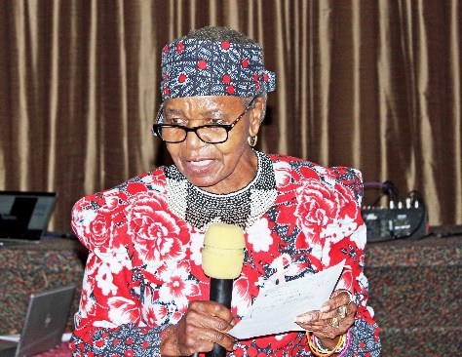
Zimbabwe Electoral Commission (ZEC), Commissioner, Joyce Laetitia Kazembe explained the role and function of ZEC including conducting and supervising elections, and organising a referendum, registering voters, delimit constituencies. She highlighted the need for women to understand the electoral systems and know where to strategically place themselves. Kazembe reminded politicians that their role is to ensure that people register to vote because numbers make a great difference.
Zimbabwe Electoral Commission, Commissioner Kazemebe explaining the electoral provisions of the quota Photo: Loverage Nhamoyebonde
Kazembe explained the various electoral systems including Presidential, Parliamentary and Local government. She further explained that Parliament has a bicameral system made up of two houses. She said that there are 210 constituencies and 60 reserved seats. She added that this is the stage where women are side-lined through being pushed to the 60 reserved seats. She therefore urged women to stand firm and compete in the 210 constituencies seats. She reminded participants that the number of seats won at National Assembly level determine the Senate hence the need to mobilise more women to get more numbers.
Speaking on the local government quota she explained that the 30% is an addition to the existing seats, adding that the number of seats will differ from each local authority depending on its size. She gave an example of a constituency with 6 seats and stated that 30% of 6 is 2 and that makes the total number of seats to arrive at 8. She added that local government and political parties must decide how the proportional representation seats will be allocated among women with disabilities, youths, and ordinary women.
Kazembe urged women to be united and fight for each other. She concluded by asking for the consolidation of the final details and tasked women to come up with modalities on how the 30% local government quota will be implemented.

Experiences with the Women’s Quota in Parliament
Zimbabwe Women’s Parliamentary Caucus member Sibusisiwe Bhuda Masara highlighted the experiences of women with the quota system in parliament. She explained that while the quota at national level has increased women’s representation, it has its challenges which prevented women from effectively participating. Some of these challenges included being stereotyped by other members of parliament and not having a constituency. However, with continued engagement, things have improved for the better in some areas and there has been less stereotyping of these women whilst some are able to work in their constituencies. Councillors were urged to prepare to face some of these challenges when they arise as they assume the proportional representation seats at the local level.

Plenary discussions on the electoral law
Participants were given a chance to ask questions or seek clarity form ZEC. Key questions that emerged include whether it is possible for ZEC to do voter education based on the 30% quota system and whether it is possible to protect the current 14% representation at local level. ZEC responded by advising participants to negotiate through parliament so that the issues will be put into law. Women politicians were urged to continue lobbying, submit prepositions and proposals that ensure the achievement of the desired goal.

Strategies of Strengthening Women’s Representation in Local Government: Panel Discussion
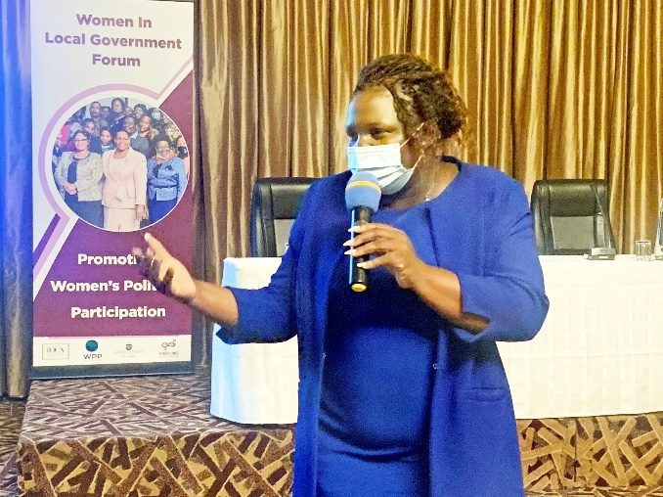
A panel discussion around strategies for strengthening women’s representation was led by the Women in Local Government Forum who suggested the following strategies:
Idirashe Dongo sharing some of strategies for strengthening women's participation in local government Photo: Tapiwa Zvaraya
- Improve communication skills.
- Establish a strong network.
- Capacity building in various aspects.
- Strengthen the lobbying and advocacy for 50/50 representation.
- Maximise on voter education and encourage more women to participate as voters and as candidates.
- Roll out mentorship programmes with young men young women.
- Lobby to all political parties to empower women financially.
- Improve on service delivery so that women will not be over burdened by multiple tasks and leave politics to men.
- Train more aspiring candidates.
- Effectively use the legal framework as a strategy to empower women.
- Lobbying for the protection of the 14% seats at local government level.

Action Plan:
At the end of the dialogue participants developed an action plan consisting of action points that Gender Links, Silveira House, WLGF and Women’s Parliamentary Caucus will consider. The action plan seeks to ensure the creation of modalities and the effective implementation of the 30% Local Government Quota before the 2023 harmonised elections. Key issues that were incorporated in the action plan include capacity building of sitting councillors, realigning of the laws and creation of awareness forums. Other planned actions include engaging political parties, implementation of mentorship programmes, lobbying for the protection of the current 14% women representation at local government level and use of the media as a tool to promote women political participation.

Closing remarks
Lupane Local Board, Cllr. Monica Ngwenya thanked all participants for finding time from their busy schedules to attend the dialogue. She thanked the organisers of the dialogue for working hard in ensuring a successful dialogue. She urged all participants to go back home and implement the presented strategies to achieve the desired goals. She challenged participants to ensure that the action plan is fully implemented within the set timeframes.

Annexes

Annex A: Programme

Zimbabwe Women’s Dialogue on the Local Government Women’s Quota
Main outcome
Increased and strengthened representation of women in local government
Objectives
- To develop a shared understanding of the women’s quota provision of the Constitution of Zimbabwe Amendment No. 2 and its implications on local government.
- To understand the challenges and opportunities brought about by the Women’s Quota in Parliament and lessons from experience.
- To develop a clear road map towards the operationalisation of the Constitutional Amendment.

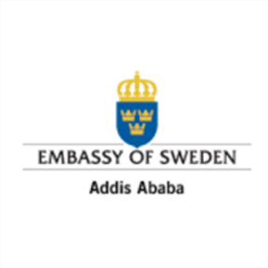



Date: 20 October 2021

Venue: Crowne Plaza Monomotapa Hotel

PROGRAMME
TIME | ACTIVITY | PRESENTER
0800-0830 | Arrival and Registration | Parliament of Zimbabwe  Silveira House  Gender Links
SESSION ONE: MODERATED BY THE ZWPC

0830-0840 | National Anthem and Opening Prayer | All
0840-0900 | Welcome, Introductions and Objectives | Zimbabwe Women’s Parliamentary Caucus  Chair: Hon Kwaramba
0900-0910 | Ministry of Local Government and Public Works Remarks | Deputy Minister of Local Government and Public Works: Hon M. Chombo
0910-0920 | Ministry of Women Affairs, Community, Small and Medium Enterprises Development Remarks | Minister of Women Affairs, Community, Small and Medium Enterprises Development: Hon Dr S. Nyoni
0920-0930 | Embassy of Sweden Remarks | Embassy of Sweden: Deputy Head of Mission and Head of Development Cooperation: Berthollet Kaboru
0930-0950 | Keynote Address | President of the Senate: Hon Mabel Chinomona
0950-1020 | TEA | All
SESSION TWO: MODERATED BY SILVEIRA HOUSE
1020-1035  1035-1050 | Regional Perspective on Women’s Political Participation | Gender Links Special Advisor: Colleen Lowe Morna
1020-1035  1035-1050 | Case study on how Mauritius trained councillors for the First Past the Post | Mauritius Representative: Loga Virahsawmy
1050-1105 | Theological Perspectives on Women and Politics | Silveira House Director:  Fr Anold Moyo SJ
1105-1135 | Unpacking the Local Government Women’s Quota  - Overview of the Constitutional provision and implications for local government | Ministry of Local Government and Public Works: Ms Tshuma
1135-1205 | Operationalising the Constitutional Amendment  - What is next? | Mrs Joyce Laetitia Kazembe (Commissioner)  Zimbabwe Electoral Commission
1205-1235 | Experiences with the Women’s Quota in Parliament | Zimbabwe Women’s Parliamentary Caucus  Hon. S. Bhuda Masara
1235-1300 | Plenary | All
1300-1400 | LUNCH | ALL
SESSION THREE: MODERATED BY WLGF
1400-1500 | Strategies of Strengthening Women’s Representation in Local Government: Panel Discussion | Women in Local Government Forum:  4 Councillors
1500-1530 | Plenary | ALL
1530-1550 | Action Plan | Silveira House
1550-1600 | Vote of Thanks | Women in Local Government Forum:
1600-1630 | Closure and Departure | ALL

Annex B: Registration list

Name | Sex | Urban/  Rural | Under  18 |  | 18-25 | 26-40 | 41-50 | 51-60 | 60+ | Do you  spend less  than $57  (R850) per | Living with a disability | Organization | Email
Gamuchirai Kajiva | F | U |  |  | 1 |  |  |  |  | No | No |  | gamutire@gmail.com | +263717943154
Michelle Sunguro | F | U |  |  | 1 |  |  |  |  | No | No |  | michellesunguro12@gmail.com | +263712889741
Helen B. Dingani | F | U |  |  |  |  |  |  | 1 | No | No | Parliament of Zimbabwe | dinganih@paelzim.gov.zw | +263712205224
Coleen Machingura | M | U |  |  |  | 1 |  |  |  | No | No | People's Voice |  | +263771682030
Samantha Rusere | F | U |  |  |  | 1 |  |  |  | No | No | ZTN |  | +263775041347
Perfect Mashepa | M | U |  |  |  | 1 |  |  |  | No | No | Parliament of Zimbabwe |  | +263775566080
Grace Chekecheke | F | U |  |  |  | 1 |  |  |  | No | No | Ruwa Local Board | gchekecheke@gmail.com | +263778410190
Dorothy Chiota | F | R |  |  |  |  |  | 1 |  | No | No | UMP RDC |  | +263773080226
Martha Paul | F | R |  |  |  |  |  | 1 |  | No | No | Makonde RDC |  | +263774002999
Siyikiwe Nyathi | F | R |  |  |  |  | 1 |  |  | No | No | Hwange RDC |  | +263773565370
Taurai Chikukwa | F | R |  |  |  |  | 1 |  |  | No | No | Marondera RDC | taurayichikukwa@gmail.com | +263772959075
Sindisiwe Nleya | F | R |  |  |  |  | 1 |  |  | No | No | Mangwe RDC | sindisiwesibanda@gmail.com | +263713782965
Sibusisiwe Budha | F | R |  |  |  |  | 1 |  |  | No | No | Member of Parliament |  | +263779295056
Ngonidzashe Chemhuru | F | R |  |  |  |  |  | 1 |  | No | No | Mangwe RDC |  | +263776321076
David Bote | M | U |  |  |  | 1 |  |  |  | No | No | Silveira House | davidbote@silveirahouse.org.zw | +263786135229
Cookie Moyo | F | R |  |  |  |  |  |  | 1 | No | No | Bubi RDC | cookiemoyo@yahoo.com | +263712730569
Patience Mlambo | F | R |  |  |  |  |  | 1 |  | No | No | Chipinge RDC | patie69@gmail.com | +263775774420
Ellina Shirichena | F | R |  |  |  |  |  |  | 1 | No | No | Mberengwa | shirichena15@gmail.com | +263777230844
Mail Nkomo | F | R |  |  |  |  |  |  | 1 | No | No | Parliament of Zimbabwe |  | +263774920439
Getrude Chibagu | F | R |  |  |  |  |  |  | 1 | No | No | Parliament of Zimbabwe |  | +263712381924
Nomvula Mguni | F | U |  |  |  |  |  | 1 |  | No | No | Parliament of Zimbabwe | mgunin@parliament.gov.zw | +263772747486
Monica Ngwenya | F | U |  |  |  |  |  | 1 |  | No | No | Lupane Local Board | monicangwenya18@gmail.com | +263774007800
Lizie Mulauzi | F | R |  |  |  |  | 1 |  |  | No | No | Chirumhanzu RDC | liziemulauzi@gmail.com | +263773570775
Lucia Mkandhla | F | U |  |  |  |  |  | 1 |  | No | No | Kwekwe City Council | kwekwedca@gmail.com | +263773582453
Mavis Mahuvava | F | R |  |  |  |  |  | 1 |  | No | No | Runde RDC |  | +263712326104
Lufayo Falawo | M | U |  |  |  |  | 1 |  |  | No | No | Parliament of Zimbabwe |  | +2637162805801
Diana Merea | F | R |  |  |  | 1 |  |  |  | No | No | Zimpapers |  | +263774175032
Farai Chidongo | F | U |  |  |  |  | 1 |  |  | No | No | Parliament of Zimbabwe | farainhekede@gmail.com | +263775055872
Metrine Mudau | F | U |  |  |  |  | 1 |  |  | No | No | Parliament of Zimbabwe | mudaum@parliament.gov.zw | +263772398536
Ferescah Nhambo | F | R |  |  |  |  | 1 |  |  | No | No | Parliament of Zimbabwe |  | +263779600651
Unity Jaji | F | U |  |  |  |  |  | 1 |  | No | No | Gweru City Council | unyja@yahoo.co.uk | +263712432581
Margaret Nyahoda | F | R |  |  |  |  |  | 1 |  | No | No | Nyanga RDC | margienyahoda@gmail.com | +263773048322
Resta Dzvinyangoma | F | R |  |  |  |  | 1 |  |  | No | No | Murehwa RDC | restamunyoro@gmail.com | +263712394544
Patricia Mwale | F | U |  |  |  |  | 1 |  |  | No | No | Victoria Falls Municipality | patriciamwale@gmail.com | +263772045081
Ignatius Makumborenga | M | U |  |  |  |  | 1 |  |  | No | No | Silveira House |  | +263712456635
Emmanuel Gasa | M | U |  |  |  |  | 1 |  |  | No | No | TAAF | taafzim@gmail.com | +263774641995
Goodlucky Kuvera | F | R |  |  |  |  | 1 |  |  | No | No | Parliament of Zimbabwe
Tendai Kokera | F | U |  |  |  |  | 1 |  |  | No | Yes | Kadoma City Council | tkokera12@gmail.com | +263777078649
Godess Bvukutwa | F | U |  |  |  | 1 |  |  |  | No | No | Silveira House | gbvukutwa@gmail.com | +263774160878
Vainet Nhari | F | R |  |  |  |  |  | 1 |  | No | No | Parliament of Zimbabwe |  | +263773514238
Memory Munochinzwa | F | R |  |  |  |  | 1 |  |  | No | No | Parliament of Zimbabwe | munochinzwam@gmail.com | +263772211281
Antony Chikutsa | M | U |  |  |  |  | 1 |  |  | No | No | Zimbabwe Electoral Commission | anthonychikutsa@gmail.com | +263773268983
Future Titori | F | U |  |  |  |  |  | 1 |  | No | No | Kwekwe City Council |  | +263774000986
Emily Chibvongodze | F | R |  |  |  |  |  |  | 1 | No | No | Buhera RDC | emilychibvongodze@gmail.com | +263772546389
Stella Ndlovu | F | U |  |  |  |  |  | 1 |  | No | No | Parliament of Zimbabwe | stellandlovu@gmail.com | +263772897956
Susan Madziva | F | U |  |  |  |  |  | 1 |  | No | No | Parliament of Zimbabwe |  | +263712374560
Tambudzai Madzimure | F | U |  |  |  | 1 |  |  |  | No | No | Hivos |  | +263712878620
Catherine Mahachi | F | R |  |  |  |  |  |  | 1 | No | No | Muzarabani RDC | cathymahachi@gmail.com | +263773520519
Lilian Zemura | F | R |  |  |  |  |  |  | 1 | No | No | Parliament of Zimbabwe | lilianzemura@gmail.com | +263774051644
Roselyn Makoni | F | U |  |  |  |  |  | 1 |  | No | No | Parliament of Zimbabwe | roselynmakoni@gmail.com | +263771462414
Sarah Mamvura | F | R |  |  |  | 1 |  |  |  | No | No | Zaka RDC |  | +263773287199
Rejoice Sibanda | F | U |  |  |  |  | 1 |  |  | No | No | Zimbabwe Electoral Commission |  | +263712878648
Idirashe Dongo | F | R |  |  |  |  | 1 |  |  | No | No | Zibagwe RDC |  | +263772815134
Nyarai Tsuura | F | R |  |  |  |  | 1 |  |  | No | No | Parliament of Zimbabwe |  | +263775770139
Cathline Gozho | F | R |  |  |  |  | 1 |  |  | No | No | Parliament of Zimbabwe |  | +263773571039
Martin Mugova | M | U |  |  |  |  | 1 |  |  | No | No | Parliament of Zimbabwe | mmugiva@gmail.com | +263777268544
Winmore Mushakavanhu | F | R |  |  |  |  |  | 1 |  | No | No | Mutare RDC |  | +26377211134
Chishona Nyore | F | U |  |  |  |  |  |  | 1 | No | No | Parliament of Zimbabwe |  | +263776821694
Base Miranzi | F | R |  |  |  |  |  |  | 1 | No | No | Parliament of Zimbabwe |  | +2637748819440
Anna Rungani | F | R |  |  |  |  |  |  | 1 | No | No | Parliament of Zimbabwe |  | +263772801701
Brenda Chikwanda | F | R |  |  |  |  |  |  | 1 | No | No | Parliament of Zimbabwe |  | +263774647013
Blessing Noozana | F | U |  |  | 1 |  |  |  |  | No | No |  |  | +263715517602
Wallace Mawire | M | U |  |  |  |  | 1 |  |  | Yes | No | PAV | wmawire@gmail.com | +263777469374
Nyembesi Shumba | F | R |  |  |  |  |  | 1 |  | No | No | Mberengwa RDC | nyembesitogara@gmail.com | +263772945871
Edmore Chidipa | M | U |  |  |  |  | 1 |  |  | No | No | ZBC Radio | vamagande78@gmail.com | +263773752002
Karen Bopoto | F | U |  |  |  | 1 |  |  |  | No | No | Ministry of Local Government Public and Works | ktbopoto@gmail.com
Tamara Mupfururi | F | U |  |  | 1 |  |  |  |  | Yes | No | Chitungwiza Municipality |  | +263786341183
Jane Chigidya | F | U |  |  |  |  |  | 1 |  | No | No | Zimbabwe Electoral Commission | jpchigidyi@gmail.com | +263712878620
Constance Chihurura | F | U |  |  |  |  |  | 1 |  | No | No | Parliament of Zimbabwe |  | +263773882981
Sisa Moyo | F | R |  |  |  |  | 1 |  |  | Yes | No | Umguza RDC | moyosisa70@gmail.com | +263777132919
Yvonne Musarurwa | F | U |  |  |  | 1 |  |  |  | Yes | No | Parliament of Zimbabwe | magumbospecial1@gmail.com | +263772272986
Patricia Muganhiri | F | U |  |  |  | 1 |  |  |  | No | No | Women In Politics Support Unit | emppowerment@wipsu.co.zw | +263775202296
Lynder Maphosa | F | R |  |  |  | 1 |  |  |  | No | No | Umguza RDC | lyndersibanda@yahoo.com | +263772920815
J. Kazembe | F | U |  |  |  |  |  |  | 1 | No | No | Zimbabwe Electoral Commission | jkazembe@gmail.com
T. Gezi | F | R |  |  |  |  |  | 1 |  | No | No | Parliament of Zimbabwe | tgezi@gmail.com | +263772956878
W. Marware | M | U |  |  |  | 1 |  |  |  | No | No | Parliament of Zimbabwe | wpmarwire@gmail.com | +263774370171
Sithembiso Nyoni | F | R |  |  |  |  |  |  | 1 | No | No | Ministry of Women Affairs | 2018mbax2018@gmail.com | +263777320803
Gladys Chivige | F | R |  |  |  |  |  | 1 |  | No | No |  |  | +263773221096
Bertholler Kaboru | M | U |  |  |  |  |  | 1 |  |  |  | Embassy of Sweden |  | +263772125998
Ephraim Jemwa | M | U |  |  |  |  |  | 1 |  | No | No | ZBC |  | +263772216877
Arnold Moyo | M | U |  |  |  | 1 |  |  |  | No | No |  |  | +263785721369
 |  |  |  |  |  |  |  |  |  |  |  | Silveira House
Muchaneta Chimutsa | F | U |  |  |  |  | 1 |  |  |  |  | Kwayedza
Mavis Mudiwalwe | F | U |  |  |  |  |  | 1 |  | No | No | Zimbabwe Electoral Commission | maviskambodza@yahoo.com | +263712878639
Elizabeth Shongedza | F | U |  |  |  | 1 |  |  |  | No | No | Parliament of Zimbabwe |  | +263772702752
TB Mohadi | F | R |  |  |  |  |  |  | 1 | No | Yes | Parliament of Zimbabwe | homohadi@gmail.com | +263773289119
Precious Mandigo | F | U |  |  |  | 1 |  |  |  | No | No | Herald
Theophilus Chuma | M | U |  |  |  | 1 |  |  |  | No | No | ZBC | theophiluschuma@gmail.com
Penlope Mazonde | F | U |  |  |  | 1 |  |  |  | Yes | No | Ministry of Local Government Public and Works | pmazonde@gmail.com | +263772539634
Brightness Mangera | F | U |  |  |  |  | 1 |  |  | Yes | No | Parliament of Zimbabwe |  | +263773363613
Marian Chombo | F | R |  |  |  |  |  |  | 1 | Yes | No | Ministry of Local Government Public and Works |  | +263772539634
Farirai Machivenyika | M | U |  |  |  |  | 1 |  |  | Yes | No | Herald |  | +263776381271
Tsitsi Chisi | F | U |  |  |  | 1 |  |  |  | Yes | No | Parliament of Zimbabwe | chototsi@gmail.com | +263772379828
Piwai Chipunza | F | R |  |  |  | 1 |  |  |  | No | No | Zvimba RDC | pchipunza6@gmail.com | +263782321290
Sipiwe Mchenje | F | R |  |  |  |  |  | 1 |  | No | No | Parliament of Zimbabwe | mchenjeml@gmail.com | +263773015513
Anna Chibamu | F | U |  |  |  |  | 1 |  |  | Yes | No | Journalist | anna.chibamu1999@gmail.com
Rumbidzayi Mudumbike | F | U |  |  |  | 1 |  |  |  | No | No | Women In Politics Support Unit | groundupzimbabwe@gmail.com | +263775916701
Shamiso Chahuruva | F | U |  |  |  |  | 1 |  |  | No | No | Zimbabwe Electoral Commission | sbchahuruva@yahoo.co.uk | +263712878605
Esther Chikuni | F | U |  |  |  |  |  |  | 1 | No | No | Parliament of Zimbabwe |  | +263774387925
Everjoy Munengiwa | F | U |  |  |  |  | 1 |  |  | No | No | Ruwa Local Board |  | +263772759287
Evangelista Machona | F | U |  |  |  |  | 1 |  |  | No | No | Chitungwiza Municipality |  | +263772138710

Annex C: Evaluation

At the end of the learning and sharing workshop, participants were asked to evaluate the meeting. Results in Figure 1, show that overall, 92% of the participants were satisfied with the meetings. Generally, participants’ level of satisfaction ranged from 84% on documentation to 96% on group work and facilitation. 87% of the participants were satisfied with the outcomes and follow-up, while 89% were satisfied with the outputs of the dialogue. 92% were satisfied with the design of the programme. Another 92% saw the engagement as a networking opportunity. 93% were satisfied with the administrative arrangements, while 94% were satisfied with the content of the programme. 95% viewed the dialogue as learning opportunity.
COMMENTS
- Which session did you find most useful? Why?
- Unpacking the Local Government Women's quota because it showed me the roadmap.
- Operationalising the Constitutional Amendment, because it addressed the problems that were affecting us as female politicians.
- All because they complemented each other.
- The regional experience was simplified for our understanding and thanks to Gender Links
- Operationalizing the Constitutional amendment, because if gave us information on how the quota system is going to be implemented.
- Operationalisation of the constitutional amendment, because ZEC was very clear.
- Strategies for strengthening women's representation, because they will make us to achieve the desired goal.
- Action Plan, because it gives us the direction.
- Operationalising the Constitutional Amendment, because it enlightened us on how things are going to be done during the next election.

- Which session did you find least useful? Why?

- None. Because all of them were good and educative.
- Strategies on strengthening women political participation because the time was too limited.
- How did the workshop contribute to learning and or sharing? Please give examples.
- Sharing of experiences between members of parliament and councillors.
- Everyone got the chance to participate.
- Plenary sessions gave us the opportunity to get answers from the election management board.
- Sharing information with the Zimbabwe Electoral Commission (ZEC) and networking with the Members of Parliament.
- There were lived examples that I could relate to.
- Mathematical calculations on the implementation of the 30% quota enlightened me.
- I benefited political strategies from presentations and experiences.
- The sharing platform enlightened us and helped us to forecast future challenges with the quota.
- I learnt a lot about laws are promulgated, who influences what and what MPs who are beneficiaries of the quota system went through.
- The experiences shared by Parliamentarians who were elected through the Proportional Representation enlightened the councillors on what to expect.

- How will you apply this?
- Cascade the information down to the grassroots levels.
- Grooming young women who aspire to be politicians.
- I will conduct awareness campaigns.
- Disseminate information to other women especially those at grassroots levels.
- Engagements with the grassroots women, young women, and people with disabilities.
- Meet as many women as possible and talk about the local government quota at any given opportunity.
- Educating and sensitising my council and other WLGF members.
- I will raise awareness using WhatsApp platforms.
- I will maximize the use of IT, WhatsApp, and Twitter in particular.
- Ensure that changes are documented at council level through resolutions on certain actions to be done on the ground.
- Through capacity building initiatives.

- Any other comments?
- We want more trainings.
- The regional experience session including the Mauritius case study brought reality home.
- The organisers must reach out to the people at grassroots level.
- Need more capacity building and awareness programmes on the 30% quota.
- We want more meetings, engagements to cover all activities in the action plan.
- We need more of these inclusive dialogues and Senate must be included.
- More workshops are essential. This one was so packed that I felt it should have been given more workshop days.
- Gender Links must keep up the good work until the action plan is fully implemented.
- The programme content was very good but the time allocated was very limited so we did not get enough time to ask questions. Overall, excellent work!

Annex D: Press Release

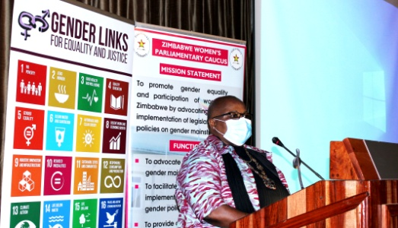
Harare, 25 October 2021: Zimbabwean women politicians have stepped up dialogue on operationalising the local government quota ahead of the 2023 elections. Following an earlier strategy meeting that outlined the nuts and bolts of the local government quota, the Zimbabwe Women’s Parliamentary Caucus (ZWPC), Women in Local Government Forum (WLGF) and the Zimbabwe Electoral Commission (ZEC) held a dialogue last week to share experiences, formulate strategies and draft an action plan on the 30% local government quota.
Speaking at the learning and sharing dialogue, Deputy Minister of Local Government and Public Works Marian Chombo noted that “Women’s equal participation in decision- making is not only a demand for simple justice or democracy but a precondition for women’s empowerment.”
The Parliamentary Women Caucus applauded the introduction of the women’s quota at the national level and its subsequent extension through the Constitutional Amendment Bill no.2. The Caucus applauded the extension of the quota from national to local level as a result of the engagement and tireless work by both the Women in Local Government Forum and the Zimbabwe Women’s Parliamentary Caucus.
“The decision to support the quota at local government came after the ZWPC’s visit to Murehwa Rural District Council, where we saw first hand the challenges faced by women in local government”, said Goodluck Kwaramba the chairperson of the Zimbabwe Women’s Parliamentary Caucus.
Zimbabwe’s 2013 Constitution introduced the mixed FPTP and PR seats for women only to increase women’s representation at the national level. Until the recent changes, the system did not extend to local government. When parliament voted to extend the 30% PR quota beyond the 2023 elections (when it was due to expire) at the national level, WLGF petitioned President Emmerson Mnangagwa, with the support of Gender Links, to ensure that the same provisions are extended to the local level.
While the quota at national level has increased women’s representation, it has its challenges which prevented women from effectively participating. Some of these challenges included being stereotyped by other members of parliament and not having a constituency. However, with continued engagement, things have improved for the better in some areas and there has been less stereotyping of these women whilst some are able to work in their constituencies. Councillors were urged to prepare to face some of these challenges when they arise as they assume the proportional representation seats at the local level.
One of the key issues that emerged during the dialogue is the need to ensure that women effectively participate in electoral processes either as voters or candidates. Zimbabwe Electoral Commission, Commissioner Joice Kazembe unpacked the 30% local government quota saying that the onus is on political parties to decide how they allocate seats amongst youths, ordinary women, and people with disabilities (PWDs).
The local government quota for women passed into law through the Constitutional Amendment Bill no.2 Act of 2021 will see an additional 587 seats added to the existing 1958 council seats bringing the total number of council seats to 2545.
The PR seats constitute 30% of the current number of council seats (1958). However, 587 out of 2545 means women only have a guaranteed 23% of the total number of seats – still higher than the current level of 14% but a far cry from 50%. GL Special Advisor Colleen Lowe Morna pointed out that to reach gender parity in the 2023 elections, “women would have to win at least 27% of the FPTP seats, which is almost double the proportion of women who won through this system in the 2018 elections.”
The dialogue, held in partnership with Silveira House (Jesuit Social Justice Development Centre); Gender Links and the International Idea Women’s Political Participation Programme called for a concerted effort to ensure that women effectively contest in the First Past the Post (FPTP) electoral system to give them a chance increase the numbers of women beyond 23%. Participants agreed that the onus is on political parties to ensure that the playing field is levelled.
The dialogue tabled strategies which included the engagement of political parties and the training of aspiring or new female candidates. Former GL Francophone Director Loga Virahsawmy shared her experience of increasing women’s representation in local government in Mauritius in the 2013 elections.
Although the gender quota there guaranteed at least 30% women candidates in the elections run on a FPTP basis, there was no guarantee that they would win. Gender Links mobilised government and civil society organisations to talent spot and train women from village to municipal level. The local government ministry also ran a spirited advocacy campaign on the benefits of women’s political participation. “There is no short cut to preparing women for effective participation,” Virahsawmy said.
For more information contact Priscilla Maposa on zimmanager@genderlinks.org.za/ +263772732722 OR visit our website and Facebook page and follow us on Twitter.

