WOMEN IN POLITICS TRAINING REPORT

COUNCIL AND MP CANDIDATES

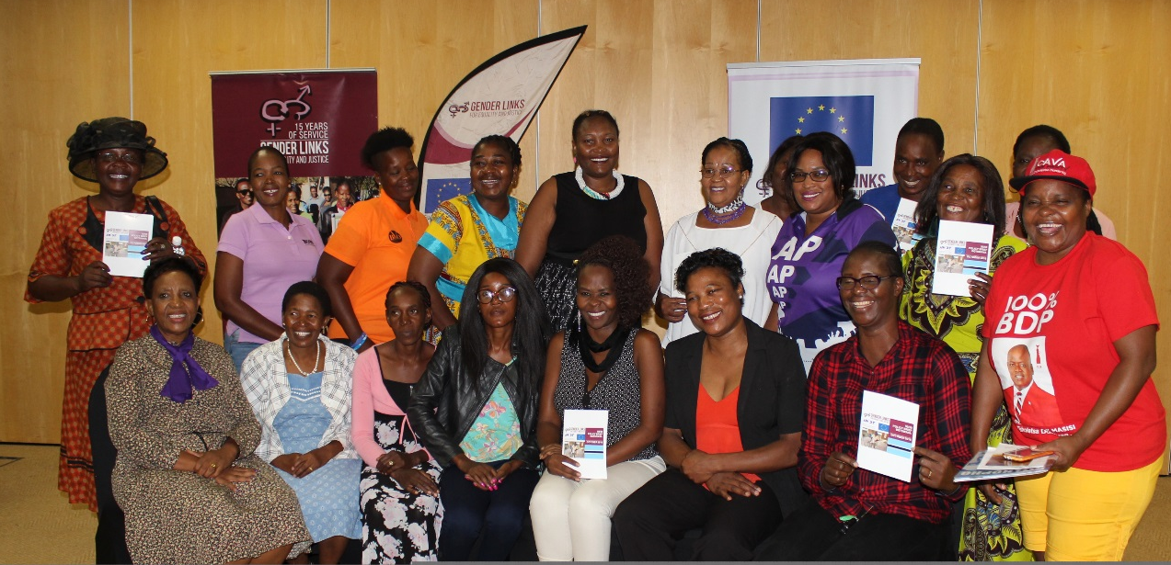

VENUE: MAUN LODGE

BOTSWANA

DATE: 12-13 FEBRUARY 2019

INTRODUCTION

This report is for the ongoing trainings that Gender Links with the funding from European Union is conduction across the country to ready the women for elections 2019 marks the 12th election. Botswana since the 1st election that was held in 1965, which led to the independence of the country in Sept 1966. Botswana’s electoral system is that of first past the post or winner takes all. Botswana has over the years experienced a low number of women participation in the political arena. The latest statistics showed that there was 19% representation of female candidates in councils while it stood at 9% for female parliamentarians.

The equitable participation of women in politics and government is essential to building and sustaining democracy. Women are highly committed to promoting national and local policies that address the socio-economic and political challenges facing women, children and disadvantaged groups. Women are particularly effective in promoting honest government. Countries where women are supported as leaders and at the ballot box have a correspondingly low level of corruption (NDI, 2014; About Women and Democracy).

Women are strongly committed to peace building. Reconstruction and reconciliation efforts take root more quickly and are more sustainable when women are involved. By helping women become participating members of a democracy, one can look to mitigate conflicts or stop conflicts before they begin. Women are strongly linked to positive developments in education, infrastructure and health standards at the local level (NDI, 2014).

TRAINING OBJECTIVES

- To train council candidates on leadership as a concept, to strengthen their leadership capabilities
- To train women council candidates on public speaking and how to use media in advocacy and in messaging
- To boost the confidence of the women and ensure their participation in council discussions is enhanced.

Women as voters Women as candidates

The above tables were shown to the women and they has a discussion about it. Some of the point raised included the following:

- There are more women who vote than those who are candidates.
- They highlighted that these table for women candidates shows that women do not stand for political positions and various reasons were given and will be highlighted at the end of the report.
- The reason for many women being voters does not mean that they should be the only ones to vote for women.

WOMEN STATISTICS IN BOTSWANA 2014 ELECTIONS

PARLIAMENTARY CANDIDATES: BDP- 5
BCP -7
UDC – 3
Independent - 1
TOTAL 16 OUT OF 57 CONSTITUENCIES

The above shows the number of women who had been field by political parties to stand for parliamentary positions.

The above shows the trend of Botswana in terms of women representation since 1979 to the 2014 elections

TOPICS COVERED

Barriers to women participation in politics

Key contributing factors/obstacles to women’s low participation – recognized globally:
- Structural barriers - Discriminatory laws and patriarchy-based institutions.
- Less return on social investment (benefits derived from being a citizen of a member of a given society/community!)
- Resources (financial, time, exposure, capacity in general, multi-dimensional skills base).
- Patriarchal nature of most societies

SADC Regional Efforts to Promote the Women’s Participation in Political Decision-Making

National Policy on Gender and Development (NPGAD) of 2015 identifies Political Power, Democratic Governance and Decision-making

The Policy will advocate for and support governance, leadership skills development, as well as improved awareness and understanding of gender issues.

Advocacy - To promote equal representation of women, men and youth as well as other vulnerable groups at all levels of governance and leadership structures such as Parliament, Local Authorities, Public Service, Parastatal organizations, the Private sector and Civil Society Organizations.

Post 2015 SADC Protocol on Gender and Development

ARTICLE 4: Constitutional Rights
- State parties shall enshrine gender equality and gender equity in the constitution
ARTICLE 5:
- State parties shall put in place special measures with particular with reference to women in order to eliminate all barriers which prevent them from participating meaningfully in all spheres of life
ARTICLE 12:
- State parties shall, ensure equal and effective representation of women in decision making positions in the political, public and private sectors including through special measures a provided for in Article 5

State parties shall ensure that all legislative and other measures are accompanied by public awareness campaigns which demonstrate the vital link between the equal representation and participation of women and men in decision making positions, democracy, good governance and citizen participation

Article 13 : State parties shall adopt specific legislative measures and other strategies to enable women to have equal opportunities with men to participate in all electoral processes including the administration of elections and voting

LEADERSHIP
To prepare the women to become leaders they had to understand what a leader is.
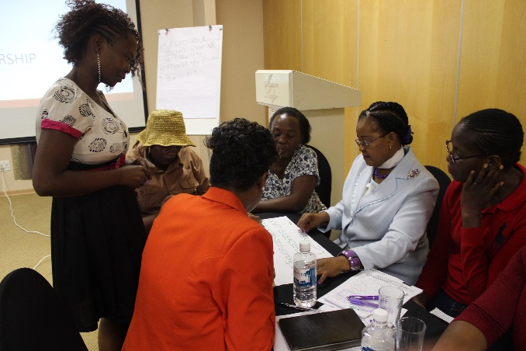
- “Leadership is the capacity to translate vision into reality” (Warren Bennis)
- Leadership is a process by which a person influences others to accomplish an objective and directs the organisation in a way that makes it more cohesive and coherent.
- Leadership is a process of social influence, which maximizes the efforts of others, towards the achievement of a goal
Group discussion by women in politics_Maun_120219_KS

They were also taught on the difference between a leader and a Manager

- Management's main function is to produce order and consistency through processes, such as planning, budgeting, organizing, staffing, and problem solving. Management is more about ensuring that the organisation's resources are allocated wisely, rather than trying to control people. In fact, good managers know that trying to control others is extremely difficult if not impossible.

- In contrast, Leadership deals with the interpersonal relations such as being a teacher and coach, instilling organizational spirit to win, and serving the organization and workers.
- While leadership's main function is to produce movement and constructive or adaptive change through processes, such as establishing direction through visioning, aligning people, motivating, and inspiring.

The Process of Great Leadership

  - Challenge the process - First, find a process that you believe needs to be improved the most.
  - Inspire a shared vision - Share your vision in words that can be understood by your followers.
  - Enable others to act - Give them the tools and methods to solve the problem.
  - Model the way - When the process gets tough, get your hands dirty. A boss tells others what to do; a leader shows that it can be done.
  - Encourage the heart - Share the glory with your followers' hearts, while keeping the pains within your own.

COMMUNICATION

The participants were taken through a communication training in order for them to understand the importance of communication and different approaches to communication. The first exercise was broken telephones. A message was passed from one participant to the other to establish if the message would reach the sender the same. The group arrived to a conclusion that when communication goes through many people the message becomes distorted.

A question was asked to participants on what communication is. Most said it was a way of relaying a message to the other person.

The following definitions were given:

- A technique of conveying a message from one party to the next in the most effect manner possible
- Feedback given determines the effectiveness of the communication
- Communication is the activity of conveying information through the exchange of thoughts, messages, or information, as by speech, visuals, signals, writing, or behaviour. It is the meaningful exchange of information between two or more living creatures.
- One definition of communication is “any act by which one person gives or receives from another person information about that person's needs, desires, perceptions, knowledge, or affective states. Communication may be intentional or unintentional, may involve conventional or unconventional signals, may take linguistic or non-linguistic forms, and may occur through spoken or other modes.”

HOW MESSAGES ARE TRANSFERRED

TIPS TO GOOD COMMUNICATION

- The conveyor will do everything possible to ensure that the message achieves the desired in the way he or she relayed the message,
- The conveyor will choose his or her words carefully, or massage the message to make it as palatable as possible.
- The conveyor has a choice of how to communicate the message.
- There are ways in which the receiver of the message can be prepared to receive the message more favourably.
- The feedback from receivers of the message very much depends on all the above
- Depending on the level of communication achieved, the feedback will either be through personal interaction, or in an impersonal written form.
- On the other hand, if due care is taken, the feedback will be one of understanding and acceptance

USING MEDIA EFFECTIVELY

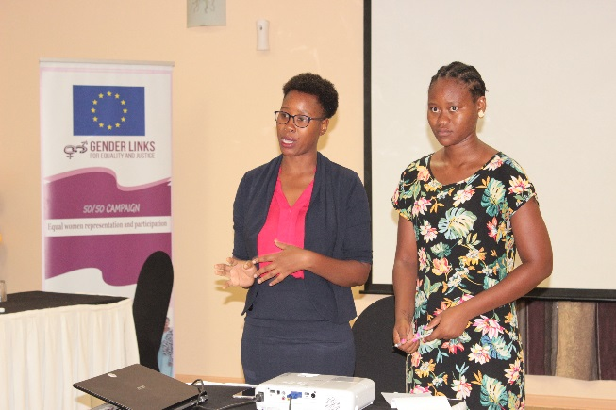
Two young women from the media in Maun were invited and gave a presentation on how the women can use media to put themselves out there.

One of the things they highlighted for participants was the need to engage the media in the work that they do to improve the lives of their community members. They stated that they do not attend events when they do not understand their value add.

Women were encouraged to come up with projects as part of their campaign strategy and invite the media. In this way it was explained that voters get to know about the women and already they appreciate their initiative. The presenters clearly stated that they will not cover an individual’s campaign but will come to cover a rally that has people in high position in the particular political party.

INDEPENDENT ELECTORAL COMMISSION
Mr Ralokwae explained to the women that The IEC exists to provide credible and transparent electoral services to its stakeholders for enhanced participation in the electoral processes. He highlighted various electoral processes and their pros and cons.

Plurality voting is a system in which the candidate(s) with the highest number of vote wins, with no requirement to get a majority of votes. In cases where there is a single position to be filled, it is known as first past the post (Winner takes all). Majoritarian voting is a system in which candidates have to receive a majority of the votes to be elected. Although in some cases only a plurality is required in the last round of counting if no candidate can achieve a majority. There are two main forms of majoritarian systems, one using a single round of ranked voting and the other using two or more rounds. Both are primarily used for single-member constituencies.
Proportional representation is the most widely used electoral system for national legislatures, with the parliaments of over eighty countries elected by various forms of the system.
Party List Proportional representation is the single most common electoral system and is used by 80 countries, and involves voters voting for a list of candidates proposed by a party. In closed systems voters do not have any influence over the candidates put forward by the party, but in open list systems voters are able to both vote for the party list and influence the order in which candidates will be assigned seats. In some countries,
In parallel voting systems, which are used in 20 countries, there are two methods by which members of a legislature are elected; part of the membership is elected by a plurality or majority vote in single-member constituencies and the other part by proportional representation. The results of the constituency vote has no effect on the outcome of the proportional vote.

BRANDING

Participants were taken through various platforms they can use to brand themselves, each one had to select one which they will use going towards elections. Those not on Facebook and had no email addresses were assisted to open them.


- Personal branding is the practice of people marketing themselves and their careers as brands . While previous self-help management techniques were about self-improvement, the personal-branding concept suggests instead that success comes from self-packaging.
- It is a way for people to know what you are about through the creation of a cohesive representation of yourself that is portrayed to the world. We all know high profile individuals with a personal brand. Think Nelson Mandela, Oprah Winfrey, Barrack Obama and various other public figures and politicians. They have all established an identity in the public realm – their personal brand – that enables others to have a level of understanding about the type of person they are. Regardless of age, regardless of position, regardless of the profession we happen to be in, all of us need to understand the importance of branding.


- Facebook is a social networking Web site that allows people to communicate with their friends and exchange information. In May 2007 Facebook launched the Facebook Platform which provides a framework for developers to create applications that interact with core Facebook features



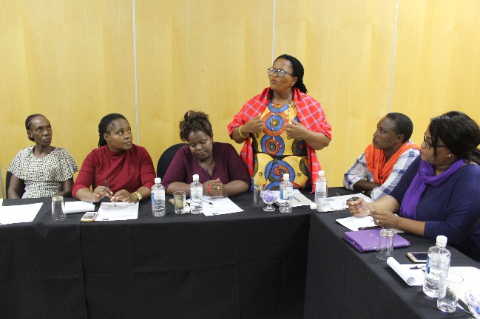
Figure Hon Nana makig a commenct during WIP training_130219_KS

EVENT: WOMEN IN POLITICS
DATE: 12-13 February 2019
VENUE: Maun Lodge

NAME | SURNAME | SEX-TICK |  |  | AGE-TICK |  |  |  |  | POLITICAL PARTY | EMAIL | CELL
NAME | SURNAME | M | F | Other | -18 | 18-25 | 26-40 | 41-50 | 51-60 | POLITICAL PARTY | EMAIL | CELL
1. Kerevima | Kanyeto |  | √ |  |  |  | √ |  |  | BMD Maun East |  | 71306856
2. Kedi | Pelontle |  | √ |  |  |  |  |  | √ | Information Services | kpelontle@gov.bw | 73911685
3. Keitshokile | Bogopa |  | √ |  |  |  |  | √ |  | Phikwe East B.D.P |  | 72678283
4.Mathodi | Modisapodi |  | √ |  |  |  |  |  | √ | BPP Tati East | mathodimosapodi@gmail.com | 77010600
5.Theresa | Mmolawa |  | √ |  |  |  |  |  | √ | AP Francistown East | tgmmolawa@gmail.com | 71381112
6. Marie | Sola |  | √ |  |  |  |  |  | √ | AP Thamaga-Kumakwane | marietsola@gmail.co | 71202050
7. Gosaitse | Mangisi |  | √ |  |  |  |  |  | √ | BPP Tati East |  | 71604408
8.Keletso | Ramoswaana |  | √ |  |  |  |  | √ |  | BDP Gantsi North | sethunyaramoswana@gmail.com | 74131975
9. Nana | Mothibi |  | √ |  |  |  |  | √ |  | BDP Gantsi North | nanamothibi@gmail.com | 73742798
10. Bains | Bosigo |  | √ |  |  |  | √ |  |  | Botswana Television | bbosigo@gmail.com | 73283836
11. Wame | Gwandu |  | √ |  |  | √ |  |  |  | Radio Botswana | wamegwandu@gmail.com | 75643823
12. Joseph | Kgamanyane |  | √ |  |  |  | √ |  |  | Gabz FM | jkgamanyane@gmail.com | 76379979
13.Elizabeth | Masuzu |  | √ |  |  |  | √ |  |  | BDP Ghantsi North | veronica@gmail.com | 71997001
14.Adelline K | Gunda |  | √ |  |  |  | √ |  |  | BPP Tati West | adelidekgunda@gmail.com | 76209045
15.Gofaone | Mabutho |  | √ |  |  |  | √ |  |  | BCP Shashe West |  | 74554495
16.Keleapere | Madome |  | √ |  |  |  |  |  | √ | BCP Selebi Phikwe East |  | 74000916
17.Grace | Moleta |  | √ |  |  |  |  | √ |  | MAA | moletagrace@gmail.com | 73758566
18.Masego | Tsiane |  | √ |  |  |  | √ |  |  | BMD Mahalapye North |  | 77496125
19. Gaoithusiwe | Senmailo |  | √ |  |  |  |  | √ |  | UDC Mabule |  | 73639170
20. Thato Pinkie | Segakise |  | √ |  |  |  |  | √ |  | AP Tlokweng Lesunyaneng |  | 71666457
21. Florence | Chibua |  | √ |  |  |  |  | √ |  | BMD Francistown South |  | 77659558
22. Veronica | Ntebele |  | √ |  |  |  |  | √ |  | BMD Mahalapye (Parwe) |  | 71293653
23. Nchadi | Alebo |  | √ |  |  |  |  | √ |  | BMD Mokoboxane |  | 75489738
24. Amantle | Moeti |  | √ |  |  |  | √ |  |  | AP Bonnington North | amantlemoeti@gmail.com | 71831348
25. Gosaitse | Rapelang |  | √ |  |  |  | √ |  |  | BMD Francistown West | gosaitserapelang@gmail.com | 74562211
26. Mariam | Madise |  | √ |  |  |  |  | √ |  | AP Etsha 6 |  | 73583940
27. Segametsi | Rantutu |  |  |  |  |  |  |  |  | AP Serowe |  | 77194363
28. Solomon | Tsinyeka |  | √ |  |  |  | √ |  |  | The Patriot | stjinyaka@gmail.com | 74914995
29. Goabaone S | Motsatsing |  | √ |  |  |  | √ |  |  | Bana ba letsatsi | sophymots@gmail.com | 74209922
30. Bonolo | Kannono | √ |  |  |  |  | √ |  |  | Bana ba letsatsi | bonolobbl@gmail.com | 74109930
31. Francinah | Baitse |  | √ |  |  |  |  | √ |  | The Voice | francinahbm@thevoice.com | 77412352
32. Masego | Galetswesepe |  | √ |  |  |  | √ |  |  | BMD Maun West |  | 74026927
33. Ompuile M | Lebelo |  | √ |  |  |  | √ |  |  | Broadcasting BTV | Omurphy05@gmail.com | 76344199
34. Tapologo | Mokoka |  | √ |  |  |  |  |  | √ | BDP | tpmokoka@gmail.com | 72761760
35. K Guylord | Ralokwai | √ |  |  |  |  | √ |  |  | I.E.C | gralokwae@gov.bw | 71219593
36. Mpho | Molemisi |  | √ |  |  |  | √ |  |  | Genderlinks |  | 3188250
37. Gomolemo | Rasesigo |  | √ |  |  |  | √ |  |  | Gender links | botsmanager@genderlinks.org.za | 3188250
38. Keletso | Serole |  | √ |  |  |  | √ |  |  | Genderlinks |  | 3188250

Media Houses(highlighted in yellow) : BTV, Radio Botswana, The Voice, Gabz fm, The Patriot, Daily news

