Youth lead local action for #VoiceandChoice in SADC
Since August 2018, GL has worked with 67 municipalities across 10 SADC countries, to involve youth in local level SRHR policies, services and practices. Gender Links’ SRHR programme has reached 439 youth champions affiliated or working directly with local government councils. The youth champions include junior councilors, youth group leaders, local arts or drama group members, civil society representatives and students. GL championed youth led advocacy on SRHR through community dramas showcased by youth.
The table summarises the youth formations that GL is working with.
Country | Number of councils reached | SRHR campaigns by youth groups | Youth involvement in GL’ SRHR local government programme
Botswana | 15 | Menstrual health | Youth associations linked to councils
Lesotho | 5 | HIV and AIDS, Comprehensive Sexual Education | Peer educators from Skills share
Madagascar | 10 | Sexual education and services | Youth associations linked to councils, schools
Mauritius | 5 – village councils | GBV, sexual diversity | Youth associations and organisations
Mozambique | 10 | Child marriages, | Youth clubs , schools
Namibia | 5 | GBV, HIV and AIDS, safe abortion, SRHR services | Junior councilors and youth groups
South Africa | 3 | HIV and AIDS, teenage pregnancy, GBV | Victim Empowerment Programme mentors
eSwatini | 4 | Safe abortion, HIV and AIDS, Menstrual health | Youth mentors working with local councils and the young women’s Alliance
Zambia | 5 | Child marriages, teenage pregnancy | Youth clubs and associations
Zimbabwe | 10 | Child marriages, sexual education and services, | Junior councils led by the National Junior Councilors’ Association

Botswana and Mauritius
eSwatini
Lesotho
Namibia
South Africa
Zimbabwe

In Botswana and Mauritius, SRHR is not the mandate of local government; instead, it falls within the Ministries of health. However, Gender Links Mauritius has been working with youth through the Safe Haven and village councils. There are various youth groups led by civil society that easily work with the village councils. GL Mauritius will organise a training of trainers’ workshop in March to identify youth champions from various youth formations, in particular youth focussed organisations.
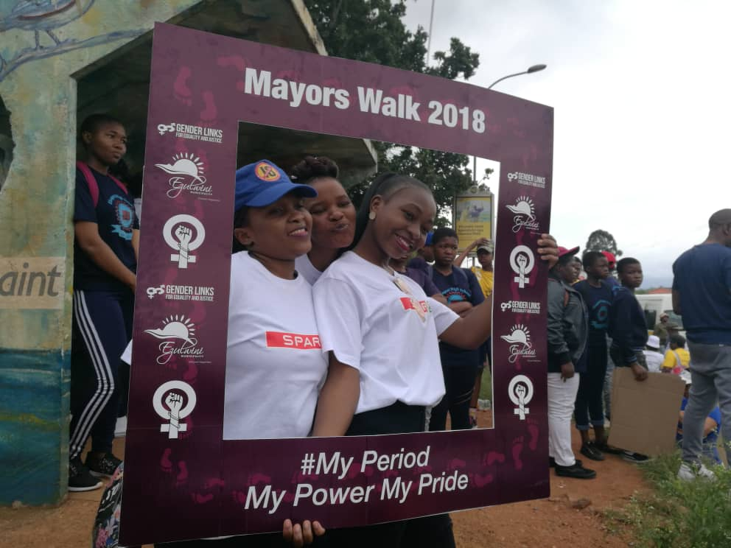
In eSwatini, GL works closely with the eSwatini local government association (ELGA) to mobilise local government for SRHR. Additionally, the gender focal persons for eSwatini’s councils are the local AMICAAL chapter officers. These have been working with GL to mobilise youth for local campaigns on SRHR. ELGA is considering setting up of junior local government councils in eSwatini. The eSwatini mayors, GL and other civil society organisations organised a walk to highlight the menstrual health campaign. GL worked with the Young Women's Alliance – a grouping of youth activists that are challenging social ills such as GBV and harmful traditional practices. The young women involve boys in the campaigns to achieve holistic results. Some of the ongoing Twitter hashtags for the group include #freecondoms #freepads. Youth mentors advance SRHR campaigns in each local authority. GL eSwatini worked with nine youth mentors since August 2018. The mentors have produced a documentary on safe abortion and have been involved in SRHR community dramas.

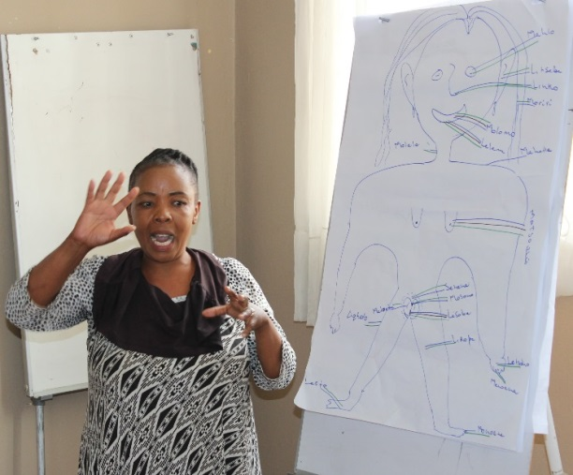
In Lesotho, GL is working with peer educators from SkillsShare to include youth in SRHR issues at a local level. The youth peer SRHR educators are advocating for demand creation for uptake of HIV services, condom promotion and distribution and creating an enabling legal environment. Recently female sex workers joined the peer educators programme to be direct influencers of target populations, selected from within and by the community. The peer educators are trusted members of the community serving as volunteers. The peer educators worked with GL in developing SRHR community dramas. GL worked with a youth group in Mafeteng council to organise a SRHR talk show during the 16 Days of activism.

In Namibia, Gender Links is working closely with junior councilors, who are the youth version of the local government councils. The three local government associations; Association of Local Authorities of Namibia (ALAN), Alliance of Mayors and Municipal Leaders (AMICAALL) and Namibia Association of Local Authority Officers (NALAO) support the junior councilors. AMICAALL has particularly worked with the youth and Gender Links in the fight against HIV and AIDS. It promotes sexual health and wellness of local communities through training and development. Junior councillors are involved in council meetings. In the past junior councillors have participated in the summits showcasing SRHR best practices. In councils such as Enhana, youth are championing anti-drug and alcohol abuse campaigns as well as GBV campaigns. There is potential for youth to champion sexual diversity campaigns in their localities. Intergenerational dialogues are common to mentor the youth on successful campaigning at the local government level.
South Africa’s Victim Empowerment Programme (VEP) worked with GL in the Limpopo province to mobilise youth for SRHR including advocating for establishment to junior councils in the target four councils. The youth champions affiliated to the VEP identified the Menstrual Health, safe abortion and gender based violence as key campaigns in the province. GL will be working with the VEP youth groups on use of social medial tools to popularise the campaigns and achieve youth friendly SRHR services. GL will work with VEP and the local government association, SALGA to mobilise South Africa local government to establish junior councils, taking advantage of 2019 as election year.

In Zimbabwe, GL involved youth in the SRHR programme through the National Association of Junior Councillors. Junior councillors need to be emulated in some councils as a best practice The National Junior Council Association has an annual forum aimed at involving youth in decision making at the local government level. The National Association of Junior Councils will host the Junior Councils Forum from 28 February to 3 March 2019 running under the theme ‘Creating Safe Spaces for Children and Youth in Local Governance.” GL has been asked to give technical support and help junior councils to plan activities around gender mainstreaming in the junior councillors overall annual plan including on SRHR. The junior councillors in the 10 target councils from Zimbabwe were responsible for developing and showcasing the SRHR community dramas. For example, Norton Town Council has brought awareness on SRHR through showcasing the child marriage drama. The junior councillors led on the key messaging for Zimbabwe’s SRHR campaigns through using local languages and social media hash tags. The association uses discovery learning, focus group discussions, peer learning, lectures, arts and drama to popularise SRHR in local government.

