Tips for photography
A picture says a thousand words-only if it is a good picture
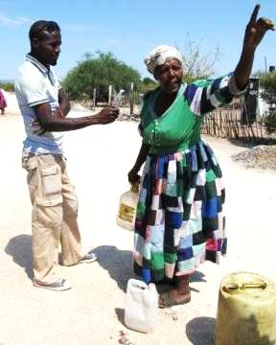

Bonnie Elifas,Reporter at Base FM (Community Radio Station) , interviewing Juditte Haoses,
a resident of the informal settlement in Outjo, Namibia, during a Media COE GBV Training field trip

Compiled by: Lucia Makamure

CHECKLIST FOR PHOTOS

QUALITY OF THE PHOTO
- Dpi (300 above)
- No camera shakes – a crisp picture

COMPOSITION OF THE PHOTO
- Clear, not cluttered
- Priority – action shots
- If workshop photo – action oriented. No duplicates!!
- If all the above are not answered but it is a unique photo, we might keep it

CAPTION - GOOD EXPLANATION OF THE PICTURE
- Who- identifies those in the picture by name, surname and designation (where applicable) where there are three or less in the photo. Names in the right order from the left, and specify the position (e.g. left or front row, second from the right). If group photo: the group is identified
- What: action in the picture, no speculation
- Why: is the action taking place
- Where: place and country
- When: at least the year, if applicable. Should be in photo information.
- If some of the above are not answered, but we know that we can get the information, and it is a good photo, please keep it because in round two we will seek to add the information.

NB
- Head shot – name, surname, designation, organisation, country
- If there are certain gaps, but is an important head shot, and we might still be able to get the information, we will keep it.

A SERIES OF PICTURES THAT LOOK THE SAME
- Please use the best one – As per guidelines above
- We only need one!!

SHOULD THE PHOTO BE SHORTLISTED
- Only if it is an action shot that speaks to the bigger issues
- No head shots
- No GL institutional shots
- Only if it answers to the above technical and quality specs and has a sufficient caption, or missing info can be obtained.

General principles of good photography

The purpose of this manual is to provide practical steps on how to take better pictures. Using examples, it illustrates the acronym to “CARE”: closer is better; action; rule of thirds; and everyday beauty. This manual also gives guidelines on how to choose better photographs to accompany a GL product such as a newsletter or a publication. Finally, this manual includes instructions on how to write comprehensive captions for photographs.

A photograph should:
- Draw the viewer’s attention immediately.
- Tell a story.
- Be relevant to the context. For example, if you are photographing a fire also show those left homeless, firefighters, personal possessions etc. If you are covering sports, do not just photograph the event but also the players, the coaches, the fans.

How to take pictures

Follow this basic guideline to improve the quality of your photographs:

Closer is better
Action
Rule of thirds
Everyday beauty

- Closer is better

The first thing to improve your photography is to get close.

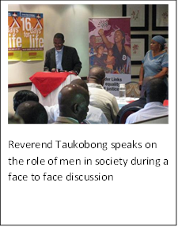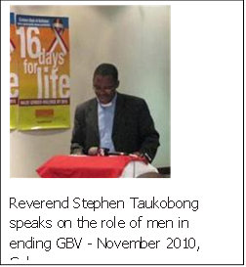

- Action

A good example from Zambia taken by Cynthia Kalizinje

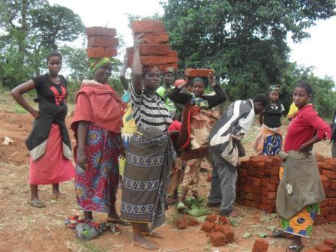

Look for action shots that tell a story. Keep taking pictures until you get the right shot.

How to select better pictures

When choosing photographs to use in the Photo Gallery or in a GL publication:
- Provide relevant photos; avoid using generic pictures.
- If photos are for a publication pay attention to whether they should be landscape or portrait.
- Pay particular attention to quality, content and composition.
- Rule of thumb: Photographs for workshops do not count as a picture to use for the Barometer.

Quality

- The main subject has clear, sharp details. A poor quality picture might be slightly out of focus.

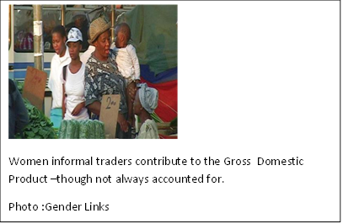
Content

Does the photo tell a story?
Is it appealing, well-composed and striking
Examples of what types of pictures work and what don’t

- Profiles or headshots

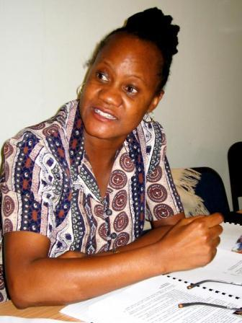
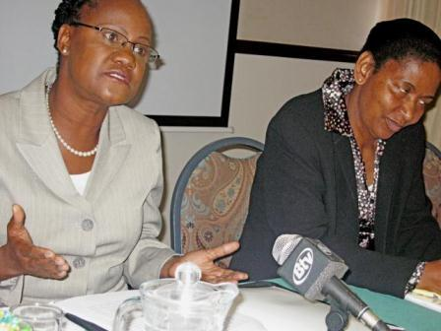

The image on the left has been used in GL products but it does not befit a professional publication. It is taken at an awkward angle and it is over-exposed (the background is too bright) and could have been cropped.

The image on the right is a much better example of a profile or headshot. It is close, it conveys emotion, it provides some and it is a clear, sharp image.

Events
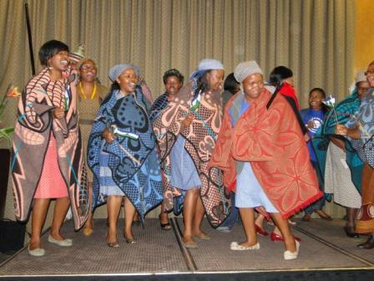
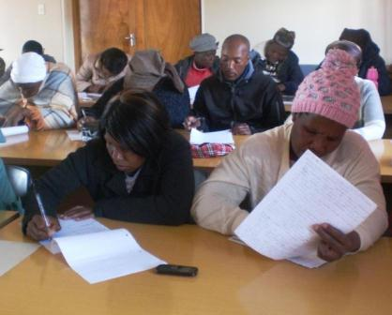

At GL, we have variations of the same stock image: participants at a workshop/conference/seminar/cyber dialogue/book launch/etc. If you use these images, try to choose the more interesting ones, the ones that convey something interesting or unusual about an event that tends to be portrayed as static and boring.

The image on the right shows us what not to do. The angle is problematic because the viewer does not know whether to look at woman with her eyes half-closed in the front row or the depressed-looking individuals in the background. The subjects do not convey any emotion other than tiredness or solemnity and this makes GL’s activities look mind-numbingly boring - which they are not! Try to photograph and select images that show the lively side of these events.

The picture on the right is a much better example of a photo taken at an event. The subjects are enjoying themselves and dance provides context and tells us a story e.g. culture

Thematic issues
See Annex A for ideas but do not limit yourself to this description

Economy
Should not just be women selling at the market (stereotype) but women in other roles e.g. bank managers, miners, construction workers, other key decision makers in the sector

Health
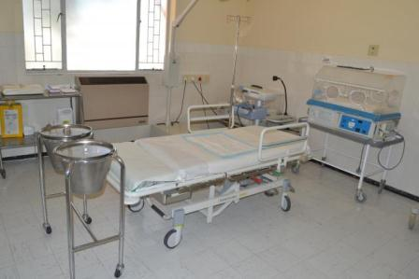
Though the picture is relevant to the theme, it does not a story (it is dead). There should be some action.

Writing captions
Re-name all photos
Provide well-named photos that include the name of the person photographed, the place, and the date. The file name of the photo should include this information that will be used in the caption. The file name template is:

full name or description of subject_event_place_country_photographer’s initials_date.jpeg

Captions are always written in the present tense. They tell the reader, briefly and clearly, the basic details of the picture and tie it to the story it illustrates. Like headlines, captions must be crisp. They must also be readable and informative, interesting and lively.

Some reminders to ease writing captions:
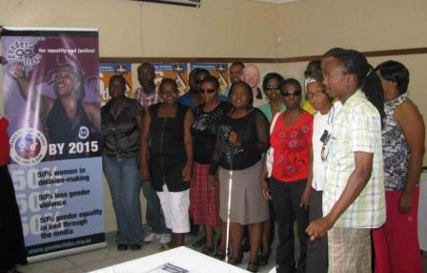
People with disabilities at 16 Days of Activism workshop-Botswana 2010
Picture Roos van Dorp

- Does the caption say when and where?
- Does it identify, fully and clearly?
- Is the name and surname of the subject included in the picture?
- Are the names in the right order? List people in a group shot from the left, and specify the position (e.g. left or front row, second from the right).
- One long sentence is boring. Use at least two short, snappy sentences.
- Stick primarily to explaining the action in the picture, but don’t speculate. [only write what you are sure of rather than descriptive/subjective opinion] Is the action mentioned in the caption really shown?
- Watch attribution and don’t let libel creep in.
- Read what you’ve written. Are all the questions answered? Count the people in the picture and the number of names. Are left-to-right designations correct?

Every photo needs to be credited with the photographer’s name.
This is done within the caption of the photograph. If you are not the photographer of a particular image but wish to use it, make sure you ask permission from the photographer.
For more information and guidelines on these ethics, read Photojournalism: an ethical approach (Lester 1999). The full text is available online:
http://commfaculty.fullerton.edu/lester/writings/pjethics.html.

Below is a picture taken by Trevor Davies but credited to Gender Links

Women breaking into non-traditional areas- a woman working in the telecommunications industry, Botswana. Photo: Gender Links

Checklist
- They all have a caption, who what where (place, country) when how
For example Caption: Hon ???Trepper (City of Windhoek Mayor) handing over certificate to Busch ??? award winner in the leadership category Leadership, Country Summit ????, Namibia
- All SADC Protocol@work must have photo (summit entries in this case).
- Pictures are relevant to story: Should tell stories on the ten themes of the SADC Gender Protocol
- Where school children (under 18), please get consent forms
- They are high quality and active
- Low res and url given – example here no url
- They all have a caption, who what where (place, country) when how
- Caption speaks to text EG This caption is vacuous: Secondary school girls from Malawi. Photo Gender Links
- FINDING PHOTOS – All SADC Protocol@work must have photo. Mada education urgently needs photo . Pls don’t pay contributors who do not include a photo
- Caption: Hon ???Trepper (City of Windhoek Mayor) handing over certificate to h Busch ??? award winner in the leadership category Leadership, Country Summit ????, Namibia
- Avoid taking pictures of people’s backs
- Pls try and find the name of the photographer – all my photos are still being called Gender Links

Conclusion: A picture says a thousand words-only if it is a good picture
http://gemcommunity.genderlinks.org.za/gallery/main.php?g2_itemId=16990
A young boy collects water from an unprotected water source in Swaziland
Photo: Samkelo Ngwenya

http://gemcommunity.genderlinks.org.za/gallery/main.php?g2_itemId=18863
A bleak future for a young girl from Morafeno Madagascar as she washes pots in a dirty river.
Photo: Zotonantenaina Razanadratefa

Used in the SADC Gender Protocol Barometer Chapter 6 for the section on sanitation.

Resolution is a measurement of the quality of an image, DPI, used worldwide, defines how many dots of ink are placed in a square inch when the image is printed. 1 inch equals 25.4 mm.. For high quality image printing, you should always strive for at least 300 dpi resolution for your image! If your image has embedded text in it, a 400 dpi resolution is strongly recommended!

