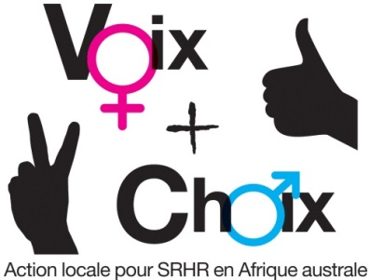

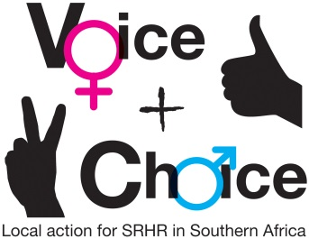

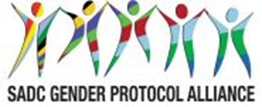

SEXUAL AND REPRODUCTIVE HEALTH AND RIGHTS (SRHR) CAMPAIGN PLAN

NAME OF COUNCIL: OSHIKUKU
Date: 05 November 2018

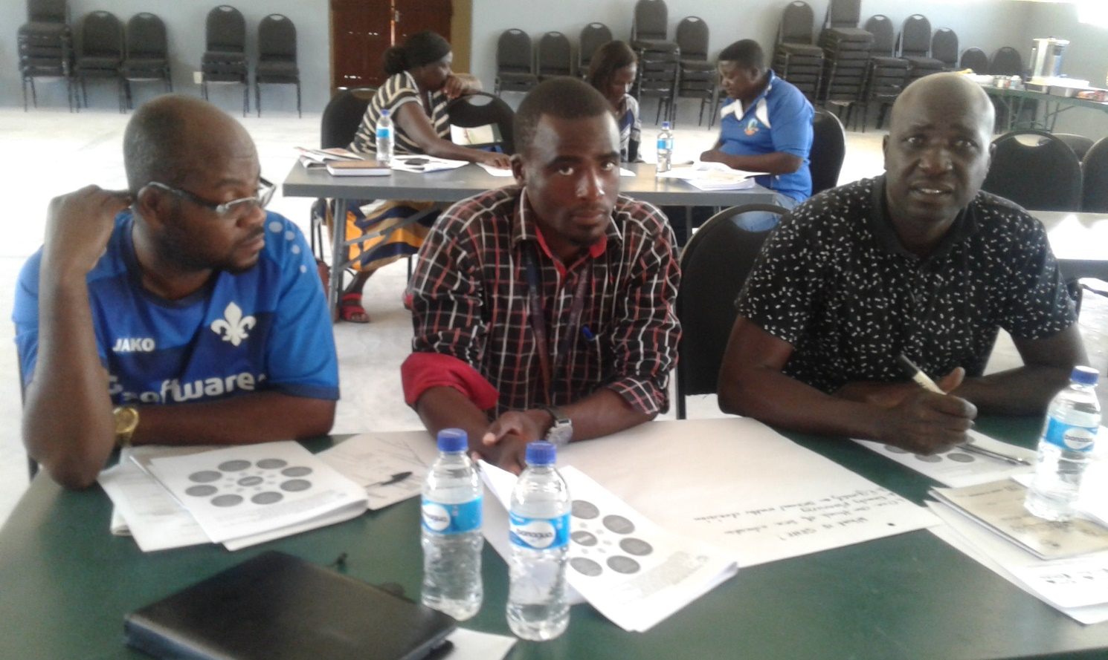
Participants during Sexual education and Services Plan

GUIDANCE ON MESSAGES:
- The group should first decide on and record the specific objectives for the country/council.
- Who are these targeted at?
- What messages/slogans are appropriate to these target groups?
- What are some of the hashtags in country you can leverage on or create? This includes in local languages
- How can they link to regional/global hashtags
- What are some of the Twitter handles you will tag – refer to the Alliance social media handles

SPECIFIC OBJECTIVES | TARGET GROUPS | MESSAGES/SLOGANS | HASHTAGS – LOCAL | HASHTAGS – REGIONAL/ GLOBAL | Social media tagging
To provide sexual education to boys and girls in schools and institutions of higher learning by December 2019 | Young people in all School settings, teachers and social workers | Everyone counts | #Ichoosetobeme | #safesex | @childlinelifeline
To provide clear information with regard to sexual education to boys and girls of 18 years above through awareness raising | Young people in all School settings, teachers and social workers, destitute children,  Parents | Abstinence is a key | #myfuturemychoice | #SayNotoSex | @UNICEF
To distribute condoms and do referrals to health clinics by December 2019 | Youth  PLWD  Key population | Health is a right | #prevention is betterthan cure | #befaithful | @UNAIDS

GUIDANCE ON PLANNING FRAMEWORK:
- Specific objectives should be recorded in the planning framework.
- Actions and activities are suggestions. Please customise as appropriate. Please be very specific about the activities to be undertaken.
- Delete any suggested activities that are not relevant to your campaign
- Which members of your consortium will be responsible for each activity?
- By When?
- What will be the main outputs?
- What resources will this require, human, financial, other? What synergies can be forged with existing activities? Are there fund raising possibilities?

OBJECTIVES AND ACTIONS | ACTIVITIES | WHO RESPONSIBLE | TIME FRAME | OUTPUTS | RESOURCES
Strategic objective | To ensure universal access to sexual and reproductive health and reproductive rights in accordance with the Programme of Action of the International Conference on Population and Development, the Beijing Platform for Action, the SDGs and the SADC Protocol on Gender and Development.
Specific objectives: To provide access to sexual reproductive health and rights to active population in accordance to international actions
1 | To provide sexual education to boys and girls in schools and institutions of higher learning by December 2019
2 | To provide clear information with regard to sexual education to boys and girls of 18 years above through awareness raising
3 | To distribute condoms and do referrals to health clinics by December 2019
1. Obtain buy-in from key stakeholders
1. Obtain buy-in from key stakeholders | 1.2. Meetings with parliamentarians (who?) | Law makers, Councillors, CEO, health directors, school counsellors | March 2019 | Signed MOU | N$1500
1. Obtain buy-in from key stakeholders | 1.3 Meetings with statutory bodies – eg law reform commissions – who?) | Law makers, Councillors, CEO, health directors, school counsellors | April 2019 | Policy formulation and review | N$2000
2. Launch the campaign and gain maximum publicity for it | 2.1 Arrange venue, logistics and date for launch | Genderlinks,  Councillors, CEO, health directors, school counsellors, Health Ministry, NGOs | June 2019 | Detailed Budget and programme | N$5000
3. Develop and disseminate campaign materials | 3.1 Pamphlets explaining XXX/ where to get help; disseminated through XXXX | Councillors, CEO, health directors, school counsellors, Health Ministry, NGOs  Junior Councillors | July 2019 | Posters and pamphlets | N$1300
3. Develop and disseminate campaign materials | 3.2 Placing billboards in all strategic areas | Town Councils, Ministry of information,  Ministry of health | August 2019 | Placed billboards | N$8000
3. Develop and disseminate campaign materials | 3.3 Radio: Docu/ drama disseminated via radio and taxis through the taxi association. Use of radio listening clubs to ensure maximum dissemination. | Town Councils, Ministry of information,  Ministry of health | September 2019 | Information disseminated | N$4000
4. Engage key stakeholders and the general public in interactive public education encounters | 4.1 Workshops in regions/ systematically- ensure all regions covered | Genderlinks,  Town Councils | October 2019 | Workshops report | N$20000
 | 4.2 Drama using local actors, followed by discussion, that is systematically performed in all districts | Genderlinks,  Town Councils Youths , School going Children | October 2019 | Detailed Activity report | N$2300
5. Leverage on special dates in the calendar for promoting the campaign | Sixteen days of activism | Genderlinks,  Town Councils Youths , School going Children | December 2019 | Report on 16 days event | N$8000
 | 10 December- International Human rights day | Councillors, CEO, health directors, school counsellors, Health Ministry, NGOs  Junior Councillors,GFPs | December 2019 | Event report | N$4000
 | 1 March- Zero Discrimination Day | Councillors, CEO, health directors, school counsellors, Health Ministry, NGOs  Junior Councillors, GFPs | March 2020 | Detailed Activity report | N$4000
 | 8 March International Women’s Day | Councillors, CEO, health directors, school counsellors, Health Ministry, NGOs  Junior Councillors,GFPs | March 2020 | Event Report | N$5000
 | 7 April- World Health Day | Councillors, CEO, health directors, school counsellors, Health Ministry, NGOs  Junior Councillors, GFPs | April 2020 | Event Report | N$4200
 | 25 May- Africa Day | Councillors, CEO, health directors, school counsellors, Health Ministry, NGOs  Junior Councillors, GFPs | May 2020 | Detailed Report | N$4000
 | 11 October-International Day of the Girl Child | Councillors, CEO, health directors, school counsellors, Health Ministry, NGOs  Junior Councillors, GFPs | October 2020 | Detailed Report | N$2000
 | 15 October - International Day of Rural Women | Councillors, CEO, health directors, school counsellors, Health Ministry, NGOs  Junior Councillors, GFPs | October 2020 | Detailed Report | N$1200
 | 21 October-Africa Human Rights Day | Councillors, CEO, health directors, school counsellors, Health Ministry, NGOs  Junior Councillors, GFPs | October 2020 | Detailed Report | N$1000
 | 1 November- Africa Youth Day | Councillors, CEO, health directors, school counsellors, Health Ministry, NGOs  Junior Councillors, GFPs | November 2020 | Detailed Report | N$4000
6. Engage with the mainstream media in obtaining space/ air time for the campaign as well as increasing media coverage | 6.1 Meetings with editors | Councillors, CEO, health directors, school counsellors, Health Ministry, NGOs  Junior Councillors, GFPs | November 2020 | Minutes | N$500
 | 6.2 Research on coverage of menstrual health in the media | Genderlinks,  Universities , polytechnics | December 2020 | Research report | N$8000
 | 6.3 Training for journalists in coverage of menstrual health | CEOs, Gender Links , GFPs, Stakeholders | December 2020 | Training report | N$6000
 | 6.4 Letters/ opinion/ radio talk shows | Councillors, CEO, health directors, school counsellors, Health Ministry, NGOs  Junior Councillors, GFPs | December 2020 | Visit report, copies | N$800
7. To launch a social media campaign | 7.1 Twitter | IT Technician, Genderlinks, GFP | December 2020 | Posted articiles
 | 7.2 Facebook | IT Technician, Genderlinks, GFP | December 2020 | Posted articiles
 | 7.3 Instagram | IT Technician, Genderlinks, GFP | December 2020 | Shared articles
 | 7.4 Website | IT Technician, Genderlinks, GFP | December 2020 | Shared articles
 | 7.5 GL Community of practise | IT Technician, Genderlinks, GFP, Gender committees | December 2020 | Printed articles | N$3000
 | OTHER
8. Initiate greater involvement of men in the struggle for women’s human rights | 8.1 Engaging with male champions | Councillors, CEO, health directors, school counsellors, Health Ministry, NGOs  Junior Councillors, GFPs, Traditional leaders | December 2020 | Report | N$9000
 | 8.2 Engaging with men for change networks | Councillors, CEO, health directors, school counsellors, Health Ministry, NGOs  Junior Councillors, GFPs, Traditional leaders | December 2020 | Report | N$1000
 | 9.1 Reports on all workshops and dissemination exercises | CEOs, GFPs and Gender committee members | Ongoing | Detailed Report | N$700
 | 9.2 Feedback from the public | Councillors, CEO, health directors, school counsellors, Health Ministry, NGOs  Junior Councillors, GFPs | Ongoing | Minutes of feedback meeting | N$800
10. Prepare best practices for the 2019 SADC Protocol@Work #VoiceandChoice Summit | 10.1 Access summit call | GL, Town councils | February 2021 | Response to the summit | N$1000
 | 10.2 Document case study | Genderlinks, Champions, GFP | April 2021 | Documented case study | N$2000
 | 10.3 Present case study at the summit | Genderlinks, Champions, GFP | May 2021 | Case study presented | N$3000

MONITORING AND EVALUATION
English: http://genderlinks.org.za/what-we-do/sadc-gender-protocol/advocacy/alliance-srhr-me/
French: http://genderlinks.org.za/what-we-do/sadc-gender-protocol/advocacy/alliance-srhr-me/alliance-srhr-se/
Portuguese: http://genderlinks.org.za/what-we-do/sadc-gender-protocol/advocacy/alliance-srhr-me/alianca-srhr-me/

