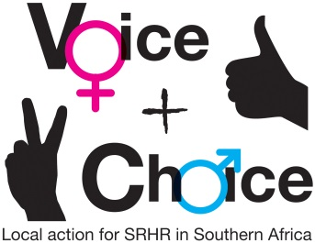
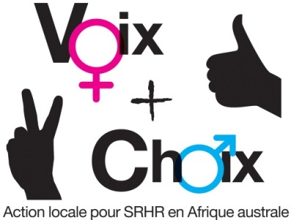
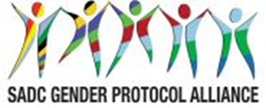

SEXUAL AND REPRODUCTIVE HEALTH AND RIGHTS (SRHR) CAMPAIGN PLAN – MATERNAL HEALTH

NAME OF COUNCIL: OUTAPI
Date: 12 December 2018

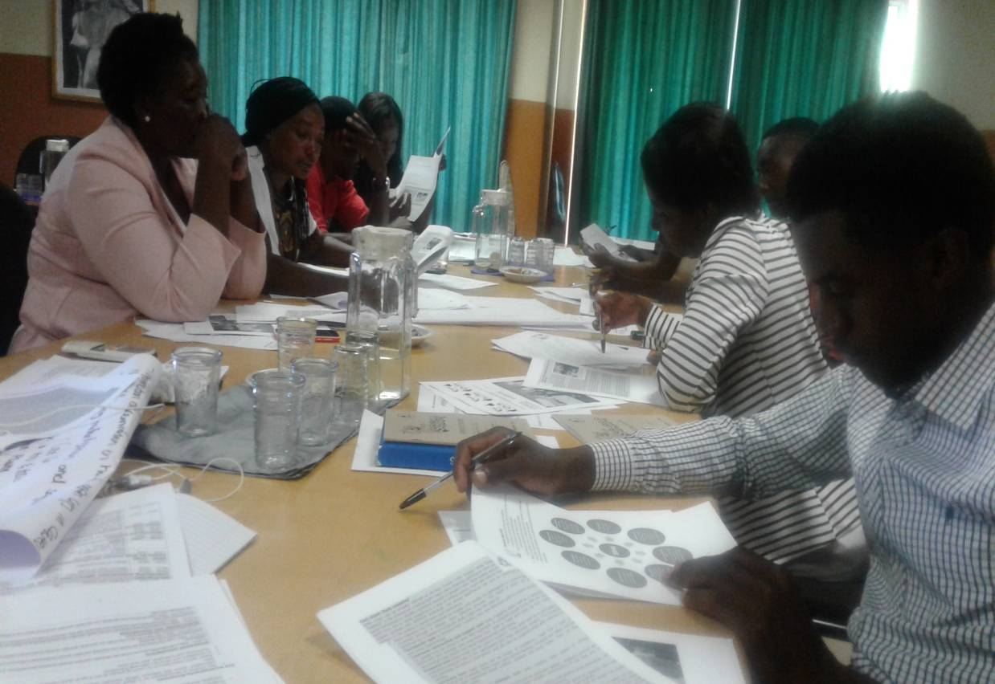
Figure 1; Participants seen during Maternal health Campaign Plan

GUIDANCE ON MESSAGES:
- The group should first decide on and record the specific objectives for the country/council.
- Who are these targeted at?
- What messages/slogans are appropriate to these target groups?
- What are some of the hashtags in country you can leverage on or create? This includes in local languages
- How can they link to regional/global hashtags
- What are some of the Twitter handles you will tag – refer to the Alliance social media handles

SPECIFIC OBJECTIVES | TARGET GROUPS | MESSAGES/SLOGANS | HASHTAGS – LOCAL | HASHTAGS – REGIONAL/ GLOBAL | Social media tagging
To eliminate neonatal morbidity and mortality by 2019 | Young Girls  Young adults,  Government houses | Zero to mortality rate | #Dienotnow | #VoiceandChoice | @Genderlinks
To enhance and promote reproductive health | Adolescents,  Ministry of Health | Information is our health | #informationispower | #Healthandpeople | @ACTIONAID
To increase contraceptive prevalence and provision of family planning services | Life school teachers, health Ministry, private clinics | One round one condom | #Dieorlive | # Onevoiceoneaction | @ UNAIDS

GUIDANCE ON PLANNING FRAMEWORK:
- Specific objectives should be recorded in the planning framework.
- Actions and activities are suggestions. Please customise as appropriate. Please be very specific about the activities to be undertaken.
- Delete any suggested activities that are not relevant to your campaign
- Which members of your consortium will be responsible for each activity?
- By When?
- What will be the main outputs?
- What resources will this require, human, financial, other? What synergies can be forged with existing activities? Are there fund-raising possibilities?

OBJECTIVES AND ACTIONS | ACTIVITIES | WHO RESPONSIBLE | TIME FRAME | OUTPUTS | RESOURCES
Strategic objective | To eliminate maternal mortality in line with the SADC Protocol on Gender and Development and SDG 5 that commit to universal access to sexual and reproductive health and Reproductive rights in accordance with the Programme of Action of ICPD.
Specific objectives: 1 To eliminate neonatal morbidity and mortality by 2019
2 | To enhance and promote reproductive health by 2019
3 | To increase contraceptive prevalence and provision of family planning services
- Obtain buy-in from key stakeholders | 1.1 conducting meetings with the relevant Ministries and key officials | Key Stakeholders  NGOs  Gender Links  Ministry of youth  Ministry of health  Churches  Schools | By April 2019 | Documented minutes | Funds
- Obtain buy-in from key stakeholders |  | Town council
2. launch the campaign and gain maximum publicity for it | 2.1 Agree date and venue including logistics and planning for the launch | Key Stakeholders  NGOs  Gender Links  Ministry of youth  Ministry of health  Churches  Schools  Town council | By Mid December 2019 | Reports | Funds
3. To empower community with knowledge and skills and create accessibility to maternal services and products | 3.1 Engage the Ministry of health  3.2 Engage relevant stakeholders  3.3 Engage suppliers on quality  assurance | Key Stakeholders  NGOs  Gender Links  Ministry of youth  Ministry of health  Churches  Schools  Town council | By November 2019 | Reports and documentation | Funds
4. Engage key stakeholders and the general public in interactive public education encounters | 8 March International Women’s Day | Key Stakeholders  NGOs  Gender Links  Ministry of youth  Ministry of health  Ministry of Gender  Churches  Schools  Town council | March 2019 | Event Reports | Funds
 | 7 April- World Health Day | Key Stakeholders  NGOs  Gender Links  Ministry of youth  Ministry of health  Ministry of Gender  Churches  Schools  Town council | April 2019 | Event Reports | Funds
 | 29 April-National Youth day | Gender Links  Ministry of education  Ministry of Gender  Ministry of Youth  Town council | April 2019 | Event reports | Funds
5. Leverage on special dates in the calendar for promoting the campaign | 25 May- Africa Day | Key Stakeholders  NGOs  Gender Links  Ministry of youth  Ministry of health  Ministry of Gender  Churches  Schools  Town council | May 2019 | Event reports | Funds
 | 16 June Day- Day of the African Child | Gender Links  Key stakeholders  NGOs  Ministry of education  Ministry of Gender  Ministry of Youth  Town council | June 2019 | Event reports | Funds
 | 31 July- Pan-African Women’s Day | Gender Links  Ministry of education  Ministry of Gender  Ministry of Youth  Key stakeholders  Town council | July 2019 | Event reports | Funds
 | 11 October-International Day of the Girl Child | Gender Links  Key stakeholders  Ministry of education  Ministry of Gender  Ministry of Youth | October 2019 | Event reports | Funds
 | 15 October - International Day of Rural Women | Gender Links  NGOs  Ministry of education  Ministry of Gender  Ministry of Youth | October 2019 | Event reports | Funds
 | 25 October-Africa Human Rights Day | Key Stakeholders  NGOs  Gender Links  Ministry of youth  Ministry of health  Ministry of Gender  Churches  Schools  Town council | October 2019 | Event reports | Funds

MONITORING AND EVALUATION
English: http://genderlinks.org.za/what-we-do/sadc-gender-protocol/advocacy/alliance-srhr-me/
French: http://genderlinks.org.za/what-we-do/sadc-gender-protocol/advocacy/alliance-srhr-me/alliance-srhr-se/
Portuguese: http://genderlinks.org.za/what-we-do/sadc-gender-protocol/advocacy/alliance-srhr-me/alianca-srhr-me/

