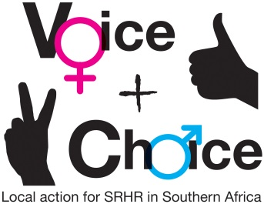
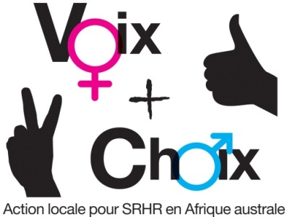
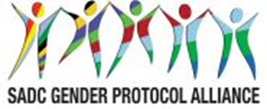

SEXUAL AND REPRODUCTIVE HEALTH AND RIGHTS (SRHR) CAMPAIGN PLAN – MATERNAL HEALTH

NAME OF COUNCIL: ONGWEDIVA
Date: 15 December 2018

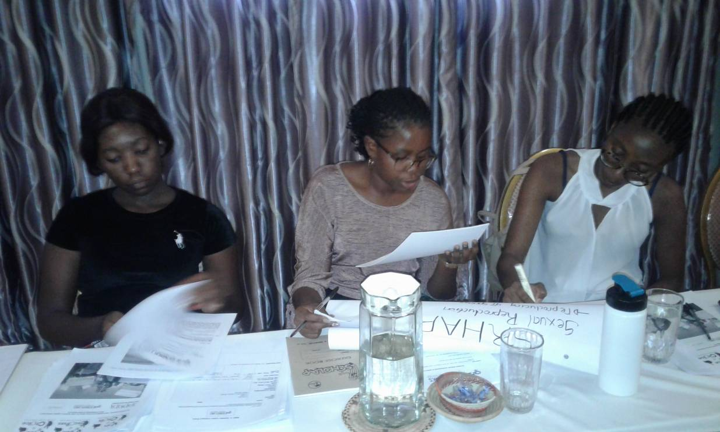
Figure 1; Participants seen during Maternal health Campaign Plan

GUIDANCE ON MESSAGES:
- The group should first decide on and record the specific objectives for the country/council.
- Who are these targeted at?
- What messages/slogans are appropriate to these target groups?
- What are some of the hashtags in country you can leverage on or create? This includes in local languages
- How can they link to regional/global hashtags
- What are some of the Twitter handles you will tag – refer to the Alliance social media handles

SPECIFIC OBJECTIVES | TARGET GROUPS | MESSAGES/SLOGANS | HASHTAGS – LOCAL | HASHTAGS – REGIONAL/ GLOBAL | Social media tagging
To reduce teenage pregnancy by end 2019 | Youth, adolescents  School Counselors | Stop early love affairs | #Endyoungsex | #UNICEFGirlsbulletin | @UNICEF
To educate the youth on how to maintain healthy relationship and avoid multiple partners | Youth,  Young adults | Protect your health | #breakthechain | #UNAIDShealthbulletin | @UNAIDS
To provide free SRHR services by 2019 | Community at large | Health for all | #myhealthmyrights | #SADChealthnews | @SAFAIDS

GUIDANCE ON PLANNING FRAMEWORK:
- Specific objectives should be recorded in the planning framework.
- Actions and activities are suggestions. Please customise as appropriate. Please be very specific about the activities to be undertaken.
- Delete any suggested activities that are not relevant to your campaign
- Which members of your consortium will be responsible for each activity?
- By When?
- What will be the main outputs?
- What resources will this require, human, financial, other? What synergies can be forged with existing activities? Are there fund-raising possibilities?

OBJECTIVES AND ACTIONS | ACTIVITIES | WHO RESPONSIBLE | TIME FRAME | OUTPUTS | RESOURCES
Strategic objective | To ensure that all harmful traditional practices such as genital mutilation are abolished as per Maputo Protocol and the SADC Protocol on Gender and Development.
Specific objectives: 1 To reduce teenage pregnancy by end 2019
2 | To educate the youth on how to maintain healthy relationship and avoid multiple partners
3 | To provide free SRHR services by 2019
1. To reduce teenage pregnancy by end 2019 | 1.1 conducting training workshops and awareness on teenage pregnancy by targeting Schools and Churches | NGOs  Gender Links  Ministry of Gender  Ministry of Education  Churches  Schools | By April 2019 | Letter of Approval from the Ministry of Education | Funds
1. To reduce teenage pregnancy by end 2019 |  | Oshakati town council  Ongwediva Town council
2. To educate the youth on how to maintain healthy relationship and avoid multiple partners | 2.1 Providing life kills trainings to the Youth and young adults | NGOs  Gender Links  Ministry of Gender  Ministry of Justice  Churches  Schools | By Mid December 2019 | Printed Training Manuals and other materials | Funds
3. To provide free SRHR services by 2019 | 3.1 Engage the Ministry of health for  quality service delivery and train  health workers | Ministry of health  NGOs  Gender Links  Oshakati town council  Ongwediva Town council | By November 2019 | Skilled health Workers | Funds
4. Engage key stakeholders and the general public in interactive public education encounters | 8 March International Women’s Day | Gender Links  NGOs  Ministry of Gender | March 2019 | Event report | Funds
 | 7 April- World Health Day | NGOs  Gender Links  Ministry of education  Ministry of Gender  Ministry of health | April 2019 | Event report | Funds
 | 29 April-National Youth day | Gender Links  Ministry of education  Ministry of Gender  Ministry of Youth | April 2019 | Event report | Funds
5. Leverage on special dates in the calendar for promoting the campaign | 25 May- Africa Day | Gender Links  Ministry of education  NGOs | May 2019 | Event report | funds
 | 16 June Day- Day of the African Child | Gender Links  NGOs  Ministry of education  Ministry of Gender  Ministry of Youth  Oshakati town council  Ongwediva Town council | June 2019 | Event report | Funds
 | 31 July- Pan-African Women’s Day | Gender Links  Ministry of education  Ministry of Gender  Ministry of Youth  Oshakati town council  Ongwediva Town council | July 2019 | Day commemorated | Funds
 | 11 October-International Day of the Girl Child | Gender Links  NGOs  Ministry of education  Ministry of Gender  Ministry of Youth  Oshakati town council  Ongwediva Town council | October 2019 | Event report | Funds
 | 15 October - International Day of Rural Women | Gender Links  Ministry of education  Ministry of Gender  Ministry of Youth  Oshakati town council  Ongwediva Town council | October 2019 | Event Report | Funds
 | 25 October-Africa Human Rights Day | Gender Links  Key stakeholders  Ministry of education  Ministry of Gender  Ministry of Youth  Oshakati town council  Ongwediva Town council | October 2019 | Event Report | Funds

MONITORING AND EVALUATION
English: http://genderlinks.org.za/what-we-do/sadc-gender-protocol/advocacy/alliance-srhr-me/
French: http://genderlinks.org.za/what-we-do/sadc-gender-protocol/advocacy/alliance-srhr-me/alliance-srhr-se/
Portuguese: http://genderlinks.org.za/what-we-do/sadc-gender-protocol/advocacy/alliance-srhr-me/alianca-srhr-me/

