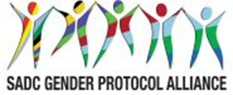
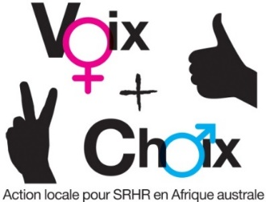
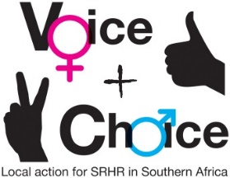
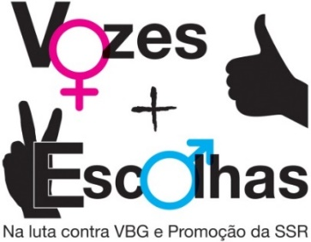

SEXUAL REPRODUCTIVE HEALTH AND RIGHTS (SRHR) CAMPAIGN PLAN – MENSTRUAL HEALTH

NAME OF COUNCIL: EENAHNA
Date: 23 November 2018

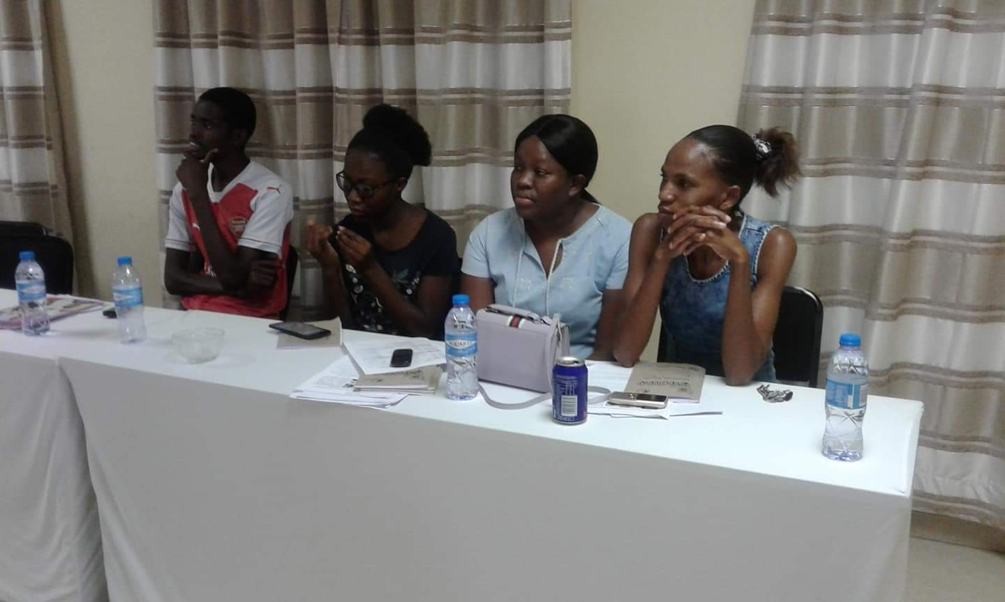
Participants are seen during the Menstrual health campaign Plan

GUIDANCE ON MESSAGES:
- The group should first decide on and record the specific objectives for the country/council.
- Who are these targeted at?
- What messages/slogans are appropriate to these target groups?
- What are some of the hashtags in country you can leverage on or create? This includes in local languages
- How can they link to regional/global hashtags
- What are some of the Twitter handles you will tag – refer to the Alliance social media handles

SPECIFIC OBJECTIVES | TARGET GROUPS | MESSAGES/SLOGANS | HASHTAGS – LOCAL | HASHTAGS – REGIONAL/ GLOBAL | Social media tagging
EDUCATION  - To provide menstrual health education to school girls and women by Dec 2019 | School girls,  Women,  Female prisoners,  Destitute children | Every woman to stay free by ensuring access to Hygienic products | #getituseit | #stayfree | @Freestyle Oshikuku
ACCESSIBILITY  - To distribute and provide free sanitary pads to women and young girls by Dec 2019 | School girls,  Women,  Female prisoners,  Destitute children | Health ministry provides free pads to women and girls | #accesscounts | #freeaccess | @Unicef
DISPOSAL & HYGIENE  - To provide efficient disposal and hygienic facilities for sanitary wear | School girls,  Women,  Female prisoners,  Destitute children | -Effective way of disposal and proper provision of proper facilities | #hygieneismy habit | #Menstruationserves | @AmplifyFund
SUSTAINABILTY  - To develop a sustainable provision of sanitary wear | School girls,  Women,  Female prisoners,  Destitute children | Improve the continuously usage of sanitary wear | #Longlive | #stopthemenstrualtion | #UNAIDS

OBJECTIVES AND ACTIONS | ACTIVITIES | WHO RESPONSIBLE | TIME FRAME | OUTPUTS | RESOURCES
Strategic objective | To ensure that women and girls have access to affordable sanitary ware, including free access in schools, in line with SDG 5 and the SADC Protocol on Gender and Development that commit to universal access to sexual and reproductive health and reproductive rights in accordance with the Programme of Action of the ICPD.
Specific objectives: What are the specific objectives in your country? For example, has sanitary ware been zero VAT rated? If not, is this an objective? If so what is the next step? Do women and girls have access to sanitary ware? Is sanitary ware freely available in schools? If not, what is the next step?
1 | To provide menstrual health education to school girls and women by Dec 2019
2 | To distribute and provide free sanitary pads to women and young girls by Dec 2019
3 | To provide efficient disposal and hygienic facilities for sanitary wear by Dec 2019
4 | To develop a sustainable provision of sanitary wear
1. Obtain buy-in from key stakeholders | 1.1 Meeting with key officials (who?) | Key Stakeholders  NGOs  Gender Links  Ministry of Gender  Churches  Ministry of health  Schools | Jan 2019 | Drafted Workplan | Venue  food  Refreshments  Stationery
1. Obtain buy-in from key stakeholders | 1.2. Meetings with parliamentarians (who?) | Key Stakeholders  NGOs  Gender Links  Ministry of Gender  Churches  Ministry of health  Schools | Feb 2019 | Documented minutes | Venue  Food  Refreshments  Stationery
1. Obtain buy-in from key stakeholders | 1.3 Meetings with statutory bodies – eg law reform commissions – who?) | Key Stakeholders  NGOs  Gender Links  Ministry of Gender  Churches  Ministry of health  Schools | April 2019 | Formulated Policies | Venue  Food  Refreshments  Stationery
1. Obtain buy-in from key stakeholders | 1.4 Meeting with social actors – eg religious groups – who? | Councils, church leaders, traditional leaders, Special Schools | May 2019 | Information disseminated | Venue  Food  Refreshments  Stationery
2. Launch the campaign and gain maximum publicity for it | 2.1 Agree date and venue for launch, ensuring synergy with other campaigns | Key Stakeholders  NGOs  Gender Links  Ministry of Gender  Churches  Ministry of health  Schools | May 2019 | Minutes indicates Date and venue for launch agreed | Venue  Refreshments  Stationery
2. Launch the campaign and gain maximum publicity for it | 2.2 Logistics and planning for the launch | Steering committee | June 2019 | Shared Tasks | Venue  Refreshments  Stationery
3. Develop and disseminate campaign materials | 3.1 Pamphlets explaining Menstrual health/ where to get help; disseminated through XXXX | Key Stakeholders,  NGOs,  Gender Links,  Ministry of Gender,  Ministry of education,  Schools | June 2019 | Pamphlets designed and distributed | Stationery  Transport
3. Develop and disseminate campaign materials | 3.2 Posters disseminated through Social media networks and put up in strategic places, eg police stations; courts; all gvt. offices; hospitals | public relations officers, GL, Alliance Partners | June 2019 | Posters placed | Transport  Refreshments
3. Develop and disseminate campaign materials | 3.3 Billboards are erected at strategic positions | public relations officers, GL, Alliance Partners | June 2019 | Billboards erected | Venue  Refreshments  Stationery
4. Engage key stakeholders and the general public in interactive public education encounters | 4.2 Drama using local actors, followed by discussion, that is systematically performed in all districts | Health Promotion Officers, Drama Artists | June 2019 | Health promoted  District reports | Venue  Refreshments
 | 4.3 Workshops with specific target groups  Traditional leaders  Local councillors  Schools debates  Medical and social worker | Council  Steering Committee  Logistics departments | June 2019 | Launch programme produced | Venue  Stationary transport refreshments
5. Leverage on special dates in the calendar for promoting the campaign | 19 November- World Toilet Day | Ministry of health  Town Councils | November 2019 | Toilet paper and Sanitary pads distributed | Transport  IEC  Food  Sanitary ware
 | Sixteen days of activism
 | 8 March International Women’s Day | Council  Steering Committee,  Logistics departments,  Ministry of health |  | Sanitary pads distributed  Information disseminated | Transport  IEC  Food  Sanitary ware
 | 12 March -Youth Day | Genderlinks  Key Stakeholders  Ministry of health Ministry of youth  Ministry of gender | March 2019 | Sanitary pads distributed  Information disseminated | Transport  IEC  Food  Sanitary ware
 | 22 March- World Water Day
 | 7 April- World Health Day | Genderlinks  Key Stakeholders  Ministry of health Ministry of youth  Ministry of gender | April 2019 | Sanitary pads distributed  Information disseminated | Transport  IEC  Food  Sanitary ware
 | 11 October-International Day of the Girl Child | Genderlinks  Key Stakeholders  Ministry of health Ministry of youth  Ministry of gender | 11 October 2019 | Sanitary pads distributed  Information disseminated | Transport  IEC  Food  Sanitary ware
 | 15 October - International Day of Rural Women | Ministry of health  GL, NGOs  Ministry of gender  Department of health | 15 October 2019 | Sanitary pads distributed  Information disseminated | Transport  IEC  Food  Sanitary ware
 | 21 October-Africa Human Rights Day
 | 1 November- Africa Youth Day | Ministry of health  GL, NGOs  Ministry of gender  Department of health | November 2019 | Sanitary pads distributed  Information disseminated | Transport  IEC  Food  Sanitary ware
 | World Menstrual Hygiene Day | Ministry of health  GL, NGOs  Ministry of gender  Department of health | May 2019 | Sanitary ware distributed  Information disseminated | Sanitary ware  IEC material
6. Engage with the mainstream media in obtaining space/ air time for the campaign as well as increasing media coverage | 6.1 Meetings with editors /  Breakfast briefings | Media Experts | July 2019 | venue obtained | Transport  Venue
 | 6.2 Research on coverage of menstrual health in the media | Researchers | July 2019 | Detailed Reports | Research material  Transport  Stationary
 | 6.3 Training for journalists in coverage of menstrual health | IT Experts | March 2019 | Information on menstrual health researched | Research material  Transport  Stationary
 | 6.4 Letters/ opinion/ radio talk shows
7. To launch a social media campaign | 7.1 Twitter | IT Technicians | April 2019 | Information disseminated | Laptops
7. To launch a social media campaign | 7.2 Facebook | IT Technicians | April 2019 | Information disseminated | Laptops
7. To launch a social media campaign | 7.3 Instagram | IT Technicians | April 2019 | Information disseminated | IT equipment
7. To launch a social media campaign | 7.4 Website | IT Technicians | April 2019 | Information disseminated | IT equipment
7. To launch a social media campaign | 7.5 GL Community of practise | IT Technicians | April 2019 | Information disseminated | IT equipment
7. To launch a social media campaign | OTHER
8. Initiate greater involvement of men in the struggle for women’s human rights | 8.1 Engaging with male champions | Genderlinks  Key Stakeholders  Ministry of health Ministry of youth  Ministry of gender | July 2019 | Male champions engaged | Refreshment  Transport
 | 8.2 Engaging with men for change networks | Genderlinks  Key Stakeholders  Ministry of health Ministry of youth  Ministry of gender | July 2019 | Engaged GFPs | Refreshment  Transport
9. Monitor and evaluate the campaign | 9.2 Reports on all workshops and dissemination exercises | Genderlinks  Key Stakeholders  Ministry of health Ministry of youth  Ministry of gender | July 2019 | Materials arranged | Food  Refreshment  Transport
9. Monitor and evaluate the campaign | 9.3 Media monitoring | Genderlinks  Key Stakeholders  Ministry of health Ministry of youth  Ministry of gender | August 2019 | M&E Officer engaged | tRANSPORT
9. Monitor and evaluate the campaign | 9.4 Speeches | Genderlinks  Key Stakeholders  Ministry of health Ministry of youth  Ministry of gender | August 2019 | Director of proceeding appointed | Refreshment  Transport
9. Monitor and evaluate the campaign | 9.5 Feedback from the public | Genderlinks  Key Stakeholders  Ministry of health Ministry of youth  Ministry of gender | August 2019 | Documented minutes | Refreshment  Food
10. Prepare best practices for the 2019 SADC Protocol@Work #VoiceandChoice Summit | 10.1 Access summit call | Genderlinks  Key Stakeholders  Ministry of health Ministry of youth  Ministry of gender | September 2019 | Internet accessed | Transport
 | 10.2 Document case study | Genderlinks  Key Stakeholders  Ministry of health Ministry of youth  Ministry of gender | November 2019 | GFPs selected | Computer  Materials
 | 10.3 Present case study at the summit | Gender links,  Key Stakeholders,  Councils | February 2020 | Presenter arranged | Transport  Refreshment  Accommodation  Meals

MONITORING AND EVALUATION
English: http://genderlinks.org.za/what-we-do/sadc-gender-protocol/advocacy/alliance-srhr-me/
French: http://genderlinks.org.za/what-we-do/sadc-gender-protocol/advocacy/alliance-srhr-me/alliance-srhr-se/
Portuguese: http://genderlinks.org.za/what-we-do/sadc-gender-protocol/advocacy/alliance-srhr-me/alianca-srhr-me/

