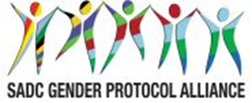
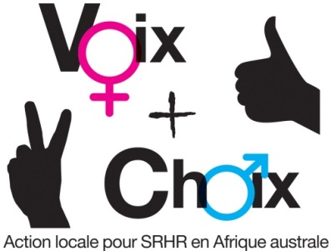

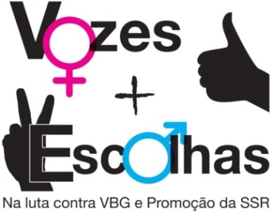
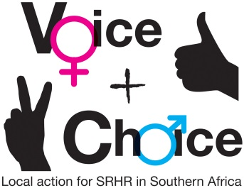

SEXUAL AND REPRODUCTIVE HEALTH AND RIGHTS (SRHR) CAMPAIGN PLAN –
HIV AND AIDS

NAME OF COUNTRY/COUNCIL:
Date:

Please add a photo from the Mapping, Policy and Campaigns Workshop
GUIDANCE ON MESSAGES:
- The group should first decide on and record the specific objectives for the country/council.
- Who are these targeted at?
- What messages/slogans are appropriate to these target groups?
- What are some of the hashtags in country you can leverage on or create? This includes in local languages
- How can they link to regional/global hashtags
- What are some of the Twitter handles you will tag – refer to the Alliance social media handles

SPECIFIC OBJECTIVES | TARGET GROUPS | MESSAGES/SLOGANS | HASHTAGS – LOCAL | HASHTAGS – REGIONAL/ GLOBAL | Social media tagging
 |  |  |  | #VoiceandChoice | @GenderLinks
 |  |  |  | #SADCGenderBarometer10 | @GenderProtocol
 |  |  |  | #SheDecidesSADC | @SAfAIDS
 |  |  |  | #worldaidsday | @AmplifyFund
 |  |  |  | #TellSomeone | ETC
 |  |  |  | #PrEP | ETC
 |  |  |  | #knowyourstatus | ETC
 |  |  |  | #EndAIDS
 |  |  |  | #TreatmentForAll
 |  |  |  | #SDG2018

GUIDANCE ON PLANNING FRAMEWORK:
- Specific objectives should be recorded in the planning framework.
- Actions and activities are suggestions. Please customise as appropriate. Please be very specific about the activities to be undertaken.
- Delete any suggested activities that are not relevant to your campaign
- Which members of your consortium will be responsible for each activity?
- By When?
- What will be the main outputs?
- What resources will this require, human, financial, other? What synergies can be forged with existing activities? Are there fund raising possibilities?

 | OBJECTIVES AND ACTIONS | ACTIVITIES | WHO RESPONSIBLE | TIME FRAME | OUTPUTS | RESOURCES
 | Strategic objective | To ensure that the resurgence of HIV and AIDS among young women is curbed in accordance with the SADC Protocol on Gender and Development and the SADC sponsored CSW Resolution 60/2 on Women, the Girl Child and HIV
 | Specific objectives: What are the specific objectives in your country? For example, is cross generational sex a major driver of the resurgence? Do you face the “sugar daddy” phenomenon? If so what is the next step?
 | 1
 | 2
 | 3
 | 1. Obtain buy-in from key stakeholders | 1.1 Meeting with key officials (who?)
 | 1. Obtain buy-in from key stakeholders | 1.2. Meetings with parliamentarians (who?)
 | 1. Obtain buy-in from key stakeholders | 1.3 Meetings with statutory bodies – (eg law reform commissions – who?)
 | 1. Obtain buy-in from key stakeholders | 1.4 Meeting with social actors – eg religious groups – who?
 | 2. Launch the campaign and gain maximum publicity for it | 2.1 Agree date and venue for launch, ensuring synergy with other campaigns
 | 2. Launch the campaign and gain maximum publicity for it | 2.2 Logistics and planning for the launch
 | 3. Develop and disseminate campaign materials | 3.1 Pamphlets explaining XXX/ where to get help; disseminated through XXXX
 | 3. Develop and disseminate campaign materials | 3.2 Posters disseminated through XXX networks and put up in strategic places, eg police stations; courts; all gvt. offices; hospitals
 | 3. Develop and disseminate campaign materials | 3.3 Billboards located at strategic points to reach the broadest possible audience eg football stadiums
 | 3. Develop and disseminate campaign materials | 3.4 Radio: Docu/ drama disseminated via radio and taxis through the taxi association. Use of radio listening clubs to ensure maximum dissemination.
 | 3. Develop and disseminate campaign materials | 3.5 Adverts using prominent entertainers eg soccer stars
 | 3. Develop and disseminate campaign materials | 3.6 Video
 | 3. Develop and disseminate campaign materials | 3.7 Gathering/ disseminating materials produced outside
 | 4. Engage key stakeholders and the general public in interactive public education encounters | 4.1 Workshops in regions/ systematically- ensure all regions covered
 |  | 4.2 Drama using local actors, followed by discussion, that is systematically performed in all districts
4.3 Workshops with specific target groups
Traditional leaders
Local councillors
Schools debates
Medical and social worker
 | 5. Leverage on special dates in the calendar for promoting the campaign | Sixteen days of activism
 |  | 1 December – World Aids Day
 |  | 10 December- International Human rights day
 |  | 1 March- Zero Discrimination Day
 |  | 2 March – She Decides Day
 |  | 8 March International Women’s Day
 |  | 12 March Youth Day 12 March
 |  | 7 April- World Health Day
 |  | 25 May- Africa Day
 |  | 16 June Day- Youth Day in SA and many countries
 |  | 31 July- Pan-African Women’s Day
 |  | 9 August – Women’s Day in SA; August commemorated as Women’s Month in some SADC countries
 |  | 11 October-International Day of the Girl Child
 |  | 15 October - International Day of Rural Women
 |  | 21 October-Africa Human Rights Day
 |  | 1 November- Africa Youth Day
 |  | ETC
 |  | ETC
 | 5. To launch mini campaigns around specific events/ test cases. | 5.1
 |  | 5.2 Cases
 | 6. Engage with the mainstream media in obtaining space/ air time for the campaign as well as increasing media coverage | 6.1 Meetings with editors /  Breakfast briefings
 |  | 6.2 Research on coverage of menstrual health in the media
 |  | 6.3 Training for journalists in coverage of menstrual health
 |  | 6.4 Letters/ opinion/ radio talk shows
 | 7. To launch a social media campaign | 7.1 Twitter
 |  | 7.2 Facebook
 |  | 7.3 Instgram
 |  | 7.4 Website
 |  | 7.5 GL Community of practise
 |  | OTHER
 | 8. Initiate greater involvement of men in the struggle for women’s human rights | 8.1 Engaging with male champions
 |  | 8.2 Engaging with men for change networks
 | 9. Monitor and evaluate the campaign (see online tools for M and E) | 9.2 Reports on all workshops and dissemination exercises
 |  | 9.3 Media monitoring
 |  | 9.4 Speeches
 |  | 9.5 Feedback from the public
 | 10. Prepare best practices for the 2019 SADC Protocol@Work #Voice&Choice Summit | 10.1 Access summit call
 |  | 10.2 Document case study
 |  | 10.3 Present case study at the summit
MONITORING AND EVALUATION
English: http://genderlinks.org.za/what-we-do/sadc-gender-protocol/advocacy/alliance-srhr-me/
French: http://genderlinks.org.za/what-we-do/sadc-gender-protocol/advocacy/alliance-srhr-me/alliance-srhr-se/
Portuguese: http://genderlinks.org.za/what-we-do/sadc-gender-protocol/advocacy/alliance-srhr-me/alianca-srhr-me/

