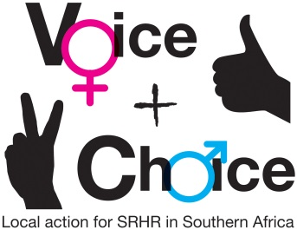
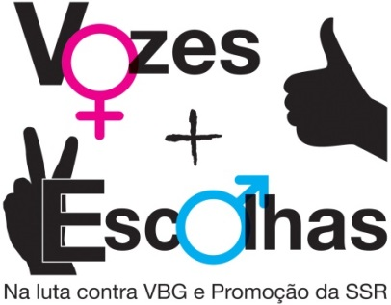
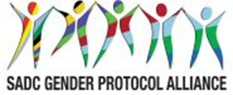

SEXUAL AND REPRODUCTIVE HEALTH AND RIGHTS (SRHR) CAMPAIGN PLAN-HIV AND AIDS

NAME OF COUNCIL: OSHAKATI
Date: 15 December 2018

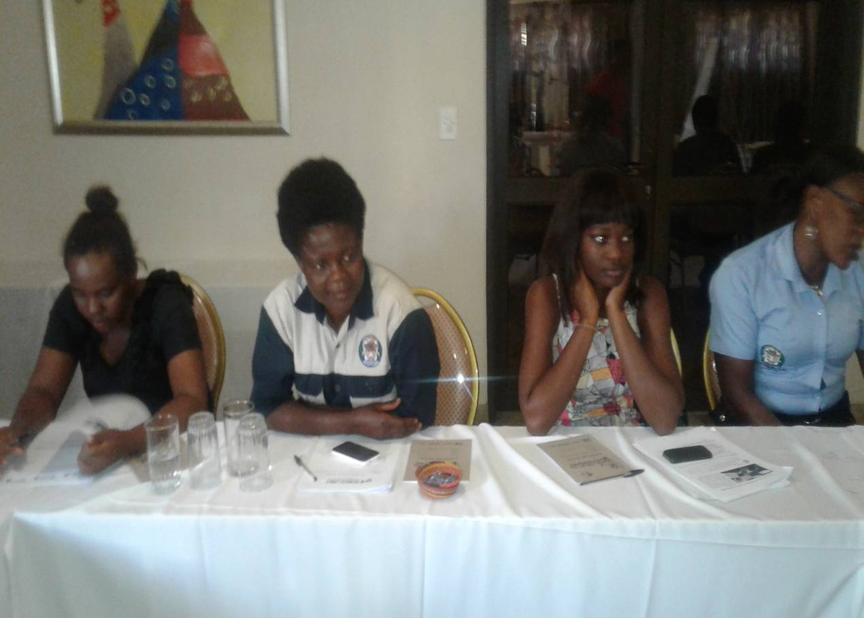
Figure 1; Participants seen during HIV AND AIDS Campaign Plan
GUIDANCE ON MESSAGES:
- The group should first decide on and record the specific objectives for the country/council.
- Who are these targeted at?
- What messages/slogans are appropriate to these target groups?
- What are some of the hashtags in country you can leverage on or create? This includes in local languages
- How can they link to regional/global hashtags
- What are some of the Twitter handles you will tag – refer to the Alliance social media handles

SPECIFIC OBJECTIVES | TARGET GROUPS | MESSAGES/SLOGANS | HASHTAGS – LOCAL | HASHTAGS – REGIONAL/ GLOBAL | Social media tagging
To promote HIV testing among the youth by 2019 | Youth, adolescents | Stay safe | #Careforyourfuture | #safesex | @UNICEF
To promote healthy emotional lifestyle amongst positive youth by 2019 | Youth, adolescents,  PLWH | Stay strong | #Be strong | #Keephopealive | @TCE
To provide HIV related information and enhance awareness for the youth by 2019 | Youth, Adolescents | Information is important | #healthmattershelps | #beinformed | @UNAIDS

GUIDANCE ON PLANNING FRAMEWORK:
- Specific objectives should be recorded in the planning framework.
- Actions and activities are suggestions. Please customise as appropriate. Please be very specific about the activities to be undertaken.
- Delete any suggested activities that are not relevant to your campaign
- Which members of your consortium will be responsible for each activity?
- By When?
- What will be the main outputs?
- What resources will this require, human, financial, other? What synergies can be forged with existing activities? Are there fund raising possibilities?

OBJECTIVES AND ACTIONS | ACTIVITIES | WHO RESPONSIBLE | TIME FRAME | OUTPUTS | RESOURCES
Strategic objective | To ensure that the resurgence of HIV and AIDS among young women is curbed in accordance with the SADC protocol on Gender and Development and the SADC sponsored CSW Resolution 50/2 on women, the girl child and HIV.
Specific objectives: To provide access to sexual reproductive health and rights services by 2019
1 | To promote HIV testing among the youth by 2019
2 | To promote healthy emotional lifestyle amongst positive youth by 2019
3 | To provide HIV related information and enhance awareness for the youth by 2019
1. Obtain buy-in from key stakeholders
1. Obtain buy-in from key stakeholders | 1.2. Meetings with parliamentarians (who?) | Councillors, CEOs, health directors, school counsellors | March 2019 | Signed Documents | N$1000
1. Obtain buy-in from key stakeholders | 1.3 Meetings with statutory bodies – eg law reform commissions – who?) | Councillors, CEO, health directors, school counsellors | April 2019 | Signed Documents | N$3000
2. Launch the campaign and gain maximum publicity for it | 2.1 Arrange venue, logistics and date for launch | Genderlinks,  Councillors, CEO, health directors, school counsellors, Health Ministry, NGOs | June 2019 | Detailed Budget and programme | N$6000
3. Develop and disseminate campaign materials | 3.1 Pamphlets explaining XXX/ where to get help; disseminated through XXXX | Councillors, CEO, health directors, school counsellors, Health Ministry, NGOs  Oshakati town council  Ongwediva town council  Junior Councillors | July 2019 | Posters and pamphlets | N$1300
3. Develop and disseminate campaign materials | 3.2 Placing billboards in all strategic areas | Town Councils, Ministry of information, Oshakati town council  Ongwediva town council  Ministry of health | August 2019 | Placed billboards | N$7000
3. Develop and disseminate campaign materials | 3.3 Radio: Docu/ drama disseminated via radio and taxis through the taxi association. Use of radio listening clubs to ensure maximum dissemination. | Oshakati town council  Ongwediva town council  Ministry of information,  Ministry of health | September 2019 | Documentations | N$5000
4. Engage key stakeholders and the general public in interactive public education encounters | 4.1 Workshops in regions/ systematically- ensure all regions covered | Genderlinks,  Oshakati town council  Ongwediva town council | October 2019 | Workshop reports | N$10000
 | 4.2 Drama using local actors, followed by discussion, that is systematically performed in all districts | Genderlinks,  Town Councils Youths , School going Children | October 2019 | Activity report | N$4000
5. Leverage on special dates in the calendar for promoting the campaign | Sixteen days of activism | Genderlinks,  Town Councils Youths , School going Children | December 2019 | Event Report | N$20000
 | 10 December- International Human rights day | Oshakati town council,  Ongwediva town council  , health directors, school counsellors, Health Ministry, NGOs  Junior Councillors,GFPs | December 2019 | Event report | N$6000
 | 1 March- Zero Discrimination Day | Health directors, school counsellors, Health Ministry, NGOs  Oshakati town council  Ongwediva town council  GFPs | March 2019 | Detailed report | N$5000
 | 8 March International Women’s Day | health directors, school counsellors, Health Ministry, NGOs  Oshakati town council  Ongwediva town council  GFPs | March 2019 | Event Report | N$5000
 | 7 April- World Health Day | Oshakati town council  Ongwediva town council  Health directors, school counsellors, Health Ministry, NGOs | April 2019 | Event Report | N$5000
 | 25 May- Africa Day | Oshakati town council  Ongwediva town council  school counsellors, Health Ministry, NGOs  Junior Councillors, GFPs | May 2019 | Detailed Report | N$4000
 | 11 October-International Day of the Girl Child | Oshakati town council  Ongwediva town council  Health directors, school counsellors, Health Ministry, NGOs | October 2019 | Detailed Report | N$8000
 | 15 October - International Day of Rural Women | Oshakati town council  Ongwediva town council  Health directors, school counsellors, Health Ministry, NGOs | October 2019 | Detailed Report | N$2100
 | 21 October-Africa Human Rights Day | Oshakati town council  Ongwediva town council  health directors, school counsellors, Health Ministry, NGOS | October 2019 | Detailed Report | N$2000
 | 1 November- Africa Youth Day | Oshakati town council  Ongwediva town council  Health directors, school counsellors, Health Ministry, NGOs | November 2019 | Detailed Report | N$4000
6. Engage with the mainstream media in obtaining space/ air time for the campaign as well as increasing media coverage | 6.1 Meetings with editors | Oshakati town council  Ongwediva town council  Health Ministry, NGOs | November 2019 | Minutes | N$500
 | 6.2 Research on coverage of menstrual health in the media | Genderlinks,  Universities , polytechnics | December 2019 | Research report | N$8000
 | 6.3 Training for journalists in coverage of menstrual health | CEOs, Gender Links , GFPs, Stakeholders | December 2019 | Training report | N$6000
 | 6.4 Letters/ opinion/ radio talk shows | Oshakati town council  Ongwediva town council  health directors, school counsellors, Health Ministry, NGOs | December 2019 | Visit report, copies | N$800
7. To launch a social media campaign | 7.1 Twitter | IT Technician, Genderlinks, | December 2019 | Posted articiles
 | 7.2 Facebook | IT Technician, Genderlinks, | December 2019 | Posted articiles
 | 7.3 Instagram | IT Technician, Genderlinks, | December 2019 | Shared articles
 | 7.4 Website | IT Technician, Genderlinks, | December 2019 | Shared articles
 | 7.5 GL Community of practise | IT Technician, Genderlinks, Oshakati town council  Ongwediva town council  Gender committees | December 2019 | Printed articles | N$3000
 | OTHER
8. Initiate greater involvement of men in the struggle for women’s human rights | 8.1 Engaging with male champions | Oshakati town council  Ongwediva town council  health directors, school counsellors, Health Ministry, NGOs | December 2019 | Report | N$9000
 | 8.2 Engaging with men for change networks | Oshakati town council  Ongwediva town council  health directors, school counsellors, Health Ministry, NGOs | December 2019 | Report | N$4000
 | 9.1 Reports on all workshops and dissemination exercises | Oshakati town council  Ongwediva town council  Health Ministry, NGOs  Genderlinks | Ongoing | Detailed Report | N$9000
 | 9.2 Feedback from the public | Oshakati town council  Ongwediva town council  Health Ministry, NGOs | Ongoing | Documented Minutes | N$6000
10. Prepare best practices for the 2019 SADC Protocol@Work #VoiceandChoice Summit | 10.1 Access summit call | GL, Oshakati town council  Ongwediva town council | February 2020 | Response to the summit | N$3000
 | 10.2 Document case study | Genderlinks, Champions, GFP | April 2020 | Documented case study | N$3000
 | 10.3 Present case study at the summit | Genderlinks, Champions, GFP | May 2020 | Case study presented | N$5000

MONITORING AND EVALUATION
English: http://genderlinks.org.za/what-we-do/sadc-gender-protocol/advocacy/alliance-srhr-me/
French: http://genderlinks.org.za/what-we-do/sadc-gender-protocol/advocacy/alliance-srhr-me/alliance-srhr-se/
Portuguese: http://genderlinks.org.za/what-we-do/sadc-gender-protocol/advocacy/alliance-srhr-me/alianca-srhr-me/

