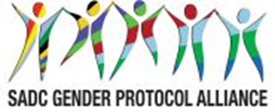
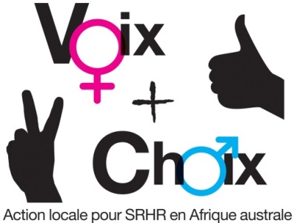

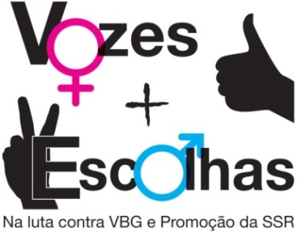
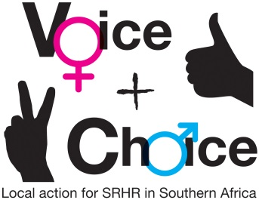

SEXUAL AND REPRODUCTIVE HEALTH AND RIGHTS (SRHR) CAMPAIGN PLAN – CHILD MARRIAGES

NAME OF COUNTRY/COUNCIL:
Date:

Please add a photo from the Mapping, Policy and Campaigns Workshop
GUIDANCE ON MESSAGES:
- The group should first decide on and record the specific objectives for the country/council.
- Who are these targeted at?
- What messages/slogans are appropriate to these target groups?
- What are some of the hashtags in country you can leverage on or create? This includes in local languages
- How can they link to regional/global hashtags
- What are some of the Twitter handles you will tag – refer to the Alliance social media handles

SPECIFIC OBJECTIVES | TARGET GROUPS | MESSAGES/SLOGANS | HASHTAGS – LOCAL | HASHTAGS – REGIONAL/ GLOBAL | Social media tagging
 |  |  |  | #Voice&Choice | @GenderLinks
 |  |  |  | #SADCGenderBarometer10 | @GenderProtocol
 |  |  |  | #SheDecidesSADC | @SAfAIDS
 |  |  |  | #Girlchild | @AmplifyFund
 |  |  |  | #Childnotbride | @GirlsNotBrides
 |  |  |  | #RightbyHer
 |  |  |  | #OurGirlsMatter
 |  |  |  | #DayoftheGirlChild
 |  |  |  | #IDG2018
 |  |  |  | #withMalala
 |  |  |  | ETC

GUIDANCE ON PLANNING FRAMEWORK:
- Specific objectives should be recorded in the planning framework.
- Actions and activities are suggestions. Please customise as appropriate. Please be very specific about the activities to be undertaken.
- Delete any suggested activities that are not relevant to your campaign
- Which members of your consortium will be responsible for each activity?
- By When?
- What will be the main outputs?
- What resources will this require, human, financial, other? What synergies can be forged with existing activities? Are there fund raising possibilities?

OBJECTIVES AND ACTIONS | ACTIVITIES | WHO RESPONSIBLE | TIME FRAME | OUTPUTS | RESOURCES
Strategic objective | To ensure that the agreed age of 18 as minimum age in the Maputo Protocol and the SADC Protocol on Gender and Development is adhered to.
Specific objectives: What is the legal status of age of marriage in your country? Is this adhered to? What proportion of young women are married before the age of 18? How is this being addressed? What is the focus of advocacy campaigns?
1
2
3
1. Obtain buy-in from key stakeholders | 1.1 Meeting with key officials (who?)
1. Obtain buy-in from key stakeholders | 1.2. Meetings with parliamentarians (who?)
1. Obtain buy-in from key stakeholders | 1.3 Meetings with statutory bodies – eg law reform commissions – who?)
1. Obtain buy-in from key stakeholders | 1.4 Meeting with social actors – eg religious groups – who?
2. Launch the campaign and gain maximum publicity for it | 2.1 Agree date and venue for launch, ensuring synergy with other campaigns
2. Launch the campaign and gain maximum publicity for it | 2.2 Logistics and planning for the launch
 | 2.3 Garner as many signatures as possible for the safe abortion campaign – see http://genderlinks.org.za/polls/polls/11
3. Develop and disseminate campaign materials | 3.1 Pamphlets explaining XXX/ where to get help; disseminated through XXXX
3. Develop and disseminate campaign materials | 3.2 Posters disseminated through XXX networks and put up in strategic places, eg police stations; courts; all gvt. offices; hospitals
3. Develop and disseminate campaign materials | 3.3 Billboards located at strategic points to reach the broadest possible audience eg football stadiums
3. Develop and disseminate campaign materials | 3.4 Radio: Docu/ drama disseminated via radio and taxis through the taxi association. Use of radio listening clubs to ensure maximum dissemination.
3. Develop and disseminate campaign materials | 3.5 Adverts using prominent entertainers eg soccer stars
3. Develop and disseminate campaign materials | 3.6 Video
3. Develop and disseminate campaign materials | 3.7 Gathering/ disseminating materials produced outside
4. Engage key stakeholders and the general public in interactive public education encounters | 4.1 Workshops in regions/ systematically- ensure all regions covered
 | 4.2 Drama using local actors, followed by discussion, that is systematically performed in all districts
4.3 Workshops with specific target groups
Traditional leaders
Local councillors
Schools debates
Medical and social worker
5. Leverage on special dates in the calendar for promoting the campaign | Sixteen days of activism
 | 1 December – World Aids Day
 | 10 December- International Human rights day
 | 1 March- Zero Discrimination Day
 | 2 March – She Decides Day
 | 8 March International Women’s Day
 | 12 March Youth Day 12 March
 | 7 April- World Health Day
 | 25 May- Africa Day
 | 16 June Day- Youth Day in SA and many countries
 | 31 July- Pan-African Women’s Day
 | 9 August – Women’s Day in SA; August commemorated as Women’s Month in some SADC countries
 | 28 Sept – International Day of Safe Abortion
 | 11 October-International Day of the Girl Child
 | 15 October - International Day of Rural Women
 | 21 October-Africa Human Rights Day
 | 1 November- Africa Youth Day
 | ETC
 | ETC
6. To launch mini campaigns around specific events/ test cases. | 6.1
 | 6.2 Cases
7. Engage with the mainstream media in obtaining space/ air time for the campaign as well as increasing media coverage | 7.1 Meetings with editors /  Breakfast briefings
 | 7.2 Research on coverage of menstrual health in the media
 | 7.3 Training for journalists in coverage of menstrual health
 | 7.4 Letters/ opinion/ radio talk shows
8. To launch a social media campaign | 8.1 Twitter
8. To launch a social media campaign | 8.2 Facebook
8. To launch a social media campaign | 8.3 Instgram
8. To launch a social media campaign | 8.4 Website
8. To launch a social media campaign | 8.5 GL Community of practise
8. To launch a social media campaign | OTHER
9. Initiate greater involvement of men in the struggle for women’s human rights | 9.1 Engaging with male champions
 | 9.2 Engaging with men for change networks
10. Monitor and evaluate the campaign (see online tools for M and E) | 10.2 Reports on all workshops and dissemination exercises
 | 10.3 Media monitoring
 | 10.4 Speeches
 | 10.5 Feedback from the public
11. Prepare best practices for the 2019 SADC Protocol@Work #VoiceandChoice Summit | 11.1 Access summit call
 | 11.2 Document case study
 | 11.3 Present case study at the summit

MONITORING AND EVALUATION
English: http://genderlinks.org.za/what-we-do/sadc-gender-protocol/advocacy/alliance-srhr-me/
French: http://genderlinks.org.za/what-we-do/sadc-gender-protocol/advocacy/alliance-srhr-me/alliance-srhr-se/
Portuguese: http://genderlinks.org.za/what-we-do/sadc-gender-protocol/advocacy/alliance-srhr-me/alianca-srhr-me/

