Note on GL’s work on SRHR, Strategic and Network Amplify Change Grant/s
GL is a Southern African Women’s Rights NGO that has championed the SADC Protocol on Gender and Development, coordinates the Southern African Gender Protocol Alliance, and lobbied for the Protocol to be updated in line with the SDGs. GL works to implement the Agenda 2030 SADC Gender Protocol in its governance, media and justice programmes, that include working directly with 425 local councils and 108 media houses that have opted to become Gender Centres of Excellence (COE) in 15 SADC countries.
Attached at Annex A is GL’s Theory of Change for its work on SRHR, showing how GL seeks to “connect the dots” from local, to national, to regional to global level. Attached at Annex B is a matrix showing the complementarity between the proposed activities of the Strategic and Network Grants in the next phase. Attached at Annex C is a matrix of GL country offices and Alliance focal networks, showing how these work together.
GL’s first Amplify Change (AC) Networking Grant 2016 to 2018 is entitled “Strengthening SRHR in the SADC Region Post 2015.” This aimed to: “establish an SRHR working group within the Alliance to gather evidence; advocate for strong SRHR provisions in the Post 2015 SADC Gender Protocol; track implementation and share best practices through SADC Protocl@Work summits.” The Alliance succeeded in lobbying for the inclusion of SRHR in the Post 2015 Protocol; established an SRHR cluster; undertook training of members on SRHR led by cluster lead SAFAIDS and on LGBTI led by GL; strengthened tracking of SRHR in the annual Barometer; identified key campaigns; established a Young Women’s Network; gathered and analysed over 300 Good Practices on SRHR at the annual SADC Protocol@Work summits (see Annex D).
STRATEGIC – VOICE AND CHOICE FROM LOCAL TO REGIONAL ACTION |  |  |  |  | NETWORKING GRANT - #SheDecides: Strengthening SRHR Networks and campaigns in Southern Africa
GLOBAL | SDG 5 – Universal access to SRHR |  |  |  | Strengthen the SRHR network – LGBTI, FBOS | Capacity building for smaller organisations | Strengthen advocacy by tracking the money! | Specific campaigns – #SheDecidesSouthernAfrica | Media as partner, train, engage | Community of Practice
REGIONAL | Regional – SADC Protocol on Gender and Development – Articles. Annual Barometer to track progress. Regional cluster led by SAFAIDS.
NATIONAL | National SRHR Policies advocated for by the focal networks of the Alliance
LOCAL | 425 Centres of Excellence for Gender and Local Government
LOCAL | Clinics | Schools | Communities | ICTS
LOCAL | Citizen engagement – youth, especially young women drive the change

GL’s proposed extension to the Network Grant is called #SheDecides: Strengthening SRHR Networks and Campaigns in Southern Africa. The initiative builds on the global momentum of the #MeToo, #TimesUp campaign, and in Southern Africa the #MenAreTrash, #NotinMyName, #JusticeForKarabo #IWearWhatILike and other campaigns, that have come together under the umbrella of the #SheDecides campaign. SAFAIDS as cluster lead, and GL as coordinator of the Alliance, propose to launch the #SheDecidesSouthernAfrica campaign, to press home the gains in the last few years, through strategic communication campaigns that have targets, indicators, and regularly publish results. Key inter- linked campaigns identified include resurgence of HIV and AIDS among young women; menstrual health; teenage pregnancies, unsafe abortion; child marriages; Comprehensive Sexual Education in Schools; and decriminalisation of homosexuality. These will be accompanied by:
- Network strengthening – through building the organisational capacity of small network members (one in each country); further work on the LGBTI sub-group in the SRHR cluster, and inclusion of Faith Based Organisations through our partnership with the ACT Alliance.
- Strengthening advocacy through a Gender Responsive Budgeting (GRB) tracking initiative for SRHR; this will also complement the policy work in the strategic grant.
- Working through GL’s media COE’s to engage the media as a partner through practical training the yields in-depth coverage.
- A strong Community of Practise that includes discussion groups, training and advocacy resources; and access to dynamic data bases.

The Strategic Grant for which GL has received provisional approval is called “Voice and Choice: From Local to Regional Action.” In line with the more flexible, strategic thrust of this grant, the main of this grant is to connect the dots from local, to national, to regional level. The hands and feet of the grant are the 425 COE for Gender in Local government. The action includes:
- Bringing the local level partners into the Alliance partnership, including a Network of Young Women Junior Councillors, to join the Young Women’s Alliance.
As the Barometer turns ten in 2018, it will feature a Spotlight on the #SheDecidesSouthernAfrica campaign that touches on many chapters – Constitutional and legal; education; health; GBV; HIV and Aids to name a few.
- Developing model SRHR policies at national level and cascading these to the local level.
- Capacity building for the 800 Gender Focal Persons in the GCOEs as part of strengthening local level action plans and advocacy on SRHR.
- Youth engagement in the provision of services, especially through the Junior Councils and use of IT.
- Gathering evidence, peer learning and sharing through the SADC Protocol@Work summits; tracking progress through the Barometer.

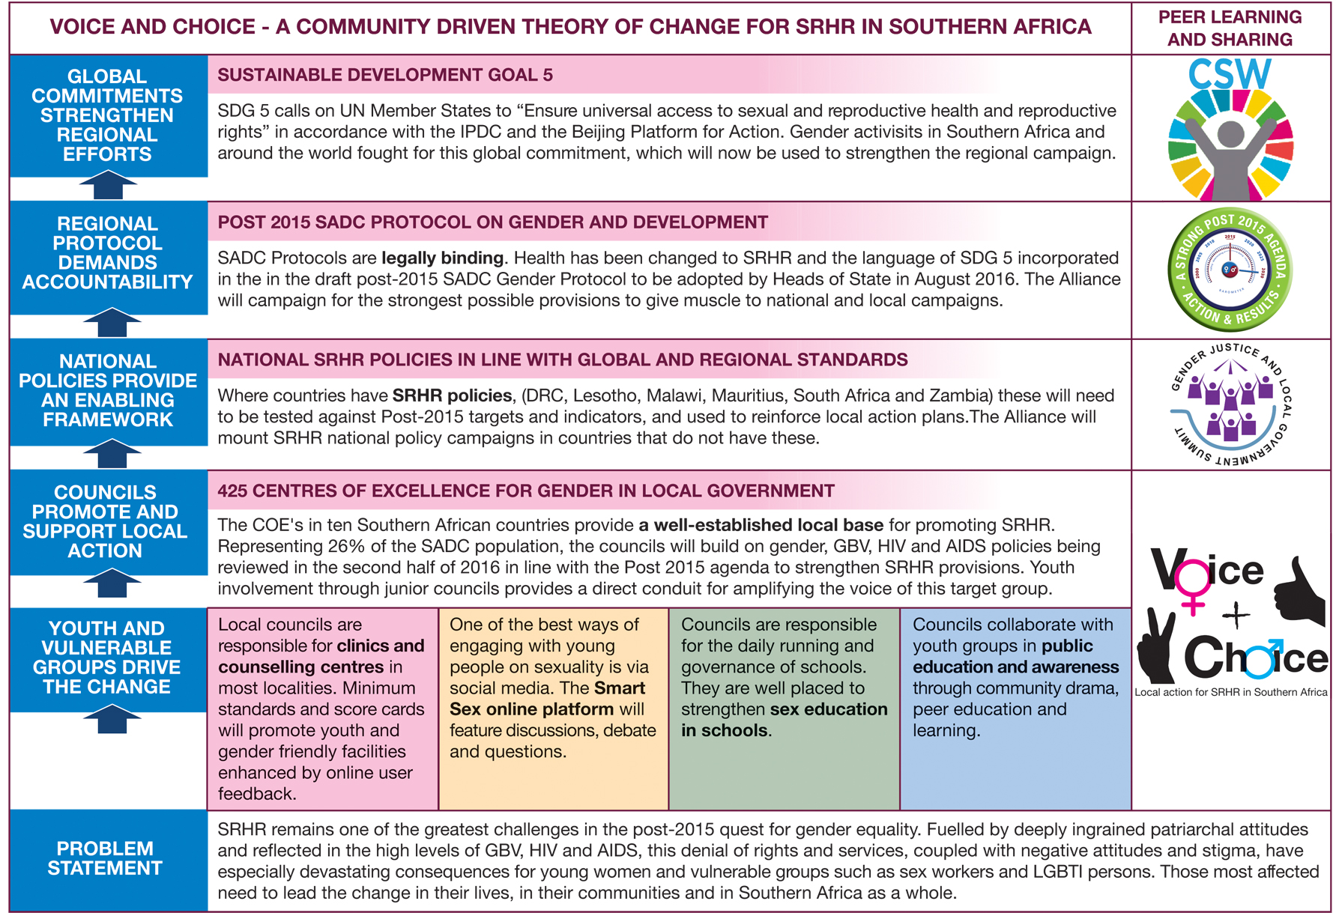
ANNEX A: GL’s THEORY OF CHANGE FOR PROMOTING SRHR IN SOUTHERN AFRICA
ANNEX B: COMPLEMENTARITY BETWEEN STRATEGIC AND NETWORK EXTENSION GRANTS

VOICE AND CHOICE FROM LOCAL TO REGIONAL ACTION | #SHEDECIDES: STRENGTHENING SRHR NETWORKS AND CAMPAIGNS IN SOUTHERN AFRICA
PROPOSED ACTIVITIES STRATEGIC GRANT | PROPOSED ACTIVITIES NETWORK EXTENSION
Activity 1: Strengthening the SRHR cluster | Activity 3. Advocacy and policy engagement and strengthening of LGBTI network in the Alliance
Sub-activity 1.1: Mapping of SRHR organisations in target countries | Sub-activity 3.1 Develop a campaign to decriminalise LGBTI in at least 7 countries
Sub-activity 1.2: Identifying youth champions for SRHR at national and local level | Sub activity 3.2 Collection of case studies on best practices on LGBTI
Sub-activity 1.3: Mapping of LGBTI groups | Sub activity 3.3 Meeting with LGBTI networks in the region
Sub-activity 1.4: Convene SRHR national cluster meetings | Sub activity 3.4 Policy dialogues with relevant government departments and policy makers in the 7 identified country
Sub-activity 1.5: Convene a SRHR regional cluster meetings | Activity 4. Partnerships with non-traditional SRHR allies – FBOs
Sub-activity 1.6: Hold discussions forums on SRHR on the Alliance and Governance Community of Practice | Sub-activity 4.1 Mapping of FBOs to partner with in the project
 | Sub-activity 4.2 Regional strategy meeting with FBOS
 | Sub-activity 4.3 Development of a faith based SRHR toolkit
Activity 2: Influencing SRHR policies | Activity 5 Analysis and advocacy on SRHR budgeting
Sub-activity 2.1: Develop a SRHR model policy and present it to policy makers | Sub-activity 5.1 Audit of international and regional normative framework guidelines on budgetary allocations on SRHR
Sub-activity 2.2: Collect and analyse SRHR data and case studies in target countries based on the SADC Gender Protocol and other SRHR frameworks | Sub-activity 5.2 Training meeting on SRHR budget tracking
Sub-activity 2.3: Analyse SRHR national policies and SRHR case studies | Sub-activity 5.3 Development of a scorecard on budgetary allocations on SRHR in SADC
Sub-activity 2.4: Compile, edit, print and launch the SRHR research publication | Sub-activity 5.4 Administer the budgetory scorecard
Sub-activity 2.5: Hold SRHR policy consultations at national level based on the SRHR research findings
Sub-activity 2.6: Develop and distribute IEC materials for SRHR (pamphlets, banners and t-shirts)
Sub-activity 2.7: Hold SRHR side events at international, regional and continental platforms
Activity 3. SRHR Campaigns and advocacy strategy | Activity 1. Evidence gathering and campaigns on resurgence of HIV and AIDS and young women, Child Marriages and Menstrual Health
Sub-activity 3.1: Identify digital and social media platforms for SRHR campaigns | Sub activity 1.1 Analysis emerging trends on the resurgence of HIV and AIDS especially among young women.
Sub-activity 3.2: Define key messages on SRHR to inform the SRHR campaign and advocacy strategy (these include key messages on SRHR policies, teenage pregnancy, access to SRHR services, GBV, sexual minorities and abortion) | Sub activity 1.2 Design and review a SRHR campaigns strategy
Sub-activity 3.3: Develop and customise the SRHR advocacy strategy for each target country | Sub activity 1.3 Update the website to prepare for launch of the campaigns
Sub-activity 3.4: Design and communicate the SRHR advocacy strategy | Sub activity 1.4 Launch the campaign
Sub-activity 3.5: Hold discussion forums on SRHR on the Community of Practice | Sub activity 1.5 Implement the campaign strategy
Sub-activity 3.6: Hold SRHR campaigns on social media and web-based platforms | Activity 2. Media training and collaboration on core campaigns
Sub-activity 3.7: Write blogs and press releases on SRHR | Sub-activity 2.1 Mapping exercise of media outlets in SADC to be part of the project
 | Sub-activity 2.2 Training meeting for journalists on reporting SRHR topics
 | Sub-activity 2.3 Commission an in-depth article on an SRHR topic in main stream media each quarter
 | Sub-activity 2.4 Media monitoring on reportage on SRHR topics
Activity 4. Enhancing youth involvement on SRHR at a community level | Activity 6: Enhancing campaigns and collaboration at grassroots through the Alliance Community of Practise
Sub-activity 4.1: Design a local government SRHR module which includes sexuality and SRHR policies | Sub-activity 6.1 Hold online forums on the Allaince community of practise on SRHR topics twice a year
Sub-activity 4.2: Develop youth and gender aware SRHR policies for local government | Sub-activity 6.2 Hold Marches during 16 Days of Activism in support of the SRHR campaigns
Sub-activity 4.3: Develop/review local government action plans including SRHR and youth
Sub-activity 4.4:Hold local government training workshops on SRHR in service delivery including junior councillors in 425 local government COEs
Activity 5: Promote Youth Involvement in SRHR through IT use
Sub-activity 5.1: Hold podcasts on particular SRHR topic
Sub-activity 5.2: Hold talkshows on particular SRHR topics
Sub-activity 5.3: Conduct local community dramas on SRHR and upload the drama videos on website, social media and mobile technology
Sub-activity 5.4: Hold youth focussed campaigns on social media
Activity 6: LEARNING, MONITORING & EVALUATION | Activity 7: LEARNING, MONITORING & EVALUATION
Sub-activity 6.1: Develop a SRHR summit concept | Sub-activity 7.1 Collect case studies on SRHR issues in SADC
Sub-activity 6.2: Gather SRHR case studies from local government | Sub-activity 7.2 Analyse case studies on SRHR
Sub-activity 6.3: Launch call for participation at the SRHR summit | Sub-activity 7.3 Compile monthly M and E reporting related to the project
Sub-activity 6.4: Organise and hold SRHR summits in target countries | Sub-activity 7.4 Collect I stories
Sub-activity 6.5: Write summit report outlining best practices | Sub-activity 7.5 Produce a booklet on best practices across the region
Sub-activity 6.6: Engage AmplifyChange grantees on SRHR strategies
Sub-activity 6.7: Administer the SRHR local government score card and attitudes survey
Sub-activity 6.8:Analyse the SRHR local government score card and attitudes survey
Activity 8: ORGANISATIONAL STRENGTHENING / CAPACITY BUILDING / SUSTAINABILITY | Activity 8: ORGANISATIONAL STRENGTHENING / CAPACITY BUILDING / SUSTAINABILITY
Sub-activity 8.1: Prepare a fundraising toolkit for SRHR | Sub-activity 8.1 Organisational capacity assessment , Organisational Development plan developed
Sub-activity 8.2: Community of Practice discussion forums on SRHR | Sub-activity 8.2 Organisation development training for small partner organisations
Sub-activity 8.3: Identifying of key champions SRHR at a national level (e.g. government ministers and celebrities) | Sub-activity 8.3 Hold virtual meetings for small organisations per quarter
Sub-activity 8.4: Hold interviews with SRHR champions and share these with potential funding partners. | Sub-activity 8.4 Evaluate outcomes of the organisational development training of small organisations

ANNEX C: GL COUNTRY OFFICES AND ALLIANCE FOCAL NETWORKS
COUNTRY | Alliance Partner
GL HEAD OFFICE |  | General | Specific
South Africa | SAWID | All financial transactions for logistic costs are paid directly through GL offices. Other costs are managed through the normal contracting, payment on delivery process. | Longstanding partnership, worked in all provinces together
GL HAS OFFICES
Botswana | BOCONGO |  | Long standing partnership, campaigned for signing of Protocol.
Lesotho | WLSA Lesotho |  | Long standing collaboration including local gvt work
Madagascar | FPPE |  | Long standing collaboration including local gvt work
Mauritius | MWO |  | Long standing collaboration including local gvt work
Mozambique | Forum Mulher |  | Long standing collaboration including local gvt work
Swaziland | CANGO |  | General NGO Network – women’s sector presently weak
Zimbabwe | Women’s Coalition of Zimbabwe |  | Strong coalition, produce own country Barometer with GL support
GL HAS PROJECT SITES
Namibia | NANGOF | GL sub-contracts partners on specific deliverables. Where possible logistic costs eg venues are paid directly. If managed by partners, three quotes must be presented and recommendation approved by GL. All reporting accompanied by rcpts as per finance guide in contract. | General NGO Network – women’s sector presently weak
Zambia | NGOCC through WLSA Zambia |  | Long standing collaboration including local gvt work. GL Board Member chairs NGOCC
GL HAS NO OFFICES
Angola | PMU |  | Recently joined Alliance, very enthusiastic, M and E improved dramatically
DRC | UCOFEM |  | Long standing partnership – media network
Malawi | NGOGCN |  | Long standing partnership, chair of the network is chair of the Alliance; GL Board Member.
Tanzania | TGNP |  | Long standing partnership
Seychelles | GEM Plus |  | Long standing partnership – media network

Connecting the dots on SRHR in Southern Africa
Gender Links Case Study

This case study demonstrates the unique way in which Gender Links (GL), the lead agency in this consortium, is driving the campaign for SRHR from local to regional level through its work with 425 Councils in ten Southern African Development Community (SADC) countries. GL and 40 NGOs in the Southern African Gender Protocol Alliance campaigned for the SADC Gender Protocol, a unique sub-regional instrument that brings together African and global commitments to gender equality. Working with gender and local government ministries GL cascades these targets to the local level through its Centres of Excellence for Gender in Local Government. Over the last five years, partners have shared over 2000 case studies of the SADC Protocol@Work in 26 district, 36 national and eight regional summits. While GL is not directly involved in implementation, the case studies reflect the extent to which gender policies and advocacy create an enabling environment for action on the ground with multiplier effects well beyond what one middle size Women’s Rights Organisation could achieve. GL’s catalytic impact has been independently evaluated and commended by Coffey, a London-based development consultancy, as one of twelve case studies in the DFID Programme Partnership Arrangement (PPA) in which GL is the only Southern based grantee (see graphic at Annex 1).
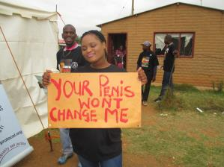
Figure 1

In 2015, as part of the campaign to update the SADC Gender Protocol in line with the Sustainable Development Goals (SDGs), the Alliance introduced SRHR as a distinct category in the summits. This analysis of the 92 case studies shared in this category in 2015 shows how, working through local government, GL is able to introduce sensitive subjects with a high degree of local ownership, as well as amplify these results through lobbying for stronger regional standard-setting.

Expertise and comparative strength on SRHR and HIV/AIDS in SADC: Over the last nine years, GL has worked with 425 councils, covering 26% of the population of SADC, to develop gender action plans with flagship programmes on SRHR, HIV and AIDS, and GBV as part of the ten stage COE programme. The range of countries that presented case studies on the impact of their work on SRHR in 2015 (see graph) demonstrates GL’s regional reach, including in Lusophone and Francophone speaking countries.

Involving local partners and target groups in preparing, planning and implementing: GL country staff assist the councils with capacity building support in developing action plans. The councils then document progress on their different interventions. One of the questions concerns how they involve beneficiaries. Testimonial evidence is a crucial part of the entries. Progress is presented in a case study format that is shared at district summits. Winners go on to national and regional summits.

Working with national and international networks: The analysis shows that while local government (27% of the case studies) is the focus of the work, the SADC Protocol@Work summits galvanise several other partners: community and faith-based organisations, NGOs and government departments. Alliance focal networks in each country organise the national summit. The Alliance regional theme clusters serve as independent judges. GL shares its results through SADC, African, Commonwealth and UN networks.

Covering all three target groups in the RNE call: The analysis shows that while the majority of the SADC Protocol@Work case studies concerned women and men in general, they also focused on youth (26%),and key populations (12% of the case studies concerned sex workers, injecting drug users, LGBTI persons, persons with disabilities and prisoners).
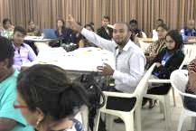
In Mauritius, for example, the Young Queer Alliance (depicted in the adjacent photo) presented its work with 15 – 29 year olds on actions to de-stigmatise LGBTI, create support networks, and lobby for enabling legislation. One case study concerned councils working with truck drivers on HIV and AIDS.
Men as partners: 27% of the case studies focused on men as partners. For example, case studies from Swaziland and South Africa showed how men are coming together to demystify some of the attributes, behaviours and myths around masculinity. Through dialogues and workshops men and boys work as partners with women to end violence and fight against the twin scourges of GBV, HIV and AIDS.

Results and effectiveness

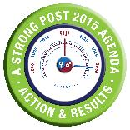
SADC Protocol targets at work: 15 of the existing 28 targets of the SADC Gender Protocol relate to SRHR. The graph shows how these are being put to work on the ground, with integrated approaches to ending GBV, universal access to HIV and AIDs treatment, SRH needs of women and men being the most referenced.

Promoting rights: The analysis shows that the case studies have a strong rights-based focus (freedom from violence; SRR). Some of the more sensitive areas (sexual pleasure, abortion, and sexual freedom) are not as prominent; however the fact that they are featuring on local agendas is a positive sign.
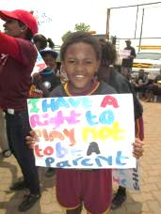

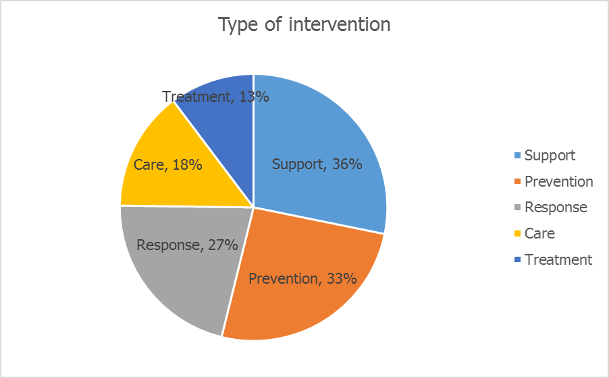

In a proactive way: The largest proportion of interventions concerns support (36%) and prevention (33%) of GBV, and HIV and AIDS. It is encouraging to see that these proactive and preventive approaches feature more prominently than the reactive ones (response, care and treatment). This is an important paradigm shift in the region, and one that opens space for more rights-based approaches.

Changing attitudes and behaviour: The most reported change in case studies analysed concerned greater public awareness (18%), followed by behaviour change (17%); reduced stigma (12%) and improved services (8%). The summary below of a case study from Madagascar shows how this is achieved:

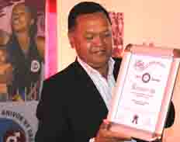
In 2012 the gender committee of the rural council of Tsiafahy, a GL COE, created an association called Amis (friend) focusing on education, information and sensitisation of young people on gender, gender violence, sexual and reproductive health. Led by an active young teacher, with the support of local health centres, they visited the 15 hamlets of the council to offer free HIV testing and medical consultation. This led to spirited campaigns during the Sixteen Days of Activism on SRHR; periodic sensitisation campaigns in schools. In 2014, the association teamed up with the Ministry of Health and UN agencies to launch “Allo Fanantenana”, free phoning, in which young people can get free counselling and information that it is free, easy to access and confidential, often provided by peers. The youth have created radio dramas conveying messages on gender equality gender violence, SRHR breaking the taboos on these topics in the community. Thanks to the association’s activities, the council included strategies for young people in the development action plan of the council, which won the runner up award for Madagascar in the SRHR category in the 2015 SADC Protcol@Work summit in Madagascar, where the mayor received the award.
Laws, policies and regulations: Seven percent of the case studies concerned changes in laws, policies and regulations on SRHR. Six SADC countries now have SRHR laws. The Alliance is campaigning for SRHR policies in the other nine -

Innovation: changing regional and global SRHR standards from the bottom up: GL used the 2015 case studies to make the case in the 2015 Barometer for stronger language on SRHR in the post 2015 SADC Gender Protocol and through the Women’s Major Group, in the SDGs. The draft post 2015 Protocol, to be adopted by Heads of State in August 2015, has a specific section on SRHR, and adopts SDG, Beijing Plus Twenty and IPDC standards for its Post 2015 Monitoring, Evaluation and Results Framework.

Transparency and accountability: Summits allow for all work and challenges to be shared and debated. The case studies are housed on the website and in Barometers. They feedback into campaigns led by the target groups.

Challenges
As reflected in the 2015 Barometer, only three countries have decriminalised sexual orientation; only South Africa allows choice of termination of pregnancy and no SADC country has decriminalised sex work. Custom, culture and religion remain strong influences on the ground, rolling back progress, especially on work with the three target groups.
Lessons learned and next steps
GL has learned to be tactful, diplomatic and incremental in prising open the envelope on SRHR. Work on GBV, HIV and AIDS at the local level has opened the door to other sensitive SRHR issues; for example GL has conducted a pilot project on LGBTI attitudes with councils in Namibia. GL has become adept at using local pressure to strengthen regional provisions and vice versa. Councils are ready to take on new challenges around flagship SRHR programmes focusing on youth and key populations.

dots on SRHR in Southern Africa
Gender Links Case Study

This case study demonstrates the unique way in which Gender Links (GL), the lead agency in this consortium, is driving the campaign for SRHR from local to regional level through its work with 425 Councils in ten Southern African Development Community (SADC) countries. GL and 40 NGOs in the Southern African Gender Protocol Alliance campaigned for the SADC Gender Protocol, a unique sub-regional instrument that brings together African and global commitments to gender equality. Working with gender and local government ministries GL cascades these targets to the local level through its Centres of Excellence for Gender in Local Government. Over the last five years, partners have shared over 2000 case studies of the SADC Protocol@Work in 26 district, 36 national and eight regional summits. While GL is not directly involved in implementation, the case studies reflect the extent to which gender policies and advocacy create an enabling environment for action on the ground with multiplier effects well beyond what one middle size Women’s Rights Organisation could achieve. GL’s catalytic impact has been independently evaluated and commended by Coffey, a London-based development consultancy, as one of twelve case studies in the DFID Programme Partnership Arrangement (PPA) in which GL is the only Southern based grantee (see graphic at Annex 1).
Figure 1

In 2015, as part of the campaign to update the SADC Gender Protocol in line with the Sustainable Development Goals (SDGs), the Alliance introduced SRHR as a distinct category in the summits. This analysis of the 92 case studies shared in this category in 2015 shows how, working through local government, GL is able to introduce sensitive subjects with a high degree of local ownership, as well as amplify these results through lobbying for stronger regional standard-setting.

Expertise and comparative strength on SRHR and HIV/AIDS in SADC: Over the last nine years, GL has worked with 425 councils, covering 26% of the population of SADC, to develop gender action plans with flagship programmes on SRHR, HIV and AIDS, and GBV as part of the ten stage COE programme. The range of countries that presented case studies on the impact of their work on SRHR in 2015 (see graph) demonstrates GL’s regional reach, including in Lusophone and Francophone speaking countries.

Involving local partners and target groups in preparing, planning and implementing: GL country staff assist the councils with capacity building support in developing action plans. The councils then document progress on their different interventions. One of the questions concerns how they involve beneficiaries. Testimonial evidence is a crucial part of the entries. Progress is presented in a case study format that is shared at district summits. Winners go on to national and regional summits.

Working with national and international networks: The analysis shows that while local government (27% of the case studies) is the focus of the work, the SADC Protocol@Work summits galvanise several other partners: community and faith-based organisations, NGOs and government departments. Alliance focal networks in each country organise the national summit. The Alliance regional theme clusters serve as independent judges. GL shares its results through SADC, African, Commonwealth and UN networks.

Covering all three target groups in the RNE call: The analysis shows that while the majority of the SADC Protocol@Work case studies concerned women and men in general, they also focused on youth (26%),and key populations (12% of the case studies concerned sex workers, injecting drug users, LGBTI persons, persons with disabilities and prisoners).
In Mauritius, for example, the Young Queer Alliance (depicted in the adjacent photo) presented its work with 15 – 29 year olds on actions to de-stigmatise LGBTI, create support networks, and lobby for enabling legislation. One case study concerned councils working with truck drivers on HIV and AIDS.
Men as partners: 27% of the case studies focused on men as partners. For example, case studies from Swaziland and South Africa showed how men are coming together to demystify some of the attributes, behaviours and myths around masculinity. Through dialogues and workshops men and boys work as partners with women to end violence and fight against the twin scourges of GBV, HIV and AIDS.

Results and effectiveness

SADC Protocol targets at work: 15 of the existing 28 targets of the SADC Gender Protocol relate to SRHR. The graph shows how these are being put to work on the ground, with integrated approaches to ending GBV, universal access to HIV and AIDs treatment, SRH needs of women and men being the most referenced.

Promoting rights: The analysis shows that the case studies have a strong rights-based focus (freedom from violence; SRR). Some of the more sensitive areas (sexual pleasure, abortion, and sexual freedom) are not as prominent; however the fact that they are featuring on local agendas is a positive sign.

In a proactive way: The largest proportion of interventions concerns support (36%) and prevention (33%) of GBV, and HIV and AIDS. It is encouraging to see that these proactive and preventive approaches feature more prominently than the reactive ones (response, care and treatment). This is an important paradigm shift in the region, and one that opens space for more rights-based approaches.

Changing attitudes and behaviour: The most reported change in case studies analysed concerned greater public awareness (18%), followed by behaviour change (17%); reduced stigma (12%) and improved services (8%). The summary below of a case study from Madagascar shows how this is achieved:

In 2012 the gender committee of the rural council of Tsiafahy, a GL COE, created an association called Amis (friend) focusing on education, information and sensitisation of young people on gender, gender violence, sexual and reproductive health. Led by an active young teacher, with the support of local health centres, they visited the 15 hamlets of the council to offer free HIV testing and medical consultation. This led to spirited campaigns during the Sixteen Days of Activism on SRHR; periodic sensitisation campaigns in schools. In 2014, the association teamed up with the Ministry of Health and UN agencies to launch “Allo Fanantenana”, free phoning, in which young people can get free counselling and information that it is free, easy to access and confidential, often provided by peers. The youth have created radio dramas conveying messages on gender equality gender violence, SRHR breaking the taboos on these topics in the community. Thanks to the association’s activities, the council included strategies for young people in the development action plan of the council, which won the runner up award for Madagascar in the SRHR category in the 2015 SADC Protcol@Work summit in Madagascar, where the mayor received the award.
Laws, policies and regulations: Seven percent of the case studies concerned changes in laws, policies and regulations on SRHR. Six SADC countries now have SRHR laws. The Alliance is campaigning for SRHR policies in the other nine -
Innovation: changing regional and global SRHR standards from the bottom up: GL used the 2015 case studies to make the case in the 2015 Barometer for stronger language on SRHR in the post 2015 SADC Gender Protocol and through the Women’s Major Group, in the SDGs. The draft post 2015 Protocol, to be adopted by Heads of State in August 2015, has a specific section on SRHR, and adopts SDG, Beijing Plus Twenty and IPDC standards for its Post 2015 Monitoring, Evaluation and Results Framework.

Transparency and accountability: Summits allow for all work and challenges to be shared and debated. The case studies are housed on the website and in Barometers. They feedback into campaigns led by the target groups.

Challenges
As reflected in the 2015 Barometer, only three countries have decriminalised sexual orientation; only South Africa allows choice of termination of pregnancy and no SADC country has decriminalised sex work. Custom, culture and religion remain strong influences on the ground, rolling back progress, especially on work with the three target groups.
Lessons learned and next steps
GL has learned to be tactful, diplomatic and incremental in prising open the envelope on SRHR. Work on GBV, HIV and AIDS at the local level has opened the door to other sensitive SRHR issues; for example GL has conducted a pilot project on LGBTI attitudes with councils in Namibia. GL has become adept at using local pressure to strengthen regional provisions and vice versa. Councils are ready to take on new challenges around flagship SRHR programmes focusing on youth and key populations.

