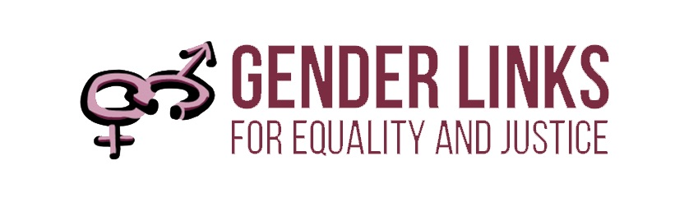
SEXUAL AND REPRODUCTIVE HEALTH AND RIGHTS (SRHR) TRAINING
FOR LOCAL GOVERNMENT
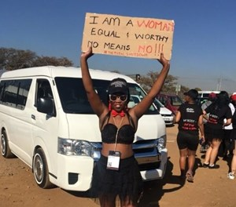
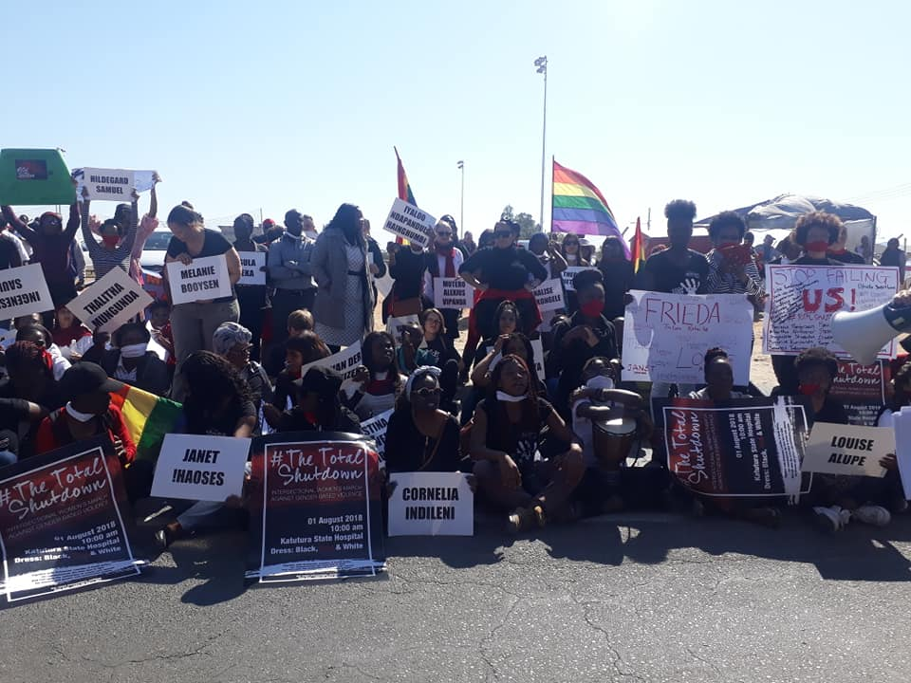
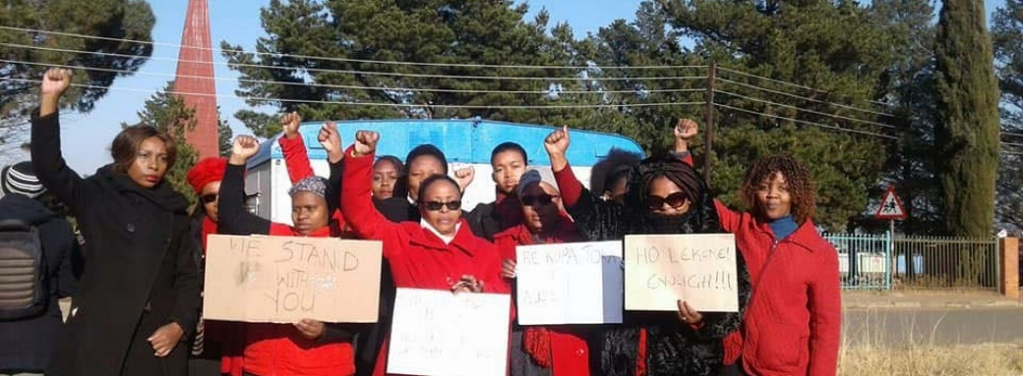
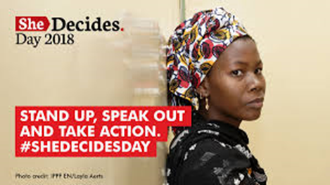

6 – 8 August 2018
GL Cottages
Johannesburg, South Africa

OBJECTIVES
- To deepen the local government SRHR plans to facilitate better service delivery and increased awareness on SRHR.
- To review existing local government SRHR materials and make the relevant changes so that they are country and context specific.
- To ensure that SRHR plans include and respond to a diverse range of target groups including amongst others young women, people with disabilities, LGBTI communities, people living with HIV and AIDS, and sex workers.

PROGRAMME
TIME | ACTIVITY | WHO | REFERENCES
Monday, 6 August 2018
08h30 – 09h00 | Welcome and introductions | Colleen Lowe Morna
09h00 – 09h15 | Programme and objectives | Colleen Lowe Morna | Programme,
Setting the scene: SRHR at local level
09h15 – 10h00 | Panel discussion:
09h15 – 10h00 | SAFAIDS | Nakai Godfrey | Transforming lives
09h15 – 10h00 | Boane Municipality, Mozambique | Regina Lourenco
09h15 – 10h00 | Analysis of SADC Protocol@work Sexual and reproductive health and rights entries | Kubi Rama | SADC Protocol@Work  Sexual and reproductive health and rights brief
10h00 – 10h30 | Discussion | All | Presentations
10h30 – 11h00 | TEA
Mapping SRHR at local level
11h00 – 12h00 | Country mapping of local SRHR initiatives | Country groups | Mapping SRHR at local level Power points
12h00 – 13h00 | Report back | Country representative | Power point
13h00 – 14h00 | LUNCH
Target groups
14h00 – 14h40 | Panel discussion:
14h00 – 14h40 | LGBTI - PILS Mauritius | Nudhar Banu
14h00 – 14h40 | People living with HIV and AIDS – Let us grow, South Africa | Rose Thamae
14h00 – 14h40 | Providing SRHR care and support for sex workers - Kadoma City Council | Daniel Chirundu
14h00 – 14h40 | National Junior Council Association – Zimbabwe | Shingirirai Chikazhe
14h00 – 14h40 | People living with disabilities, eSwatini | Ncane Maziya
14h40 – 15h30 | Identifying partners at local level to ensure that all target groups are represented | Country groups | Power point
15h30 – 16h00 | TEA
16h00 – 16h45 | Report back | Country representative | Power point
16h45 – 17h00 | Briefing on dramas and community media | Facilitator | Drama brief
Tuesday, 7 August 2018
Reviewing local government SRHR action plan template
08h30 – 10h30 | Conduct an audit of the current content: | Country groups | SRHR Word document
08h30 – 10h30 | Review data required and identify sources at local level. | Country groups | SRHR Word document
08h30 – 10h30 | What should be removed? Why? | Country groups | SRHR Word document
08h30 – 10h30 | What should be retained? | Country groups | SRHR Word document
08h30 – 10h30 | Any proposed changes? | Country groups | SRHR Word document
08h30 – 10h30 | Review indicators and change to align with proposed changes. | Country groups | SRHR Word document
10h30 – 11h00 | TEA
11h00 – 13h00 | Report back | Country representative | SRHR Word document with track changes
13h00 – 14h00 | LUNCH
Developing accessible media interventions on SRHR
14h00 -15h30 | Presentation of thematic dramas: |  | Drama brief
14h00 -15h30 | Teenage pregnancy | Zimbabwe | Drama brief
14h00 -15h30 | Termination of pregnancy | Swaziland/Zambia | Drama brief
14h00 -15h30 | Water and sanitation | Madagascar | Drama brief
14h00 -15h30 | Child marriages | Mozambique/Mauritius | Drama brief
14h00 -15h30 | Discussion | All | Drama brief
15h30 – 16h00 | TEA
16h00 – 17h00 | Prevention of HIV and AIDS | Botswana/Lesotho | Drama brief
16h00 – 17h00 | Recognition of care work | South Africa/Namibia | Drama brief
16h00 – 17h00 | Discussion | All | Drama brief
Wednesday, 8 August 2018
Reviewing SRHR training materials for local government
08h30 – 10h30 | Audit the SRHR training module – use track changes: | Country groups | Training materials
08h30 – 10h30 | Assess model and provide feedback on how it would work in your country? Suggest changes if needed? | Country groups | Training materials
08h30 – 10h30 | Examine the training content and suggest any changes that might be necessary. | Country groups | Training materials
08h30 – 10h30 | Review planning templates and provide feedback. | Country groups | Training materials
08h30 – 10h30 | Identify the next steps to take the process forward | Country groups | Training materials
10h30 – 11h00 | TEA
11h00 – 13h00 | Feedback | Country representative
13h00 – 14h00 | LUNCH
14h00 – 14h45 | Feedback | Country representative
14h45 – 15h00 | Evaluation and closure | All | Evaluation form

SADC PROTOCOL@WORK
Sexual and reproductive health and rights
(Including HIV and AIDS, gender-based violence, and sexual and reproductive health)

The analysis of Sexual and reproductive health and rights submissions for the Summit covers HIV and AIDS, gender-based violence (GBV) and sexual and reproductive health (SRH). There are several linkages between the three areas.
HIV and AIDS
SRH
GBV
- People experiencing GBV access SRH to treat the psychological, physical and sexual consequences.
- Violence is a barrier in accessing HIV prevention, care, and treatment services.

- The majority of HIV cases are sexually transmitted and require SRH.
- The greater proportion of pediatric HIV infections is spread from mother-to-child in the process of pregnancy, childbirth, and breastfeeding.
- The majority of new HIV cases are among
women and girls, a major target of SRH services.
- SRH provides family planning and contraceptives.
- Violence or threat of violence increases women’s and girls’ vulnerability to HIV.
- Violence makes it difficult for women to sex when in a relationship, to get their partners to be faithful, or to use a condom.
- Forensic medicine plays an important role in collecting evidence to support the criminal prosecution of a perpetrator.

The linkages between HIV and AIDS, GBV and sexual and reproductive health supports the notion that integrated approaches are a key strategy to address the growing levels of HIV and AIDS as well as GBV. Utilising joint initiatives will decrease duplication and competition for resources.

The analysis will focus on the following topics and sub topics:
Topics
- The right and access to services to choose to terminate pregnancy.
- The right to sexual pleasure.
- The right to sexual autonomy, sexual integrity, and safety of the sexual body; sexual equity.
- The right to sexual freedom and to sexually associate freely.
- Improved safety during pregnancy.
- The right to make free and responsible reproductive choices.
- The right to making individual decisions about family planning; affordable and acceptable methods of birth control.
- The right to, accessible and affordable sexual and reproductive health and services.
- Sexual and reproductive rights.
- The right and access to comprehensive sexual information and sexuality education.
- Freedom from gender-based violence.

Sub topics
- Abortion
- Sex work
- Maternal mortality
- Sexual orientation, gender identity and expression
- STIs
- Access to SRHR services
- Family planning
- HIV and AIDS GBV

Gender Links (GL) works with all levels of governments, organisations and communities to implement strategies and programmes to meet the targets set in the Revised SADC Protocol on Gender and Development. GL gathers good practices and analyses how they are contributing to the implementation of the targets set in the Protocol.

A total of 75 good practices on Sexual and Reproductive Health and Rights were presented at Summits between 2017 and 2018. Of these 31 were on gender-based violence (GBV), 30 on health, and 14 on HIV and AIDS.

Freedom from gender-based violence tops the regional agenda: A total of 89% of the Summit entries in the Sexual and Reproductive Health and Rights category included a focus on the freedom from GBV. This a positive sign given the scale of the GBV pandemic in the region.

Goromonzi Rural District Council, Zimbabwe lighting up to prevent GBV

The street lighting project was initiated to prevent gender-based violence. The Council is responsible for providing lighting as mandated by the Councils Act. The project set out to reduce risk factors and enhance safety and security from a gender perspective. Women and young girls report lower levels of violence in areas with street lights. The street lighting contributes to a positive sense of safety and security.
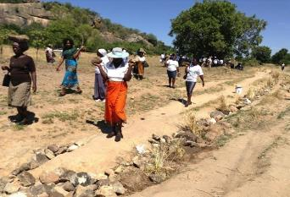
Goromonzi RDC installing lights to improve women’s safety.
Photo: Tapiwa Zvaraya

The Goromonzi Rural District Council partnered with Econet Wireless Private to use its existing base stations for installation of floodlights. Econet will pay half the cost of base station levies. The council will expand the project by delivering solar street lighting in its other areas

Approximately two thirds of the case studies prioritise sexual education and sexual and reproductive rights: Of the 75 case studies 69% covered sexual information and sexuality education and 62% on sexual and reproductive rights.

Sexual and reproductive health services, contraception and reproductive choices received equal focus: Of the total, 62% of the entries focus on the right to accessible and affordable sexual and reproductive health service. Similar proportions of case studies focused on decisions on family planning and reproductive choices. While more than 50% of the case studies focus on these topics it is not sufficient. Women need access to effective and high quality sexual and reproductive health services and contraception. There must an increased focus in these areas.

Polokwane Victim Support Unit, South Africa, providing holistic services to GBV survivors

There is often confusion about what survivors need to do when they want to report incidences of GBV. The Polokwane Victim Support Unit (VSU) assist victims of crime and violence after the initial crisis by giving emotional and practical support. The VSU refers survivors to local service providers for further assistance. It provides information on matters such as the status of the investigation, of the accused (arrested or released), the court system, the rights and the role of the victims in the court process and services available to victims.
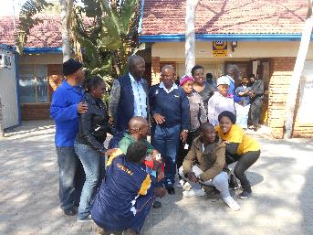
The team at the Polokwane Victim Support Unit making justice work for survivors.
Photo: Regina Mailula

The centre is based within the South African Police Services (SAPS) Polokwane building. The VSU has four social auxiliary victim empowerment practitioners, two qualified social workers and trained VEP coordinator.

The organisation works to reduce the psychological shock and trauma a victim suffers by lending emotional and practical support immediately at the time of the incident being reported.

The VSU conducted three workshops to empower women on issues such as domestic violence, gender-based violence and victim's rights. The organisation empowered hundred women during the workshops. All stakeholders are aware of their roles in assisting victims of crime and violence. The VSU has improved responses and services for survivors of violence.

Around half of the Summit entries focused on safety in pregnancy, sexual freedom, sexual autonomy and sexual pleasure: Between 45 and 58% of the case studies conducted activities to promote safety in pregnancy, sexual freedom, sexual autonomy and sexual pleasure.

Termination of pregnancy received the least amount of attention: In all SADC countries the right to termination of pregnancy is legal in a particular and limited set of circumstances except in South Africa where it is a fundamental human right for women. The right to abortion must become an inalienable right for all women across SADC. In the absence of the legal right to abortion women seek illegal abortions that have detrimental effects on their health and sometimes results in death.

HIV and AIDS most prevalent sub topic: HIV and AIDS received extensive coverage in the case studies, 72% of the entries made reference to HIV and AIDS. The highest number of case studies covered the topic GBV. The intersection between GBV and HIV and AIDS may account for the large proportion of entries in that cover both areas. One of the 14 HIV and AIDS case studies focused on prevention and three on HIV and AIDS and sex work. The majority of the case studies focuses on care and treatment.

Family planning and sexually transmitted infections (STIs): Around half of the Summit entries focused on family planning and STI’s. This number is low given that many women are unable to negotiate safe sex and contract STIs and HIV and AIDS through unprotected sex.

Sexual orientation, gender identity and expression: At 41%, the number of studies making reference to sexual orientation, gender identity and expression is on the rise. Homosexuality is still illegal in many SADC countries.

In December 2017, a transgender woman won a landmark case against Botswana’s government to be recognised as female. Tshepo Ricki Kgositau sued the Botswana government for refusing to change the sex on her identity document from male to female. In her court papers, Kgositau argued that gender in her identity document was causing her emotional distress and increased her vulnerability to abuse and violence. Justice Leatile Dambe ordered that the document be changed within seven days.

In 2014, the Botswana government lifted a ban on a gay rights lobbying group, ruling that lesbians, gay people and bisexual people of Botswana be allowed to register and campaign for changes to the law. However, it reiterated that it was still illegal to engage in homosexual acts. These examples illustrate the contradictions in Botswana law.

In a similar vein the right to equality of all is guaranteed in SADC constitutions while homosexuality and different gender identities remain illegal. These are constitutional contradictions that must be challenged.

Increased focus on maternal mortality needed: Only 35% of the case studies referenced maternal mortality. Levels of maternal mortality in the SADC are high in several.
Country | Maternal mortality (Number of deaths per 100 000 live births)
DRC | 693
Malawi | 634
Mozambique | 489
Lesotho | 487
Angola | 477
Zimbabwe | 443
Tanzania | 398
Swaziland | 389
Madagascar | 353
Comoros | 335
Namibia | 265
Zambia | 224
South Africa | 138
Botswana | 129
Mauritius | 53
Seychelles | No data
Nine of the 16 SADC countries (DRC, Malawi, Mozambique, Lesotho, Angola, Zimbabwe, Tanzania, Swaziland and Madagascar) feature amongst the 35 countries with the highest maternal mortality rates worldwide. Health systems must provide improved safety and services for women during pregnancy.

A very low proportion of case studies address sex work: Only 27% of the case studies made reference to sex work. Sex workers are often experience marginalisation, stigmatisation and criminalisation making preventing them from accessing healthcare, legal and social services. On average, sex workers are 10 times more likely to become infected with HIV than adults in the general population.

Zimbabwe Ministry of Health and Child Care making care accessible to sex workers
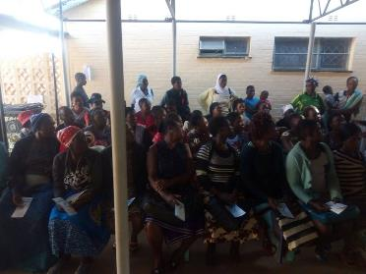
Women accessing health care services in Kadoma.
Photo: Thomas Ferenando
Kadoma has many commercial sex workers who need access to health, treatment and care services. The Ministry set up a clinic at the Kadoma hospital to assist sex workers. The services include HIV therapy, treatment for STIs and counselling.

The clinic offers HIV prevention programs for sex workers, especially female sex workers. Given their marginalisation, concerted efforts must be made to ensure sex workers have equitable access to HIV prevention, care, and treatment services, as well as wider health services, particularly for STIs, mental health, and addictions.

Women in commercial sex work now have equal access to health, treatment and care services.

Overall the number of case studies that focus on HIV and AIDS is low: Only 19% (14 of 75) of the case studies focused on HIV and AIDS. Of these 35% were on access to treatment and 32% referred to gender sensitive strategies to prevent new infections.

Recognition of care work receives little attention: Only 26% of the case studies covered the recognition of care work and care givers, most of whom are women. Care givers often work as volunteers with little or no remuneration or psycho-social support. Care givers jobs are physically strenuous and psychologically intensive.

Umfunti Foundation, Swaziland providing HIV and AIDS care

The organisation was established due to the high mortality rate in the Lubombo Region due to HIV and AIDS. Umtfunti home-based care assists family caregivers in providing AIDS-related care, because public health services could not cope with the increasing demand for treatment and care.
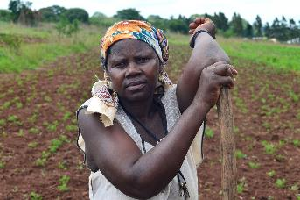
Umtfunti empowers women to sustain themselves economically.
Photo: Mujahid Safodien (IRIN)

Some home-based care services focus on providing social and psychological support, with some nutritional support and basic nursing care. Others also dispense antiretrovirals (ARVs) and treat opportunistic infections. These services, whether provided through NGOs, government health clinics, or community groups, are essential in supporting people living with HIV and AIDS, as well as people who provide care and support within families.

Umtfunti volunteers do door-to-door visits in the communities, teaching households about prevention of mother-to-child transmission (PMTCT), HIV and AIDS, home based care and GBV. The organisation also teaches in community meetings and schools. Part of Umtfunti’s services includes taking care of the people who are terminally ill.

Women and girls provide the majority of HIV and AIDS-related care, this being seen as a continuation of their role as care providers in families. Duties that are related to home-based care are seen as domestic and are, therefore, considered to be women's work and are unpaid. Umtfunti empowers women to sustain themselves economically, and to improve their lives.

Largest number of case studies focus on legislation prohibiting GBV: Of the total number of case studies on GBV 74% covered enacting or enforcing legislation prohibiting all forms of GBV. None of the case studies were on enacting legislation, all of them focused on providing support to survivors who had reported incidences of GBV.

Similar numbers of case studies were on integrated approaches and comprehensive testing, treatment and care for survivors of GBV: About two thirds of the case studies focused adopting integrated approaches to reduce GBV by half. Out of the total, 64% made reference to ensuring that legislation provides for the comprehensive testing, treatment and care for survivors of GBV.

Review, reform and enact laws to effectively address GBV, sexual assault and sexual harassment: About half the case studies addressed the need to review and reform criminal procedures applicable to sexual offences and GBV. Similar numbers of case studies focused on enacting and implementing sexual harassment laws.

Human trafficking is low on the agenda: Only 36% of the case studies made reference to human trafficking. Human trafficking legislation in the SADC region is relatively recent. While laws are in place, implementation of the provisions are still gaining momentum and convictions for human trafficking are low.

Botswana Police Services in Lobatse works with the community to prevent GBV

When addressing issues gender equality and the eradication of GBV the main target group was women and the girl child. “Special populations" such as orphans, vulnerable children and people living with disabilities were excluded. Limited progress was made in achieving a gender equal and GBV free community.
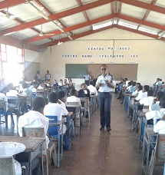
Lobatse Police gender focal person creating awareness about gender equality and GBV at the Ipelegeng Junior Secondary School.
Photo: Victoria Morapedi

Orphans, vulnerable children and people living with disabilities do not always understand what abuse is and how to report it. The project set out to educate orphans, vulnerable children and people living with disabilities on gender-based violence and gender equality. The Lobatse Police also works with caretakers of orphans, vulnerable children and people with disabilities on the rights of the people under their watch and care.

The police raise awareness on GBV and gender equality through outreach programmes in homes, for individuals, in schools and churches. The gender focal person makes public addresses at different sites on commemorative days.

The community understands the need to recognise the rights, dignity and self-worth of orphans, vulnerable children and people living with disabilities. Orphans, vulnerable children and people with disabilities are no longer “special populations” but are part of the community. Communities offer them support and report any abuse perpetrated on orphans, vulnerable children and people with disabilities.

Primary focus on providing gender sensitive, appropriate and affordable health care: Of the total number of submissions, 30 of the 75 were on sexual and reproductive health. Of these 68% focused on the provision of gender sensitive, appropriate and affordable health care. While substantial there is a need for more interventions as the current health systems are providing inadequate treatment and care.

Women’s health needs, hygiene and sanitation, and maternal mortality receive little attention: About a quarter of all case studies focus on women’s mental, sexual and reproductive health. Only 24% of the submissions focused on the provision of the hygiene and sanitary facilities, and nutritional needs of women. The lowest proportion of case studies were on maternal mortality. As mentioned previously high levels of maternal mortality persist in SADC. The issue needs urgent attention.

AMICAALL Swaziland promotes access to sexual and reproductive health
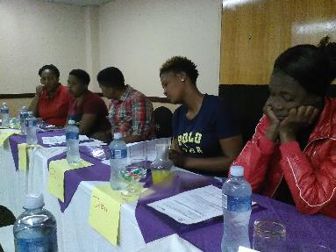
AMICAALL Swaziland conducting a workshop on safe sex and contraception.
Photo: Linda Chissano

The Alliance of Mayors and Municipal Leaders on HIV and AIDS in Africa (AMICAALL) creates access sexual and reproductive health services in Piggs Peak in the Hhohho district. UN agencies claim, sexual and reproductive health includes physical, as well as psychological well-being vis-a-vis sexuality.

Reproductive health implies that people are able to have a responsible, satisfying and safer sex life and that they have the capability to reproduce and the freedom to decide if, when and how often to do so. Individuals face inequalities in reproductive health services. Inequalities vary based on socioeconomic status, education level, age, ethnicity, religion, and resources available in their environment.

It is possible for example, that low income individuals lack the resources for appropriate health services and the knowledge to know what is appropriate for maintaining reproductive health. Women bear and usually nurture children, so their reproductive health is inseparable from gender equality. Denial of such rights also worsens poverty.

The organisation informs women and men about and have access to safe, effective, affordable and acceptable methods of birth control. Women are often unable to access maternal health services due to lack of knowledge about the existence of such services or lack of freedom of movement. The project provides access to health services particularly in areas with high levels of poverty.

AMICAALL Swaziland promotes positive sexuality. Sexual health requires a positive and respectful approach to sexuality and sexual relationships, as well as the possibility of having pleasurable and safe sexual experiences, free of coercion, discrimination and violence. For sexual health to be attained and maintained, the sexual rights of all persons must be respected, protected and fulfilled.

Local government and NGOs submitted the majority of the sexual and reproductive health and rights case studies: Local government submitted the highest number (48%) of case studies in this category. This was closely followed by NGOs at 36%. Community based organisations submitted 15% of the case studies and faith-based organisations submitted 1% of the sexual and reproductive health and rights case studies.

Primary target groups are women, youth and men: Women constitute 88% of the target group in the category sexual and reproductive health and rights. Lower proportions of youth (77%) and men (66%) are targeted.

More than 50% of the case studies target people with disabilities: More than half (54%) the case studies targeted people with disabilities. This is an important development. Initiatives are targeting the unique needs of people with disabilities while at the same moving them from beng a “special population” to being an integral part of communities.

Sex workers are slowly moving from the margins into the mainstream: Sex workers are afriad to access sexual and reproductive health services because of stigma and discrimination. They are particularly vulnerable to contracting HIV and to experiencing GBV. It is encouraging to note that 34% of the case studies specifically targeted sex workers.

Less than a fifth of all case studies targeted mobile populations, drug users, LGBTIQ persons and prisoners: HIV ad AIDS is one of SADC’s most urgent challenges. Moblie populations, drug users and prisoners are vulnerable to contracting HIV. LGBTIQ persons sometimes need specialised sexual and reproductive health services and face discrimination when accessing such services. More targeted interventions are need to address the sexual and reproductive health and rights of these target groups.

High levels of interventions on prevention and capacity building: Of the 75 case studies 81% focused on prevention while 76% built capacity amongst their target groups.

Lower proportions of interventions addressing issues of treatment and response: Of the total number of case studies 64% and 61% promoted better quality treatment and responses for HIV and AIDS, GBV and sexual and reproductive health.

Policy change receives less focus: Less than 50% of the case studies promoted policy change. Legislative reform and implementation is an important policy imperative to guarantee long term change.

Highest levels of change in the community and individuals: Community involvement in the prevention of HIV and AIDS and GBV; and providing better sexual and reproductive health is central to successful SRHR campaigns. There are similar high levels of change in individuals (82%). The level of change in communities and individuals is encouraging. Changes in society at 69% are positive. Close relations experienced the lowest level (57%) of change.

More than 80% of the case studies contribute to changes in awareness, behaviour and attitude: Of the 75 case studies 86% created greater public awareness about sexual and reproductive health and rights, 81% and 80% resulted in changes in behaviour and attitudes respectively.

Large proportion of the case studies contribute to better service delivery: The crisis in the provision of public health in most SADC countries has severely impacted sexual and reproductive health services. It is encouraging to note that 77% of the case studies focus on improved services.

Changes in legislation and policy difficult to attain: A recurring theme across all categories is the limited focus on policy and legislative change. This is true in the SRHR category with only 54% of the case studies recording changes in legislation and policy.

Challenges
The Sexual and Reproductive Health and Rights category included HIV and AIDS, GBV and sexual and reproductive health. In and of themselves each sub theme has several dimensions that require analysis. In addition, there are multiple intersections between the three areas such as for example rape, contracting HIV through the rape and testing, treatment and care thereafter.

This presents a challenge in terms of analysis and selecting when to group the data across all themes and when to keep the analysis discrete. The important consideration was to ensure that there was a comprehensive overall analysis with critical findings for each of the three sub themes.

Lessons learned and next steps
Only 14 of the 75 case studies in this category focused primarily on HIV and AIDS. This is very low and might be indicative of fatigue around HIV and AIDS. HIV infections across the SADC region remain high and the pandemic has not abated. There is need to urge more partners to submit entries on HIV and AIDS, and to work with partners to re-prioritise HIV and AIDS interventions.

In contrast there were relatively high numbers of submissions on GBV. The challenge is despite all the good practices levels of GBV are not decreasing at a rapid rate. Moving forward there needs to be an analysis of what works in the short, medium and long term to prevent all forms of GBV.

Levels of maternal mortality in the SADC is unacceptably high. More initiatives are required to demand better quality, accessible and an increase in reproductive health services.

A glaring absence in the case studies was on sexual harassment. None of the case studies focused on sexual harassment. This is particularly concerning during a time when the issue was so prominent with launch of the global MeToo campaign. MeToo is an international movement against sexual harassment and sexual assault. In future Summits GL should actively seek out case studies that address sexual harassment.

Issues of sexual and reproductive health and rights are particularly significant for sex workers and LGBTIQ persons. Both groups face stigma and discrimination within communities and when accessing services. There were several case studies that targeted sex workers specifically. This however was not the case for LGBTIQ persons. This is an area that needs bolstering.

SUPPORTING INFORMATION

Key terms

Reproductive health: “Within the framework of WHO’s definition of health as a state of complete physical, mental and social well-being, and not merely the absence of disease or infirmity, reproductive health addresses the reproductive processes, functions and system at all stages of life. Reproductive health, therefore, implies that people are able to have a responsible, satisfying and safe sex life and that they have the capability to reproduce and the freedom to decide if, when and how often to do so.

Implicit in this are the right of men and women to be informed of and have access to safe, effective, affordable and acceptable methods of fertility regulation of their choice, and the right of access to appropriate health care services that will enable women to go safely through pregnancy and childbirth and provide couples with the best chance of having a healthy infant” (ICPD PoA, 1994: 40, Para 7.2).

Reproductive rights: “Reproductive rights embrace certain human rights documents and other consensus documents. These rights rest on the recognition of the basic right of all couples and individuals to decide freely and responsibly the number, spacing and timing of their children and to have the information and means to do so, and the right to attain the highest standard of sexual and reproductive health. It also includes their right to make decisions concerning reproduction free of discrimination, coercion and violence, as expressed in human rights documents. In the exercise of this right, they should take into account the needs of their living and future children and their responsibilities towards the community” (ICPD PoA, 1994:40, Para 7.3).

Sexual health: “Sexual health is a state of physical, mental and social well-being in relation to sexuality. It requires a positive and respectful approach to sexuality and sexual relationships, as well as the possibility of having pleasurable and safe sexual experiences, free of coercion, discrimination and violence” (WHO, www.who.int).

Sexuality: Sexual heath cannot be defined, understood or made operational without a broad consideration of sexuality, which underlies important behaviours and outcomes related to sexual health. The working definition of sexuality is: a central aspect of being human throughout life and encompasses sex, gender identities and roles, sexual orientation, eroticism, pleasure, intimacy and reproduction. Sexuality is experienced and expressed in thoughts, fantasies, desires, beliefs, attitudes, values, behaviours, practices, roles and relationships. Sexuality is influenced by the interaction of biological, psychological, social, economic, political, cultural, legal, historical, religious and spiritual factors (DoH, 2011:2).

Sexual orientation: “Sexual orientation refers to an enduring pattern of emotional, romantic, and/or sexual attractions to men, women, or both sexes. Sexual orientation also refers to a person’s sense of identity based on those attractions, related behaviours, and membership in a community of others who share those attractions’’ (American Psychological Association, www.apa.org).

Sexual and Gender Based Violence: Gender based violence is defined at that which is directed against a person on the basis of gender. The inclusion of sexual violence as defined by WHO includes ‘“any sexual act, attempt to obtain a sexual act, unwanted sexual comments or advances, or acts to traffic women’s sexuality, using coercion, threats of harm or physical force, by any person regardless of relationship to the survivor, in any setting, including but not limited to home and work” (Population Council, 2008:9). The scope of the definition is also expanded to include the forced sex, sexual coercion and rape of adult and adolescent boys and girls, and child sexual abuse.

Disability/disabilities: “Disabilities are an umbrella term, covering impairments, activity limitations, and participation restrictions. An impairment is a problem in body function or structure; an activity limitation is a difficulty encountered by an individual in executing a task or action; while a participation restriction is a problem experienced by an individual in involvement in life situations (WHO, www.who.int).

LGBTI: is an abbreviation for 'lesbian, gay, bisexual, transgender, and intersex'. Lesbian: a female homosexual; a female who feels romantic love or sexual attraction to other females. Gay: a homosexual person; commonly referring to homosexual males but can also include lesbians. Bisexual: a romantic/sexual attraction or sexual behaviour toward both males and females. Transgender: sometimes referred to as “trans”; people whose gender identity is different from the gender they were assigned to at birth. Intersex: the intersex definition is a person is born with a combination of male and female biological characteristics, such as chromosomes or genitals, that can make doctors unable to assign their sex as distinctly male or female.

Sex workers: are women, men and transgendered people who receive money or goods in exchange for sexual services, and who consciously define those activities as income generating even if they do not consider sex work as their occupation.

Adolescence: United Nations Population Fund (UNFPA) along with the World Health Organization (WHO) and United Nations Children’s Fund (UNICEF) defines adolescence between the ages of 10-19. The UNFPA breaks this age category down further by classifying early adolescence for the ages 10-14 years and late adolescence for the ages 15-19.

What falls under the umbrella of SRHR?
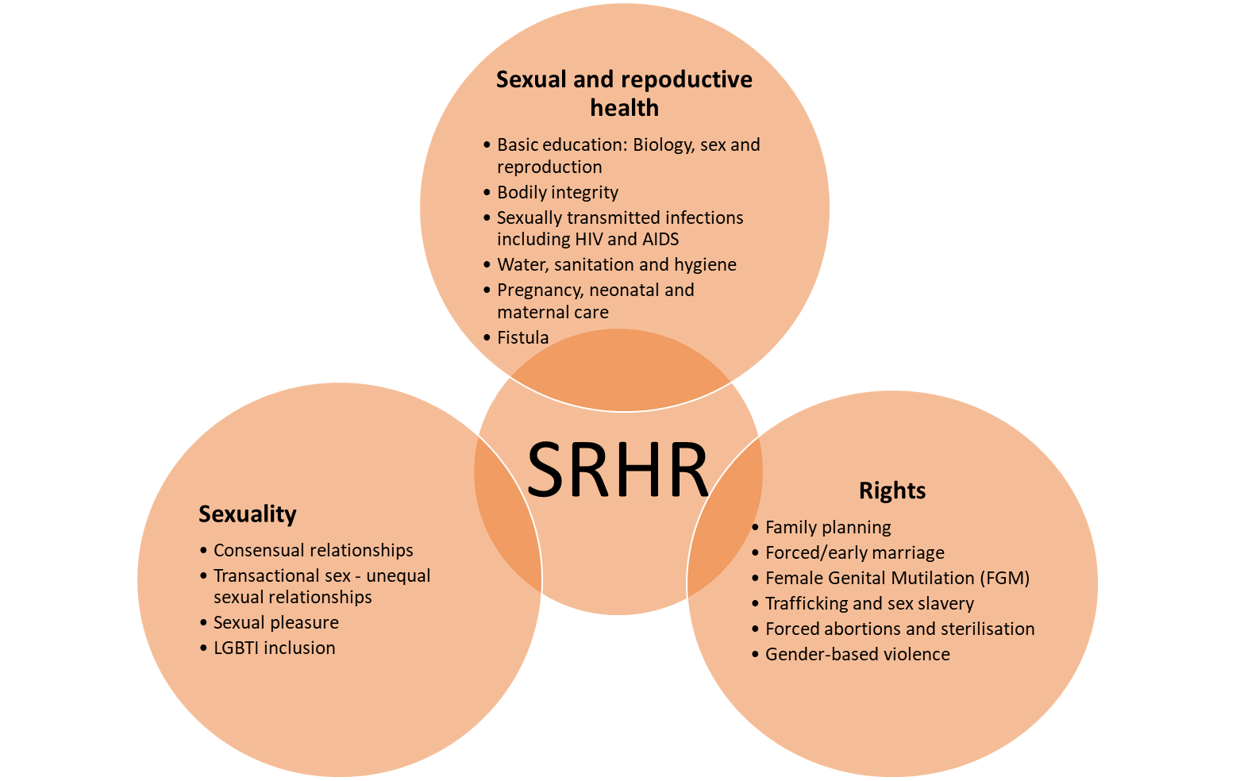

Functions/competencies of local government

COUNTRY/  FUNCTION | BOTS | LES | MAD | MAU | MOZ | NAM | SA | ESWA | ZAM | ZIM
General administration
Police | X |  |  |  |  | X | X
Fire protection | X | X |  |  |  |  | X |  | X
Ambulance services
Civil protection |  |  |  | X
Criminal justice
Civil justice |  |  |  |  |  |  | X
Civil justice register
Statistical office
Cultural, leisure and sports
Theatre and concerts | X |  |  | X |  | X
Museums and libraries | X |  |  | X |  | X | X |  | X
Parks and open spaces | X |  |  | X | X | X | X | X | X
Sports and leisure |  |  |  |  |  |  |  |  | X
Economic
Agricultural, forests and fisheries |  | X |  |  |  | X |  |  | X
Economic promotion | X | X |  | X |  | X | X
Trade and industry |  |  |  |  | X | X | X
Tourism |  | X |  |  | X | X | X | X
Other economic services |  | X |  |  | X
Education
Pre-school | X |  |  | X |  |  | X |  | X
Primary | X | X
Secondary |  | X
Vocational and technical |  | X |  | X
Higher education
Adult education |  | X
Environment and public sanitation
Water and sanitation | X |  |  |  |  | X | X |  | X
Refuse collection and disposal | X |  |  | X |  | X | X |  | X
Cemeteries and crematoriums | X |  |  | X |  | X | X | X | X
Slaughter houses | X |  |  |  |  | X | X | X | X
Environmental protection | X |  |  | X |  | X | X | X
Consumer protection | X |  |  | X |  | X | X |  | X
Housing and town planning
Housing | X | X |  | X | X | X | X | X | X
Town planning | X | X |  |  | X | X | X | X | X
Regional planning |  |  |  |  |  | X
Public health
Primary care | X | X |  |  |  |  | X | X | X
Hospitals |  | X
Health protection | X | X |  | X |  |  | X | X | X
Social welfare
Kindergarten and nursery | X
Family welfare services | X | X
Welfare homes |  | X |  |  |  |  |  | X
Social security |  | X
Transport
Roads | X | X |  | X |  | X |  |  | X
Transport |  | X |  |  |  |  |  | X | X
Urban roads | X | X |  |  |  | X |  | X | X
Urban rail | X
Ports | X |  |  |  |  | X
Airports |  |  |  |  |  | X |  | X
Utilities
Gas supply | X |  |  |  |  |  | X
District heating | X
Water supply | X | X |  |  | X | X | X | X | X
Electricity |  |  |  |  | X | X | X

http://clubofmozambique.com/news/transgender-woman-wins-landmark-case-in-botswana/
https://photius.com/rankings/2017/population/maternal_mortality_rate_2017_1.html
UNAIDS (2016) ‘Prevention Gap Report’

