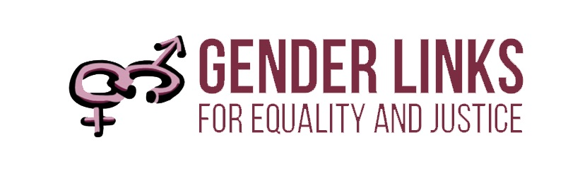

DIVERSE GENDER EXPRESSIONS & IDENTITIES

EXERCISE
- Do you know anyone who does not quite conform to your traditional definition of male and female?

- What is your relationship with that person?

- Has this changed over time?

- Has this helped you to challenge your own stereotypes?

FACT SHEET

The Five Sexes: Why Male and Female Are Not Enough
http://www.uta.edu/english/timothyr/Fausto-Sterling.pdf
By Anne Fausto-Sterling
Anne Fausto-Sterling is Professor of Biology and Women's Studies in the Department of
Molecular and Cell Biology and Biochemistry at Brown University.

MALE | INTERSEX |  |  | FEMALE
MALE | male pseudo hermaphrodites  (the "merms"), | hermaphrodites  (“herm”) | female  pseudo hermaphrodites (the "ferms") | FEMALE
MALE | who have testes and some aspects of the female genitalia but no ovaries | who possess one testis and one ovary (the sperm and egg-producing vessels, or gonads) | who have ovaries and some aspects of the male genitalia but lack testes | FEMALE

In 1843 Levi Suydam, a twenty-three-year-old resident of Salisbury, Connecticut, asked the town board of selectmen to validate his right to vote as a Whig in a hotly contested local election. The request raised a flurry of objections from the opposition party, for reasons that must be rare in the annals of American democracy: it was said that Suydam was more female than male and thus (some eighty years before suffrage was extended to women) could not be allowed to cast a ballot. To settle the dispute a physician, one William James Barry, was brought in to examine Suydam. And, presumably upon encountering a phallus, the good doctor declared the prospective voter male. With Suydam safely in their column the Whigs won the election by a majority of one.

Barry's diagnosis, however, turned out to be somewhat premature. Within a few days he
discovered that, phallus notwithstanding, Suydam menstruated regularly and had a vaginal opening. Both his/her physique and his/her mental predispositions were more complex than was first suspected. S/he had narrow shoulders and broad hips and felt occasional sexual yearnings for women. Suydam's "'feminine propensities, such as a fondness for gay colors, for pieces of calico, comparing and placing them together, and an aversion for bodily labor, and an inability to perform the same, were remarked by many," Barry later wrote. It is not clear whether Suydam lost or retained the vote, or whether the election results were reversed.

For biologically speaking, there are many gradations running from female to male; and depending on how one calls the shots, one can argue that along that spectrum lie at least five sexes and perhaps even more.

For some time medical investigators have recognized the concept of the intersexual body. But the standard medical literature uses the term intersex as a catch-all for three major Sub groups with some mixture of male and female characteristics: the so-called true hermaphrodites, whom I call herms, who possess one testis and one ovary (the sperm and egg-producing vessels, or gonads); the male pseudo hermaphrodites (the "merms"), who have testes and some aspects of the female genitalia but no ovaries; and the female pseudo hermaphrodites (the "ferms"), who have ovaries and some aspects of the male genitalia but lack testes. Each of those categories is in itself complex; the percentage of male and female characteristics, for instance, can vary enormously among members of the same subgroup. Moreover, the inner lives of the people in each subgroup their special needs and their problems, attractions and repulsions have gone unexplored by science.

But on the basis of what is known about them I suggest that the three intersexes, herm,
merm and ferm, deserve to be considered additional sexes each in its own right. Indeed, I
would argue further that sex is a vast, infinitely malleable continuum that defies the constraints of even five categories.

The psychologist John Money of Johns Hopkins University, a specialist in the study of congenital sexual-organ defects, suggests intersexuals may constitute as many as 4 percent of births. Recent advances in physiology and surgical technology now enable physicians to catch most intersexuals at the moment of birth.

The word hermaphrodite comes from the Greek name Hermes, variously known as the messenger of the gods, the patron of music, the controller of dreams or the protector of livestock, and Aphrodite, the goddess of sexual love and beauty. According to Greek mythology, those two gods parented Hermaphroditus, who at age fifteen became half male and half female when his body fused with the body of a nymph he fell in love with.

In some true hermaphrodites the testis and the ovary grow separately but bilaterally, in others they grow together within the same organ, forming an ovo-testis. Not infrequently, at least one of the gonads functions quite well, producing either sperm cells or eggs, as well as functional levels of the sex hormones androgens or estrogens. Although in theory it might be possible for a true hermaphrodite to become both father and mother to a child, in practice the appropriate ducts and tubes are not configured so that egg and sperm can meet.

In contrast with the true hermaphrodites, the pseudo hermaphrodites possess two gonads
of the same kind along with the usual male (XY) or female (XX) chromosomal makeup. But their external genitalia and secondary sex characteristics do not match their chromosomes. Thus merms have testes and XY chromosomes, yet they also have a vagina and a clitoris, and at puberty they often develop breasts. They do not menstruate, however. Ferms have ovaries, two X chromosomes and sometimes a uterus, but they also have at least partly masculine external genitalia. Without medical intervention they can develop beards, deep voices and adult-size penises.

CASE STUDY: CASTOR SEMENYA
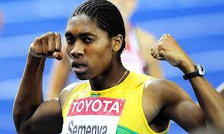

- Who is Castor Semenya? Why did she become famous?

- The World Athletics Committee said they would be carrying out a gender verification of Castor Semenya. Is this the correct terminology?

- What did the Committee find? Based on what? Why was this important?

South Africa: Semenya challenges our deeply ingrained stereotypes
By Colleen Lowe Morna

Is she a girl or is she a boy? That’s been the level of debate surrounding teenage athlete sensation Mokgadi “Caster” Semenya at home and abroad.

The question we should be asking ourselves in Women’s Month in South Africa and in a globalised world steeped in gender stereotypes is how this young woman, who defies all templates of what we expect a woman to be, should help us see through our own blinders to the beauty of her success.

Let’s start with some definitions. Sex is a biological given. Gender is a social construct: it is about society’s expectations of what a woman or man should look like, behave and be.

In sport, testing for sex is legitimate, as is testing for drugs. There are physical differences between women and men. To the extent these might give an athlete an advantage, they can be questioned. This kind of testing indeed started in the sixties as a result of men sneaking into women’s sport is disguise. It was about proving that men are not women; not about women proving that they are women. Men, it should be noted, never have to undergo tests in sports to prove that they are men.

Gender testing, if that is what happens, is completely wrong. What would such a test involve? Determining if a person looks or thinks or acts like a woman or a man? And how exactly does a woman or man think or look or act?

Ironically, gender not sex testing is exactly what Semenya is being subjected to. She is being questioned on the basis of our assumptions about how a woman should look and behave: not the biological facts.

Over the last few days, we have heard from Semenya’s coach; her room mate, her mother and grandmother, all of whom confirm that she is biologically a girl. The experts say that there is more to it than simple gynecological tests. In the same breath, they caution that hormonal balance is murky territory; especially when one is talking about super fit athletes whose balance is anyway going to be quite different from the average man or woman.

Could it be that the real issue is that we are blown away by a confident and fit young woman who exudes not only physical but also psychological strength in a way that challenges our deeply held views about what girls should or should not be? And is race conceivably part of this stereotypical mix?

Hark back two decades ago to Mozambican athlete Maria Mutolo’s debut on the world stage, when similar questions were raised about her sex. How different is her physique to that of Semenya? On the other hand, of late we have seen a muscular Madonna making public appearances after four hours of gym each day. Why are we not asking whether the world’s great sex symbol is indeed still a woman?

The singer Caiphus Semenya has a great line in one of his songs: woman has a right to be. That is what Women’s month in South Africa is all about. Our biggest gold medal is a Constitution that celebrates diversity: that embraces women and men of all shapes, forms and colours.

We should celebrate Semenya on her return not just because she is bringing back a gold medial, but because she has refused to conform to societal norms and expectations.

When little girls were being told not to play soccer, she declared she loved the sport. When she was teased and humiliated and told to pull down her pants before she could use the “ladies” she cast her energies and concentration into running. In Berlin, when an Australian newspaper leaked the sordid details about her “gender test” on the eve of her big race, she ran like there is no tomorrow.

Today it’s the Athletic World Championships; tomorrow it’s Soccer 2010. What is that next big global sporting event going to mean for the women of Southern Africa? A chance to make a bit more money in the dark alleys of illegal sex work? Or a chance to play the game; build roads and bridges; run thriving businesses; drive taxis and be a part of public life?

If Semenya helps us to see past all that has made our society blind to these possibilities for women, rendering them politically, socially and economically second class citizens in our society, her agony will not have been in vain. We can only turn her trauma to victory if we raise the current tempo of the debate from a Twelfth Night drama to a serious questioning of what exactly gender equality means.

(Colleen Lowe Morna is executive director of Gender Links. This article is part of the GL Opinion and Commentary Service that offers fresh views on every day news)

TRANSGENDER:

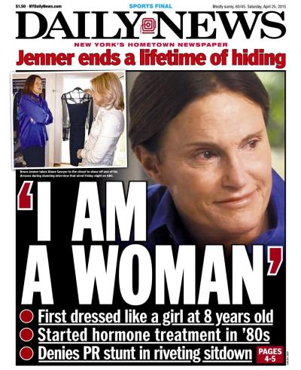
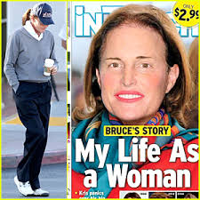

- Who was Bruce Jenner?

- When and how did he become Caitlyn?

- How was this received ?

SEXUAL ORIENTATION
CASE STUDY:
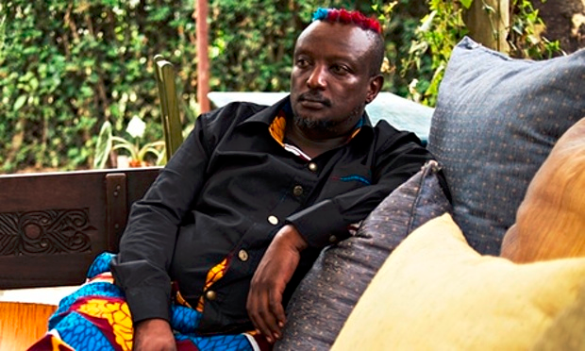

https://youtu.be/8xFjTzp7198

1 July, 2000.

This is not the right version of events.
Hey mum. I was putting my head on her shoulder, that last afternoon before she died. She was lying on her hospital bed. Kenyatta. Intensive Care. Critical Care. There. Because this time I will not be away in South Africa, fucking things up in that chaotic way of mine. I will arrive on time, and be there when she dies. My heart arrives on time. I am holding my dying mother’s hand. I am lifting her hand. Her hand will be swollen with diabetes. Her organs are failing. Hey mum.

Ooooh. My mind sighs. My heart! I am whispering in her ear. She is awake, listening, soft calm loving, with my head right inside in her breathspace. She is so big – my mother, in this world, near the next world, each breath slow, but steady, as it should be. Inhale. She can carry everything. I will whisper, louder, in my minds-breath. To hers. She will listen, even if she doesn’t hear. Can she?

Mum. I will say. Muum? I will say. It grooves so easy, a breath, a noise out of my mouth, mixed up with her breath, and she exhales. My heart gasps sharp and now my mind screams, sharp, so so hurt so so angry.
“I have never thrown my heart at you mum. You have never asked me to.”

Only my mind says. This. Not my mouth. But surely the jerk of my breath and heart, there next to hers, has been registered? Is she letting me in?
Nobody, nobody, ever in my life has heard this. Never, mum. I did not trust you, mum. And. I.

Pulled air hard and balled it down into my navel, and let it out slow and firm, clean and without bumps out of my mouth, loud and clear over a shoulder, into her ear.
“I am a homosexual, mum.”
July, 2000.

This is the right version of events.

I am living in South Africa, without having seen my mother for five years, even though she is sick, because I am afraid and ashamed, and because I will be thirty years old and possibly without a visa to return here if I leave. I am hurricaning to move my life so I can see her. But she is in Nakuru, collapsing, and they will be rushing her kidneys to Kenyatta Hospital in Nairobi, where there will be a dialysis machine and a tropical storm of experts awaiting her.

Relatives will rush to see her and, organs will collapse, and machines will kick into action. I am rushing, winding up everything to leave South Africa. It will take two more days for me to leave, to fly out, when, in the morning of 11 July 2000, my uncle calls me to ask if I am sitting down.

“She’s gone, Ken.”

I will call my Auntie Grace in that family gathering nanosecond to find a way to cry urgently
inside Baba, but they say he is crying and thundering and lightning in his 505 car around Nairobi because his wife is dead and nobody can find him for hours. Three days ago, he told me it was too late to come to see her. He told me to not risk losing my ability to return to South Africa by coming home for the funeral. I should not be travelling carelessly in that artist way of mine, without papers. Kenneth! He frowns on the phone. I cannot risk illegal deportation, he says, and losing everything. But it is my mother.

I am twenty nine. It is 11 July, 2000. I, Binyavanga Wainaina, quite honestly swear I have known I am a homosexual since I was five. I have never touched a man sexually. I have slept with three women in my life. One woman, successfully. Only once with her. It was amazing. But the next day, I was not able to.

It will take me five years after my mother’s death to find a man who will give me a massage and some brief, paid-for love. In Earl’s Court, London. And I will be freed, and tell my best friend, who will surprise me by understanding, without understanding. I will tell him what I did, but not tell him I am gay. I cannot say the word gay until I am thirty nine, four years after that brief massage encounter. Today, it is 18 January 2013, and I am forty three.

Anyway. It will not be a hurricane of diabetes that kills mum inside Kenyatta Hospital Critical Care, before I have taken four steps to get on a plane to sit by her side.
Somebody.
Nurse?

Will leave a small window open the night before she dies, in the July Kenyatta Hospital cold.
It is my birthday today. 18 January 2013. Two years ago, on 11 July 2011, my father had a massive stroke and was brain dead in minutes. Exactly eleven years to the day my mother died. His heart beat for four days, but there was nothing to tell him.

I am five years old.

He stood there, in overalls, awkward, his chest a railway track of sweaty bumps, and little hard beads of hair. Everything about him is smooth-slow. Bits of brown on a cracked tooth, that endless long smile. A good thing for me the slow way he moves, because I am transparent to people’s patterns, and can trip so easily and fall into snarls and fear with jerky people. A long easy smile, he lifts me in the air and swings. He smells of diesel, and the world of all other people’s movements has disappeared. I am away from everybody for the first time in my life, and it is glorious, and then it is a tunnel of fear. There are no creaks in him, like a tractor he will climb any hill, steadily. If he walks away, now, with me, I will go with him forever. I know if he puts me down my legs will not move again. I am so ashamed, I stop myself from clinging. I jump away from him and avoid him forever. For twentysomething years, I even hug men awkwardly.

There will be this feeling again. Stronger, firmer now. Aged maybe seven. Once with another slow easy golfer at Nakuru Golf Club, and I am shaking because he shook my hand. Then I am crying alone in the toilet because the repeat of this feeling has made me suddenly ripped apart and lonely. The feeling is not sexual. It is certain. It is overwhelming. It wants to make a home. It comes every few months like a bout of malaria and leaves me shaken for days, and confused for months. I do nothing about it.

I am five when I close my self into a vague happiness that asks for nothing much from anybody. Absent-minded. Sweet. I am grateful for all love. I give it more than I receive it, often. I can be selfish. I masturbate a lot, and never allow myself to crack and grow my heart. I touch no men. I read books. I love my dad so much, my heart is learning to stretch.

I am a homosexual.

Questions

- Why did it take Wainana so long to come to terms with his sexual orientation?

- How has his coming out been perceived in Kenya and elsewhere?

- Are there gendered differences between gays and lesbians?

Fact sheet: Sexual orientation and gender identity

Gender identity refers to a person’s internal sense of being male, female or something else. For many people, their gender identity often corresponds to their biological sex. A person who identifies as transgender has a gender identity that does not correspond to their biological sex.
Gender expression relates to how a person chooses to communicate their gender identity to others through clothing, hair, styles, mannerisms and so on. This communication may be conscious or unconscious. While most people’s understandings of gender expressions relate to masculinity and femininity, there are countless combinations that may combine both masculine and feminine expressions, or neither, through androgynous expressions.

Sexual orientation describes whom we are romantically attracted to and love. A person’s gender identity does not predetermine their sexual orientation. It is important to understand that these are all on a continuum and they are all fluid. This means that anyone could begin life at one point on a continuum and, depending on their circumstances, choices and bodies, they could change (or not) and move between the extremes on either side.

For example, there could be two people A and B who were born female (biological sex), have a masculine gender expression, and identify as bisexual (loving and desiring both sexes). Person A might live their life expressing this, while person B might grow up to realise that they were born in the wrong body and would rather be male (biological sex). Person C might have grown up to identify as heterosexual, but may change to find others of the same sex attractive and perhaps even try out a homosexual relationship.

People who change from one side of the gender identity continuum to the other are known as transgender. People who change from one side of the biological sex continuum to the other are known as transsexual (undergoing hormone replacement and/or surgery). People who are intersex are born with ambiguous genitalia, and often the doctor or parents decide for the infant which sex they should be. This choice could be wrong; therefore, intersex people are advocating against doctors or parents making the choice for infants.

In order to counter the gender norms that are assigned to ‘males’ and ‘females’, there is also a movement to bring up children in a gender ‘neutral’ manner. This means not making distinctions between boys’ and girls’ clothes, colours, toys and activities (for example, blue for boys, pink for girls; cars for boys, dolls for girls; football for boys, playing house for girls).

A question that may be raised is that if sex and sexuality are all fluid, then could we change people of homosexual orientation to heterosexual orientation? However, the key point here is that all of these points on the continuum are related to self-identification rather than labels that can be applied to us by others or by us to others. Just as you cannot force a person to fall in love with someone, you cannot force a person who identifies as homosexual to fall in love with or desire someone of the opposite sex, or vice versa.

DEFINITIONS
Gender identity is a person’s perception of their gender and how they choose to identify themselves. I.e. man, woman or gender neutral.

Gender expression is the outer manifestation of a person’s gender identity, often expressed via clothing, haircut, voice, behaviour or body characteristics.

Sexual orientation relates to a person’s physical attraction to another person. Gender identity and sexual orientation are not the same. Transgender people can be straight, gay or bisexual.

Transgender is an umbrella term referring to individuals who do not identify with the sex category assigned to them at birth or whose identity or behaviour falls outside of stereotypical gender norms. The term “transgender” encompasses a diverse array of gender identities and expressions, including identities that fit within a female/male classification and those that do not. Transgender is not the same as intersex, which refers to biological variation in sex characteristics, including chromosomes, gonads and/or genitals that do not allow an
individual to be distinctly identified as female/male at birth.

Lesbian is a term used to describe a woman attracted to the same sex and women who do not identify as heterosexual.

Gay is a term used to describe individuals attracted to the same sex, though more commonly refers to men who do not identify as heterosexual.

Bisexual is a person attracted to both men and women. This attraction may not be split equally between genders, and there may be a preference for one gender over others.

Intersex is a term used to describe people whose biological sex is unclear. Thus, internal sex organs and genitals differ from the two expected patterns of male or female.

Asexual is a sexual orientation whereby a person has a lack or low level of sexual attraction to others and do not desire sex or to have sexual partners. An asexual person may be straight, gay, bisexual, transgender. Asexual people may be emotionally attracted to others and desire partnership, but may not wish to express that attraction sexually. Discrimination and prejudice directed at people based on their asexuality, is called aphobia.

Queer is a general term used to describe people who do not identify as straight or who have a gender-variant identity. It is often used interchangeably with LGBTIA, but due it its historical derogatory use, not all LGBTIA people use or embrace the term.

HOMOPHOBIA
Read the article below and answer the questions that follow

Case study: Malawi’s homophobic challenges
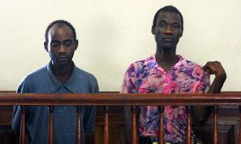

https://www.dropbox.com/home
Steven Monjeza (left) and Tiwonge Chimbalanga.jpg
Malawian authorities arrested Steven Monjeza (left) and Tiwonge Chimbalanga because they attempted to get married. Photo: Google Images
Gregory Gondwe

Only when transwoman Tiwonge Chimbalanga and man Steven Monjeza, decided to come out in the open and get engaged in December 2009, did a blanket of silence lift from Malawi society around LGBT rights. Malawi authorities arrested them and found both guilty of having committed "unnatural offenses" and "indecent practices between males."

The magistrate imposed the maximum penalty of 14 years imprisonment with hard labour. Magistrate Nyakwawa Usiwausiwa said, "I will give you a scaring sentence so that the public be protected from people like you so that we are not tempted to emulate this horrendous example." This caused an international outcry and many human rights organisations condemned the action taken by the Malawian government.

Due to international pressure, the late President Bingu wa Mutharika's government pardoned the couple, but upheld Malawi's anti-gay law. His successor, Joyce Banda, now plans to repeal that law, which has created a sea of controversy and divided the country.

Homophobia is widespread in Malawi and the country's media has taken a central role in ensuring homophobic opinions remain publicised. The media not only had a field day denouncing and humiliating Chimbalanga and Monjeza, but also the majority of commentators published in The Nation, a Malawian daily newspaper, opposed Banda's suggestion to repeal the law. They all based their arguments on biblical teachings, with one saying, "Legalising same-sex marriage is pricking into Jehovah's eyes."

Banda has observed that since revealing her government's intention to repeal anti-gay laws, the public chorus of disapproval has been deafening. At a Blantyre press briefing on 25 May 2012, she attempted to placate opponents saying, "I will not force MPs to pass it. If the people of Malawi do not want same-sex marriages, MPs will not pass the law."

It is clear that Banda is between a rock and a hard place. On the one hand, she has a population that has been mostly behind her since she came to power, yet many are turning against her attempt to repeal the country's anti-gay legislation. On the other, she has donors who are ready to turn off the aid taps if she keeps the country's anti-gay law in place. UK Prime Minister David Cameron recently threatened to cut aid to countries that continue to criminalise homosexuality.

Questions
- Why has this become an iconic case in Southern Africa?

- What was the response in Malawi/ the region?

- How has this latered policy/ practise/ attitudes/ perceptions

Homophobia is a general term for negative attitudes toward members of LGBT community. These attitudes often translate into discrimination, different forms of violence and hate crimes. The term extends to bisexual and transgender people, but terms like biphobia and transphobia are used to emphasise specific prejudices against bisexual and transgender people.

Heterosexism, the presumption that everyone is heterosexual and/or the belief that heterosexual people are naturally superior to lesbian, gay, transgender and bisexual people.

A HUMAN RIGHTS PERSPECTIVE
https://www.youtube.com/watch?v=WXayhUzWnl0
Rory O'Neill, also known by his stage name as Panti or Panti Bliss is a drag queen and gay rights activist from Ballinrobe, County Mayo, Ireland
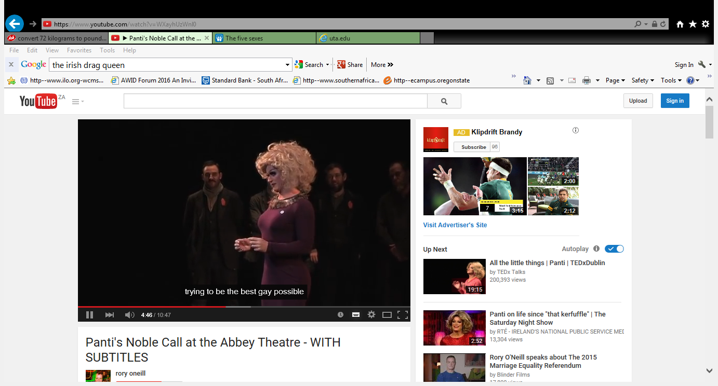

Questions:

- What are your stereotypes regarding gender and trans gender?

- What pertinent points does this video raise about stereotypes?

- Does it help you to challenge your stereotypes?

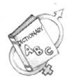
Last word: We can back SA’s golden girl by challenging stereotypes
By Colleen Lowe Morna

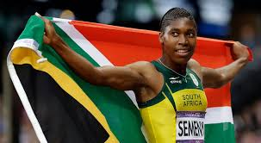
Johannesburg, 4 May 2018:
I remember well when Caster Semenya came home after her first gold win and the controversy it stirred over her sex. Among the many placards at the airport, one carried by a young man read: “Don’t worry Caster, I will marry you!”

In other words, she would be “normalised” according to what would make us all comfortable, and all would be well in the public psyche.

In the event, Semenya married a woman. And here we are, nearly a decade later, incensed by the ruling by the International Association of Athletics Federations (IAAF) on her testosterone levels, but arguably no closer to understanding sexual orientation, gender identity and expression.
Is it Caster, or just the gold medals, driving our appeal? If we fail to use this moment to challenge not only the IAAF but also our own stereotypes, we may win the battle but lose the war.

Let’s start with the facts. After that first win, Semenya was subjected to a “gender verification test”. Actually, it was a “sex” verification test, because gender is a social construct. Sex, on the other hand, refers to biological difference. By whatever checklist that was used (and we now know that the differences between men and women are not cast in stone), the IAAF pronounced Semenya a woman. She went on winning.

The issue of testosterone levels continued to rear its head. Test results are reported to show that Semenya’s body secretes three times the “normal” female levels of testosterone, the dominant “male” hormone, which some competitors say gives her an unfair advantage.

The question of fairness is fundamental to organised sports. It is clearly wrong for athletes to use performance-enhancing substances. These chemicals are unhealthy and undermine the physical and philosophical integrity of competition.

But the question in the case of Semenya is very different: if she has an advantage from a naturally occurring condition — and her body is as it is through no direct action of her own — is barring her from competition or forcing her to reduce her testosterone not comparable to excluding athletes with exceptionally long legs, or those whose muscles show too much ease with the fast-twitch reflex?

How can one determine who is too naturally advantaged to compete, or on what criteria racing categories should be determined?

If such logic held, all athletes would need to be grouped by height, weight, age and hormonal level. In his letter of resignation from the IAAF disciplinary tribunal, South African lawyer Steve Cornelius put his finger on it when he pointed out that the IAAF’s rules, bent on “ostracising” certain individuals, all happen to be applied to women.

Indian sprinter Dutee Chand’s previous success in appealing IAAF rules on testosterone levels that would have barred her from competing, coupled with the strong political support from the South African government, offers hope that the sporting body may again be overruled.

Chand has offered Semenya legal support. We will all be delighted to see Semenya competing uninhibited at the Olympics in Tokyo in 2020. But are we listening to her posts on social media? Her posts all take the line: “I am who I am, and proud to be who I am!” What if Semenya were not winning gold medals? Would we stand by her in the same way?

Despite South Africa boasting the only Constitution in the world that recognises sexual orientation, every day in this country lesbian women are beaten and raped to “correct” their sexual orientation.

I sit in meetings of the Southern African Development Community, the African Union and the United Nations in which homophobia is ubiquitous, and South African government officials choose to remain silent. I hear young women who are fed up with the status quo — with the conspiracy of silence that surrounds sexual orientation, gender identity and expression — and also with the hypocrisy that support for our “golden girl” reeks of.

Prior to her leap into the media frenzy, Semenya was just an 18-year-old girl from Limpopo who liked to run. She chose not to adhere to the socially accepted roles of how women should behave. Semenya did not fit the mould — in fact, she broke it, just as she broke records. We can honour her by letting her be whom she was born to be.

TEST YOURSELF!
 |  | Strongly agree | Agree | Disagree | Strongly disagree
1 | It is possible to be a different gender from you were born into
2 | Homosexuality is unAfrican
3 | Homosexuality is unGodly
4 | Gays are responsible for the spread of HIV/AIDS
5 | Homosexuality is a sickness can be cured
6 | Lesbians are trying to become men
7 | Lesbians can be made to like men
8 | You can either be homosexual or heterosexual.
9 | Transgender people use the wrong toilets as an excuse to target people
10 | People who dress outside of the sex in which they were born are putting themselves in danger
11 | It is deceiving if someone appears to be female who is born male
12 | All transgender people are gay
13 | You are either born a man or a woman
14 | When a baby is born, and has indeterminate sex organs, it is the right decision to make a corrective surgery immediately
15 | Gay marriages are immoral
16 | We need stronger laws to protect our children from LGBTI people
17 | Police should protect us from LGBTI people who want to flaunt themselves in public
18 | People who are attracted to the same sex should be outlawed.
19 | Same sex couples should not be permitted to be parents
20 | Women with high levels of testosterone should not be allowed to compete in sport

http://www.aidsalliance.org/assets/000/001/769/LinkUp_101_SRHRintegration_FINAL_original.pdf?1441105738

