PHASE FOUR: SEXUAL AND REPRODUCTIVE HEALTH AND RIGHTS (SRHR)

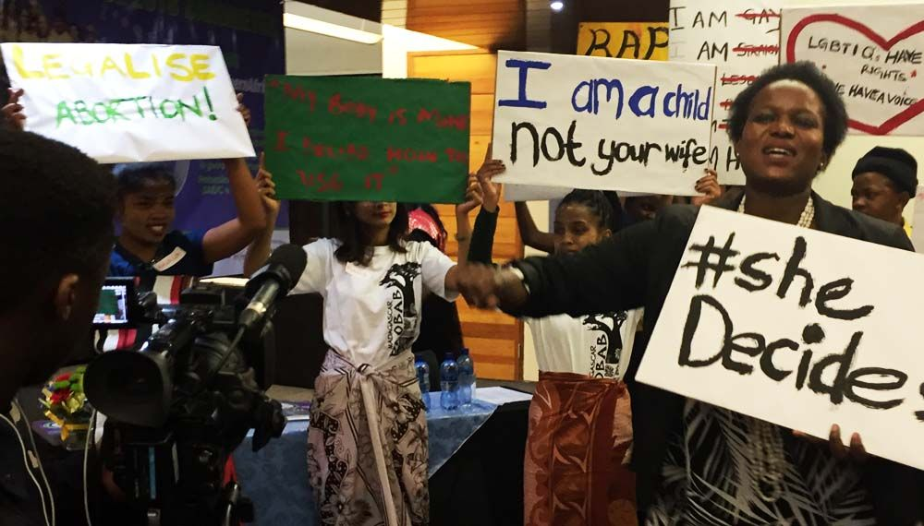
Introduction
Sexual and reproductive health and rights (SRHR) are fundamental for promoting development, fighting poverty and, ultimately, for achieving the Sustainable Development Goals (SDGs) attaining the targets of the 2015 SADC Protocol on Gender and Development. Sexual and reproductive health is a human right which is essential to good health and human development.


Objectives
- Strengthen gender and SRHR plans and budgeting at local level.
- Train local councils and young people on SRHR.
- Enhance SRHR at community level through developing youth and gender aware policies, services and service directories.
- Promote better information and greater freedom of choice for adolescents and young people.
- Use social media and IT to demand greater accountability and delivery on SRHR.

Description
Local councils will strengthen their Sexual and Reproductive Health and Rights (SRHR) plans with strong youth involvement.

Target group
- Councillors and officials from local councils who champion gender mainstreaming in their municipalities
- Youth
- Clinics

Key outputs
- 100 local councils’ in ten countries strategic plans with the gender action plans integrated.
- 100 local councils’ in ten countries strategic plans with gender responsive budgets.
- 100 youth structures in ten countries in place to promote SRHR.
- SRHR campaigns in 100 councils in ten countries.

Key outcomes
- There is a strong SRHR movement in local councils.
- Contributes to more responsive, accountable government through active participation of youth.
- Peer learning amongst councils, GL will not be able to reach all of these councils, a hub and spoke will be in place to roll out and sustain the local government SRHR programme.

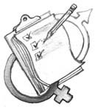
Exercise one: Body mapping

- Stick four pieces of flipchart paper together. Create four big sheets of paper. Draw figures as below on each piece.


- Divide participants into four same sex groups. Two with only women and girls and two with only men and boys.
- Introduce to the group to the concept of body mapping. Body mapping is a way of helping us understand our bodies better.
- Provide each group with a green, red, blue and black marker. Ask each group to mark in:
- Green parts of the body they like.
- Red the parts of the body they don’t like.
- Blue the parts of the body where they feel pleasure.
- Black the parts of the body where they feel pain.
- Ask the groups to put up their diagrams on the wall.
- Discuss the diagrams using the guiding questions that follow:
- What did you learn?

- Did anything surprise you from your or other groups’ body maps?

- How did it feel doing the activity?

- Were there any issues that emerged in your group?

- Were any items on the body maps contentious?

- Are there any final comments?

- Sum up by reminding the group that body mapping is a creative process that helps us explore how we feel about our bodies. We can use images, symbols and words to map places on our bodies that we like and don’t like, that are full of life or full of pain; and places that hold hope for the future. In the process, we discover links between the places in us and gain a deeper understanding of our own power to become healthier in our bodies and through the way we live in this world.

Remind participants that we can feel both pleasure and pain on the same place on the body depending on the situation, who we are with, and what happens. Also, our feelings can vary from time to time, and over time. For example, something we don’t like today may change into something we like in the future.


Fact sheet: Body mapping
Body maps can be broadly defined as life-size human body images, while “body mapping” is the process of creating body maps using drawing, painting or other art-based techniques to visually represent aspects of people’s lives, their bodies and the world they live in. Body mapping is a way of telling stories, much like totems that contain symbols with different meanings, but whose significance can only be understood in relation to the creator’s overall story and experience.
- Body mapping has the potential to engage and enable its participants to communicate creatively through a deeper, more reflexive process. The result of which can be beneficial for a variety of purposes. Body maps may be used as:
- Therapeutic tool: to develop fresh insights, find new directions and to explore identity and social relationships.
- Treatment information and support tool: body mapping works well as a workshop for people who are about to start ARV treatment. It prepares people living with HIV and AIDS with the strength and awareness they need to build and keep up their bodily (biomedical) and mental and social (psychosocial) well-being.
- Research tool: body maps can be used in research. They work well as a participatory qualitative research tool, if the participants give their informed consent. The drawings and paintings are data in themselves, and can also be supplemented with interviews or writing.
- Advocacy tool: body maps can be shown at exhibitions, made into a book, or published on a website. Body maps communicate feelings, thoughts and ideas, and are able to raise awareness about political, personal and social issues. They can draw attention to public
- health challenges.
- Inter-generational dialogue tool: body mapping helps people of different generations
- to talk to each other. The process can be used with children, caregivers, parents, and guardians, to build trust and deepen people’s understanding of how their lives all connect with each other.
- Team building tool: body maps can be used to build positive group relationships, and to help people in the group appreciate their differences.
- Art making tool: body maps can be used to learn about art, drawing, colour and composition. They also help people to open up to their own creativity.
- Biographical tool: body maps can be used to show and tell people’s life stories (biographies) and important relationships.
- Body maps are used in sexual and reproductive health studies to explore sex and sexuality, risks and pleasures, and to understand individual's perceptions of their bodies and to encourage frank discussion about sexual behaviour. Body maps probe issues around sexual behaviour. Women point to body parts without having to verbalise potentially embarrassing anatomical terms. Body maps are used to discuss pleasure and pain. Body maps are used to enhance discussions around sexual behaviour. Body maps provided women with a non-intimidating way of discussing and disclosing their sexual practises and minimized miscommunication of anatomical terminology.
Exercise two: What is SRHR?
- Provide each participant with three pieces of cardboard.
- Ask everyone to write down the three things that come to mind when they hear the term sexual and reproductive health and rights.
- Everyone should put their cards up on the wall.
- Get a small group to start clustering the cards according to theme.
- Gather the participants around the clustered cards and ask volunteers to present each theme. Follow the presentation by discussion after each theme.
- After all the discussions the facilitator can summarise the discussions and present the SRHR mapping below.

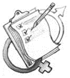
Exercise three: Why is SRHR a local government issue?
- Divide participants into six groups. Each group must focus on one case study.
- Review the case studies.
- Identify the key SRHR issues for local government that emerge from the case studies using the guiding questions.
- Document your discussion in the PowerPoint template provided.
- Present the findings in a plenary.
- Consolidate the discussion with a panel of SRHR experts to present on the SRHR activities and priorities in the Council.
- After the presentations have a plenary discussion.

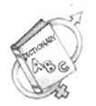
Case study one: Zimbabwe Ministry of Health and Child Care making care accessible to sex workers
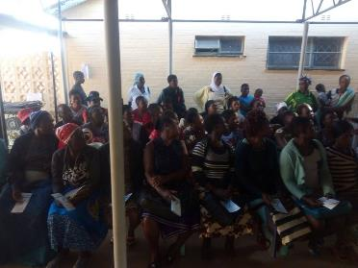
Women accessing health care services in Kadoma.
Kadoma has many commercial sex workers who need access to health, treatment and care services. The Ministry set up a clinic at the Kadoma hospital to assist sex workers. The services include HIV therapy, treatment for STIs and counselling.

The clinic offers HIV prevention programmes for sex workers, especially female sex workers. Given their marginalisation, concerted efforts must be made to ensure sex workers have equitable access to HIV prevention, care, and treatment services, as well as wider health services, particularly for STIs, mental health, and addictions.

Women in commercial sex work now have equal access to health, treatment and care services.

Questions
- What are the key SRHR issues highlighted in the case study?

- Why is it important to address these issues?

- What strategies are being used to address these issues?

- Does your Council face similar issues?

- How can you use these strategies in the Council?

Case study two: Itumeleng’s (not her real name), 15 years old, story

“I was raped in October 2017, I was initially afraid to report the matter to my parents as my rapist is a relative. However, when he raped me again a month later I became aware that he will never stop and I decided to report the matter to my parents who immediately informed the police. My case was referred to the children’s court where the magistrate ordered some tests to be done on me. All the other tests came back negative except for the pregnancy test that indicated that I was six weeks pregnant. The magistrate gave an order for a termination of such pregnancy. At the hospital where I was supposed to be assisted with the abortion as dictated by the Penal Code, I was thrown from pillar to post. I was told the order should not be hand written but typed, when I came back with a typed order I was told the stamp was too vague, when that was corrected, I was told the signature did not seem legit. This continued until I was six months pregnant and was no longer eligible for abortion. Today I have to raise a child that will always remind me of my dilemma because people who were supposed to assist me did not do so. If abortion was legal in Lesotho, I would not have suffered like this just waiting for someone to approve my abortion. I will not be raising a child when I am a child myself.”

Questions
1. What are the key SRHR issues highlighted in the case study?

2. Why is it important to address these issues?

3. What strategies are being used to address these issues?

4. Does your Council face similar issues?

5. How can you use these strategies in the Council?

Case study three: Goromonzi Rural District Council lighting up to prevent GBV

The street lighting project was initiated to prevent gender-based violence. The Council is responsible for providing lighting as mandated by the Councils Act. The project set out to reduce risk factors and enhance safety and security from a gender perspective. Women and young girls report lower levels of violence in areas with street lights. The street lighting contributes to a positive sense of safety and security.
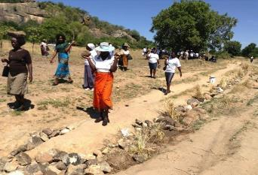
Goromonzi RDC installing lights to improve women’s safety.

The Goromonzi Rural District Council partnered with Econet Wireless Private to use its existing base stations for installation of floodlights. Econet will pay half the cost of base station levies. The council will expand the project by delivering solar street lighting in its other areas.

Questions
1. What are the key SRHR issues highlighted in the case study?

2. Why is it important to address these issues?

3. What strategies are being used to address these issues?

4. Does your Council face similar issues?

5. How can you use these strategies in the Council?

Case study four: AMICAALL Swaziland promotes access to sexual and reproductive health

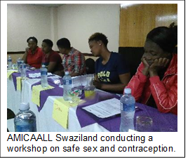
The Alliance of Mayors and Municipal Leaders on HIV and AIDS in Africa (AMICAALL) creates access sexual and reproductive health services in Piggs Peak in the Hhohho district. UN agencies claim, sexual and reproductive health includes physical, as well as psychological well-being vis-a-vis sexuality.

Reproductive health implies that people are able to have a responsible, satisfying and safer sex life and that they have the capability to reproduce and the freedom to decide if, when and how often to do so. Individuals face inequalities in reproductive health services. Inequalities vary based on socioeconomic status, education level, age, ethnicity, religion, and resources available in their environment.

It is possible for example, that low income individuals lack the resources for appropriate health services and the knowledge to know what is appropriate for maintaining reproductive health. Women bear and usually nurture children, so their reproductive health is inseparable from gender equality. Denial of such rights also worsens poverty.

The organisation informs women and men about and have access to safe, effective, affordable and acceptable methods of birth control. Women are often unable to access maternal health services due to lack of knowledge about the existence of such services or lack of freedom of movement. The project provides access to health services particularly in areas with high levels of poverty.

AMICAALL Swaziland promotes positive sexuality. Sexual health requires a positive and respectful approach to sexuality and sexual relationships, as well as the possibility of having pleasurable and safe sexual experiences, free of coercion, discrimination and violence. For sexual health to be attained and maintained, the sexual rights of all persons must be respected, protected and fulfilled.

Questions
1. What are the key SRHR issues highlighted in the case study?

2. Why is it important to address these issues?

3. What strategies are being used to address these issues?

4. Does your Council face similar issues?

5. How can you use these strategies in the Council?

Case study five: Botswana Police Services in Lobatse works with the community to prevent GBV

When addressing issues gender equality and the eradication of GBV the main target group was women and the girl child. “Special populations" such as orphans, vulnerable children and people living with disabilities were excluded. Limited progress was made in achieving a gender equal and GBV free community.
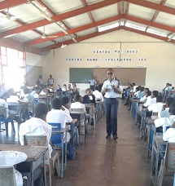
Lobatse Police gender focal person creating awareness about gender equality and GBV at the Ipelegeng Junior Secondary School.

Orphans, vulnerable children and people living with disabilities do not always understand what abuse is and how to report it. The project set out to educate orphans, vulnerable children and people living with disabilities on gender-based violence and gender equality. The Lobatse Police also works with caretakers of orphans, vulnerable children and people with disabilities on the rights of the people under their watch and care.

The police raise awareness on GBV and gender equality through outreach programmes in homes, for individuals, in schools and churches. The gender focal person makes public addresses at different sites on commemorative days.

The community understands the need to recognise the rights, dignity and self-worth of orphans, vulnerable children and people living with disabilities. Orphans, vulnerable children and people with disabilities are no longer “special populations” but are part of the community. Communities offer them support and report any abuse perpetrated on orphans, vulnerable children and people with disabilities.

Questions
1. What are the key SRHR issues highlighted in the case study?

2. Why is it important to address these issues?

3. What strategies are being used to address these issues?

4. Does your Council face similar issues?

5. How can you use these strategies in the Council?

Case study six: Umfunti Foundation, Swaziland providing HIV and AIDS care

The organisation was established due to the high mortality rate in the Lubombo Region due to HIV and AIDS. Umtfunti home-based care assists family caregivers in providing AIDS-related care, because public health services could not cope with the increasing demand for treatment and care.
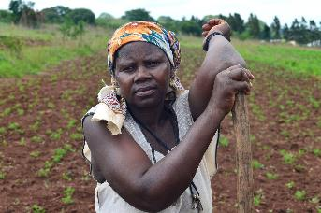
Umtfunti empowers women to sustain themselves economically.

Some home-based care services focus on providing social and psychological support, with some nutritional support and basic nursing care. Others also dispense antiretrovirals (ARVs) and treat opportunistic infections. These services, whether provided through NGOs, government health clinics, or community groups, are essential in supporting people living with HIV and AIDS, as well as people who provide care and support within families.

Umtfunti volunteers do door-to-door visits in the communities, teaching households about prevention of mother-to-child transmission (PMTCT), HIV and AIDS, home based care and GBV. The organisation also teaches in community meetings and schools. Part of Umtfunti’s services includes taking care of the people who are terminally ill.

Women and girls provide the majority of HIV and AIDS-related care, this being seen as a continuation of their role as care providers in families. Duties that are related to home-based care are seen as domestic and are, therefore, considered to be women's work and are unpaid. Umtfunti empowers women to sustain themselves economically, and to improve their lives.

Questions
1. What are the key SRHR issues highlighted in the case study?

2. Why is it important to address these issues?

3. What strategies are being used to address these issues?

4. Does your Council face similar issues?

5. How can you use these strategies in the Council?

Fact sheet: Mapping of local government competencies in ten SADC countries
COUNTRY/  FUNCTION | BOTS | LES | MAD | MAU | MOZ | NAM | SA | ESWA | ZAM | ZIM
General administration
Police | X |  |  |  |  | X | X
Fire protection | X | X |  |  |  |  | X |  | X
Ambulance services
Civil protection |  |  |  | X
Criminal justice
Civil justice |  |  |  |  |  |  | X
Civil justice register
Statistical office
Cultural, leisure and sports
Theatre and concerts | X |  |  | X |  | X
Museums and libraries | X |  |  | X |  | X | X |  | X
Parks and open spaces | X |  |  | X | X | X | X | X | X
Sports and leisure |  |  |  |  |  |  |  |  | X
Economic
Agricultural, forests and fisheries |  | X |  |  |  | X |  |  | X
Economic promotion | X | X |  | X |  | X | X
Trade and industry |  |  |  |  | X | X | X
Tourism |  | X |  |  | X | X | X | X
Other economic services |  | X |  |  | X
Education
Pre-school | X |  |  | X |  |  | X |  | X
Primary | X | X
Secondary |  | X
Vocational and technical |  | X |  | X
Higher education
Adult education |  | X
Environment and public sanitation
Water and sanitation | X |  |  |  |  | X | X |  | X
Refuse collection and disposal | X |  |  | X |  | X | X |  | X
Cemeteries and crematoriums | X |  |  | X |  | X | X | X | X
Slaughter houses | X |  |  |  |  | X | X | X | X
Environmental protection | X |  |  | X |  | X | X | X
Consumer protection |  |  |  | X |  | X | X |  | X
Housing and town planning
Housing | X | X |  | X | X | X | X | X | X
Town planning | X | X |  |  | X | X | X | X | X
Regional planning |  |  |  |  |  | X
Public health
Primary care |  | X |  |  |  |  | X | X | X
Hospitals |  | X
Health protection | X | X |  | X |  |  | X | X | X
Social welfare
Kindergarten and nursery | X
Family welfare services | X | X
Welfare homes |  | X |  |  |  |  |  | X
Social security | X | X
Transport
Roads | X | X |  | X |  | X |  |  | X
Transport |  | X |  |  |  |  |  | X | X
Urban roads | X | X |  |  |  | X |  | X | X
Ports |  |  |  |  |  | X
Airports |  |  |  |  |  | X |  | X
Utilities
Gas supply |  |  |  |  |  |  | X
District heating | X
Water supply | X | X |  |  | X | X | X | X | X
Electricity |  |  |  |  | X | X | X

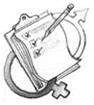
Exercise four: Adolescent and Youth Reproductive Health (AYRH)
- Divide participants into groups.
- Give them the case study.

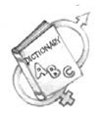
Case study: Barriers to young people accessing SRHR

Many governments fail to give sufficient priority and support to help address the SRHR challenges faced by young people. Social, legal and cultural norms perpetuated by educators, health professionals, community leaders and families and institutionalised through law, policy and practice can also lead to restrictions in young people’s freedom of expression as well as their access to comprehensive sexuality education and sexual and reproductive health services.

Whilst demographic and health data on fertility, contraceptive access and gender are important in setting the background for any public health programme, the lived realities, experiences and perspectives of young people are vital in determining the focus of youth sexual and reproductive health programmes as well as the approaches adopted. Gathering information from young people can be done through a variety of methods, including operational research, surveys and focus group discussions.

Very few countries prohibit the provision of sexuality education in schools, yet far too few mandate it. Even where mandated by law, sexuality education - an intervention that has the potential to raise individual awareness of human rights and transform patriarchal gender dynamics. Where they exist, sexuality education curricula are not comprehensive enough, often omitting topics related to human rights, gender, sexuality or menstruation. A 2012 UNESCO and UNFPA review of sexuality education curricula revealed that gender-based violence was often overlooked.

Comprehensive sexuality education programmes should ensure that young people have the resources and practical information they need to turn their decisions regarding sex and sexuality into reality by accessing a full range of youth-centred sexual and reproductive health services; yet too often education and health institutions are not well joined up to do this.

As is evident by the high rate of suicides among this age group, there needs to be an increased awareness among service providers of the pressures and risks adolescents are exposed to during this pivotal stage of life.

Health systems rarely offer young people the sexual and reproductive health services designed to meet their needs that respect their rights to dignity and privacy. Whilst all people face barriers to access to services, young people face particular challenges, for example, the reaction of health professionals when they do visit a health centre. Cost can also be a barrier for young people, who are more likely to be dependent financially on their parents or another adult. Transport and inconvenient opening hours may also prevent young people from accessing the services they need in a timely manner.

Record your discussion in the table (add more rows if you need to)

Barriers to accessing SRHR | How can the problem be addressed?
Fact sheet: Adolescent and Youth Reproductive Health (AYRH)

More than a quarter of the world’s population is between the ages of 10 and 24, with 86% living in less developed countries. These young people are tomorrow’s parents. The reproductive and sexual health decisions they make today will affect the health and wellbeing of their communities and of their countries for decades to come.

In particular, two issues have a profound impact on young people’s sexual health and reproductive lives: family planning and HIV/AIDS. Teenage girls are more likely to die from pregnancy-related health complications than older women in their twenties. Statistics indicate that one-half of all new HIV infections worldwide occur among young people aged 15 to 24.

The World Health Organization (WHO) defines an adolescent as an individual in the 10-19 years age group and usually uses the term young person to denote those between 10 and 24 years.

Adolescence is a period of transition from childhood to adulthood during which adolescents develop biologically and psychologically and move towards independence. Although we may think of adolescents as a healthy group, many die prematurely and unnecessarily through accidents, suicide, violence and pregnancy-related complications. Some of the serious conditions of adulthood (for example, sexually transmitted infections (STIs), like HIV; and tobacco use) have their roots in adolescent behaviour.

Studies show that young people are not affected equally by reproductive health problems. Orphans, young girls in rural areas, young people who are physically or mentally impaired, abused or have been abused as children and those migrating to urban areas or being trafficked are more likely to have problems.

The negative health consequences of adolescents can pass from one generation to the next. For example, babies born to adolescent mothers have a high risk of being underweight or stillborn. They are also likely to suffer from the same social and economic disadvantages encountered by their mothers. That is why addressing the needs of adolescents is an intergenerational investment with huge benefits to subsequent generations.

Services that should be provided for young people
- Information and counselling on sexual and reproductive health issues
- Promotion of healthy sexual behaviours
- Family planning information, counselling and methods of contraception (including emergency contraceptive methods)
- Condom promotion and provision
- Testing and counselling services for pregnancy, HIV and other STIs
- Management of STIs
- Antenatal care (ANC), delivery services, postnatal care (PNC) and pregnant mother-to-child transmission (PMTCT)
- Abortion and post-abortion care
- Appropriate referral linkage between health facilities at different levels.
Exercise five: Setting up youth structures
- This session will be held in plenary.
- Facilitator to use the PowerPoint presentation on setting up Junior Councils.
- Discuss and record responses to the following questions.

- How are young people included in the Council’s activities currently? Are there formal structures in place?

- If yes, how does it work?

- Would the concept of junior councils work in this context? If yes how can it be rolled out? If no, what are the main challenges?

- What other option can be used to include young people in Council activities? How should young people be organised to be part of Council’s activities?

- Who will be the focal person/department that young people can liaise with?

- When, how regularly and where will the Council meet with young people?

- Agree on a schedule of meetings.

Exercise six: Key populations
- SADC identifies Men having sex with men (MSM), sex workers, transgender persons, people who are using drugs (PWUD) and people in prisons as key populations.
- Divide participants into five groups. Each group will focus on one key population, these are:
  - Men having sex with men
  - Sex workers
  - Transgender persons
  - People who are using drugs (PWUD)
  - People in prisons
- Each group should discuss:
- Does the Council consider this population in its programming?

- If yes, how are they included?

- If no, how can they be included?

- Record your discussion on a piece of flip chart paper.
- Each group should present what they discussed.
- Have a plenary discussion and record any additional information.

Fact sheet: SADC Strategy for HIV prevention, treatment and care and Sexual and Reproductive health and rights among key populations

Men having sex with men (MSM), sex workers, transgender persons, people who are using drugs (PWUD) and people in prisons have significantly higher prevalence of HIV than the general population and thus their need for services is greater. It includes young key populations who are increasingly vulnerable to HIV and have specific sexual and reproductive needs.

Stigma and discrimination
All key populations identified in this strategy face high levels of stigma and discrimination which impedes their access to health services, including HIV and SRH services. Key populations face stigma and discrimination in health care settings, the workplace, families, and within communities. A study focused on southern and eastern Africa found high levels of stigma and discrimination against gay men and other MSM. This is also the case for sex workers and transgender persons.
PWUD and people in prisons find it difficult to access services due to stigma and discrimination.

Violence
All key populations experience high vulnerability to violence. MSM, female sex workers and transgender persons are likely to face gender-based violence because either they defy gender norms or are women. Due to their vulnerability and experience of police abuse, trans persons are less likely to approach law enforcement or health services for necessary assistance. Sex workers in southern Africa have reported a fear of and routine police abuse including sexual violence and beatings.

Lack of a protective legal and policy environment
The lack of a protective legal and policy environment is a significant obstacle to key populations’ ability to access services. As of 2015, approximately half of SADC Member States have specific laws criminalising consensual, same-sex relationships between adults and some aspect of sex work. These punitive laws render MSM and sex workers vulnerable to violence from law enforcement and others.

Lack of data
There is a dearth of information on the needs of key populations in SADC making it difficult to provide effective programming. There is almost no data regarding young key populations, transgender persons, people in prisons and PWUD in SADC. Though most countries in SADC have some data regarding HIV prevalence among MSM and sex workers, the type of detailed information does not exist in many SADC countries.

Lack of programming, funds and services aimed at key populations
In SADC, there continues to be limited funds dedicated to programming specifically for key populations and thus, minimal services effectively addressing the needs of key populations. Most countries do not dedicate funds for key populations. No country in SADC allocates specific funds for addressing the HIV needs of transgender populations as part of their HIV expenditure resulting in limited programming tailored for transgender persons.
Exercise seven: Developing the Council SRHR plan of action
- For this exercise you need the Council’s SRHR plan that was developed as part of the COE process.
- The updated SRHR Planning framework
- The Council’s overall plan.
- You need statistics to put in the baseline figures for the different five different areas. Facilitator’s please send the planning template to the Council’s before the workshop so that all the statistics are available during the workshop. Please note that the plan does not include gender-based violence and HIV and AIDS, these plans were recently updated.
- Divide into groups according to the different areas of the action plan.
- The plan is divided into the four areas including menstrual health; comprehensive SRHR information and services; and maternal health; and key populations. For each area you need to populate eight columns. You need to populate it as follows:

Category | What you need to do?
Baseline | If the Council is already engaged in an activity what statistics are in place. Add these in the relevant cells in the table.
Indicators | These are measures that show that progress has been made.
Means of verification | What will be the evidence that the indicator has been achieved?
Target groups including key populations | Who will the council be targeting for the activity? Ensure that the key populations including men having sex with men (MSM), sex workers, transgender persons, people who are using drugs (PWUD) and people in prisons are part of your target populations.
Actions | What will the council do to address the different areas?
Who | Who will implement the actions?
Timeframe | When will it occur?
Budget in local currency | How much will be allocated to the activity?
Where to find this in the Council action plan | In the next segment of the workshop, we will be integrating gender action plans into the council’s existing plans. Its important to start identifying now how the SRHR plan will be reflected in the council’s overall plan.
- Develop the Council’s SRHR plan of action.
- Share a summary of the plans in a plenary.

Exercise from Changing the Rivers Flow for Young People, SAFAIDS
Reproduced from Solomon, J. (2002). ‘Living with X’: A body mapping journey in the time of HIV and AIDS - A facilitation guide (p.3). Psychosocial wellbeing series. Johannesburg: REPSSI.
https://www.liebertpub.com/doi/full/10.1089/aid.2014.5009a.abstract
https://amplifychange.org/about-us/5-themes/youth/barriers-and-solutions/
http://www.open.edu/openlearncreate/mod/oucontent/view.php?id=62&printable=1
https://www.sadc.int/files/2715/3060/7629/ADC-regional-strategy-hiv-srhr-key-pops_FINAL.pdf

