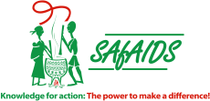
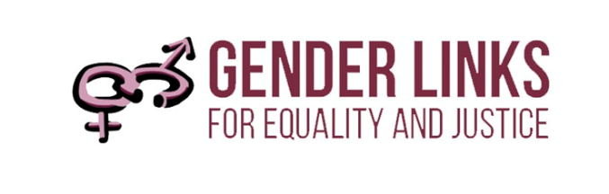

STRENGTHENING SEXUAL AND REPRODUCTIVE HEALTH AND RIGHTS (SRHR) AND GENDER IN LOCAL GOVERNMENT

Concept note

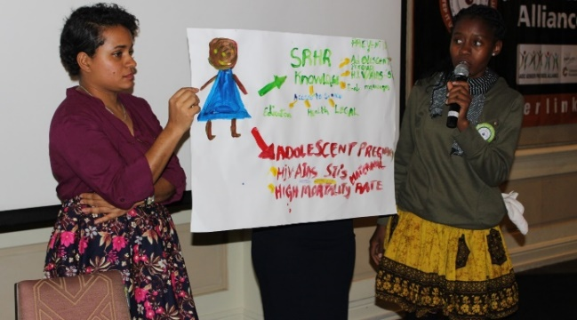
Synopsis
This concept paper outlines the process to integrate local councils’ gender action plans into their strategic plans and review budget allocations from a gender perspective. Through the process local councils will strengthen their Sexual and Reproductive Health and Rights (SRHR) plans with strong youth involvement.

Background
In ten countries, Gender Links worked with 425 local councils to develop gender action plans (GAPs) alongside the councils’ strategic plans. This ensured that gender received the concentrated focus that was needed. A decade later gender has become an integral part of the Councils’ way of working. In the next phase of the programme GL will work with ten councils in ten countries to integrate the GAPs into their strategic plans and budgets. This will ensure that the GAPs become part of the institutional planning and budgeting processes in the long term.

While integrating the GAPs into councils GL will work with councils to strengthen their responses on sexual and reproductive health and rights (SRHR). Unintended teenage pregnancies, unsafe abortions, contraception and lack of adequate sanitary wear compromises young peoples, particularly young women’s, ability to fully realise their potential.

Objectives
- Strengthen gender and SRHR plans and budgeting at local level.
- Train local councils and young people on SRHR.
- Enhance SRHR at community level through developing youth and gender aware policies, services and service directories.
- Promote better information and greater freedom of choice for adolescents and young people.
- Use social media and IT to demand greater accountability and delivery on SRHR.
- Gather and share good practices through annual SADC Gender Protocol@Work summits.

Target groups
The meetings and workshops include:
- Councillors and officials from local councils who champion gender mainstreaming in their municipalities
- Management structures of councils
- Schools
- Youth
- Clinics
- Communities at large

Partners
GL will work with the following partners to roll out the programme: Southern Africa HIV and AIDS Information Dissemination Service (SAfAIDS); local government, health and gender ministries; health departments; local government associations; local councils; junior councils; community-based organisations and youth structures.

Process
The process will be constituted of three phases. These are:

Outputs
- 100 local councils’ in ten countries strategic plans with the gender action plans integrated.
- 100 local councils’ in ten countries strategic plans with gender responsive budgets.
- 100 youth structures in ten countries in place to promote SRHR amongst adolescents in partnership with local councils.
- Sixteen days plans in 100 councils in ten countries.

Outcomes
- The gender action plans are integrated into the local councils’ strategic plans.
- There is a three to five percentage point improvement in the Local Government Gender Scorecard in the participating local councils.
- There is a strong SRHR movement in local councils.
- Contributes to more responsive, accountable government through active participation of youth.
- Peer learning amongst councils, GL will not be able to reach all of these councils, a hub and spoke will be in place to roll out and sustain the local government SRHR programme.

