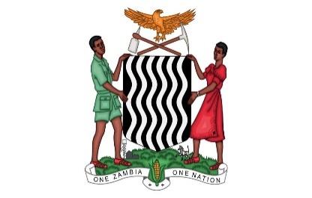
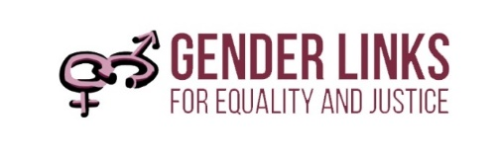


SADC GENDER AND ELECTIONS MISSION TO ZAMBIA
3 TO 5 MARCH 2020, LUSAKA

DRAFT PROGRAMME

DATE & TIME | AGENDA ITEM | WHO | REFERENCE
2 March
Experts travel to Lusaka
3 March - Briefing with stakeholder groups
8:30 – 09:30 | Briefing with Ministry of Gender and key civil society partners | Gender Links, Experts
10:00 – 11:00 | Courtesy call of experts to the Office of the President | Ministry of Gender , Experts
11.30– 13.00 | Courtesy call of experts to the office of the Speaker of Parliament | Ministry of Gender ,
14:00 – 17:30 | Meeting with the Zambia Electoral Commission and the Local Government Association of Zambia | Ministry of Gender, Experts
4 March – Briefing with stakeholder groups
08:30 – 12:30 | Briefing with the Zambian Women’s and Men’s Parliamentary Caucus | Ministry of Gender, experts
14:00 – 17:30 | Briefing with Political Parties, Civil Society Organisations and Ministry of Gender | Ministry of Gender, Experts
5 March – Presentation from experts , Venue – Ministry of Gender offices
08.30 – 09.00 | Registration | Gender Links
09.00 – 09.15 | Welcome remarks | Chair of the Women’s Parliamentary Caucus
09.15 – 09.30 | Objectives of expert mission | SADC PF | Concept Note
09.30 – 09.45 | Overview of Women’s Political participation in SADC | Colleen Lowe Morna  Gender Links CEO | Power Point
09.45 – 10.30 | Testimonials from Zambian Women Political leaders - Parliament and local government | Ministry of Gender
10.30 – 11.00 | TEA
11.00 – 11.15 | Remarks from Zambia Electoral Commission | Zambia Electoral Commission
11.15 – 11.30 | Remarks from Local Government Association of Zambia | LGAZ
11.30 – 11.45 | Remarks from UN Women | UN Women
11.45 – 12.15 | The situation on Women in Politics in Zambia | Zambia Minister of Gender
12.15 – 13.00 | Regional Panel Discussion | Moderator
12.15 – 13.00 | Zambia | Women’s Caucus | Power Point
12.15 – 13.00 | Lesotho | Hon. Mats’epo Molise -Ramakoae | Power point
12.15 – 13.00 | Mauritius | Tanya | Power point
12.15 – 13.00 | Namibia | Hon Ipinge | Power point
12.15 – 13.00 | Zimbabwe | Hon. Kwaramba | Power Point
13.00 – 13.30 | Discussion | Moderator
13.00 – 14.00 | Lunch
14.00 – 16.30 | Group work | All | Zambia Gender and Elections country profile
14.00 – 16.30 | National options | Led by Ministry of Gender | Zambia Gender and Elections country profile
14.00 – 16.30 | Local Government Options | Led by LGAZ | Zambia Gender and Elections country profile
16.30 – 17.00 | Report back | WLSA | Zambia Gender and Elections country profile
17.00 – 17.10 | Wrap up and next steps | Colleen Lowe Morna
17.00 – 17.10 | Vote of thanks | Sara Longwe

