


EMPOWERING WOMEN, END VIOLENCE

LIFE SKILLS TRAINING MANUAL

MODULE ONE

PARTICIPANT’S MANUAL

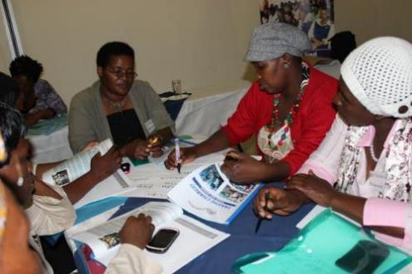

2018
Inside cover

Gender Links (GL) is committed to a region in which women and men are able to participate equally in all aspects of public and private life in accordance with the provisions of the Southern African Development Community (SADC) Protocol on Gender and Development.

Taking charge! Empowering GBV survivors through life and applied entrepreneurship skills
© Copyright 2018, Gender Links.
ISBN:

Gender Links
9 Derrick Avenue
Cyrildene, 2198
Johannesburg, South Africa
Phone: 27 (11) 622 2877
Fax: 27 (11) 622 4732
Email: enterprise@genderlinks.org.za
Website: www.genderlinks.org.za

Editors: Colleen Lowe Morna, Anne Hilton and Mariatu Fonnah

Design/Layout and print: Gender Links

Sponsors:

introduction

Gender Links is a Southern African NGO founded in March 2001 with offices in Johannesburg, Mauritius (Francophone base), Mozambique (Lusophone base) and Botswana (headquarters of the Southern African Development Community) as well as six other countries (Lesotho, Madagascar, Namibia, Swaziland, Zambia and Zimbabwe) with South Africa also a location of all GL programmes. GL has four programme areas: the SADC Protocol on Gender and Development; media; governance and justice. See www.genderlinks.org.za.

Over the last 14 years GL worked with GBV survivors to document their personal testimonies or “I” stories. The project entitled Healing through writing has provided insights into some of the drivers of GBV particularly of intimate partner violence. Many women write about economic dependence also; both as a cause for violence and as a reason for staying or returning to abusive relationships.

The GL programme set out to add to the research on the links between economic independence and GBV in the SADC region. Over two years the programme trained 1350 women in life skills and entrepreneurship training in 10 SADC countries and 101 local councils. The overall results showed that in this target group 87% of the women indicated that GBV experiences were “better or much better” in their relationships. Many attributed this to the fact that they were able to earn them income and “put food on the table”.

The results have made this a model of reducing GBV viable and worth pursuing. Lessons were learnt and are well documented on our website. The programme manuals have been revised and it is our hope that this will further contribute to the fight against GBV and the economic empowerment of women.

Objectives
- To increase women’s agency and independence, socially, emotionally and economically
- To empower them to participate fully in all aspects of their private and public lives
- To provide them with the tools to realise their economic potential as entrepreneurs
- To provide women alternatives to persevering in situations where they experience GBV
- Break the stereotypes of women in business in emerging markets
- Connect women with information, services and resources in their own countries to enhance their ability to succeed

The implementation focusses on an integrated approach of:
- Training: Life skills including confidence building; writing; public speaking; decision making.
- Training: Entrepreneurship skills which includes starting up a business; basic business management skills such as financial management, marketing and applying for tenders.
- Use of computers and Microsoft applications is an essential part of the Phase one process which encourages women to explore and use the computer as a tool for change. They type up their original business ideas with the help of facilitators.
- Networking to identifying sources of support and business opportunities.
- Addressing the underlying structural inequalities between men and women.

Learning materials
The course is accompanied by two training manuals in the series called Taking charge: Ending Violence Empowering Women
- Life skills training manual
- Entrepreneurship training manual
- IT Manual

Collectively these promote personal agency and the potential for economic independence.

How GL will be measuring change?
A very strong component of GL programs is the emphasis on Results for Change. GL has developed several tools to measure changes in the women as well the communities they are a part of. At the level of community GL will:
- Review the council’s GBV action plan at the beginning of the process and at the end to assess how the plans have changed and levels of progress in implementing the plan.
At the level of the individual GL will do:
- “I” stories or personal accounts of experiences of GBV will be colle4cted before and after the training. Prior to the training GL will work with the participants to document their stories using the “healing through writing” methodology and this will be repeated to measure change.
- The Gender Empowerment Index (GEI) measures experiences of GBV; agency; entrepreneurial flair; depression and economic status. Each participant will complete the GEI at the beginning of the programme to establish baselines. These will be re-administered at the end of the process to measure change. The GEI is online and is set up to generate automated reports. Each participant will have a profile with baseline and progress data.
- In first workshop each participant completes a personal action plan where the participants identify three things they want to achieve. This is reviewed again at the same time as the repeat I stories and GEI.
- The women develop business plans which are monitored over time as they develop their business ideas through each stage.

All this information will be collated and analysed to provide qualitative and quantitative evidence of progress and change in these women’s lives at a personal and business level.

Tools you will find in each manual

Each module has various tools and resources that will help participants apply their experience and to learn by doing. These are:
ICON | TOOL OR RESOURCE | ICON | TOOL OR RESOURCE
 | Exercises - Gets you doings things yourself and in groups |  | Case studies - Are examples based on real findings and experiences that will help you to learn more.
 | Fact sheets - give you information about the modules. |  | Definitions - define new words and terms that you will be learning as you work through the manual.
 | Diary entry – this can be done through a written diary or recording your thoughts on your cell phone. |  | Resources - These are materials meant to aid the facilitator and participants enhance their understanding of the subject matter.

Materials required | Monitoring and evaluation tools needed
- Flip charts | - Registration forms
- Pens | - Personal action plan format
- Paper | - Business planning tool.
 | - Evaluation forms

MODULE ONE: GENDER AND GBV
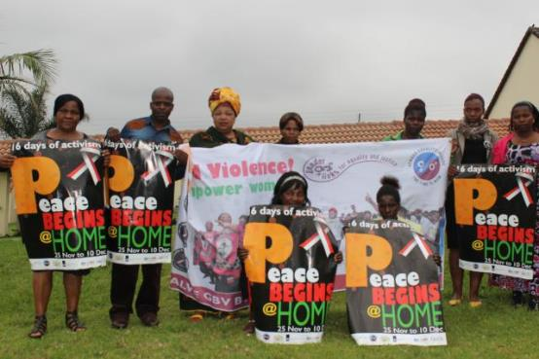

Through this module the participants will:
- Understand the concepts of sex and gender, and sex and gender roles.
- Understand the different forms of GBV.
- Understanding the impact of GBV and the link with gender equality.
- Exploring the link between GBV and economic development

Exercise 1.1.1: Defining sex and gender
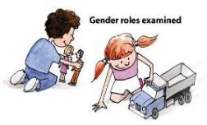
In a plenary, each participant will be asked to identify three (sticky notes, or equivalent; can be used) roles that women and men play in society. This can be different roles, activities or occupations. Prepare two columns on flip chart paper headed as women or men. Participants should be provided with examples to draw on as follows. Please prepare these on flip chart paper in advance of the workshop without any gender allocations.
Here are some examples you can think about:
Politician, Manager, Chef, Hairdresser, Bus driver, Construction worker, Doctor, Engineer, President, Lawyer, pregnant, grows a beard, takes care of children, provides for the family, fetches water, goes to school, cleans the house, fixes the car, cooks, mows the lawn, goes to university, plays soccer, drinks beer, sews clothes, plays with dolls, plays with guns, owns land, drives a car, makes decisions.
After you have finished pinning up these functions under boy/man; or girl/woman, the titles will be changed around, putting boy/man where you have girl/woman and vice versa.

Answer this question about the swapping of roles:
Which do you think can be swapped? | Which do you think cannot be swapped?

What does the exercise tell you about sex and gender?

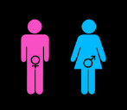
Fact sheet
The difference between sex and gender
"Sex" refers to the biological differences between men and women.
"Gender" refers to the socially created roles and behaviours that a society decides is right for women. Our gender identity determines how we are perceived and how we are expected to behave as men and women.

Biological differences are permanent except for those who undergo sex changes.
Gender difference depend on the factors such as politics, culture, race and patriarchy. They vary over time and place and between different groups of people.

Exercise 1.1.2: Sex and gender roles
In the following table write different types of reproductive, productive, community work and personality traits and place them in the appropriate place on the table of the biologically determined and socially determined roles of men and women. (Definitions have been provided below for reference).

SEX/GENDER ROLE | WOMAN | MAN
REPRODUCTIVE WORK
PRODUCTIVE WORK
HOME
WORK PLACE
COMMUNITY WORK

Please complete the questions below:
- Is this a natural division of labour? Yes or No
- What is right or wrong with these assumptions?

- What are the economic differences between the roles assigned to men and those assigned to women?

4. How do they lead to discrimination?

Gender: Some examples of the roles society expects men and women to play.
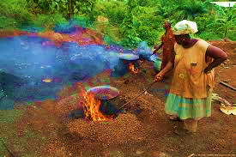 | 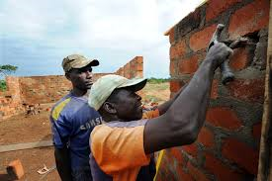
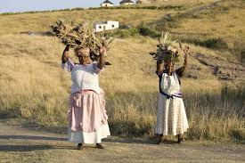 | 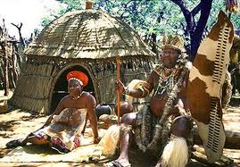

Definitions:
Gender relations: Describes the social relationships between women and men. These are socially constituted and do not derive from biology.
Reproductive work: The gendered division of labor includes reproductive labor, which refers to work performed within the domestic or private sphere and which helps to sustain a household (e.g. cleaning, cooking, child care and rearing, etc.).
Productive work: Comprises work done by both women and men for payment in cash or kind. It includes both market place production with an exchange value, and subsistence/home production with an actual use value, but also a potential exchange value. For women in agricultural production this includes work as independent farmers, peasant’s wives and wageworkers.
Community work can mean a range of things: being involved in local or neighborhood groups or associations, being a volunteer or unpaid worker, being involved in a non-profit, not-for-profit, or charitable organisation or association. This is doing public interest or public benefit work.
Patriarchy is a social system in which males hold primary power, predominate in roles of political leadership, moral authority, social privilege and control of property. In the domain of the family, fathers or father-figures hold authority over women and children.
Gender and the economy: The contribution by women to national economies is often hidden, unrecognised and unremunerated. Women face both structural (indirect) and direct
discrimination in the work place and in entering business. The majority of women continue to operate in the so called “informal sector” under immense pressure and even harassment, when in fact this sector is the backbone of most developing country economies. Multinational agencies that have belatedly “discovered” that gender equality is good for economics and development are putting pressure on governments to “mainstream” gender into poverty reduction strategies.
Source: Gender Planning and Development: Theory Practice and Training, Caroline O.N. Moser

1.2: GENDER BASED VIOLENCE

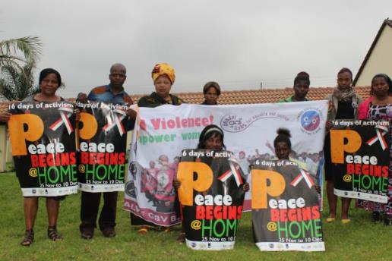

SECTION INTRO

Exercise 1.2.1: GBV and gender (in)equality
In plenary ask participants to share the following story. If participants want to share their own stories, that will be preferable.

Case study 1.2.1

UNHAPPY IN MY MARRIAGE Written by Mary*
When I married, I was 20 years old and very much in love. My brothers warned me that he was not a good man, but I thought they were jealous of him. As you know, when love is concerned we don't like to listen to the truth. l stayed in an abusive marriage with him for seven years.

When we had our first born daughter, this is when the problems started. My husband left me and went for my best friend, marrying her as well. All the love he had for me was no more. As if that wasn't bad enough, I never thought that one day things would change to be even worse.

Bigger problems started when my girl turned six months old. He used to demand sex anytime he felt like it. l never enjoyed sex from the time he married my friend, maybe he just wanted to punish me. He was one of those men who would take one to two hours doing it. To me, sex is about enjoying and satisfying one another, but he liked dry sex, meaning he had no time to communicate so that l also enjoyed.

He used to beat me up if l say no to sex. At times, I would put on a pad for two weeks pretending to be menstruating, sometimes even developing sores. One day when he discovered that l was pretending, he started beating me until some of my neighbours rescued me.

He used to tell his mother whenever l said no to sex. His family neglected me because of the love they had for him. His parents would insult me saying tawafundwa [properly taught] - how can you deny your husband’s demand.

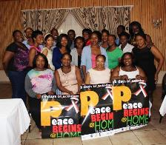
He never took care of our children. Our first born completed her grade twelve last year and as I am writing this story, she is pregnant by his best friend.

A few years ago, he sold the house without my knowledge. I discovered this when the buyer came for change of ownership. The house was my own property and I refused to do the transactions. Around midnight that day, I was badly beaten. I was completely naked when my elder brother rescued me.

I went to the clinic but they didn't treat me, but they referred me to the police. He was even locked up for 3 days. And that's when the marriage was terminated by the local court.
I have learned that life is a test, a gift, and we should bear it. I encourage my fellow women to always take caution that you are not abused in your marriage.
*Not her real name. Taken from the GL “I” Stories series
Exercise 1.2.1 GBV and gender equality/inequality
You will work in groups to answer this question. Please record your own thoughts in your manual.

How does GBV affect women’s lives?

From the story, what kinds of GBV did Mary experience?

Where could Mary have gotten help?

Why is GBV a critical issue in the struggle for gender equality?

How does GBV affect women’s economic status (depending on others or the ability to earn money)?

Definitions
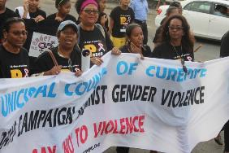
Gender based violence (GBV) is “any act which results in, or is likely to result in, physical, sexual or psychological harm or suffering to women, including threats of such acts, coercion or arbitrary deprivations of liberty, whether occurring in public or in private life”.
Sexual abuse
Sexual abuse is nonconsensual completed or attempted contact between the penis and the vulva or the penis and the anus involving penetration, however slight; nonconsensual contact between the mouth and the penis, vulva, or anus; nonconsensual penetration of the anal or genital opening of another person by a hand, finger, or other object; nonconsensual intentional touching, either directly or through the clothing, of the genitalia, anus, groin, breast, inner thigh, or buttocks; or nonconsensual non-contact acts of a sexual nature such as voyeurism and verbal or behavioral sexual harassment( Basil et al (2002).

Physical Violence
Physical violence is the intentional use of physical force with the potential for causing death, disability, injury, or harm (Saltzman, 2002). Physical violence includes, but is not limited to, scratching; pushing; shoving; throwing; grabbing; biting; choking; shaking; slapping; punching; burning; use of a weapon; and use of restraints or one’s body, size, or strength against another person.

Emotional Violence
Trauma to the victim caused by acts, threats of acts, or coercive tactics. Psychological/emotional abuse can include, but is not limited to, withholding information from the victim, deliberately doing something to make the victim feel diminished or embarrassed, isolating the victim from friends and family, and denying the victim access to money or other basic resources (Saltzman, 2002). It is considered psychological/emotional violence when there has been prior physical or sexual violence or prior threat of physical or sexual violence’.

Economic abuse
An abuser’s goal is to manipulate the victim, and he will frequently hurt her emotionally in order to achieve it. In addition to hurting the victim emotionally and physically, an abusive partner may also hurt the victim in the pocketbook. Economic of financial abuse includes controlling the finances, withholding money or credit cards, giving a partner an allowance, making a partner to account for every penny spent, stealing or taking money from partner, exploiting a partner’s assets for personal gain, withholding basic necessities (food, clothes, medications, shelter), preventing a partner from working or choosing a career or sabotaging a partner’s job by making them miss work.

Exercise 1.2.1: Links between GBV and economic development
There are different ways of looking at how economic development may impact survivors and their communities. The facilitator will divide the class into two groups. One group will brainstorm the ways that economic development can reduce GBV. The other group will brainstorm ways that economic development may increase GBV. Once each group has had time to identify at least five factors, the two groups will discuss and debate their answers. Please record the group feedback in your manual.

- Economic development can reduce GBV because

- Economic development may increase GBV because

1.3: GROWING AGENCY

Through this module the participants will:
- Understand self-concept, self-esteem and self-ideal.
- Explore how these concepts impact on our ability to
- Engage with the ways self-concepts are destroyed and built.

GROWING CONFIDENCE AND SELF-BELIEF

Exercise 1.3.1: Self-concept, self-esteem and self-ideal
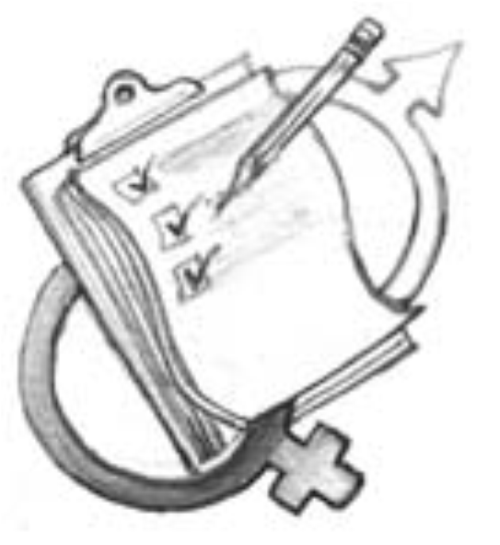

- In groups discuss the following terms:
- Self-concept (what do I think about myself), how does this develop?
- Self-esteem (how much do I value myself), what affects self-esteem positively and negatively?
- Self-ideal (what is my dream self).
2. Each group should record their answers on three pieces of flip chart paper and paste on the walls of the workshop venue.
3. Each group must report on their discussion. The report back must happen per question followed by discussion on each question. Record your won thoughts and the feedback in your manual.

Self-concept

Self-esteem

Self-ideal

Definitions
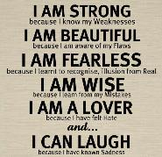

Self-concept: The term self-concept is a general term used to refer to how someone thinks about or perceives themselves. The self-concept is how we think about and evaluate ourselves. To be aware of oneself is to have a concept of oneself. Baumeister (1999) provides the following self-concept definition: "the individual's belief about himself or herself, including the person's attributes and who and what the self is".
How does your self-concept develop?
One’s self-concept is developed over time. It is how a person sees him/herself or answers the question “who am I?” A person’s sense of self-worth can be seen as a combination between their self-concept and self-esteem.
How can your self-concept be built?
A person’s self-concept can be built by finding a positive role model, identifying a positive mentor, accepting praise from others and yourself, focusing on the positive, keeping criticism to a minimum and setting and achieving goals.
- Accepting and loving who and what you are
- Believing that you can make a difference
- Believing that you can make things happen
- Knowing you are good at something
- REALISING THAT YOU ARE IMPORTANT!!!!!!
What things affect your self-concept negatively?
One’s self-concept can be negatively affected by comparing yourself to others, putting yourself down, abuse, as well as negative thoughts and feelings about yourself.
- Having little affection or encouragement
- Criticism, ridicule, sarcasm and cynicism
- Physical beatings, sexual and emotional abuse
- Not being recognised and praised for doing well and achieving things
- Not being reminded that you are unique.
Self-esteem: the term self-esteem is used to describe a person's overall sense of self-worth or personal value. Self-esteem is often seen as a personality trait, which means that it tends to be stable and enduring. Self-esteem can involve a variety of beliefs about the self, such as the appraisal of one's own appearance, beliefs, emotions and behaviours. According to one definition (Braden, 1969), there are three key components of self-esteem:
- Self-esteem is an essential human need that is vital for survival and normal, healthy development.
- Self-esteem arises automatically from within based upon a person's beliefs and consciousness.
- Self-esteem occurs in conjunction with a person's thoughts, behaviours, feelings and actions.
Self-ideal: Ideal Self is the person you want to be. The ideal self is an idealized version of yourself created out of what you have learned from your life experiences, the demands of society, and what you admire in your role models.
Exercise 1.3.2: Tree of life
- Look at the pictures. Each part of the tree represents various aspects of your life. Use the tree as inspiration to write information about yourself referring to each part of the tree as indicated below.
- Draw your own tree of life on the next page.
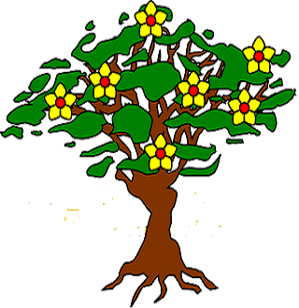
The roots represent the background from which you come and he strong influences that have shaped you into the person you are today.

The trunk represents the structure of your life today (such as your job, your family, the organisations you belong to, etc.).

The leaves represent our sources of information and learning (such as newspapers, radio, TV, friends, lectures, life experiences etc.).

The fruits represent our achievements (such as projects we have organised, scholastic or academic achievements, personal victories etc).

The flowers represent our desires, hopes and dreams for the future.

1.3.2 Draw your own tree of life.

Make notes about your tree of life which you can share with the group

Which part of the tree was easy to write about? Why?

Which part of the tree of life was difficult to write about? Why?

Exercise 2.3.3: Developing a personal action plan
In this session, develop a personal action plan using the table below to identify personal goals you would like to achieve. You may want to share something of their plans with the group. After some time you will be asked if you achieved this or not and will then answer the last column.
GOALS | DESCRIPTION | WAS THIS ACHIEVED?
Three things I will do to increase my self-esteem. | 1. | Yes No Partly
Three things I will do to increase my self-esteem. | 2. | Yes No Partly
Three things I will do to increase my self-esteem. | 3. | Yes No Partly
Three things I will do less that negatively impacts on my self-esteem | 1. | Yes No Partly
 | 2. | Yes No Partly
 | 3. | Yes No Partly
Three things I want to achieve in the next six months | 1. | Yes No Partly
Three things I want to achieve in the next six months | 2. | Yes No Partly
Three things I want to achieve in the next six months | 3. | Yes No Partly

https://rohabatool.wordpress.com/2014/11/29/the-nuts-and-bolts-of-gender-and-sex/
http://www.thisfabtrek.com
http://www.rescue.org
http://kwekudee-tripdownmemorylane.blogspot.com
http://www.pahof.de
https://www.google.com/search?sourceid=navclient&aq=&oq=define+reproductive+work&ie=UTF-8&rlz=1T4LENN_enZA572ZA572&q=define+reproductive+work&gs_l=hp..0.0j0i22i30.0.0.0.22620...........0.Tjg-giXcphttp://www.tcls.org.au/01_cms/details.asp?ID=67E
https://en.wikipedia.org/wiki/Patriarchy
Cited in (2008), Population Council, “Sexual and Gender-based Violence in Africa – A literature review”, available at: http://www.popcouncil.org/pdfs/AfricaSGBV_LitReview.pdf
Violence and associated terms by Basil and Saltzman (2002)
http://www.4woman.gov/violence/types/emotional-cfm.
http://www.simplypsychology.org/self-concept.html
http://mynewfavoriteoutfit.blogspot.com/2013/05/i-am.html
http://psychology.about.com/od/sindex/f/what-is-self-esteem.htm
http://www.alleydog.com/glossary/definition.php?term=Ideal%20Self
http://www.englishhints.com/prefixes-and-suffixes.html

