


EMPOWERING WOMEN, END VIOLENCE

ENTREPRENEURSHIP TRAINING MANUAL

MODULE TWO

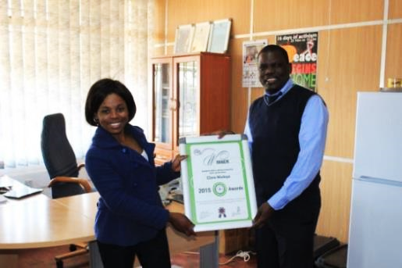

2018

Gender Links (GL) is committed to a region in which women and men are able to participate equally in all aspects of public and private life in accordance with the provisions of the Southern African Development Community (SADC) Protocol on Gender and Development.

Taking charge! Empowering GBV survivors through life and applied entrepreneurship skills
© Copyright 2018, Gender Links.
ISBN:

Gender Links
9 Derrick Avenue
Cyrildene, 2198
Johannesburg, South Africa
Phone: 27 (11) 622 2877
Fax: 27 (11) 622 4732
Email: coo@genderlinks.org.za
Website: www.genderlinks.org.za

Editors: Colleen Lowe Morna, Anne Hilton and Mariatu Elba

Design/Layout and print: Gender Links

Sponsors:

TABLE OF CONTENTS

1. IDENTIFY AND DEMONSTRATE ENTREPRENEURIAL IDEAS 4
2. MATCH NEW VENTURE OPPORTUNITY TO MARKET NEEDS 17
3. MANAGE MARKETING AND SELLING PROCESSES OF A NEW VENTURE 27
4. APPLY THE BASIC SKILLS OF CUSTOMER SERVICE 33
5. SIZE, LOCATION AND DIVERSITY 38
6. START UP FINANCE 43
7. PRICING 47
8. CASH FLOW 50
9. RECORD KEEPING 53
10. STOCK CONTROL 56
11. TENDERING AS A BUSY OPPORTUNITY 59
12. FUNDING A BUSINESS 63

  - IDENTIFY AND DEMONSTRATE ENTREPRENEURIAL IDEAS

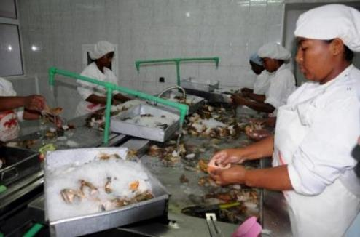

This section covers
- Identifying own entrepreneurial strengths and weaknesses in relation to opportunity identified.
- Identifying the characteristics of a typical entrepreneur.
- Identifying entrepreneurial opportunities in own context.
- Compiling entrepreneurial goal and personal growth plan.

Exercise 2.1.1: What is an entrepreneur and entrepreneurship?
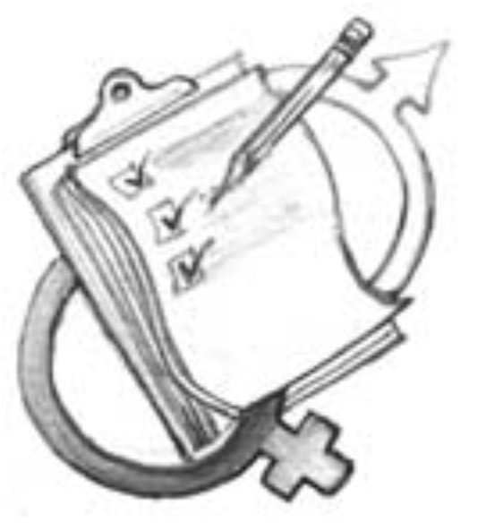

nswer the following questions in your manuals and share your anwers in the plenary sessions with the group.
      - What do you understand the word entrepreneur means.
      - List words that describe an entrepreneur in your view.
      - What do you understand the word entrepreneurship.
      - Why is entrepreneurship important?
- Identify female and male entrepreneurs? What kinds of businesses are they involved in?
- What are the differences in the businesses women and men are in? Explain why this is so.

What is an entrepreneur

Give four words you think describe an entrepreneur?

What is entrepreneurship?

Why is entrepreneurship important?

Identify female and male entrepreneurs? What kinds of businesses are they involved in?

What are the differences in the businesses women and men are in? Explain why this is so.

Fact sheet two: Gender and economic concepts
Economic empowerment is the capacity of women and men to participate in, contribute to and benefit from growth processes in ways that recognise the value of their contributions, respect their dignity and make it possible to negotiate a fairer distribution of the benefits of growth.
Gender aware economic empowerment is achieved through integrating gender concerns into all aspects of policies, programmes, projects, institutional mechanisms and budgets. It can also be achieved using gender-specific action to redress inequalities. Economic empowerment also includes encouraging, and developing the skills for, self-sufficiency, with a focus on eliminating the future need for charity or welfare in the individuals of the group.
An entrepreneur: Someone that starts their own business when they see an opportunity or gap in the market.

Entrepreneurship is one form of economic development. It means owning a business of your own (either by yourself or in partnership with other people). A person who owns her own business is called an entrepreneur

Resources
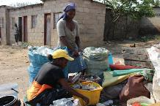
Starting your own business is hard work and requires careful planning and a lot of commitment. Men and women both have challenges starting a business. For example, people might not want to buy what he or she is selling, this may mean that there has not been proper planning to find out what people want to buy. An entrepreneur could experience a lack of money or struggle to find the necessary skills or machines. However, women entrepreneurs may face additional gender based barriers including:
- Lack of individual property and land rights.
- Financial institutions, such as banks, may be unwilling to give business loans to women. Women may not be allowed control over income and household investments.
- Lack of confidence and support from friends and family members.
- Lack of access to information
- The pressures of household responsibilities may prevent a woman from finding time as women are generally considered to be the primary care providers for children.
- Cultural pressures to hire family members.
- Limited opportunities given societal beliefs that some industries are only suitable for men (e.g. mining) while others should be the domain of women (e.g. child care or nursing).
- Lack of access to training or experience.
- Tendency to trade in saturated markets or copy other business ideas.
- Tendency to develop businesses based on so-called traditional women’s skills.
- Lack of access to finance.
- Limited freedom of movement.
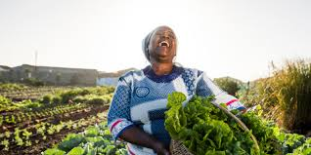
Source: http://www.huffingtonpost.co.za/wendy-engel/agriculture-is-a-polarising-subject-in-south-africa-we-need-m_a_23070608/
Women and land
In Southern Africa women’s ability to access, own and control means of production such as land and livestock are severely limited by cultural practices and customary laws. This in turn has devastating impacts on their economic independence and ability to move out of poverty.

Yet women’s access to land for food production is critical to the welfare of the entire region as it is women who are primarily responsible for maintaining households. Women provide 70-80 percent of all agricultural labour and 90 percent of all labour involving food production in the region. But they own only a fraction of the land, and constitute most of the population living in poverty. Unequal access to land and other productive resources such as livestock, markets, credit, and modern technology are among the most significant forms of economic inequality between men and women and have consequences for women as social and political actors.

Under customary law – subscribed to by most countries in Southern Africa which operate dual legal systems – a woman loses her rights to own property upon marriage as ownership passes to her husband and then her male Because women's ties to land are mediated by their relationship to men in patrilineal societies, their attempts to assert their rights in ways that challenge customary land tenure systems are most often perceived as an attempt to disrupt society. In the patriarchal societies which dominate Southern Africa women generally do not inherit land from either their fathers or their husbands.

Since women are almost completely dependent on men to access land, women who are childless, single, widowed, disabled, separated/divorced, or with only female children are particularly vulnerable. Across the region, governments have instituted legal reforms to address the issue of women’s land ownership.

The results have been varied and point to the need for a more pro-active approach which includes addressing the negative effects of customary law. To do this though, governments would have to abandon their dual legal systems and develop and uphold progressive constitutional law that would provide for equality between men and women.

For women to achieve sustainable economic independence there is a need to address:
- Women’s understanding of the social constructs of gender
- The building of self-confidence of women who have experienced GBV
- Entrepreneurship as a tool for change
2.1.2 Case study: Puleng’s Soul Food Kitchen
Read the case study and do the activity that follows.
Puleng, a 35-year old woman entrepreneur has been married to Karabo for 14 years. They have three daughters, aged 9, 11 and 13. Karabo has steady work as a sales agent, which means the family was able to buy the food and shelter they needed but he was often out of town. Karabo managed to buy a house and he recently paid off the bond. Running the household and looking after the children kept Puleng busy for years. It was only three years ago when all three girls were in school that Puleng suddenly found herself with some time on her hands.

She started to think about owning her own business and realised there may be an opportunity because of the new stadium construction happening just around the corner from her house. Puleng always had a passion for food and she is a very good cook. She thinks she may be able to earn some money by selling food to the workers building the stadium.
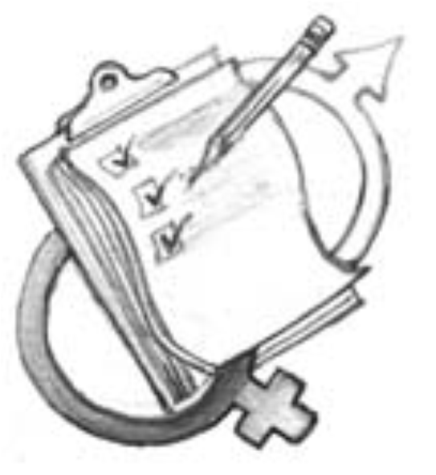
Exercise 2.1.2: Gender and entrepreneurship role-play
The facilitator will divide the participants into small groups to role play different scenarios based upon the story above. There is no wrong answer as there are many ways that Puleng’s story may continue.

Each group will be responsible for role playing one of the following scenarios:
- Puleng discusses with her husband the idea of her starting a business. The group will determine his reaction.
- Puleng goes to the bank to ask for money to start her own business. The group will decide on the reaction of the bank manager (who may be either male or female).
- Puleng tells her friend about her business idea as she suspects that her friend might be involved in a violent relationship.

After each of these role plays decide how gender influenced her attempts to discuss the idea of owning her own business with the different people. Record your answers in the space provided. Share your thoughts in the plenary.

Fact sheet: Small business may be in the following sectors
Retail businesses sell ready-to-use products to consumers (i.e. the customers who willbuy their products). Retailers buy their products from wholesalers, manufacturers and other suppliers. Most of us use retailers daily to buy goods like groceries (food), clothes and other items we need or want. Examples of retail businesses include supermarkets (e.g. Shoprite Checkers), spaza shops/kiosks (i.e. small businesses selling basic products to consumers in the local area), fruit and vegetable sellers and clothing shops.
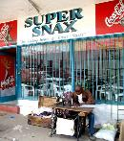
Example of a retail business.

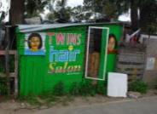
Example of a service business
Service operators sell services rather than products.
A service is an action that requires specific knowledge (e.g. hairdressers, plumbers or electricians). Examples of service operators include a hair salon, transport/taxi services (which do not sell cars, but transports customers for a fee) or mechanics (which do not sell but repairs cars and other vehicles).
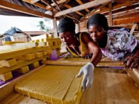
Making furniture is a manufacturing business
Manufacturers use raw materials which they change into a new product. For example, a carpenter buys wood and (using skilled staff) turn the wood into tables, chairs and other furniture. Manufacturers sell their completed products to retailers and wholesalers to sell and might even provide products to service operators. There are many types of manufacturing businesses producing the things we need daily (e.g. cars, desks, telephones, cups and clothing).

Some businesses are difficult to categorise. This is because some businesses can be classified in more than one category. For example, some manufacturers are also retailers (like furniture manufacturers that have a shop where consumers can buy their products) and some retailers are also service operators (like a car dealership offering repair services).

Seasonal business? Some businesses do not operate all year round because what they sell is not available all year round or is most likely to be needed during some part of the year. Some examples are planting fruits or vegetables that only grown in summer such as mangoes. Selling umbrellas in the rainy season. A seasonal business is usually only busy at certain times of the year. The best example is agriculture where some fruits or vegetables only grow at a particular time e.g. mangos in summer. This can mean that there is no income between seasons if this is all that you do. Other seasonal business can include selling to school children, selling school uniforms, selling Christmas cakes or catering for weddings. Weddings are usually more popular in summer. If you sell blankets, then you were sell more in winter.

If you run a business that is most likely to earn income at certain times and not all the time, then you should try to find something to keep you going for the rest of the time.

Social entrepreneurship is a business that not only seeks to sell a product or service, but at the same time seeks to address a social challenge. The business aim is to make money and at the same time solve issues such as poverty, unemployment, environmental sustainability. A social entrepreneur must do everything a traditional entrepreneur must do. In addition they must also understand the social challenge and how their business will help solve these problems. The money earned from the business is used to reinvest in the business and other solutions to that to that social problem.

Many business types can fall into the category of social entrepreneurship. To run a social enterprise you would need to be a social entreprenerur.
Definition
What is a social entrepreneur?
Social entrepreneurs are individuals with innovative solutions to society’s most pressing social problems.
Rather than leaving societal needs to the government or business sectors, social entrepreneurs find what is not working and solve the problem by changing the system, spreading the solution, and persuading entire societies to take new leaps.

Why "social" entrepreneur?
Just as entrepreneurs change the face of business, social entrepreneurs act as the change agents for society, seizing opportunities others miss and improving systems, inventing new approaches, and creating solutions to change society for the better. While a business entrepreneur might create entirely new industries, a social entrepreneur comes up with new solutions to social problems and then implements them on a large scale.

Start a vegetable garden | Recycling | Day care
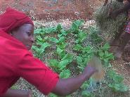 | 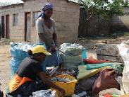 | 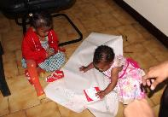

These activities can serve a community need and also make money; even a profit.
Exercise: Social entrepreneurship opportunities in your own community or council
- Divide the participants into groups.
- Discuss the questions below.
- Feed back into plenary.

Exercise 2.1.3 Types of social enterprise opportunities in the community. Fill in the form below to answer the questions about social entrepreneurship.

What types of social or service delivery problems are people in the community dealing with? | How can members of the community address these by starting a social enterprise?

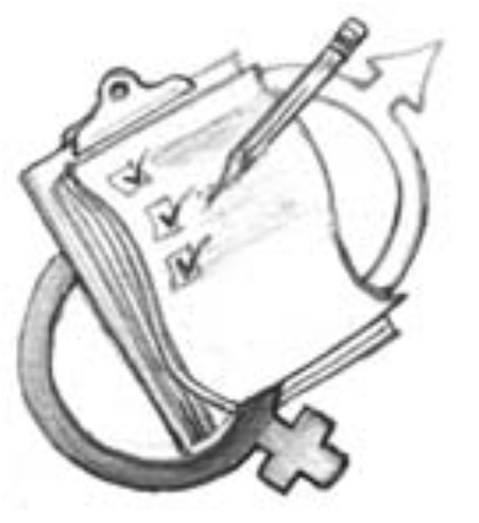
Exercise 2.1.3: Types of businesses
Discuss in plenary.Can you think of different kinds of businesses that are run in your community?
Type of business? | What business type are they?

Fact sheet: There are also different business sizes.
Business are defined in different ways according to their size. The definitions are not the same in all countries. Business sizes can be demonstrated in a pyramid.

SMME scenario
SUPPORT

NEED INTENSIVE SUPPORT AND APPROPRIATE ACCESS TO FINANCE
GAP IN ACCESS AND PRODUCTS
MICRO FINANCE
BANKING FINANCE AND CREDIT
EQUITY
GL client base

Does it take special knowledge or skills to be an entrepreneur?
It is important to know some aspects of what you want to do in a business. This is gained through:
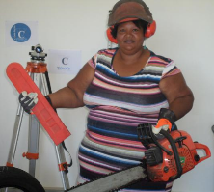
- Knowledge such as what you learn from school or the Gender Links workshops
- Skills such as cooking, sewing, plumbing, construction, helping in someone’s business
- Experience such as making clothes, building a house
- Interest in what you do in the business such you like gardening
- Looking for good ideas to grow the business
- Finding ways to be better than the competition
- Being prepared to work hard
- Being really interested in making the business a success
- Being willing to keep learning
- Be willing to sometimes fail for example a product does not sell as well as you thought it would
Areas you are not sure about you can ask other people to help, search for information or do more training.

What do you think are your strengths or weakness as a business person?
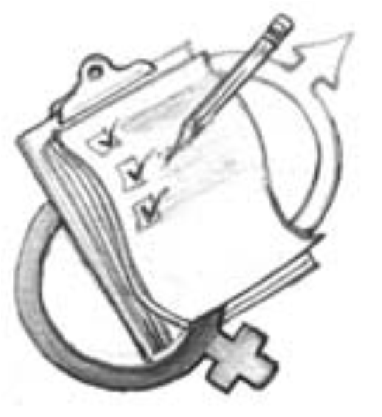
Exercise 2.1.4: Identify what you think are your strengths and weaknesses that would affect you running a successful business.
List some of your strengths and weaknesses in knowledge, skills and experience that could affect your business.

 | Weaknesses | Strengths
Knowledge

Skills
Experience

Then list ideas that you think you are able to do, would enjoy doing and would like to do in business.

What I am able to do? | What I enjoy doing? | What I would like to do?
Case study 2.1.5: Mrs Ncube’s experience
Answer the questions that follow after reading through.
Mrs Ncube wanted to go into business to expand her family’s income. Because Mrs Ncube enjoyed making baskets and wall hangings which many of her friends admired she thought about opening a household furnishing shop where she could sell these. However, after talking to many local shopkeepers, she found out that there would be too few customers in her area for such a business to be profitable. Next, she considered making clothes but found that there were many dressmakers in her area.

While still looking for a good idea for her business, Mrs Ncube tried to find a place for her son in a local nursery school. She knew that when she started her business she would have no time to teach him at home, and it is good to begin education early. However, all the nearby nursery schools were full and most had waiting lists.


Many of the women she met complained that there were not enough nursery schools in the area. Mrs Ncube realized that there was a need for another nursery school and decided to start one. She talked to her friends and neighbours with small children to find out what they wanted from a nursery school. With the start-up finance her husband provided her, she rented a building and hired a qualified teacher to help her. Although she did not have any training herself, Mrs Ncube used her strengths and assets. Today her nursery school is a profitable business and has a long waiting list.

Exercise 2.1.5: Types of businesses
Think about the story about Mrs. Ncube and answer the questions below.
- What products or services does the business offer?
- Who are the customers?
- How does the business sell its products or services?
- Which need(s) does the business fulfil for the customers?

What products or services does the business offer? | Who are the customers? | Which need(s) does the business fulfil for the customers? | Is this business respected in the community and why?
  - MATCH NEW VENTURE OPPORTUNITY TO MARKET NEEDS

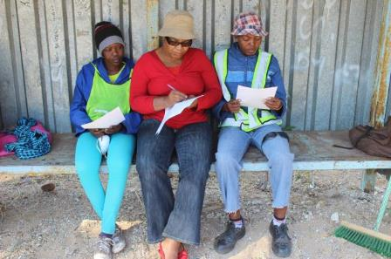

Through this section the participants will:
- How to work out who your customers will be in a new venture
- How to conduct market research to find out if there is a need for a product or service in the market you are targeting
- Understand how to do marketing
- Understand customer service
- Exploring product/service life cycle.

Case study 2.2.1: Why business planning is important

Answer the questions that follow.
Puleng decides that she wants to sell sandwiches and cool drinks to the workers at the construction site across from her home. She talks to a couple of the workers, who confirm that nobody else is selling lunch nearby. Most workers said that they would buy lunch if there was something available nearby.

Puleng has saved 250 by putting away 10-R20 a month over the last year. She decides that she will use this money to buy what she needs to start selling to the workers. In Puleng’s excitement, she buys six loaves of bread, five 71/2kg of meat, 1/2kg of cheese and 6 litres of cool drinks. She spends nearly all of her money.

On Monday, Puleng begins selling her sandwiches outside the construction site. By Friday she has sold twenty sandwiches. Unfortunately, even though she sold a lot of sandwiches she still had four loaves of bread left over and it was getting stale. She knew she could not sell it the following week. Furthermore, she learned that the workers were going to go on strike the next week so the left over supplies would probably spoil before she could sell them.

Exercise 2.2.1: Business planning
The facilitator will divide partricipants into groups. Dsicuss the following questions.
What was Puleng’s mistake when buying her supplies?
What should she have done first?
How could Puleng have avoided the problem?

Resources: Importance of business planning
Planning is probably the most important part of starting a business. Do not think your business is too small to require planning. Without a plan you won’t have the information you need to run a business. You will need to know how many supplies you need and how much to sell them for. You will need to know how much money you will need to start your business. Business planning looks at answering the following questions:
- What do you want your business to do?
- How do you want to do it?
- What do you need to get it done?
- What can get in your way and how will you prevent that?
- What are your long-term goals?

Fact sheet: You will need a business plan if you want money from a bank to help you start your business. Before you start a business, you should get as much information as possible about your business. You can do this by conducting market research and a feasibility study. A business plan helps to make sure you get enough information about the important things you need to think about.
When deciding on a business there are two important things to know;
- Is the business idea feasible? Is it the right product, will it sell, who will buy it?
- Is the business sustainable? Will it make enough money to keep me in business?
Remember you will not be able to sell your product or service if:
- You want to sell something that people do not want.
- Nobody knows what you have one or where to find it.
- Your pricing is wrong for the target market.
- Your quality is not good.
You need to ask questions about the market that you want to reach.
This is called market research. Market research is the process of assessing the potential success of a new product or service through techniques such as surveys, product testing and focus groups.
- A survey is a process of asking a set of questions to get information to decide if your product or service will sell. You need to ask everyone the same questions. The more people you interview the better your results will be.
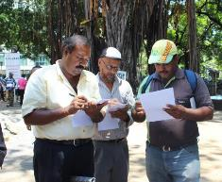
Doing a survey with people. Source Gender Links.
- Focus groups: This is a process of asking a group of people to get together and then ask them questions as a group to find out if they would buy your products or services.
- Product testing: This means giving samples to see if people liked the products.
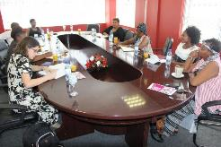
A focus group: Source Gender Links.
Other ways can include:
Find out what type of businesses are already operating in your area and see if you can find gaps in the market. Ask people what they can buy and what they would like to buy.
See if there any kinds of goods that are not available that you could provide.
- Investigate your environment.
  - What is there in your environment that you can use to develop a business?
  - What grows in your area – fruit – grass – add value to something?
  - What other businesses/organisations are in your area that can help your own business – tourism, bed and breakfasts, supermarkets, schools, spots clubs, and hospitals?
- What do people buy that they cannot get locally?
- Waste that can be recycled?
- Observe what people are doing or buying?
- Value add is the change you make to make a product or service before selling it to customers? Taking something from its original state to make it more valuable.
- Product life cycle: The stages a product goes through from when it was first thought of until it finally is removed from the market. Not all products reach this final stage.
Product life cycles are different for different kinds of products. Some products stay on the market for a long time and some for a very short time. Some products disappear completely.
There are four product life cycle stages:
- Introduction – researching, developing and then launching the product
- Growth – when sales are increasing at their fastest rate
- Maturity – sales are near their highest, but the rate of growth is slowing down, e.g. new competitors in market or saturation
- Decline – final stage of the cycle, when sales begin to fall

This means that some products are popular for a short time and others for a long time. This is because people get excited about a new product but only buy for a short time e.g. fashions change very quickly; some for a long time like corn flakes.
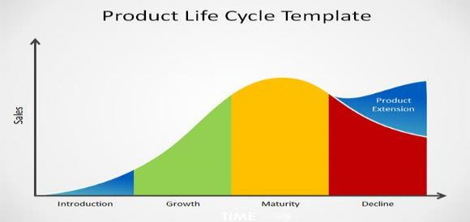

Exercise 2.2.2: Products in the market that have stayed or disappeared. Each person in the group should do this exercise in their manual.

Think of three products that have stayed in the market for a long time and four that have disappeared.

Have been around for a long tome | Are no longer available
Why do you think that these products are  Still on the market? | Why do you think these have disappeared”?

How can you extend the life of a product?
- Do more marketing to both old and potentially new customers
- Find new markets
- Change your product to meet new trends or needs
- Package the product differently – give it a new look

See how many times logos can change in a big company.
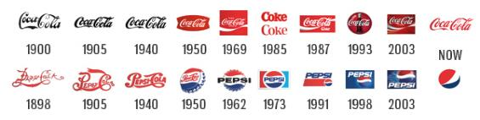
Big firms can afford to change their logos and branding, but it is more difficult for small business. Ideas for giving a brand a fresh look:
- Change the colour of your logo
- Use fresh packaging
- Change the logo
- Change the look of the advertising

What does a value add process involve?
It involves using one process to increase the value to the customer. Bread for example is the product of turning wheat on the farm to bread in the shops. Tomatoes can become tomato sauce.
Bread has value added?




Tomatoes are not but can become a value added product.
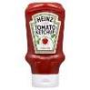


Oranges become orange juice or even jam.



Exercise 2.2.3: Choose two of these products you think has had value added? Participants will be put in groups to answer this question..

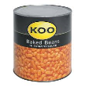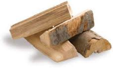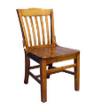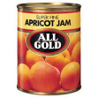

Why have you chosen these products?

Think of three things in your own area or home that you could add value to; to make and sell and start or grow your business?

Fact sheet: Many small businesses assume that they know what customers want without trying to find out if this is true. The goal of knowing your market is to identify where the business can compete. Women often operate in what is called saturated markets. This means that too many people are selling the same thing to close to each other and the market isn’t big enough for all of them.
Identifying a market gap: Identifying things people need that are not available to them is called identifying the market gap. The businesses you identified in the previous case studies meet the unfulfilled needs of people (filling the market gap). There are many reasons for these market gaps which could be warning signs that a business would be unlikely to succeed. These could include:
- Not enough potential customers;
- High costs (i.e. products that are too expensive for the local market);
- Transport difficulties which increase the cost of the products;
- Products that do not really meet the needs;
- Remember that people will need a good reason to buy a new product;
  - Cheaper;
  - Of higher quality;
  - Available more regularly and in different sizes, quantities, colours or designs;
  - Sold in a more accessible location; and,
  - A totally new idea.

Who do you want to sell to – what is your target market?
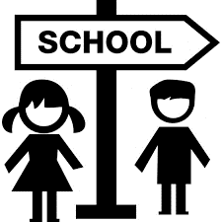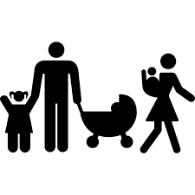

Exercise 2.2.4: Individual should do this exercise on their own and report back to plenary. Give three examples of products you could sell to scools, school children or for weddings.

What will influence what people may want or need to buy?
People at different stages in their lives will buy different things. Teenagers will buy different clothes to old people for example. People who are rich and live in an expensive area will buy different kinds of groceries to people living in poor communities. Men and women may have different shopping needs for clothes.

What is the difference between a want and a need?


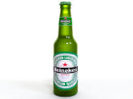


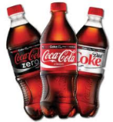
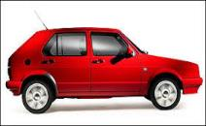
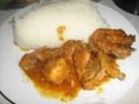


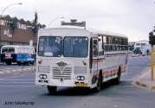

Exercise 2.2.5: Think of the pictures above and which you think are a need or a want.

Need | Want

The 5 most important things to consider when you want to sell products are:

Target market
Age: People at different ages want or need different things
Location: Where people live can tell you about what people are likely to buy.
Levels of education: May affect what people buy or want.
Gender: Different products may appeal differently to men or women
Income: It matters if people have a low or high income

How to plan your market research
- Decide what it is you want to find out
- Decide how to find the information e.g. interviews or focus groups
- Collect the information e.g. put a questionnaire together
- Analyse and interpret the information when you have collected it
- Use the information to plan in your business

What does a questionnaire look like? This is only an example.

Questions | Answers
Do you buy cakes? | Daily | Weekly | Monthly | Less often | Make my own
What kind of cakes do you buy? | Birthday cakes for children | Birthday cakes for adults | Wedding cakes | Christmas cakes | Make my own
Where do you buy cakes | Supermarket | Bakery | Neighbour | Small shop | Make my own
How far do you travel to buy cakes | Less than 1 kilometre | Between 1 and 5 Kilometres | More than five kilometres |  | Make my own
Would you buy cakes if I made them and delivered them to you? | Yes | No

Exercise 2.2.6: Identifying market gaps?
The facilitator will pair the participants and each pair will identify gaps in the markets using the template below.

What are the needs in the community/council? | What would the product be? | Who are the customers? | How will the business sell its products or services? | Where can you access financial support to start up the business?

2.3 MANAGE MARKETING AND SELLING PROCESSES OF A NEW VENTURE

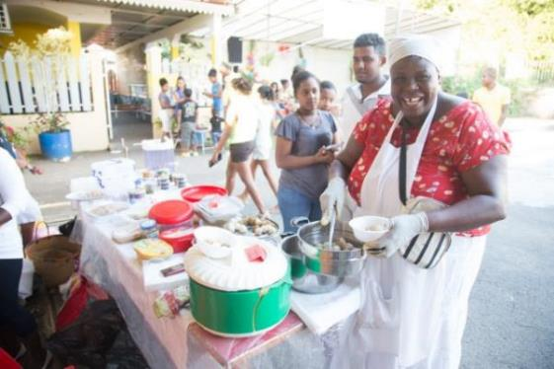

Through this section the participants will:
- Iincrease their knowledge and awareness of participants about the importance of market research.
- Improve their understanding of the market and meeting market needs.
- Be able to develop a framework for marketing planning
Definitions
Marketing plan: To grow your business, you need a marketing plan which includes who your target customers are, how you can reach them and how you can retain (keep) them.
Repeat customers are the people that keep coming back to your business. Most businesses cannot survive without repeat customers so you need to keep your customers happy.
Marketing: Is a strategic mix of business activities that work towards a goal of building your brand and business. It is about knowing who your customers are; understanding your customers and developing products and services that meet their needs. Marketing is everything that will attract and keep customers.
Marketing is everything you do to make customers aware of a product or service and to get them to buy from you and keep buying from you.. This includes:
- Advertising your product and services
- Selling
- Communicating with your market
- Giving good customer service
- Making sure your customers can find you
Advertising is the way that you make old customers and likely new customers aware of your products or services by using different options such as:
- Adverts on TV, the radio, on buses, in newspapers, in shop windows
- Pamphlets or brochures that you can hand out or leave in places where you customers may go
- Calling on possible clients to introduce your product or service e.g. a shopkeeper, your neighbours, your church group

Fact sheet
Remember you will not be able to sell your product or service if:
- You want to sell something that people don’t want
- Nobody knows what you have one or where to find it
- Your pricing is wrong for the target market
- Your quality is not good
Marketing is one area of business that many small and very small businesses fail to do well. This happens for a number of reasons, especially for women:
- Women don’t have the knowledge through lack of experience or exposure to business
- Courses on marketing are usually broad and the information is difficult to apply to an individual business
- Women often lack the freedom of movement to explore business opportunities outside of their own community because of patriarchal customs which restrict women’s movements
- Women are most likely to be responsible for managing the home and childcare leaving them little time
- Women may lack the financial resources to spend money on marketing
To develop a way to market a business needs a plan that asks questions about the market that you want to reach. This includes questions such as:
- How will your marketing plan improve your sales?
- Who are you trying to reach with your marketing activities?
- What is the best way to do that?
- What makes your business stand out from other similar business and how can you use this to your advantage?
- How much money can you spend?
- How will you carry out your plan?
- What resources will you need? Resources can include money, labour, skill etc.

Case Study 2.3.1 Miriam has decided her business at the taxi rank is going well and she wants to start selling more by expanding her business to another three taxi ranks. She has visited three other taxi ranks. She has noticed that there are many people going to work from these ranks. She has seen that there is not food being sold in the morning. She wants to expand her business and wants to be able to market and advertise specials and products. She needs to think of three ways in which she attracts new customers to her new taxi ranks. She also needs to keep her customers at her first taxi rank.
Exercise 2.3.1: The facilitator will break group into small groups to answer the following questions.

What marketing can Miriam do to make people aware of her new businesses?

What can she do to increase her number of sales in her first taxi rank business?

Definitions
Branding: The marketing practice of creating a name, symbol or design that identifies and differentiates a product from other products.
A logo is a design that is used by a business to make the business stand out and be recognised by consumers. Here are three examples.





Exercise 2.3.2 Can you think any products that you can recognise by their name or their logo.
1.__________________ 2_____________ 3_______________

Why do you think you remember these products?
1.____________________________________________________
2.____________________________________________________
3.____________________________________________________
Fact sheet: What should a marketing plan look like?
To make marketing plan you need to be able to answer these questions.
- Who are you trying to reach with your marketing activities?
- What is the best way to do that?
- What will make your business stand out from other similar businesses and how can you use this to your advantage?
- How much money can you afford to spend on marketing?
- How will you carry out your marketing plan?
- What resources will you need? Resources can include money, labour, skills and time.
- Who are your competitors and what do you know about them?

Sample of a simple marketing plan.
What you need | How to accomplish this
What/who is your target market | People catching taxis early in the morning to get to work from my community
How your business be better than others? | I want to the best food and hot drinks at the taxi rank
What will you offer to customers | Homemade sandwiches, fruit, chips, juice and hot tea.
How will you price your product | I will add 10% to my price because I will be offering fresh, clean and tasty food nicely wrapped. My competition does not sell appetizing food and no hot tea.
How will you get your products to the markets? | I will sell at the taxi rank in my community.
What will you do to encourage people to buy from you? | For the first two weeks I will offer free tea with each sandwich bought. I will give each customer a pamphlet with my logo and contact details. I will give pamphlets to all the taxi drivers.
What do you intend to do to give good customer service? | To always be at the taxi rank on time, to always provide fresh and well-presented food and always greet my customers.
How will you promote/market your business? | I will develop a logo and name for my business that people can recognise. I will have pamphlets and posters printed to give away, put up in taxis and shop windows.
Marketing Research | I will regularly ask my customers what they would like me to provide as part of my service. I will take orders from regular customers the day before.
Can you think of any other ideas that will keep customers buying from you? | I will encourage people to come back by giving them a loyalty slip which I will sign each time they come. After 10 sales I will give them a free cup of tea.

2.3.3 Case Study. Miriam has decided her prepared food business at one taxi rank is going well and she wants to start selling more by expanding her business to another three taxi ranks. She has visited three other taxi ranks. She has noticed that there are many people going to work from these ranks. She has seen that there is no food being sold in the morning for the people catching the taxis. She wants to expand her business and wants to be able to market and advertise specials and products. She needs to think of three ways in which she attract new customers to her new taxi ranks. She also needs to keep her customers at her first taxi rank.
Exercise 2.3.3: The facilitator will break group into small groups to answer the following question. What marketing can Miriam do to make people aware of her new businesses?

What can she do to increase her number of sales in her first taxi rank business?

Some tips to consider when looking at a marketing plan.
Packaging:

Packaging may or may not be required depending on the product. For the sale of fresh fruits, vegetables or other agricultural produce, there is generally no need for packaging. A simple plastic or paper bag is sufficient.
Presentation:
Presentation can play a role even in the sale of fresh food products. Neatness, cleanliness and organization make the sales outlet attractive and appealing to customers.
Market test:
It is sometimes interesting to test different types of presentation or packaging to find the one that appeals most to customers.
Competition:
Competitors offering the same or similar product must never be ignored as they already have clients and may be more experienced. Check their presentation, price and sales technique. As a new micro-entrepreneur, you can learn from the experience of others and adapt it to your personality.
Trading in a saturated market:
This means lots of people selling the same things to the same people at the same time and in the same place. There is more product available than people to buy it. This also forces businesses to lower their prices.

Competition in business
Definitions
Competitor: A business that provides similar products or services. The presence of competitors in an industry drives down the price of goods and services because consumers have more alternatives from which to choose if the price of a good or service is too high.
Competition happens when two or more business acts independently to supply their products to the same group of customers/target market.

Fact sheet: To understand the competition you need to know;
Who your customers are – who is your target market? Otherwise you will not know who your completion will be.
Who are my competitors?
Who is selling the same or similar products or services?
How are these businesses doing: Is the business growing? Has it stayed the same size for a long time? Has their business dropped off (declined)?
What are their strengths? Their weaknesses?
How is their product or service different to yours?
If it is the same, why and how do you think you can compete with them?
One of the most important part of competing in the market and getting or keeping customers of the ability to set a standard of and keep up your standard of quality. This is called quality control.

How can you find out about the competition?
First build a table of things you want to find out about. You can use the example below.

Product | Your price? | Their price? | How far are they? | Why do people shop there? | Why do people not shop there?
30 cm birthday cakes with butter icing
2 tier wedding cakes
3 tier wedding cakes
Decorated cupcakes with butter icing

Exercise 2.3.4: Now that you have this information how would you use it to compete with them?

Exercise 2.3.5: What featurees in this quote show the importance of doing a proper quotation?

Fact sheet: Quality control.

No matter you make or sell your customers will expect quality and consistency (given the same quality all the time). Quality control is a process through which a business seeks to ensure that product quality is maintained or improved and manufacturing errors are reduced or eliminated.

It is important to offer the same quality each time that you provide a product or service. If you do not then you will lose customer confidence and they will likely not buy from you anymore. If you advertise one thing and deliver something different then people will not support, you.

These pictures give some idea of what can happen if your product is not the same as what you promise the customer.

 |  |  | 
 | 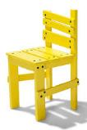 |  | 

2.4 APPLY THE BASIC SKILLS OF CUSTOMER SERVICE

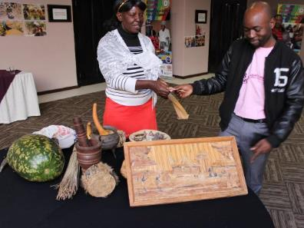

Through this section the participants will:
- Learn how to price products and services
- Understand how properly pricing a product or service is important to a business
- Understand a simple priding formula

Definition: Customer service is taking care of a customer's needs by being professional and helpful and assisting before, during, and after the customer has made a purchase. It is the experience that a customer has when dealing with your business. Good customer service is building good relationships with your customers so that they are happy and want to come back.

Fact sheet: A happy customer is more likely to support your business than an unhappy customer. A happy customer is also likely to spend more money. Customer service is just as important as the products you sell and an unhappy person will go somewhere else next time. An unhappy customer will tell everybody about their bad experience.

Why is customer service important? Simply because, sometimes, it may spell the difference between getting that sale and losing it to the next competitor. There are times when you and your competitor sell practically the same excellent product or service, at nearly the same price. What can make a customer enter your door instead of theirs? Excellent customer service. When you, as a business owner, and your employees treat your customers well, make them feel special, and manage to convince them that you offer the best value for their money, you are most likely to get that sale. When your business sells something similar to another competitor, but you serve your customers better, you are most likely to get a satisfied and loyal customer. And for the record, loyal and satisfied customers have been known to come back, and bring even more customers with them.

Exercise 2.4.1: What do you think makes up good customer service.
What kind of service do expect when you go shopping? Give two examples.

Give two examples of when you have experienced good service.

Give two examples of bad customer service that you have experienced.

What makes good customer service?
- Always greet people who come to your business
- Thanking the customer when they visit your business
- Be positive, helpful and friendly environment
- Always give customers a good impression of your business
- Ask your customers if they are happy with your service
- Ask them how you can improve the service
- Accept complaints and compliments and follow these up
- Always give customers feedback if they have complained
- Make sure that anyone who works in your business treats the customers well
- Help people and show an interest in what they are looking for
Listen to customer complaints; you may learn something about your product or service. Let customers know that you appreciate feedback.
Ask your customers what they think about your business. This is called a customer satisfaction survey.
Example of a survey


The best bake shop
Please take the time to fill in this survey to help us/me serve you better.

Please circle the number that best represents your view. The number 10 is the highest and 1 is the lowest. Please circle N/A for any questions that you don’t have enough experience to comment on.

Professionalism levels:
10 9 8 7 6 5 4 3 2 1 N/A
Ability to understand your needs:
10 9 8 7 6 5 4 3 2 1 N/A
Knowledge of the products:
10 9 8 7 6 5 4 3 2 1 N/A
Quality of products:
10 9 8 7 6 5 4 3 2 1 N/A
Value for money:
10 9 8 7 6 5 4 3 2 1 N/A
Customer service
10 9 8 7 6 5 4 3 2 1 N/A

Briefly tell us how we can improve or other products you would like to buy from us. Describe how could we add more value to your organization?

The importance of quotations in business.
Definition: A quotation is a document that offers to sell goods or services at a stated price, under specified conditions. A quotation is a document that offers to sell goods or services at a stated price, under specified conditions. Quotations are used to let a potential buyer know how much your goods or services will cost before committing to purchase them.
Fact sheet:
- In business, a quotation is a document that a service provider would give to a customer, usually on request, which lays out clearly what goods or services that they can provide and what it will cost the customer.
- A quotation tells the customer how much they will pay if they buy from you
- Makes clear what the terms of the transaction will be such as when payments will be due, the quality, quantity and design of a product.
- It is also a promise that goods or services will be delivered according to what is on the quote.
- The customer needs to sign that that accept the quotation.
- It is always a good idea to take a deposit to cover the costs of production if you are making something like food, clothes or furniture for example. This covers you if the order gets cancelled after you have made the products.
- Terms of payment can include “Cash”, “Cash on Delivery”, “30 days”, a “50% deposit and balance on delivery. “
- If you say that you will make a deliver 10 chocolate cakes, you cannot deliver eight vanilla chocolate cakes.
- If you cannot provide what you have promised, then this can break the contract with the customer and the customer may not want to pay.

What does a quotation look like?
- Firstly, you need a letterhead that gives the information about your business – name, address contact details, business registration and tax number.
- The document should clearly say that it is a quotation
- Each quote should have a different number, the date of writing and delivery of the quote.
- Your Customer or Client Name and Address
- All the information about what you are supplying, such as number, size, costs and description of each item.

Example:
THE BEST LINEN SHOP
35 Happy Lane, Johannesburg.
Telephone number: 0112345678
Cell: 0834256990
Company registration: 012345
Tax number: 00257897

QUOTATION 006

Date: 07 March 2016

For: COSY BED AND BREAKFAST
14 Cozy Avenue, Johannesburg.

Quantity | Description | Unit price | Total
6 | Custom made Red and blue duvet covers – queen size | R600 | R3600
24 | Custom made pillow cases in same blue | R50 | R1200
6 | Custom made fitted sheets in same blue | R100 | R600
 | Subtotal |  | R5400
 | Delivery | R50 | R50
 | Total |  | R5900

This quotation is valid for 14 days from the date above. Payment terms: 50% deposit and 50% cash on delivery.

If you accept the terms of this quotation please sign:

I accept the terms of the above quote:

Name__________________________ Date______________________

Position____________________________________________________

  - SIZE, LOCATION AND DIVERSITY

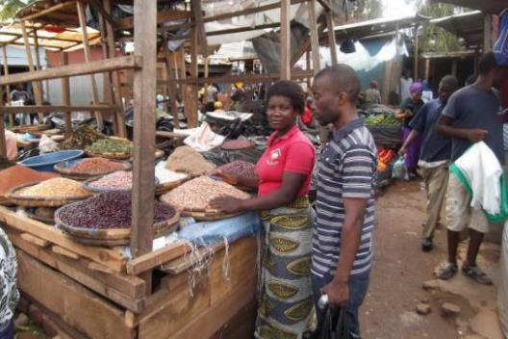

Through this section the participants will:
- Understand the importance of location for a business
- Learn that product and service diversity increases business
- Understands size as a measure of a business and that this can impact on business

Definitions
Size of a business – what size a business is. It can be micro, small, medium or large
Location – this is where the business trades from e.g. a big supermarket may sell food, clothes and books. Location is also important to avoid some of the risks you may face in a business such as floods.
Diversity is the variety of products or services that a business provides. It also means looking at your market and identifying something that nobody else sells and then filling this gap.
Exercise 2.5.1: Choosing where, what and how big to start a business. In the plenary brainstorm with participants what they understand about the importance of:

SIZE | LOCATION | DIVERSITY

Exercise 2.5.2: Judging size, place and variety (diversity)
The facilitator will divide participants into small groups of and discuss the following.

The pictures on the next page are all of businesses that sell fruit and vegetables but are selling different products in different ways. Some are selling very few products of the same kind. Some are selling small amounts of different kinds. Some have much more to sell than others. But all have one thing in common.

They are trying in some way to earn income to support themselves and their families by being in some kind of income generating activity.

Look at these businesses closely and think about what is similar or different about each of them in terms of their:
- Size
- Location
- Products they are selling

Try to see if these businesses are in a good place, selling enough products and big enough to make profits. Try to identify the advantages of one business over another.

- Which of these types of fruit and vegetable businesses is most likely to make profit? Explain why you have given this answer.

Picture Number | Explain

- Which of these types of fruit and vegetable businesses is most likely not to make profit? Explain why you have given this answer.

Picture Number | Explain

- Which of these businesses are most likely to grow? Explain why you have given this answer.

Picture Number | Explain

- Which of these businesses are in the best location? Explain why you have given this answer.

Picture Number | Explain

- Which of these businesses are most likely to need money to get started? Explain why you have given this answer.

Picture Number | Explain
Fact sheet
We know that the same kind of businesses can operate in many different ways.
All the businesses in the above pictures sell shoes in different ways and places. Some will make more profit than others.
Where you set up your business, what you decide to sell and who you want to sell too are all important. Businesses selling shoes on the street, in a shopping mall or as a part of a large store that sells all types of clothes are all positioned where they think they will find the right customers.
Location is very important. A business needs to be where there target customers are and needs to sell what the customer wants to buy. It is also important that you look at any riks that you may face where you set up your business.
Size is important for many reasons. If you do not have a lot of money then you should start small and grow. Many people think that they should start big to impress people and borrow lot’s of money rather than growing big.
Having a variety of products will probably attract more customers. People like getting things they need in one place.
How you display your products is also important: People should be able to see what you are selling and should be atracted by the way you display them.
Risks in business. These are any kind of event that can stop your business from operationg. There are many ways that a business can be interrupted from operating. This can be short term of long term.

Exercise 2.5.3: What kind of events can stop a business from operating? Please give for examples that you can think of. Participants should work in pairs to do this exercise.

Event | How can this affect a business?
Exercise2.5.4: How would these events affect the running of a business?

Type of event | Effect on business | What could be done to prevent this?
Fire in a market
Floods
Suppliers moved away
No power
Roof caved in the shop
Theft from the business

  - START UP FINANCE

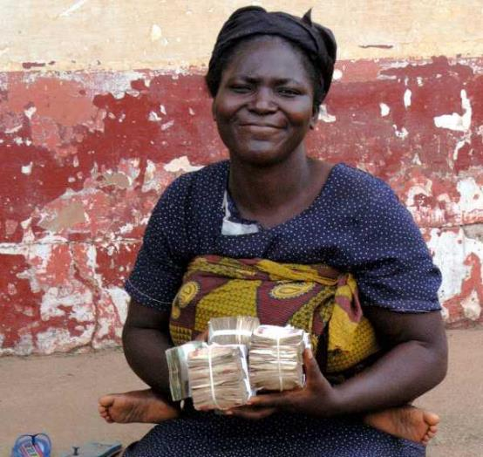

Through this section the participants will:
- Understand basic financial concepts (ideas) used in running an enterprise
- Learn how to work out their start-up costs
- Learn how to work out cash flows

Definitions
- Start-up costs are the costs you will have when you start your business. These can be for stock, equipment such as a sewing machine or raw materials.
- Cost is the money that has to be paid out or spent to buy something at the price the supplier charges
- Business costs is the money you need to spend to buy things for the business, to run a business
- Fixed and variable costs
- Fixed costs are cost that you have to pay every month and they don’t vary each month whether the sales increase or decrease (that is not dependent on the level of output). For example whether you make and sell 100 loaves of bread or 10 loaves of bread a month, the rent you pay would stay the same. Fixed costs are things like rent, insurance, and salaries to staff and lease payments on equipment.
- Variable costs are those which do vary with the number of sales. For example the amount of flour you need to buy to make 100 loaves of bread, will be less than the costs of buying enough flour to back 500 loaves of bread. Costs change depending on how you make/sell.
- Owner’s wages: Many do not include the money they will draw out from each month for themselves. This can be fixed or variable and will need to be factored into monthly expenses.
- Running costs are the expenses needed to run the business form day to day.
- Income: This is the money that comes into your business from sales.
- Expenses: These are the costs of running the business so that you can earn the income.
- Cash flow: This is a record of how much cash is available to the business. Cash flow is the movement of money into or out of a business and is usually measured during a specified, limited period of time e.g. monthly, annually. A business needs a positive cash flow in order to meet its expenses.
- A positive cash means that you have more money coming into the business than you are spending on costs.
- Negative cash flow: More money has gone out than has come in. This can happen for example if sell on credit or buy what you need to run the business before making any sales.
- Cash flow projections/plan: This shows you how much money is expected to come in (income) and to go out in expenses.
- Monthly expenses: What expenses you have to run the business each month.
- Pricing: An amount you will charge the customers. This amount to cover your expenses and make a profit.
- Mark-up is the percentage of cost price that one gets as profit on top of cost price.
2.6.1 Case study
Miriam wants to start her business selling bread rolls/buns with filling. She has had a good response to her market research and has found out that:
- Most people leave home at 5am to catch the taxi to the taxis to get to work
- Some 800 workers catch the taxi between 5.30 and 7.30 am every morning
- Many don’t have time to eat before they leave and like something to be sold at the taxi rank and are not happy with what is on sale now
- They think that bread rolls/buns with savoury or sweet filling will be good
- She is excited to start and needs to work out her start-up costs. She makes a list of what she needs. She plans to buy 100 bread rolls/buns per day.

Items | Expenses | Costs per unit | What are the total start-up costs with working capital for one week (six trading days)
Start-up equipment costs
Umbrella x1 |  | $5 | $5
Stool to sit on | Already has a stool | 0
Blackboard for advertising x 1 |  | $5 | $5
Baskets to carry the bread rolls/buns x 2 |  | $2.50 | $5
Annual Licensing/permits |  | $5 | $5
TOTAL |  |  | $20
Running Expenses
Bread bought from bakery @ $4 per 100 per day |  | $4 p/day | $24
Paper packets |  | $1 x 1000 | $1
Serviettes |  | $1 x 1000 | $1
Transport |  | $1 p/ day | $6
Electricity and water |  | $1 p/ day | $6
Fillings |  | $2 p/day | $12
Telephone |  | $1 p/ day | $6
Owner wages per month |  | $4 p/day | $24
TOTAL EXPENSES |  |  | $80
GRAND TOTAL |  |  | $100

These figures have been made up to make them easy to work with and are not real prices.
Note: Many small business owners do not factor their own income into their expenses. This gives a false view of the income and expenses and potential of the business.

Exercise 2.6.1: Work out what Miriam’s running expenses will be for the month (24 trading days)
Facilitator breaks group into small groups to calculate what it would cost Miriams buisness to run for four weeks.

Items | Expenses | Costs per unit | Total start-up costs with working capital for one week (six trading days) | Total working capital for four weeks (24 trading days)
Umbrella x1 |  | $5 | $5
Stool to sit on |  | 0
Blackboard for advertising x 1 |  | 0
Baskets to carry the bread rolls/buns x 2 |  | $5 | $10
Licensing/permits |  | $5 | $5
TOTAL START UP COSTS |  |  | $20
Expenses
Bread rolls/buns bought from bakery @ 4 per 100 rolls/buns per day |  | $4 p/day | $24
Paper packets |  | $1 x 1000 | $1
Serviettes |  | $1 x 1000 | $1
Transport per day |  | $1 p/day | $6
Electricity and water p/day |  | $1 p/ day | $6
Fillings per day |  | $2 p/day | $12
Telephone per day |  | $1 p/ day | $6
Wages per day |  | $4 p/day | $24
TOTAL EXPENSES |  |  | $80
GRAND TOTAL |  |  | $100

Groups should explain how they got to their answer and share this on flipchart paper.

  - PRICING

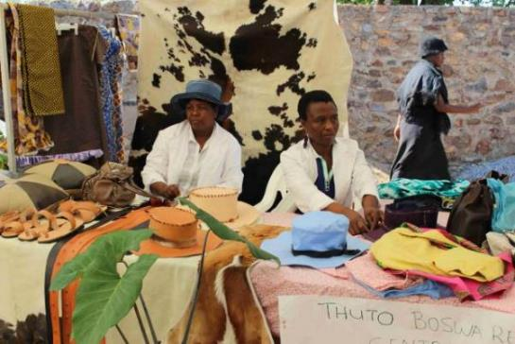
Through this section the participants will:
- Learn how to price products and services
- Understand how properly pricing a product or service is important to a business
- Understand a simple priding formula

Exercise 2.7.1: Pricing

The facilitator will divide partricipants into groups of 2 to answer the following questions.Is price the only way to attract customers? What other things can attract customers? Please list 3 ways?

Exercise 2.7.2: Facilitator break group into small groups to do the following exercises. Portia runs a business from home. She sells window frames. She buys the window frames for $20 each and the transport costs her $2 each. She wants to markup by 30%. What will her selling price be?
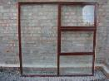
- Cost x mark-up percentage = added amount
- Cost + added amount = selling price
Take your time to work this out there is no hurry.

Fact sheet
Remember that your expenses and income will not be the same every month. The more you sell the higher your overhead costs such as ingredients will be.
Only your fixed costs will stay the same each month for the first 12 months. Doing a cash flow plan will help you to understand how much you need to sell each month TO Make a surplus (profit). If you do not understand how much money is going out of your business (expenses) and how much is coming in (income from sales) then you will never know if you are running at a loss or a profit. This is the case with many very small businesses.
Remember: Many small businesses also never consider their own salary (drawings) from the business in their cash flow. This is a very bad idea and creates a completely wrong impression of the health of your business because you be taking money out that you have not planned for.
One of the most common mistakes in business is that the lower price gets the most sales. Small business have to price products and services to cover their costs and to create a surplus for growth to survive. What you charge needs to consider the following:
- Your costs to produce the product – if you can’t cover costs you will go out of business
- Any competition you might have
- What the customers are prepared to pay
Customers will pay more for a number of reasons:
- Quality of the product or service
- Convenience – e.g. don’t have to spend money to travel, can be in smaller amounts
- Quantity – providing the right size for the market
- Good service/ Reliability/Value for money
To price your products you need to also:
- Promote sales
- Not be too expensive either
- Review prices on a regular basis for example to keep up with changes in costs of production of any new competition
There are many ways to work out a price for your goods or services. The absolute basic for pricing anything you sell is that you sell it for more that it has cost you to make or buy to sell.
Many of these methods are very complicated. The simplest way is the mark up formula. A mark-up formula tells you what to sell something for to cover your running costs. This method lets you identify your costs per item and then add on an amount (mark-up) to make money out of the sale.
You prbably use this to decide what to buy when you go shopping. In your head you try to decide how much the item cost the shop to try to work out the markup and to decide if the price is too high. If you think the price is too high you might wait for a sale to get a better price.
Let’s look at some examples
- Leah sells computers from her home. She buys computers for $200 (cost) and it costs $10 to have each one delvered to her home. These computers cost her $210 each to get to her home. She charges a 50% markup. To work this out multiply the mark-up by the cost of the product then add the cost to the added amount you have worked out:
Cost x mark-up percentage = added amount
Cost + added amount = selling price ($210 x 50% = $105.)
The selling price of each computer will therefore be 315 each.

- It costs Alice $5 to make a tracksuit, including all her expenses. She needs to decide how many she needs to sell and at what price to make a profit. She wants to add on 50%. She works out that:
If Alice has a a 50% mark-up
@ 50% x $5 = $2.50 per unit mark-up
= Selling price will be $5 + $2.50 = $7.50 per unit sold
She plans to sell 20 per month. Her income/turnover will be $150 per month. Her expenses ar $100 per month. She will make $50 dollars profit per month if all her expenses stay the same.

Now you are ready to look at your cash flow needs.
  - CASH FLOW
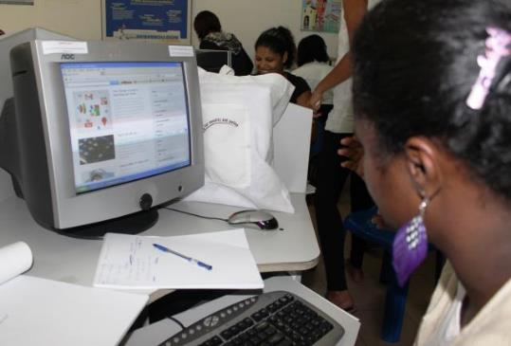

Through this section the participants will:
- Learn to do cash flow projections on cash flow projection chart
- Learn to do cash flow on a cash flow chart
- Understand the importance of managing cash flow
CASH FLOW PLANNING - 12 MONTH PROJECTION TO HELP YOU DECIDE HOW MUCH YOU NEED TO SELL

MONTH: | 1 | 2 | 2 | 4 | 5 | 6 | 7 | 8 | 9 | 10 | 11 | 12 | TOTAL
Income from sales
Other income
Other income
Total
Expenses
Total Payments
Surplus/Deficit (-)

EXAMPLE OF A SIMPLE 12 MONTH CASH FLOW STATEMENT FORM TO TRACK YOUR ACTUAL MONTHLY INCOME AND EXPENSES
 | JAN | FEB | MAR | APR | MAY | JUN | JUL | AUG | SEP | OCT | NOV | DEC | TOTAL
INCOME FROM SALES
OTHER INCOME
OTHER INCOME
TOTAL
EXPENSES
Owner salary
TOTAL

  - RECORD KEEPING

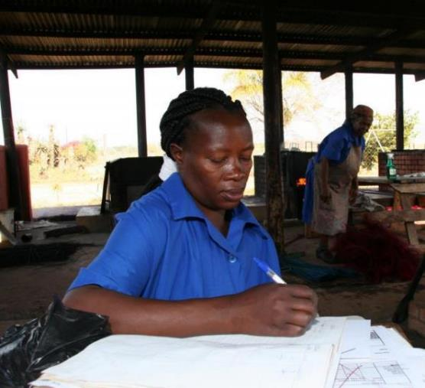

Through this section the participants will:
- Understand the importance of keeping records.
- Understanding how this makes a difference to them understanding their businesses income and expenses and profitability.
- Understood simple ways of keeping records.

Definitions
- Records are written evidence of past business activities such as expenses and sales. In other words if you keep records you will know what you are spending and what you are making from sales.
- Cash book is a record of all cash receipts and payments
- Invoice is a list of goods or services provided, with a statement of the amount they owe for these things.
- Receipt is written proof that you have paid for goods or services.
- Loan is money that has been borrowed that needs to be paid back
- Stock is the goods and products which is in the business and can be sold to customers
Case study
Maia lives in a rural village. The nearest shops are ten kms away so the people in the village tend to buy locally when they can. Maia sells eggs which she buys from a nearby farm. She started with $10 that she had saved to buy eggs. She been in business for two months and realised that she doesn’t really know if she is making money. She decides to start keeping a record. She always wants to understand her business better because she wants to also start buying some chickens who can lay eggs for her. She plans to also sell chickens when she has enough. She has identified her daily expenses as stock (buying eggs), travelling to the farm to buy eggs costs her $1 each trip. When she buys eggs she pays $1 for ten. She sells them $2 per ten.

Exercise 2.9.1: Keeping records of income, expenses and stock levels.
Facilitator will break groups into small groups to complete the following exercise based on the case study.

Groups need to complete this record keeping exercise.
DATE | CASH IN HAND | NUMBER YOU BOUGHT | TRAVEL  COSTS | AMOUNT  SPENT | TOTAL SPENT | NUMBER YOU SOLD | AMOUNT MADE IN SALES | CASH IN HAND | NUMBER OF EGGS LEFT
DAY 1 | $10 | 40 eggs | $1 | $4 | $5 | 20 eggs | $4 | $9 | 20
DAY 2 | $9 | 0 |  |  |  | 20 eggs | $4 | $13 | 0
DAY 3 | $13 | 40 eggs | $1 | $4 | $5 | 20 eggs | $4 | $12 | 20
DAY 4 |  | 40 eggs |  | 4 |  | 30 eggs
DAY 5 |  | 40 |  | 4 |  | 10 eggs

Remember: The cash in hand at the end of the day becomes the cash in hand at the beginning of the next day. The stock you have at the end of the day becomes the stock you have at the beginning of the next day.
Fact sheet
Keeping up-to-date and correct records is important for your business. Records help you keep track of your expenses and your income. To achieve this you need to keep records of all your:
- Sales and takings (money coming in for sales)
- Purchases and expenses (money you have spent to run the business)

Records you may need in your business
- Cashbooks
- Invoices and receipts – keep these in a file
- Bank statements (if you have a bank account)
- Loans or debt for example for equipment or a business loan
- Stock in your business
- A record of money taken out of the business for personal use

Records can be kept in many different ways, on paper or on a computer. These records can be simple but still help you to track the money in your business.

Some very good rules
- It is important that you keep your business and personal records separate, so that you can understand which expenses are about the business itself. You keep a record of expenses if you work from home and allocate a portion to your business expenses. This will give you a more realistic idea of how much your business costs you to run.
- When you start keeping records you should do this daily until you get used to the way the figures work. This is a simple example of how this works.
- Always keep receipts and invoices and in a safe place.

Example of a simple way to record. Apply this to other products you may sell. Try with more than one product.

DATE | CASH IN HAND | NUMBER YOU BOUGHT | TRAVEL  COSTS | AMOUNT  SPENT | TOTAL SPENT | NUMBER YOU SOLD | AMOUNT MADE IN SALES | CASH IN HAND | NUMBER LEFT
DAY 1
DAY 2
DAY 3
DAY 4
DAY 5

2.10: STOCK CONTROL

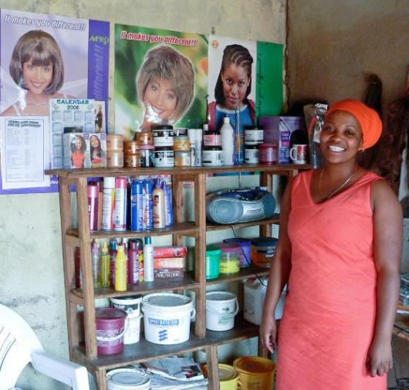

Through this section the participants will:
- Understand the basic of stock management and control
- Have an appreciation of ways to prevent stock shrinkages (losses)
- Understand how to plan to have enough stock to meet custmers needs

Definitions
Stock control is the checking of what stock you have in a business to meet what customers may want. Stock control is important so that you always know how much stock you have in your business at any one time.
Stock is the amount of goods, raw materials and products that you have available in your business at any one time

Case study 2.10.1
Leah owns a hair salon on the outskirts of a large town. Her salon is very popular and she employs 10 hairdressers. She is very worried because her stock of hair straightening lotion does not last out the month and she has to top up every month. This costs her extra money and she wants to solve the problem. For the next 2 months she keeps a daily stock sheet of all the products used in the salon.
She discovers that the staff are not measuring the correct amount of straightening lotion and are often using too much. They should only be using 50 mls each time. The next time she orders she also orders small plastic bottles that only hold 50 ml. She will decant the 5 litre bottle into these small bottles each day to make sure that she has better control.

Allala owns a salon in a section of a large city where there are many hairdressers. Her salon is the farthest from the local shopping centre. She often runs out of braids because she doesn’t buy enough to service her customers. Sometimes she sends a customer to the shopping centre to buy her own. On the way many customers pass other hairdressers who have braids in stock. These costumers usually do not come back to Allala’s salon. Allala has not made a success of her business and is thinking of closing if business doesn’t improve.

Exercise 2.10.1: Facilitator breaks group small groups to answer the following question based on the Allala case study. How can Allala improve her stock control to improve her business?

Fact sheet
All businesses big or small need to be able to keep track of their stock. Controlling stock does not mean having as little as possible in your business.
It’s about having enough stock to satisfy customer needs and to check on losses or theft.
How does managing stock help a business? You develop an idea of usage or sales of items and this helps you to identify trends in your business. For example if you own a shop you might notice that you sell a lot of chocolates but very little chewing gum.
- You would notice that you sell more chocolate at Christmas than any other time.
- You will notice that some things sell quickly and other not.
- Helps you to have the right quantity available for your customers and to anticipate the sales
- Helps you to know when to increase stock at special times
- Helps you to identify theft or losses or wastage in your business:
- raw materials in a manufacturing business
- goods in a retail business
You need to count your stock on a regular basis.
- This can be done daily, weekly or monthly.
- Record all the items that leave your business if you are a shop or a business that sells ready made goods that you have bought from someone else
- At the need of the day/week/month you need to check stock against what you have sold
If you run a business that uses portions of an item such as flour for baking or hair straightener for hair, then you can break up the large stock item into smaller stock items for better control.
This would be important if you employ staff and they do not know exactly how much to use.

  - TENDERING AS A BUSY OPPORTUNITY

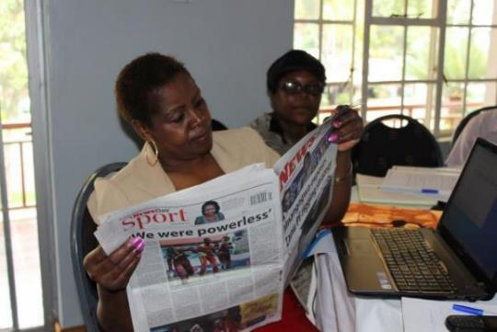

Through this section the participants will:
- Understand what tenders are.
- How small business can benefit from tenders but that they need to not rely on them as the only source of business.
- Tendering is hard and many things need to be considered.
- Where you can look for tenders.

Definitions
Tendering: Is the process of offering to carry out work or to supply goods to a private company or government department on the basis of meeting certain requirements needed to fulfil the work or supplying of goods.
Tender process: The process that a government or private companies carry out to request companies to bid to provide goods or services on a competitive basis to get the best or cheapest company to supply goods or do a job.
Procurement: Is the buying of goods or services from an external service provider.
Affirmative procurement: Is a policy which is practiced by some governments and firms that allocates quotas of procurement opportunities to communities which have not had a fair share in the past such as women and in the case of South Africa, black owned businesses.
Compliance: This is the process of obeying external regulatory requirements and or policies within a company.

Case study
Alicia has been a dressmaker for a number of years. She has been running a very small business, making clothes from her home and selling them to neighbours and at the local market. She heard that the government had a new policy for procurement and was given at least 50% of tenders to women.
Alicia found out from her local council where she finds out which tenders were available and when. They told her to look in the newspaper every Saturday. Alicia started to buy the paper every week. On the third week she found a tender to make school uniforms and track suits for a primary school of 400 children in the nearest large town. Alicia worked out how much it would cost her to make the items. This included costs for materials, travel, transport, and extra sewing machine and 2 more seamstresses for 3 weeks. She would have to borrow money from her family to buy the sewing machine and the materials. She would only do this if she got the tender. The 2 staff she would pay when she got paid for delivering the goods.

She checked the price of buying school uniforms from the shops in town and found out that she could make 15% profit and still be competitive. The income would allow her to pay back the family and still have enough money to put some aside for the next tender she would apply for. She decided to apply for the tender.

Exercise 2.11.1: Facilitator will set up small groups to answer based on the case study above.

What did Alicia do to make tendering a potentially good idea to grow her business? Give at least 3 ideas.

Fact sheet

A TENDER MAY BE ADVERTISED IN A NEWSPAPER LOOK LIKE THIS
RFP NUMBER: | GL/2012/00015
DESCRIPTION: | REQUEST FOR PROPOSALS FOR THE APPOINTMENT OF A SERVICE PROVIDER TO PROVIDE CLEANING SERVICES TO GENDER LINKS OFFICES IN JOHANNESBURG.
PUBLISH DATE: | 03 February 2014
VALIDIY PERIOD: | 30 days from the closing date
CLOSING DATE: | 3 MARCH 2014
CLOSING TIME: | 11:00 AM Late bids will not be accepted.
COMPULSORY BRIEFING SESSION | Briefing to be held at 10 am on the 7 February 2014.  (This is often a requirement)
BID RESPONSES MUST BE HAND DELIVERED TO: | Gender Links Head Office  Derrick Avenue,
ATTENTION: | Ms Fikile
NB: Bidders must ensure that they sign the register at the reception when delivering their bids.
BIDDER NAME: Mozambique Rural Women’s Trading Company

Issues to think about if you want to tender for business:
- You need to decide if you are ready to meet what the tender requires:
- Do you have enough staff?
- Do you have enough equipment to do the job?
- Can you afford what it will cost to increase your staff and equipment and survive until the first payment comes in?
- Can your business survive for the time it takes for the tender to be awarded?
- Do you have enough work to carry you through – always remember that there is no guarantee that you will get the tender and that you can’t therefore rely on this one opportunity?
- If you have enough work already, can you meet the needs of the tender?
- Tenders are very specific and if you don’t deliver in terms of the requirements you may have to pay penalties, so it is very important that you have the right resources to do the work or provide the goods.
- To be considered for a tender a business needs to be:
  - Compliant with the laws and regulations of a country e.g. department of labour, local government trading permits etc.
  - Registered as a business in that country
  - Have a bank account and good history with the bank
  - Have a good credit history
  - Be registered with the tax department and be up to date with tax payments
  - Have the right skills and equipment or is able to buy in these things into the business for the tender
  - Would you need to borrow money to meet the tender needs – can you afford to borrow? The cost of capital needs to be added to the price of yur tender submission.
- Businesses can often work together on a tender and this will be stated in the tender document with all the rules that apply for this arrangement. The company that is the primary bidder takes all the risk and so must be sure of the people they choose to work with.
- You need to have enough time to prepare the tender proposal accurately and in full. It is always important to provide all the information even if you think it isn’t important. If you don’t then they will probably disqualify your bid.
- Tenders always ask for a lot of supporting documents and you need to have these in good time and up to date e.g.:
- A tax clearance certificate
- Company registration papers
- Proof of bank accounts
- Vat registration details
- Any other information that they ask for
- Recently certified copies of original documents
  - You need to know how to price properly! A tender proposal needs to be priced properly if you want to make profit on the tender. This is sometimes difficult because you won’t know what other firms are charging. But it is important to price at the rate that supports your own business. Getting tender and losing money is a waste of time.
  - The simplest way to price remembers is to work out your costs and then add a margin. The bigger the business and the bigger the tender, the more complex this gets. If you can’t work out the pricing then you could ask for help with the financials and figures.
- Tenders can be simple or very complicated.
  - Simple tender can be once off to supply pens, flash drives or computers. You would build in the costs:
  - of the products,
  - of getting the products to you
  - of delivering the products
  - More complicated tenders will need more complicated pricing.

What this means is that many people will apply for the same tender. It is very risky to base your business on hoping for tenders. You need to broaden your approach to your business. Some tenders are too small to keep a business running and getting one tender now and again won’t sustain your business. A business needs to spread its risk by not relying on only one customer or source of income.

  - FUNDING A BUSINESS

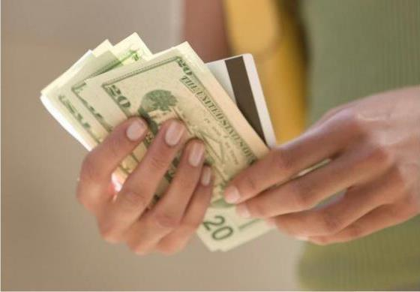

Through this section the participants will:
- Understand different ways to fund a business.
- Understand different types of funding.
- Will have some idea of how much information they have about available funding.

Definitions
- Debt: This is money you have borrowed and need to pay back
- Credit: Credit is an amount of money approved for you to spend if you qualify. The use of this money can be specified for example to buy a car or to buy things for a business
- Credit means that you can take something home and own it because it has been paid for by the credit provider eg credit card. This debt still has to be paid and you will need to pay extra as interest will be charged on the loan. If you don’t pay the money you owe then you can get a bad credit record or have goods taken back by the shop.
- Revolving credit: This is form of credit that gives you a pre-approved a lump sum which you can use to buy things. You only pay back the amounts you have spent. Once you pay you can re-use the credit. A common use of this is a store card. You buy clothes and take them home and then pay the amount off.
- Interest: Interest is an extra amount that you pay for money that you borrow
- Savings: This is money that you can put aside either for personal needs such as school uniforms or for the business so that you can build the business.
- Working capital: This is money that a business needs to pay everyday expenses. When a business starts up it doesn’t generate enough money to meet all its expenses.
- Bridging finance: This is an amount of money that you may need to borrow to cover the expenses of an order until you get paid. For example you get a tender from government to supply 100 computers. You only have enough money to buy 10. You would need to borrow money for the other 90. This funding is usually short term and needs to be paid in full when the contract is finished.
- Micro finance is money lent in very small amounts, usually to groups of people who stand security for each other.

2.12.1 Case study
Mary runs a printing business with her husband. They live in a small town where there are not a lot of shops. For printing ink and paper they need to travel one hundred kilometres to the nearest large town. They have a large order for a local hotel to design and print brochures but they only have enough money to do 10% of the job. They travel to the nearest big town and buy what they can. They deliver these pamphlets and asked to be paid. They use this money to travel back to the big town to carry on to do another 30% of the order. This they repeat until they have completed the order.

Exercise2.12.1: Facilitator breaks group into small groups to answer the question based on above case study. Ask the question – does this business need funding and why?

How would this business benefit from borrowing money?

Fact sheet: How can you save?
Informal savings
Small amounts can be saved at home and many people save in a stokvel. The main problem with this is the money won’t earn interest if the money is not in a bank.

Savings plans in banks

Term Deposits
If you are easily tempted to draw money out of your savings, you can open a savings account which forces you to keep the money in the bank for a period of time.
- Lump sum Fixed term Deposit
This is an amount of money placed in a bank for a term no longer than one year. The money can only be drawn out after the time has expired
- Fixed term
This means savings for a fixed period of time such as 12 months but you must deposit money each month
- Ordinary savings accounts
You can put money in these accounts and draw it out anytime you need it but the interest will be low.

What is interest? A fee paid for the use of another party's money. To the borrower it is the cost of borrowing the money, to the lender the income from lending the money. It is a rate which is charged or paid for the use of money. In other words we buy and sell money like any other commodity.
Why do we pay more interest for the money that we borrow? At its very core, a bank borrows money at lower interest rates and lends them out at higher interest rates. Banks make money by borrowing depositor’s money at a lower rate than they sell money onto someone else.






People put money in a bank
People borrow from a bank

They earn interest of 5%
Pay 10%
Yes to another 5%

Exercise 2.12.2: Finding funding?
Invite the group to share information they have about any sources of funding that they may know about, what those options offer and whether they suit the needs of local women. Invite women to share their own experiences with raising funds for their business. Put the input on the flip charts and collate the responses to answer the following questions and include in the workshop report.
- Are there sources of funding that the women are aware of?
- What types of funds are available?
- Are women able to source these funds?
- What difficulties have they encountered when seeking finance for their businesses from these sources?
- If they have raised funding?
- What amounts were available e.g. between 500 and 1000 of local currency?
- Did the money help their businesses?
- In what ways did it help?

Fact sheet
Access to finance for business can be difficult for both men and women. Women however find it more difficult for a range of reasons, mainly because they are women. This includes the idea that women don’t have enough time to run a business because of family responsibilities.

Women often work from home and for a long time this was not considered to be a real business. Traditional sources of business finance such as banks may require that a women’s application be co-signed by a husband or a father which undermines women’s independence and can lead to conflict, if the men do not want the woman to access credit for the business.


Women’s businesses often start out small and small loans are not attractive to banks. The vast majority of women are in micro or very small businesses. The primary source of finance for these women is micro finance. This is high interest bearing, very small loans, usually offered to women in groups who stand security for each other’s debt.

This has become celebrated as alleviating poverty and empowering women. There are several arguments against this. These loans are very small and group lending constrains women who want to be independent as they have outgrown the group.

The emphasis on micro finance as a source of business finance has meant that very little effort has been made by countries and the financial services sector to develop products and services more suitable for women and which can close the gap between micro finance and traditional sources of finance such as banks so that they can grow.

The main sources of funding for women in business include:
- Savings
- Borrowing from friends and family
- Micro finance
- Credit cards
- Banks when their businesses are growing

Why do businesses need to borrow money?
For most people in business, they assume that borrowing money will make their business a success. This is not always the case. Sometimes people need to run their business properly and to manage their finances rather than borrow money. This is why you need a cash flow.
For some businesses the money you raise from your own resources won’t be enough. You may need money for equipment or a vehicle or working capital or bridging finance.

Close the session with these thoughts: Borrowing money to run your business can be a big help but it is important to remember that:
- You should only borrow when you really need it.
- Don’t borrow for things you don’t really need but want.
- Borrowed money is expensive as interest is charged.
- Borrowed money has to be paid back whether you can afford it or not.
- You may be able to solve your problem by running your business smarter.

http://www.minnpost.com/business/2013/10/land-o-lakes-helps-empower-women-sub-saharan-africa-develop-business-skills
http://www.bulawayo24.com/index-id-news-sc-national-byo-48259.html
http://futurestreams.co.za http://www.compassodyssey.net http://thinkafricapress.com/ghana
https://www.ashoka.org/social_entrepreneur
http://www.free-power-point-templates.com/articles/free-product-life-cycle-powerpoint-template/
https://www.google.com/search?q=products+changed+to+attract+sales&rlz=1T4LENN_enZA572ZA572&source=lnms&tbm=isch&sa=X&ved=0ahUKEwin7dPV0bjMAhWhBcAKHd16AIwQ_AUICSgD&biw=1366&bih=589#tbm=isch&q=old+and+new+branding+ideas+coca+cola&imgrc=Bl8Bo_VnhOV3fM%3A
http://www.investorwords.com/6455/competitor.html
https://www.google.com/search?sourceid=navclient&ie=UTF-8&rlz=1T4LENN_enZA572ZA572&q=quality+control+definition
http://www.voteforus.com/whyiscustomerserviceimportant.html
https://debitoor.com/dictionary/quotation
http://www.imow.org/economica/projects/story?key=4108
http://dealbook.nytimes.com/2014/04/01/tap-to-pay-not-so-much-in-the-u-s/?_php=true&_type=blogs&_r=0
http://www.iconarchive.com/show/sleek-xp-basic-icons-by-hopstarter/Files-icon.html
http://www.premiumpsd.com/coloful-office-files-icon-psd-download.html
http://www.doublexeconomy.com/2013/02/01/the-oxford-forum-for-women-in-the-world-economy/
http://madamenoire.com/114425/10-obvious-and-not-so-obvious-ways-to-save-money/8/

