


EMPOWERING WOMEN, END VIOLENCE

ENTREPRENEURSHIP TRAINING

FACILITATOR’S GUIDE



2018

Gender Links (GL) is committed to a region in which women and men are able to participate equally in all aspects of public and private life in accordance with the provisions of the Southern African Development Community (SADC) Protocol on Gender and Development.

Taking charge! Empowering GBV survivors through life and applied entrepreneurship skills
© Copyright 2018, Gender Links.
ISBN:

Gender Links
9 Derrick Avenue
Cyrildene, 2198
Johannesburg, South Africa
Phone: 27 (11) 622 2877
Fax: 27 (11) 622 4722
Email: coo@genderlinks.org.za
Website: www.genderlinks.org.za

Editors: Colleen Lowe Morna, Anne Hilton and Mariatu Elba

Design/Layout and print:

Sponsors:

BACKGROUND AND RATIONAL

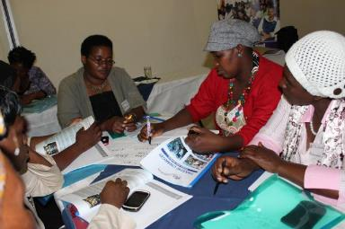

Gender Links (GL) is a Southern African NGO founded in March 2001 with the head office in Johannesburg, Mauritius (Francophone base), Mozambique (Lusophone base) and Botswana (headquarters of the Southern African Development Community) as well as Lesotho, Madagascar, Swaziland and Zimbabwe. GL is committed to an inclusive, equal and just society in the public and private space in accordance with the SADC Protocol on Gender and Development. This has been updated in line with the Sustainable Development Goals, Beijing Plus Twenty and Africa Agenda 2063. GL coordinates the Southern African Gender Protocol Alliance and works to achieve the targets of the Protocol in its core media, governance and justice programmes.

Embedded in the aims is a mission to end GBV as the scourge of gender based violence in the SADC region, community by community. This to be achieved by recognising the important role played by local government; in the pursuit of excellence in the implementation of policies and strategies that serve all of their constituents.

GL VISION AND MISSION
VISION:
Gender Links (GL) is committed to an inclusive, equal and just society in the public and private space in accordance with the SADC Protocol on Gender and Development.
MISSION:
GL achieves its vision through a people-centred approach guided by the SADC Protocol on Gender and Development that is aligned to the Sustainable Development Goals, Beijing Plus Twenty and Africa Agenda 2063.

Working with more than 100 of 425 Centres of Excellence (COEs) for Gender Mainstreaming in Local Government in SADC, GL has run a successful programme aimed at reducing gender based violence (GBV), through the economic empowerment of survivors.

Over the last 17 years GL has worked with gender based violence (GBV) survivors to document their personal testimonies or “I” stories; has provided insights into some of the drivers of GBV particularly of intimate partner violence. Many women write about economic dependence as both a cause for violence and as a reason for staying or returning to abusive relationships.

GL was from the onset cognisant of the diverse views in terms of the impact of economic independence for those experiencing GBV. The GL programme therefore set out initially as a pilot to add to the research on the links between economic independence and GBV in the SADC regions.
The aim was also to test the hypothesis that economic empowerment for women can reduce their vulnerability to GBV.

In a successful pilot started in 2013; 1350 women were trained in life skills and entrepreneurship training in 10 SADC countries and 101 local councils; in both urban and rural environments. The overall results showed that in this target group 87% of the women indicated that GBV experiences were “better or much better” following participation in the project. Many attributed this to the fact that they were able to earn them income and “put food on the table”. The results have made this a model of reducing GBV viable and worth pursuing.

Objectives
- To increase women’s agency and independence, socially, emotionally and economically

LIFE SKILLS
ENTERPRISE TRAINING

MENTORSHIP
ACCESS TO FINANCE

INTEGRATED MODEL FOR ENTREPRENEURSHIP AS AN INSTRUMENT OF CHANGE
SURVIVORS OF GBV
- To empower them to participate fully in all aspects of their private and public lives
- To provide them with the tools to realise their economic potential as entrepreneurs
- To provide women alternatives to persevering in situations where they experience GBV
- Break the stereotypes of women in business in emerging markets
- Connect women with information, services and resources in their own countries to enhance their ability to succeed

The implementation focuses on an integrated approach of:
- Life Skills Training: Life skills including confidence building; writing; public speaking; decision making.
- Entrepreneurship Training: Entrepreneurship skills which includes starting up a business; basic business management skills such as financial management, marketing and applying for tenders.
- IT training: Use of computers and Microsoft applications is an essential part of the Phase one process which encourages women to explore and use the computer as a tool for change. They type up their original business ideas with the help of facilitators.
- Networking to identifying sources of support and business opportunities.
- Addressing the underlying structural inequalities between men and women.

How GL measures change?
GL is a learning organisation with a strong commitment to measuring change in the projects of the organisation. A very strong component therefore of GL programs is the emphasis on Results for Change. GL has developed several tools to measure changes in the social and economic status of the women that participate in the Sunrise Campaign project.
At the level of community GL will:
- Review the council’s GBV action plan at the beginning of the process and at the end to assess how the plans have changed and levels of progress in implementing the plan.
At the level of the individual GL will do:
- “I” stories or personal accounts of experiences of GBV will be collected before and after the training. Prior to the training GL will work with the participants to document their stories using the “healing through writing” methodology and this will be repeated to measure change.
- The Gender Empowerment Index (GEI) measures five keys areas: experiences of GBV; agency; entrepreneurial flair; depression and economic status. Each participant will complete the GEI at the beginning of the programme to establish baselines. These will be re-administered at the end of the process to measure change. The GEI is online and is set up to generate automated reports. Each participant will have a profile with baseline and progress data.
- In first workshop each participant completes a personal action plan where the participants identify three things they want to achieve. This is reviewed again at the same time as the repeat I stories and GEI.
- The women develop business plans which are monitored over time as they develop their business ideas through each stage.

All the information is collated and analysed to provide qualitative and quantitative evidence of progress and change in these women’s lives at a personal and business level.

Results of the programme to date
To measure change GL conducted both quantitative and qualitative research before and after the training.
Key facts
- 1350 survivors of GBV in 101 councils in ten Southern African countries trained in life skills and as entrepreneurs.
- 91% completed a business plan and 79% followed through on the plan
- The average increase in income per month for the region was R526; the overall increase in income in 2015 because of the project is R10.8 million; a 66% increase following the pilot
- 59% added new products and 54% found new markets; 48% indicated starting a new business and 29% increased the size of their business; 41% opened a bank account and 35% increased email usage.
- 87% of participants said they experience less or much less GBV. Overall, the relationship control index increased by four percentage points to 66%.

Personal accounts: Some important outcomes are demonstrated in the personal accounts of participants through “I” stories and interviews:

One of the key aims was achieved increases in income for the women. “In the past I couldn’t make decisions in the house because my husband was always dominating me. He did not respect me because I was not earning any income. I was not happy because my husband forced me to accept decisions that he made. He thought I was not mature enough to make the right decision. After I got the training for starting a business everything went back to normal in the house. This workshop helped me because I am getting income from my business. I make clothes for children and women and the business is really progressing well, even although I was facing challenges at the beginning.” Donatilla Amwaalwa from Oshikuku in Namibia

In some cases, survivors have been able to provide jobs for others in their community. “In order to improve the productivity of her business, she opted to hire one person who is assisting her to do much of the work especially selling finished products and washing bakery dishes. She managed to register this person with social security commission and is paying her reasonable salary.” Allensia Garab from Outja, Namibia

Before the project started some of the women were already running small businesses and have said they have been able to improve how they run the businesses. “Before the training I was not interested in doing business as such. I was teaching swimming but after the training I learned that I could also earn extra money. I am still doing my swimming classes but with an added twist. I prepare snacks g and sell this to those who come to swimming lessons. Thanks to the training I have been able to develop this idea. My family especially my daughter really appreciates the fact that I have been able to get a chance to make the most of my old age.” Dorine Volafite Beau Bassin, Mauritius.

One of the main aims of the project was to increase survivor’s personal agency and many have indicated positive changes in their relationships. “I now know where I am today. I have learned to be strong and stand up for myself as a woman. I have experienced violence from my husband. We fought a lot about money. These days we can talk about our problems as adults and mostly I am the one who has to initiate the talking.” Thembakazi Ngemntu from Bitou South Africa.

The programme brought about a change in IT skills.

As illustrated in the graph, 68% women now use a computer compared to 18% at the start of the project. 48% have access to E Mail (compared to 13% at the start). 32% surf the internet (compared to 13% at the start). 7% now have a website or space on a website, compared to 3% at the start.

Impacting on gender mainstreaming in local government: The programme has helped Centres of Excellence for Gender in local government; to put their gender action plans to work. “From the action plan generated during the gender training workshops, the council has managed to develop a drafted HIV policy, which is engendered. The council has also been quite proactive in considering women for job opportunities particularly in waste management, and fire emergency response. This action has come because of the entrepreneurship programme being carried out in partnership with Gender Links.” Case study of the Lusaka Council by Albert Ngosi.

Role of the COE’s: The roles and contributions of the COEs have been instrumental in the success of the project. Whilst some results were mixed between councils, the overall result showed GL where the strengths and weaknesses were in the relationship between GL and these COEs. This has been fundamental in the changes suggested to the project going forward from 2018; about the relationship and support between these partner organisations.

The perceptions of council support varied from country to country, council to council. The outcome was the introspection of the initial design for the roll out of the project and the need to review this in line with a more structured and sustainable approach; based on clearer information provided to councils, council evaluations and sound negotiations to achieve the aims of the project. For example, there needs to be a clearer understanding of the resources available to councils; both internally and externally; to achieve sustainable results.

Given the strengths and weaknesses between councils; it was also mooted that councils be encouraged to work together in cluster formations for stronger and more experienced councils to support their weaker or less resourced counterparts; for peer support, learning, cost effectiveness and sustainability.

Other recommendations for sustainability and success included:
- Revising approaches, roles and responsibilities of GL, GFPs and COEs. COEs should be selected that have the resources, capacity and willingness to provide support to women in the longer term.
- Identification and mobilising of resources available as a primary upfront requirement to promote programme and client sustainability; longitudinal process for the support of the women
- Selection of participants based on their desire to start or grow a business as GBV survivors is essential to maximise the economic aims of the training
- Training of COE gender focal persons to backstop and roll out the programme: Relevant staff in the backstopped councils in 2016 will receive training on programme content, logistics and management to facilitate the ongoing running of the project.
- Including partners and families in the pursuit of gender justice should be introduced to the programme with the consent of individual women
- Encourage the setting up of women’s business and community groups
- Introduce best practises prize for COES in rolling out the Sunshine Campaign
- Integrate the Comminute of Practise (COP) programme into the Sunrise campaign
Key to achieving the longevity of the programme work is the need to capacitate councils to manage and integrate the project into their council activities. This TOT programme is a step in the journey to achieve this.

Target group for training
Four key criteria need to be considered in the selection of participants to meet the aims of the project as currently run. These include:

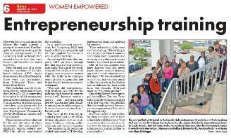
1. GBV survivors: Given the specificity of the target group and aims of the programme; it is important that GBV experiences are verifiable. This is done through interviews with the women selected through the service provider during their interaction with their clients. Service providers are required to sign confirmation of this when recommending women for the programme.
2. Age: Women survivors of GBV; irrespective of, or at what age or circumstances; this has or is occurring. The assumption being that if a woman has sought help; they are experiencing the impact. For many they have experienced multiple forms or instances of GBV from different sources. Women must be 18 years or older and are identifiable as GBV survivors from the councils own GBV programmes or via relationships with other organisations providing support for GBV survivors; such as NGOs. Ideally 50% should be between the ages of 18 and 35 years.
3. Economic status: Must be unemployed or running their own business,
4. Motivation: It is important that women want to start or grow an existing business; to qualify for this programme.

Training methodology
Key issues
The aim of the training is to both development of personal agency and basic skills needed to start and run a micro enterprise. This GL project provides a framework for the development of potentially sustainable entrepreneurship opportunities for survivors of GBV through an integrated model of life skills preparation, business development skills training, mentorship opportunities and access to finance.

It is well documented that entrepreneurship development for women, especially women in under resourced environments, is exacerbated by gender related challenges.
Whilst men and women both experience difficulties when wanting to start or run a business, women face additional challenges which are gender specific.

These include issues such as lack of mobility, lack of experience, poor skills base, a lack of assets and resources and multiple roles associated with patriarchal relationships. These obstacles often women are further exacerbated by exposure to GBV which undermines their self-esteem and confidence in taking charge of their own lives.
To affect sustainable economic independence the programme recognises the need to address:
- Women’s understanding of the social constructs of gender
- The building of self-confidence of women who have experienced GBV
- Entrepreneurship as a tool for change

The programme has therefore been designed for the target market in line with GLs vision and mission. The programme addresses both issues of social and economic justice in the pursuit of ending GBV.

Participants are selected by COEs through their relevant structures and GFPs. Given the side variety of local councils in terms of size and geographic positioning; the profile of participants is unlikely to be homogeneous and the training methodology may need to be reviewed by facilitators based on the composition of groups.

The curriculum has been designed to provide basic business skills and tools most likely to be accessible to the target market. These can be adjusted in terms of difficulty if the facilitator if appropriate to the participant group. It will help to starting to understand the level of business understanding and experience at the beginning of the programme. The training has been designed to prepare participants to plan to start or grow a business and to understand the process of writing a business plan. A tool is provided for them to take notes in sequence along with the content in terms of each section.

It is important to emphasise the need for participants to have a business idea as early as possible in the process and this should form the basis of their response to the training and the use of this tool. The aim of the project is developing economic independence through self-employment as a means of building personal confidence and an ability to make positive decisions about their lives.
Overall view
For many in the previous training experiences indicated that their self-confidence, their ability to make positive choices and negotiate relationship boundaries, was attributed to a number of factors;
- Learning new skills and knowledge
- Demonstrating their ability to earn their own income or run a business
- Putting food on the table and contributing to household sustainability
Some examples of women’s experiences:
Selection of participants: When women are selected they will be asked if they want to start or already have a business and this will inform their eligibility for the programme. This will help focus the training and group motivation and coherence. The content is provided in a way which introduces key business concepts in a practical and easy way to understand. These are core skills needed to start or run a business more effectively and provide a basis on which to expand knowledge in these areas though further training.

Key is an understanding of financial management skills; core to which is start-up finance, cash flow, pricing and record keeping. These are presented in an accessible way but need special attention during training as it is usually the most difficult content for participants to grasp. Extra time and effort is allowed on the programme. The training can be expanded through out of classroom activities such as field visits to businesses in the area, meetings with local government departments and programmes, participation in trade fairs and the introduction of “experts” into the programme. Women can share their own experiences

Key issues to remember;
- Groups may include participants at different levels of learning and this is influenced by life experience, business exposure, educational background, income, culture, geography and language.
- The content provides a basic platform but can be adapted according to the groups needs. Experienced facilitators can add content and anecdotes to enhance the experience and should gauge the groups response.
- The course is aimed at micro level businesses

Course content
The programme focusses on an integrated approach of:
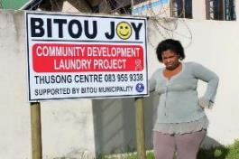
- Life Skills Training: Life skills including confidence building; writing; public speaking; decision making.
- Entrepreneurship Training: Entrepreneurship skills which includes starting up a business; basic business management skills such as financial management, marketing and applying for tenders.
- IT training: Use of computers and Microsoft applications is an essential part of the Phase one process which encourages women to explore and use the computer as a tool for change. They type up their original business ideas with the help of facilitators.

Learning materials
The course is accompanied by three training manuals in the series called;
- Taking charge: Life skills training manual: Ending Violence Empowering Women.
- Taking charge: Entrepreneurship training manual: Ending Violence Empowering Women.
- Taking charge: IT training manual: Ending Violence Empowering Women.

Collectively these promote personal agency and the potential for economic independence.

The role of the facilitator and trainer
In this context the roles of trainer and facilitator overlap as both are needed. The following table helps us to understand this.
4 Major Differences Between Facilitator and Trainer Roles
Great Facilitator | Great Adult Educator (Trainer)
Is not necessarily a content expert. | Is a content expert.
Is an expert in many forms of group process (including inter-and-intra-group conflict resolution, strategic planning, team building, etc.) | Is not necessarily expert in many forms of group process. Instead, continually develops new methods to help participants achieve specific learning outcomes.
Often helps the group to define and verbalize its own outcomes (e.g. to solve a specific problem or develop a new procedure.) When outcomes are externally prescribed, helps the group develop, implement and “own” action steps to achieve the outcomes. | Most often in corporate, organizational or higher education settings, the trainer does not help each learner group establish its own learning outcomes. (That’s a whole other approach, called Popular Education.) However, the trainer may be involved in implementing and/or analyzing the results of training needs assessments. These should include input from representative (potential) participants as well as other stakeholders.
Sees facilitation as a process to help achieve specific “bits” of broad organizational goals. | Often focuses on training’s impact on actual, discrete job performance or tasks. Trainer may evaluate training’s effectiveness long after the training event takes place.
Elements the Two Roles Share
Both great facilitators and the best trainers…
- Help the group achieve specific outcomes through the use of active, participatory, participant-centered methods.
- Regularly evaluate the process in real time, and can measure how well the participants achieved the stated outcomes at the end of the process.
- Have made themselves familiar with the organizational culture and context in which they are working, and ensure the processes “fit” that culture.
- Stimulate dialogue and interaction between participants, not just between themselves and the participants.

These are useful guidelines. When training the participants, we need to be both content experts and good facilitators to ensure full participation, goals are set. Goals are reached and aims understood.

Facilitators need to be familiar with the content and able to transfer this knowledge to participants. This is not enough and the ability to involve people, ensure everyone participates and learns at their own pace is just as important. This is a vulnerable group and it is very important for each to feel equally involved and respected.

Workshop guidelines to put the participants at ease
This is a potentially vulnerable group of women and sometimes there are anxieties about the workshops, so it is a good idea to start off with introductions, explanations and an icebreaker. Allow participants to ask questions.

Preparation
- Always familiarise yourself with the programme and content before a workshop begins
- Check in advance that all logistics are in place for the workshop
- Always arrive before the group
Introductions at the beginning of a workshop
- Introduce yourself to the participants explaining who you are
Let the participants introduce themselves individually
- Be sure to welcome each person before moving to then next participant. Give full attention to each delegate as they introduce themselves
- Give them information about the programme for the day, when the beaks will be and for how long. Tell them where the toilets are and what time you intend to finish
- Completion attendance registers, distribute manuals and discuss housekeeping rules; especially about punctuality and respecting everyone’s right to participate
- Go through the objectives and the content of the programme
- Explain the importance and role of the consent forms which participants have signed and reinforce the importance of respecting one another’s experiences and right to privacy
- Participants cannot be forced to share information that they are not comfortable to share
Break the ice
- Once the introductions are competed introduce an appropriate activity, such as an icebreaker to build the groups confidence and to feel relaxed.
- Ask participants to state their expectations of the course and write them down on a sticky note and these can be stuck on a flipchart and attached to the wall for reference during the workshop.
- Go through the objectives and the content before you proceed with your programme.
- This learning programme introduces a holistic approach to the subject matter presented in this manual, as an introduction to applying acquired knowledge and skills in the workplace.
Workshop administration
GL requires the following administrative tasks at workshops;
- Participants complete an attendance register every morning of the workshops
- Workshop evaluations are made on the last day of each workshop series .

MODULE TWO: ENTREPRENEURSHIP TRAINING

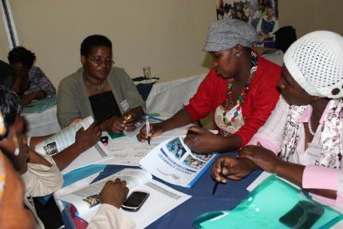

ITEM | DESCRIPTION
Time allocated | Six days
Overview | Combining life and entrepreneurship skills provides a framework for building personal and economic agency for survivors of GBV.
Learning  Objectives | The aim of the entrepreneurship training is to provide women with the basic skills and knowledge to use to start or grow their own business to achieve economic freedom to make positive choices.
Preparation  None. | Familiarize yourself with the content of the manual before the training.  Ensure enough copies of the following are printed and available:  - Participants manuals  - Daily registration forms  - Workshop evaluation forms  - Facilitators manual  Make sure the venue is available and if able, a projector and screen.  Check catering has been confirmed and confirm numbers with the caterer.
Materials | Life skills manual.  Sticky notes. Flip chart and paper. Pens. Koki pens. Note paper.  Prestik or equivalent.
Session type | Lectures, group work and exercises.
M&E | Registration forms  Workshop assessment forms

NOTES TO THE FACILITATOR
This is the second module of the TOT manual which us designed to develop the basic and necessary skills and knowledge needed to start or run a very small business. The aim of the programme is to provide the basic skills required to develop a business plan for the starting or growing of a business for each of the women. The business plan will serve as the groundwork for exploring their ideas further and testing the feasibility and viably in the market.

The training is not an end in and of itself. The training has a purpose. The aim is to improve the knowledge and understanding of running a small business, to provide potentially sustainable opportunities for women that have survived GBV; to become more economically capable and independent. Economic development is therefore the next step in achieving the overall goal of reducing women’s vulnerability to GBV.

This manual aims to provide accessible and practical skills for the management of a business and highlights those key areas where micro enterprises; and indeed, women in business; often fail.

SECTION 2.1: IDENTIFY AND DEMONSTRATE ENTREPRENEURIAL IDEAS

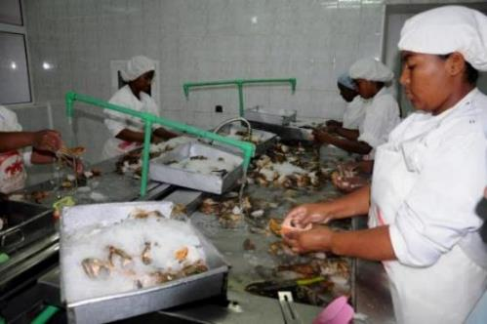

ITEM | DESCRIPTION
Time allocated | 3.5 hours
Learning  outcomes | This section provides information and discussions key to understanding the concepts of;  - Entrepreneurship  - Different types and sizes of businesses  - Gender and economic empowerment; including entrepreneurship  - Identifying strengths and weakness as potential entrepreneurs
Session type | Lectures, group work, role plays and exercises.

Notes to facilitators: It is important for participants to develop a broad understanding of entrepreneurship and their potential to succeed. Definitions are provided which have been revised to be understandable in this target market. Please be familiar with this section and these definitions before embarking on the training.

The first exercise promotes discussion on entrepreneurship.

Exercise 2.1.1: What is an entrepreneur and entrepreneurship?
- Brainstorm what is an entrepreneur and entrepreneurship in a plenary session and record the answers on a flipchart.
- Group the words that best describe an entrepreneur and entrepreneurship in your view, record the answers on a separate flipchart.
- Divide participants into groups of four and ask them to use the words from this list to develop a working definition of an entrepreneur and entrepreneurship using the spaces provided in the manual.
- Get each group to report back to plenary and then discuss the definitions provided in the manual.
- In plenary prepare a flip chart with the headings of women and men. Ask the group to identify businesses they know of that are owned by men or women. Discuss the differences there may be between businesses run by men or women. Engage the group in discussions why they think men and women many run different kinds of businesses.

Important points
Depending on location groups may have different experiences and may already be aware of cross over business ideas and practise. However, it is important to discuss with the group the gender biases that impact on women in business and in the economy in general. Please familiarise yourself with the definitions and information provided to guide this discussion. It is particularly important to understand the underlying social constructs of gender inequality in an economy.

Resource information provided to guide discussion;
Issues faced by women in business include:
It is well documented that entrepreneurship development for women, especially women in under resourced environments, is complicated by gender related challenges. Whilst men and women both experience difficulties when wanting to start or run a business, women face additional challenges which are gender specific.

These include issues such as lack of mobility (freedom to move around), lack of experience, poor skills base, a lack of assets and resources and multiple roles associated with patriarchal relationships. These obstacles often women are further exacerbated by exposure to GBV which undermines their self-esteem and confidence in taking charge of their own lives. Other issues to consider include:
- Lack of individual property rights.

- Cultural norms may prevent women from owning assets (including land).
- Financial institutions, such as banks, may be unwilling to give business loans to women. Women may not be allowed control over income and household investments.
- Lack of confidence and support from friends and family members.
- Many women are not encouraged or allowed to attend school to gain important skills.
- Lack of access to information
- Government and other role-players may only be willing to support male-owned businesses.
- The pressures of household responsibilities may prevent a woman from finding time as women are generally considered to be the primary care providers for children.
- Women may lack the ability to make their own decisions.
- Cultural pressures to hire family members.
- Limited opportunities given societal beliefs that some industries are only suitable for men (e.g. mining) while others should be the domain of women (e.g. child care or nursing).

Therefore, for women to achieve sustainable economic independence there is a need to address more than simply the skills required to run a business:
- Women’s understanding of the social constructs of gender
- The building of self-confidence of women who have experienced GBV
- Entrepreneurship as a tool for change

Use the C study 2.1.1 to demonstrate some of the issues and complete the Exercise 2.1.1 with the group. This exercise is a role play and provides three potential scenarios for role playing groups to identify.

Exercise 2.1.1: Gender and entrepreneurship role-play
The facilitator will divide the participants into three groups to role play the three different scenarios based upon the story above. There is no wrong answer as there are many ways that Puleng’s story may continue.

Each group will be responsible for role playing one of the following scenarios:
- Puleng discusses with her husband the idea of her starting a business. The group will determine his reaction.
- Puleng goes to the bank to ask for money to start her own business. The group will decide on the reaction of the bank manager (who may be either male or female).
- Puleng tells her friend about her business idea as she suspects that her friend might be involved in a violent relationship.
After each of these role plays discuss with the whole group how gender influenced her attempts to discuss the idea of owning her own business with the different people.

Notes to facilitators: The next section speaks to different kinds of businesses:
- Retail
- Service
- Manufacturing
- Seasonal
- Social

Issues to be addressed during discussion would include the gender and economic implications of these types of businesses. The following questions could be asked to the plenary:
- What type and size of businesses are women most likely to be active in?
- Why are women most likely to be active in these types and sizes of businesses?
- What do women need to run a successful business?

Work to solicit gender based issues in these discussions in terms of barriers that women face that impacts on their economic and business choices. For example;
- Limited access to resources such as land and property which in terms impedes access to credit
- Patriarchy
- Limited exposure to work and business
- Poor access to information and business skills training
- Cultural norms and values
- Limited access to finance to invest in a business
- Time constraints and family responsibilities

Two specific types of business are included in the programme as these are ventures that women participate in.
Seasonal business: Explore the dynamics of seasonal business and the need to be able to support oneself between seasons; for example, mango farming which provides income once a year. Open discussion on how this can be addressed such as other business ideas, value added products made or ensuring crops that mature at different times of the year
Social entrepreneurship? This is introduced to get participants to understand this as a potential source of income but also a social good in their communities. The important message is that although this may be a socially motivated idea, it still needs to be run as a business to be sustainable.
Start a vegetable garden | Recycling | Day care
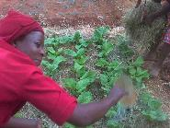 | 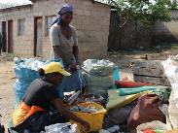 | 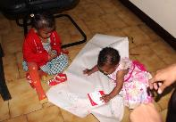

Exercise 2.1.3: The businesses in these pictures can serve a community need and make money; even a profit. Divide the participants into groups of four. Discuss the questions below and get each group to report back to plenary. Record the feedback on flip chart. The idea is to stimulate potentially feasible ideas for social entrepreneurship in the area; as individuals, groups or cooperatives.
- Feed back into plenary.
- Fill in the form to answer the following questions in their manuals.

What types of social or service delivery problems are people in the community dealing with? | How can members of the community address these by starting a social enterprise?

Exercise 2.1.3: Types of social enterprise opportunities in the community
Discuss in plenary the potential opportunities for social enterprise options in the surrounding community based on the answers given in Exercise 2.1.3.

Notes to facilitators: Business are defined in different ways according to their size. The definitions are not the same in all countries and this is quite diverse. Business sizes can however be demonstrated in a pyramid. Use this diagram to explain different business sizes and in plenary as the group to provide some examples of each level of business.

The least resourced businesses are likely to be at the lowest end of the pyramid marked as the GL target base. These businesses are usually owner managed, have very few assets and lack available to resources such as finance. Micro entrepreneurs often do not keep records or build up any level of reputational equity that can support them in their pursuit of resources for their businesses; especially finance. The older a business is, the more historic information is available, the more likely the business owner will have access to finance. Access to resources such as property or land to offer as collateral also impacts on the ability to leverage support such as debt or equity.

This leaves women to predominate at the lowest end of the market with few resources, limited income and reliance on friends and familiar as the most likely sources of capital. The most likely source of funding beyond this is micro finance; very small loans, usually in groups and high interest bearing. For some commentators this contributes to empowering women and ending poverty. To others these outcomes are questioned in relation to the gender and economic impact of access to micro finance.

“Opinions on the impact of microfinance have been divided between those who see Microfinance as a “magic bullet” for women’s empowerment and others who are dismissive of its abilities as a cure-all panacea for development… It becomes apparent that while access to financial services can and does make vital contributions to the economic productivity and social well-being of poor women and their households, it does not “automatically” empower women, just as with other interventions, such as education, political quotas, etc, that seek to bring about a radical structural transformation that true empowerment entails. These other interventions simply constitute different entry points into this larger project, each with the potential for social transformation, but each is contingent on context, commitment and capacity if this potential is to become a reality.”

The other source of support which may be available to the women in our target base are business development services (BDS). These programs can vary a great deal depending on the size, the industry subsector in which they operate, the products and services produced, the processes and level of technology used.

BDS should be specific to the community and business environment where they are located. BDS services need to be gender sensitive and ideally flexible and not based on a rigid timetable given the time constraints that women are likely to face; especially women involved in enterprise activities in addition to other responsibilities. Women often lack mobility because of their multiple responsibilities as well. Programmes that target women need to be cognisant of women’s time constraints and the opportunity costs associated with women when they are away from their businesses. Ideally BDS should be demand and not supply driven and meet the needs of the recipients rather than the programme.

Be cognisant of these issues whilst running the programme but impress upon the participants that punctuality and discipline are important.

Whilst drawing on the literature to design the pilot, GL sought to both add to the body of knowledge on the links between the economic status of women and GBV; and to develop a programme which would integrate life and business management skills into a programme with local governments.

SMME scenario
SUPPORT
GL client base
NEED INTENSIVE SUPPORT AND APPROPRIATE ACCESS TO FINANCE
GAP IN ACCESS AND PRODUCTS
MICRO FINANCE
BANKING FINANCE/CREDIT
EQUITY

Exercise 2.1.4: Facilitators notes: When stating a business, it is a good idea to assess one’s own strengths and weaknesses. The key areas are knowledge, skills and experience. Women often rely on so-called traditional skills when looking for opportunities. Re-introduce ideas of ways in which women can pursue non-traditional business ideas.

This section also asks each participant to explore their own potential as an entrepreneur by asking them what they think are their strengths or weakness as a business person?

Exercise 2.1.4: Identify what you think are your strengths and weaknesses that would affect you running a successful business. List some of your strengths and weaknesses in knowledge, skills and experience that could affect your business.

 | Weaknesses | Strengths
Knowledge

Skills
Experience

Then participants should draw on their own experiences and background to complete the exercise and list ideas that they think they would be good at, would enjoy doing and would like to do in business.

What I am able to do? | What I enjoy doing? | What I would like to do?

SECTION 2.2: MATCH NEW VENTURE OPPORTUNITY TO MARKET NEEDS

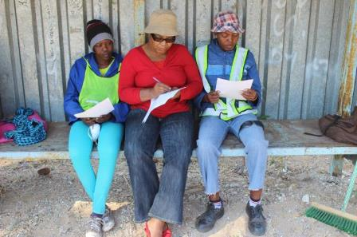

ITEM | DESCRIPTION
Time allocated | 3.5 hours
Overview | This section focuses on understanding the need to plan and do research when deciding on a business idea.
Learning  outcomes | Through this section the participants will:  - How to work out who your customers will be in a new venture  - How to conduct market research to find out if there is a need for a product or service in the market they are targeting  - Understand how to do marketing  - Understand customer service  - Exploring product/service life cycle
Session type | Lectures, group work and exercises

Notes to facilitators: This section aims to provide participants with information they need to promote more effective business planning. The Case study 2.2.1 demonstrates poor planning in a very basic catering business. The lesson should be about doing market research and planning carefully to avoid losses.

Divide group into groups of four but ensure that the same participants do not stay in the same group. Questions posed to the groups in Exercise 2.2.1 include;
- What was Puleng’s (the business owner) mistake when buying her supplies?
- What should she have done first?
- How could Puleng have avoided the problem?

The group should be able to recognise that Puleng did not do enough research to understand her market and did not buy her supplies in the most effective way to avoid losses.

Use the information sheet provided as points of discussion in this session. Questions to plenary can include:
- Why is planning important in a business?
- What can happen if you do not plan properly?
- What is a business plan?
- How can writing a business plan help your business?
- How will you know if your product or service is a good idea?
- What can you do to find out?
- Do products or services stay the same all the time?
- Why do you think products and services change? Think of some examples locally that would demonstrate these points.
- How can value add processes add value to a product?
- How can businesses compete with competition in their area?

Key point: Many small businesses assume that they know what customers want without trying to find out if this is true. The goal of knowing your market is to identify where the business can compete. Women often operate in what is called saturated markets. This means that too many people are selling the same thing to close to each other and the market isn’t big enough for all of them.
Identifying a market gap: Identifying things people need that are not available to them is called identifying the market gap. The businesses you identified in the previous case studies meet the unfulfilled needs of people (filling the market gap). There are many reasons for these market gaps which could be warning signs that a business would be unlikely to succeed. These could include:
- Not enough potential customers;
- High costs (i.e. products that are too expensive for the local market);
- Transport difficulties which increase the cost of the products;
- Products that do not really meet the needs;
- Remember that people will need a good reason to buy a new product;
  - Cheaper;
  - Of higher quality;
  - Available more regularly and in different sizes, quantities, colours or designs;
  - Sold in a more accessible location; and,
  - A totally new idea.

Exercise 2.2.4: Individual should do this exercise on their own and report back to plenary. Give three examples of products you could sell to scools, school children or for weddings. These exercises need to be explored for some time. Forexample the wedding option can solicite up to 15 options and this really gets the groups thinking? In plenary keep pushing for more options such as; flowers, invitations, transport, attire, photos, videos, food etc etc.

 | 

One of the key issues in understanding the market is to differentiate in terms of age, location, income, gender and levels of education. Stimulate discussion by asking the following questions;
- Would you try to sell a Mercedes Benz car in your community?
- If not, why not?
- Would you open a restaurant that served food that local people do not eat? Think of some examples of food that would not be eaten locally. If not, why not?
- Raise issues of price, income, age etc in relation to this discussion.
- Examples can include imported brands would sell best in a high-income area.

Needs and wants: This leads to the issue of the difference between needs and wants and why this is so important when understanding business.
What will influence what people may want or need to buy?
People at different stages in their lives will buy different things. Teenagers will buy different clothes to old people for example. People who are rich and live in an expensive area will buy different kinds of groceries to people living in poor communities. Men and women may have different shopping needs for clothes.

What is the difference between a want and a need? This is critical issue in understanding business and the market; especially if the market is a low income one. The manual explores the difference in terms of needs and wants and how this can impact on business planning and success. Questions to put to participants include;
- What is the difference between a need and a want?
- What do people need in your potential market?
- What do people want in your potential market?
- Why do people buy things they want even when they do not need them?

Exercise 2.2.5 explores in pictures some examples of needs and wants. This is largely related to issues of necessities such water versus coke. However, depending on the group, many other examples can be used to demonstrate the differences as well. You can change these pictures to items that may be more familiar in the local environment or country.










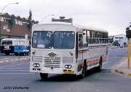

Basic information is provided on research techniques, but this can be expanded on; namely:
Market research is the process of assessing the potential success of a new product or service through techniques such as surveys, product testing and focus groups.
- A survey is a process of asking a set of questions to get information to decide if your product or service will sell. You need to ask everyone the same questions. The more people you interview the better your results will be.
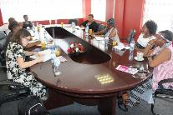
A focus group: Source Gender Links.
- Focus groups: A process of asking a group of people to get together and then ask them questions as a group to find out if they would buy your products or services.
- Product testing: This means giving samples to see if people liked the products.
Other ways can include:
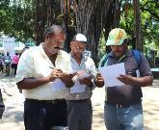
Doing a survey with people. Source Gender Links.
Find out what type of businesses are already operating in your area and see if you can find gaps in the market. Ask people what they can buy and what they would like to buy.
Planning market research: Market research should draw on all the information provided in this to aid participants to develop a market research plan for their business idea. Key issues to be posed to the group are to;
- Decide what it is you want to find out
- Decide how to find the information e.g. interviews or focus groups
- Collect the information e.g. put a questionnaire together
- Analyse and interpret the information when you have collected it
- Use the information to plan in your business

The manual provides an example of a questionnaire for potential customers which can be used by participants. This can be added to depending on the types and sizes of businesses.

Questions | Answers
Do you buy cakes? | Daily | Weekly | Monthly | Less often | Make my own
What kind of cakes do you buy? | Birthday cakes for children | Birthday cakes for adults | Wedding cakes | Christmas cakes | Make my own
Where do you buy cakes | Supermarket | Bakery | Neighbour | Small shop | Make my own
How far do you travel to buy cakes | Less than 1 kilometre | Between 1 and 5 Kilometres | More than five kilometres |  | Make my own
Would you buy cakes if I made them and delivered them to you? | Yes | No

Completing Exercise 2.2.6; identifying market gaps, will complete this section of the programme. Participants should work on this exercise in pairs and report back to plenary.
  - MANAGE MARKETING AND SELLING PROCESSES OF A NEW VENTURE

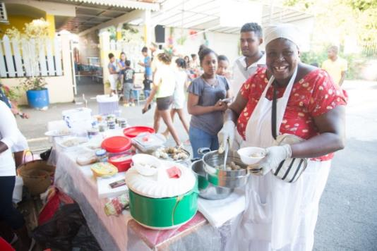

ITEM | DESCRIPTION
Time allocated | One hour
Learning  Outcomes | This section aims to increase the knowledge and awareness of participants about the importance of market research; understanding the market and meeting market needs.
Session type | Lectures and group work.

Notes for facilitators: One of the main reasons that micro businesses may fail is because of a lack of visibility or targeted marketing. This section tries to unpack this to give a wider view of what marketing and sales mean to a business.

Some key definitions have been included to guide you. One of the key points to get across is that if you do not have a market you do not have a business. It doesn’t matter how many bricks you make; if you cannot sell them you do not have a business. The issues to consider include;
- Business cannot sell what people do not want or need
- Big business can afford to create wants but not at this end of the market
- Visibility is important, and a business cannot sell if customers do not know where to find them or that they exist
- Pricing is a very key issue in this target market. It is key for participants to understand the role of pricing in a business and market appetite for prices (What people are prepared to pay). This is also closely tied with the competitive environment. Very important also is for participants to understand that being cheaper is not the only or even desirable way to compete and that other factors also play a role.
- Another key issue is the importance of quality and consistency in what is produced or sold.
- The concepts of presentation and branding are included to stimulate and understanding of these aspects in running a business. Please explore this in relation to participants own experiences of brand loyalty.
Trading in a saturated market:
- This is a problem; especially for women in micro enterprise. This means lots of people selling the same things to the same people at the same time and in the same place. There is more product available than people to buy it. This also forces businesses to lower their prices. Think of some local examples such as fruit vendors, craft vendors all trading together and explore how this may impact negatively on business.

The competitive environment is very important to understand both in relation to saturated trading but also the wider market.

Finding out about the competition is important and a example of basic competitor analysis is provided. This can be adapted to local conditions with different examples as well.

Learning tool: Competitor analysis.
Product | Your price? | Their price? | How far are they? | Why do people shop there? | Why do people not shop there?
20 cm birthday cakes with butter icing
2 tier wedding cakes
2 tier wedding cakes
Decorated cupcakes with butter icing

SECTION 2.4. APPLY THE BASIC SKILLS OF CUSTOMER SERVICE

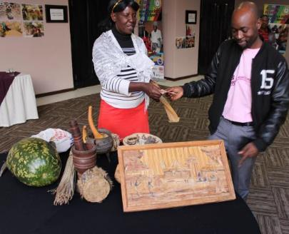

ITEM | DESCRIPTION
Time allocated | One hour
Learning outcomes | This session aims to improve participants understanding of what good customer service is and why this is important.
Session type | Lecture and group work

Notes to facilitators: This section covers the basic understandings of customer service and the importance of good customer service. The underlying principle being a happy customer is more likely to support your business than an unhappy customer. This may spell the difference between getting that sale and losing it toto someone else. Participants have likely experienced good and bad services and it important to draw on these experiences in discussion. The group should be broken up into groups of four to discuss these questions posed in Exercise 4.1.1 and to report back to plenary. The manual provides information related to providing good service to customers.

Exercise 2.41 Draw out the discussion by asking;
What do you think makes up good customer service?
What kind of service do expect when you go shopping? Give two examples.
Give two examples of when you have experienced good service.
Give two examples of bad customer service that you have experienced.

The course introduces the idea of using a customer satisfaction survey and provides an example of this.

Learning tool: Ask your customers what they think about your business. This is called a customer satisfaction survey.

Example of a survey


The best bake shop
Please take the time to fill in this survey to help us/me serve you better. Please circle the number that best represents your view. The number 10 is the highest and 1 is the lowest. Please circle N/A for any questions that you don’t have enough experience to comment on.

Professionalism levels:
10 9 8 7 6 5 4 2 2 1 N/A
Ability to understand your needs:
10 9 8 7 6 5 4 2 2 1 N/A
Knowledge of the products:
10 9 8 7 6 5 4 2 2 1 N/A
Quality of products:
10 9 8 7 6 5 4 2 2 1 N/A
Value for money:
10 9 8 7 6 5 4 2 2 1 N/A
Customer service
10 9 8 7 6 5 4 2 2 1 N/A

Briefly tell us how we can improve or other products you would like to buy from us. Describe how could we add more value to your organization?

The importance of quotations in business is also included. The proper pricing and presentation of quotations can be a problem in this market. Key issues include:
- A quotation is a document that offers to sell goods or services at a stated price, under specified conditions.
- Makes clear what the terms of the transaction will be such as when payments will be due, the quality, quantity and design of a product.
- It is also a promise that goods or services will be delivered according to what is on the quote.
- The customer needs to sign that that accept the quotation.
- It is always a good idea to take a deposit to cover the costs of production if you are making something like food, clothes or furniture for example. This covers you if the order gets cancelled after you have made the products.
- This is a legally binding document. If you cannot provide what you have promised, then this can break the contract with the customer and the customer may not want to pay.

An example of a quotation document is provided as a guideline.Example of a quotation
THE BEST LINEN SHOP
25 Happy Lane, Johannesburg.
Telephone number: 0112245678
Cell: 0824256990
Company registration: 012245
Tax number: 00257897
QUOTATION 006
Date: 07 March 2016
For: COSY BED AND BREAKFAST 14 Cozy Avenue, Johannesburg.

Quantity | Description | Unit price | Total
6 | Custom made Red and blue duvet covers – queen size | R600 | R2600
24 | Custom made pillow cases in same blue | R50 | R1200
6 | Custom made fitted sheets in same blue | R100 | R600
 | Subtotal |  | R5400
 | Delivery | R50 | R50
 | Total |  | R5900

This quotation is valid for 14 days from the date above. Payment terms: 50% deposit and 50% cash on delivery. If you accept the terms of this quotation, please sign.
I accept the terms of the above quote:

Name_________________ Date ____________________Position______________

2.5 SIZE, LOCATION AND DIVERSITY

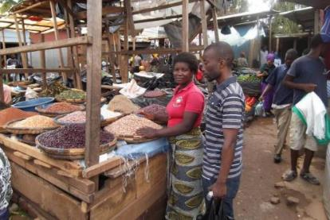

ITEM | DESCRIPTION
Time allocated | One hour
Learning outcomes | Through this module the participants will:  - Understand the importance of location for a business  - Learn that product and service diversity increase business  - Understands size as a measure of a business and that this can impact on business performance
Session type | Lecture, discussion and group work.

Notes to faciltator: This section discusses issues of location, product selection and business size. The issues to highlight are demonstrated in the examples of businesses in the fruit and vegetable trade in Exercise 2.5.2.

Exercise 2.5.2: Judging size, place and variety (diversity)
The facilitator will divide participants into small groups of fourto work on this exercise and groups should reprot back to plenary. Groups need to look at these businesses closely and think about what is similar or different about each of them in terms of their:
- Size
- Location
- Products they are selling

They need to be able to identify if these businesses are in a good place, selling enough products and big enough to make profits. Try to identify the advantages of one business over another. The pictures are in colour and if manuals are printed in black and white then this page of pictures should be provided as separate copies in colour for each group.

Learning tool: Size, location and diversity of products Exercise 2.5.2.

Groups are asked to analysis and answer questions based on these photos and explain their answers. Issues that could be identified for each picture are:
Picture 1: This shows a business in a railway station, with lots of passing trade likely to buy from the business on the way or from the trains.
Picture 2: This is indicative of many problems; saturated trade (many selling same item at same place), they are only selling one item, they have no shade so will experience losses and are unlikely to make any real income.
Picture 2: This is again the same products being sold in the same place by many traders. Advantage is that they have cover but there is no evidence of passes by.
Picture 4: This shop sells fruit and veg inside bit also sells other goods to attract customers.
Picture 5: This is a mobile “shop” that takes the goods to the customer.
Picture 6: Many small businesses at the taxi rank. Lots of people but also lots of competition. Does not look clean and success would depend on where you are in the long line of stalls.
This section also raises issues of business risk such as floods or loss of power and why taking risk into consideration is good business practice.

2.6 START UP FINANCE

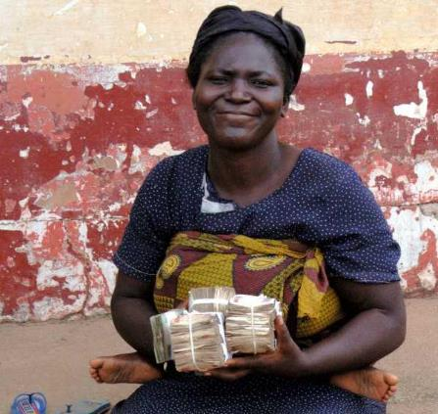

ITEM | DESCRIPTION
Time allocated | 2.5 hours
Learning  Outcomes | Through this module the participants will:  - Understand basic financial concepts (ideas) used in running an enterprise  - Learn how to work out their start-up costs  - Learn how to work out cash flows
Preparation  None. | Please print extra copies of the cash flow charts for drafting purposes.
Session type | Lecture, discussion and group work.

Notes to facilitators: The financial sections are usually the ones that require most time. Break the group into groups of five for exercises. It is helpful to have less and more advanced participants in the same groups. The stronger candidates can assist the weaker participants within the group. If you assess that sufficient time has not been allocated to a group, accommodate this in the programme to give all the women a chance to learn these skills.

Facilitators should make themselves familiar with the financial concepts and definitions and discuss these in plenary. These include:
- Start-up costs are the costs you will have when you start your business. These can be for stock, equipment such as a sewing machine or raw materials.
- Cost is the money that must be paid out or spent to buy something at the price the supplier charges
- Business costs is the money you need to spend to buy things for the business, to run a business
- Fixed and variable costs
  - Fixed costs are cost that you have to pay every month and they don’t vary each month whether the sales increase or decrease (that is not dependent on the level of output). For example, whether you make and sell 100 loaves of bread or 10 loaves of bread a month, the rent you pay would stay the same. Fixed costs are things like rent, insurance, and salaries to staff and lease payments on equipment.
  - Variable costs are those which do vary with the number of sales. For example, the amount of flour you need to buy to make 100 loaves of bread, will be less than the costs of buying enough flour to back 500 loaves of bread. Costs change depending on how you make/sell.
- Owner’s wages: Many do not include the money they will draw out from each month for themselves. This can be fixed or variable and will need to be factored into monthly expenses.
- Running costs are the expenses needed to run the business form day to day.
- Income: This is the money that comes into your business from sales.
- Expenses: These are the costs of running the business so that you can earn the income.
- Cash flow: This is a record of how much cash is available to the business. Cash flow is the movement of money into or out of a business and is usually measured during a specified, limited period e.g. monthly, annually. A business needs a positive cash flow to meet its expenses.
- A positive cash flow means that you have more money coming into the business than you are spending on costs.
- Negative cash flow: More money has gone out than has come in. This can happen for example if sell on credit or buy what you need to run the business before making any sales.
- Cash flow projections/plan: This shows you how much money is expected to come in (income) and to go out in expenses.
- Monthly expenses: What expenses you have to run the business each month.
- Pricing: An amount you will charge the customers. This amount to cover your expenses and make a profit.
- Mark-up is the percentage of cost price that one gets as profit on top of cost price.

Learning tool: Start-up costs
In the case study Miriam plans to buy 100 bread rolls per day. She works out her expenses as follows. She already has a stool and does not need to buy one. The umbrella, blackboard, baskets and permit are once of costs.

Items | Expenses | Costs per unit | What are the total start-up costs with working capital for one week (six trading days)
Start-up equipment costs
Umbrella x1 |  | $5 | $5
Stool to sit on | Already has a stool | 0
Blackboard for advertising x 1 |  | $5 | $5
Baskets to carry the bread rolls/buns x 2 |  | $2.50 | $5
Annual Licensing/permits |  | $5 | $5
TOTAL |  |  | $20
Running Expenses
Bread bought from bakery @ $4 per 100 per day |  | $4 p/day | $24
Paper packets |  | $1 x 1000 | $1
Serviettes |  | $1 x 1000 | $1
Transport |  | $1 p/ day | $6
Electricity and water |  | $1 p/ day | $6
Fillings |  | $2 p/day | $12
Telephone |  | $1 p/ day | $6
Owner wages per month |  | $4 p/day | $24
TOTAL EXPENSES |  |  | $80
GRAND TOTAL |  |  | $100

These figures have been made up to make them easy to work with and are not real prices. They are in US Dollars but can be translated into local currency if dollars are not suitable in a country.

Note: Many small business owners do not factor their own income into their expenses. This gives a false view of the income and expenses and potential of the business. Participants need to understand that this is a cost to their business. They need to be aware that they can draw what the business can afford and that this can increase as the business grows.

Once the group understands this then an exercise in groups of five should follow.

Exercise 2.6.1: Work out what Miriam’s running expenses will be for four weeks.
Facilitator breaks group into groups of five to calculate what it would cost Miriams business to run for four weeks.

Notes to facilitators: The equipwnt costs are once off and do not need to be repeated. Some of the variable costs of running the business will need to be recalculated to accommodate the number of sales ie the paper packets and serviettes. The groups need to be able to identify the need to buy more of these as the initial 1000 will not be enough. Each group should present their calculations to the plenary on flip chart paper. Once all the groups have presented the plenary should discuss which are not correct and why.

Items | Expenses | Costs per unit | Total start-up costs with working capital for one week (six trading days) | Total start-up costs with working capital for four weeks (24 trading days)
Start-up equipment costs
Umbrella x1 |  | $5 | $5
Stool to sit on |  | 0
Blackboard for advertising x 1 |  | 0 | $5
Baskets to carry the bread rolls/buns x 2 |  | $2.50 | $5
Licensing/permits |  | $5 | $5
TOTAL START UP COSTS |  |  | $20
Expenses
Bread rolls/buns bought from bakery @ 4 per 100 rolls/buns per day |  | $4 p/day | $24
Paper packets |  | $1 x 1000 | $1
Serviettes |  | $1 x 1000 | $1
Transport per day |  | $2 p/week | $6
Electricity and water p/day |  | $1 p/ day | $6
Fillings per day |  | $2 p/day | $12
Telephone per day |  | $1 p/ day | $6
Wages per day |  | $4 p/day | $24
TOTAL EXPENSES |  |  | $80
GRAND TOTAL |  |  | $100

2.7 PRICING

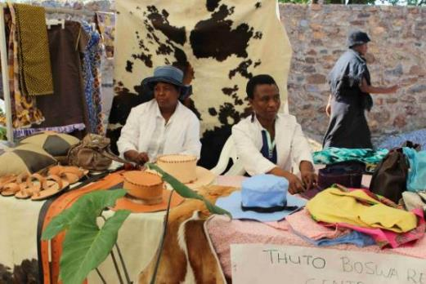

ITEM | DESCRIPTION
Time allocated | 2 hours
Learning  Objectives | Through this module the participants will:  - Learn how to price products and services  - Understand how properly pricing a product or service is important to a business  - Understand a simple priding formula
Preparation | Think of some local products or services that the participants may be involved in and use this for additional examples for pricing.
Session type | Lectures, discussion and group work

Notes to facilitators: Pricing is a fundamental skill that participants need to learn. Most micro entrepreneurs do not understand this aspect of a business and therefore have no idea whether their pricing is making or losing them money. What is critical is that all aspects of running the business need to be built into the pricing of goods or services such as transport, time, electricity and wages. These are not tangible expenses and are often not considered as costs that need to be included in pricing.
Familiarise yourself with the pricing model used in the manual which is an easy option for pricing;
- Cost x mark-up percentage = added amount
- Cost + added amount = selling price

Think of some additional examples to apply the pricing format in your own area. Be aware that all individual goods or services need to be priced separately.
Be firm in helping participants to understand owner salary as a cost to the business and therefore needs to be included in the pricing formula. This can be time based such as hours spent.

To stimulate discussion, ask the following questions in plenary and list answers on flip chart:
- What expenses need to be included in the price of goods or services?
- What do you think has been left out? Use an example such as travelling to buy ready made goods in another town. Participants should be prompted to understand that transport and time are also part of their expenses.
- If anyone has a business already ask them how they price.
- What is the best way to compete with businesses doing the same kind of business?

Exercise 2.7.1: Pricing as a competitive strategy? Good or bad idea?
The facilitator divides partricipants into groups of four to answer the following questions;
- Is price the only way to attract customers?
- What other ways can you attract customers? Please list 2 ways?
- Make reference to the information provided in this section for pricing as a competative strategy;
One of the most common mistakes in business is that the lower price gets the most sales. Small business has to price products and services to cover their costs and to create a surplus for growth; to survive. What is charged needs to consider the following:
- Your costs to produce the product – if you can’t cover costs you will go out of business
- Any competition you might have
- What the customers are prepared to pay
Customers will pay more for many reasons; not just price:
- Quality of the product or service
- Convenience – e.g. don’t have to spend money to travel, can be in smaller amounts
- Quantity – providing the right size for the market
- Good service/ Reliability/Value for money
To sell your products, you need to also:
- Promote sales
- Not be too expensive either compared to the same product somewhere else
- Review prices on a regular basis for example to keep up with changes in costs of production of any new competition

Share the two examples for pricing provided before doing the next exercise;
- Leah sells computers from her home. She buys computers for $200 (cost) and it costs $10 to have each one delvered to her home. These computers cost her $210 each to get to her home. She charges a 50% markup. To work this out multiply the mark-up by the cost of the product then add the cost to the added amount you have worked out:
Cost x mark-up percentage = added amount
Cost + added amount = selling price ($210 x 50% = $105.)
The selling price of each computer will therefore be 215 each.

- It costs Alice $5 to make a tracksuit, including all her expenses. She needs to decide how many she needs to sell and at what price to make a profit. She wants to add on 50%. She works out that:
If Alice has a a 50% mark-up
@ 50% x $5 = $2.50 per unit mark-up
= Selling price will be $5 + $2.50 = $7.50 per unit sold
She plans to sell 20 per month. Her income/turnover will be $150 per month. Her expenses ar $100 per month. She will make $50 dollars profit per month if all her expenses stay the same.

Exercise 2.7.2: Break group into groups of two; to do the following exercise.
Portia runs a business from home. She sells window frames. She buys the window frames for $20 each and the transport costs her $2 each. She wants to markup by 20%. What will her selling price be?
- Cost x mark-up percentage = added amount
- Cost + added amount = selling price
Take your time to work this out there is no hurry. Now you are ready to look at your cash flow needs.

2.8. CASH FLOW

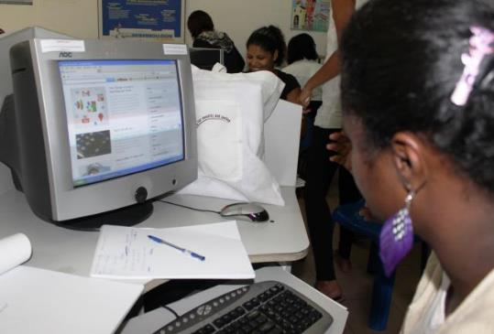

ITEM | DESCRIPTION
Time allocated | Five hours
Learning  Objectives | Through this section the participants should develop the skills to do cash flow projects and understand how to manage cash flow monthly.
Preparation | Be familiar with the process of cash flow projections. Make copies of the cash flow pages for participants to work on before completing the cash flow in their manuals.
Session type | Lectures, discussion and group work.

CASH FLOW PLANNING - 12 MONTH PROJECTION TO HELP YOU DECIDE HOW MUCH YOU NEED TO SELL

MONTH: | 1 | 2 | 2 | 4 | 5 | 6 | 7 | 8 | 9 | 10 | 11 | 12 | TOTAL
Income from sales
Other income
Other income
Total
Expenses
Total Payments
Surplus/Deficit (-)
EXAMPLE OF A SIMPLE 12 MONTH CASH FLOW STATEMENT FORM TO TRACK YOUR ACTUAL MONTHLY INCOME AND EXPENSES
 | JAN | FEB | MAR | APR | MAY | JUN | JUL | AUG | SEP | OCT | NOV | DEC | TOTAL
INCOME FROM SALES
OTHER INCOME
OTHER INCOME
TOTAL
EXPENSES
Owner salary
TOTAL

2.9. RECORD KEEPING

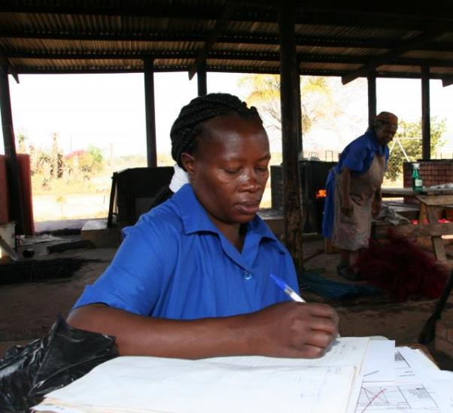

ITEM | DESCRIPTION
Time allocated | One hour
Overview | Provide a framework for entrepreneurs to develop and manage a record keeping system.
Learning  Outcomes | Through this section the participants will:  - Understand the importance of keeping records.  - Understanding how this makes a difference to them understanding their businesses income and expenses and profitability.  Understood simple ways of keeping records.
Session type | Lecture, discussion and group work.

Notes to facilitators: Records are written evidence of past business activities such as expenses and sales. The most important records are of stock, income and expenses. Again this should be presented in ways which make keeping records important but also not to burden this with overly complex ways to achieve this. Participants will then be more likely to want to do what many consider a chore.

Familiarise yourself with the flowing case study and Exercise 9.1.1
Case study: Maia lives in a rural village. The nearest shops are ten kms away so the people in the village tend to buy locally when they can. Maia sells eggs which she buys from a nearby farm. She started with $10 that she had saved to buy eggs. She been in business for two months and realised that she doesn’t really know if she is making money. She decides to start keeping a record. She always wants to understand her business better because she wants to also start buying some chickens who can lay eggs for her. She plans to also sell chickens when she has enough. She has identified her daily expenses as stock (buying eggs), travelling to the farm to buy eggs costs her $1 each trip. When she buys eggs she pays $1 for ten. She sells them $2 per ten.

Exercise 2.8.1: Keeping records of income, expenses and stock levels.
Facilitator breaks groups into pairs to complete the following exercise based on the case study. Work with the groups to complete this exercise. Allow more time if needed and make sure all the groups understand this exercise.

DATE | CASH IN HAND | NUMBER YOU BOUGHT | TRAVEL  COSTS | AMOUNT  SPENT | TOTAL SPENT | NUMBER YOU SOLD | AMOUNT MADE IN SALES | CASH IN HAND | NUMBER OF EGGS LEFT
DAY 1 | $10 | 40 eggs | $1 | $4 | $5 | 20 eggs | $4 | $9 | 20
DAY 2 | $9 | 0 | 0 | 0 | 0 | 20 eggs | $4 | $13 | 0
DAY 2 | $13 | 40 eggs | $1 | $4 | $5 | 20 eggs | $4 | $12 | 20
DAY 4 |  | 40 eggs |  |  |  | 20 eggs
DAY 5 |  | 40 |  |  |  | 10 eggs

Notes to facilitators: Emphasise the following;
- It is important that you keep your business and personal records separate, so that you can understand which expenses are about the business itself. You keep a record of expenses if you work from home and allocate a portion to your business expenses. This will give you a more realistic idea of how much your business costs you to run.
- When you start keeping records you should do this daily until you get used to the way the figures work. This is a simple example of how this works.
- Always keep receipts and invoices and in a safe place.

Learning tool: Example of a simple way to record. By adding more than one product you can ask participants to complete this exercise using two or more products.
DATE | CASH IN HAND | NUMBER YOU BOUGHT | TRAVEL  COSTS | AMOUNT  SPENT | TOTAL SPENT | NUMBER YOU SOLD | AMOUNT MADE IN SALES | CASH IN HAND | NUMBER LEFT
DAY 1
DAY 2
DAY 2
DAY 4
DAY 5

2.10 STOCK CONTROL

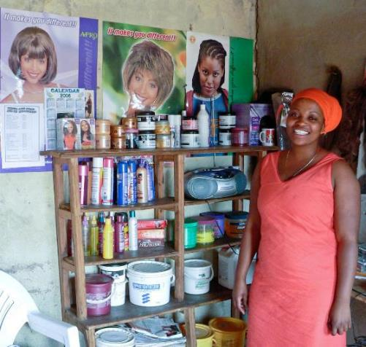

ITEM | DESCRIPTION
Time allocated | One hour
Learning  Outcomes | Through this module the participants will:  - Understand the basic of stock management and control  - Have an appreciation of ways to prevent stock shrinkages (losses)  - Understand how to plan to have enough stock to meet customers’ needs
Session type | Lecture, discussion and group work.

Notes to facilitators: This section aims to develop the skills and knowledge to run a basic but effective stock control system and to understand the role this plays in a business.
- Stock control is the checking of what stock is available in a business to meet what customers may need or want.
- Stock control shows how much stock is in a business at any one time and that what has been used ties up with sales as a means of control.
- Stock is the amount of goods, raw materials and products that are available in a business at any one time

Be familiar with the following to guide the session;
All businesses big or small need to be able to keep track of their stock. Controlling stock does not mean having as little as possible in your business. It’s about having enough stock to satisfy customer needs and to check on losses or theft.
How does managing stock help a business?
- Builds a record of usage or sales of items and this helps to identify trends in a business. For example, if you own a shop you might notice that you sell a lot of chocolates but very little chewing gum.
- You would notice that you sell more chocolate at Christmas than any other time.
- You will notice that some things sell quickly and other not.
- Helps you to have the right quantity available for your customers and to anticipate future sales.
- Helps you to know when to increase stock at special times such as holidays.
- Helps you to identify theft or losses or wastage in your business:
- raw materials in a manufacturing business
- goods in a retail business
You need to count your stock on a regular basis.
- This can be done daily, weekly or monthly.
- Record all the items that leave your business if you are a shop or a business that sells ready made goods that you have bought from someone else
- At the need of the day/week/month you need to check stock against what you have sold
If you run a business that uses portions of an item such as flour for baking or hair straightener for hair, then you can break up the large stock item into smaller stock items for better control.
This would be important if you employ staff and they do not know exactly how much to use.

Two case studies are provided to demonstrate stock control issues. Read these in plenary and ask the participants to complete the exercise that flows in groups of four. Each group should share with the rest of the participants in a plenary.

Case study 2.10.1
Leah owns a hair salon on the outskirts of a large town. Her salon is very popular and she employs 10 hairdressers. She is very worried because her stock of hair straightening lotion does not last out the month and she has to top up every month. This costs her extra money and she wants to solve the problem. For the next 2 months she keeps a daily stock sheet of all the products used in the salon.

She discovers that the staff are not measuring the correct amount of straightening lotion and are often using too much. They should only be using 50 mls each time.
The next time she orders she also orders small plastic bottles that only hold 50 ml. She will decant the 5 litre bottle into these small bottles each day to make sure that she has better control.

Allala owns a salon in a section of a large city where there are many hairdressers. Her salon is the farthest from the local shopping centre. She often runs out of braids because she doesn’t buy enough to service her customers. Sometimes she sends a customer to the shopping centre to buy her own. On the way many customers pass other hairdressers who have braids in stock. These costumers usually do not come back to Allala’s salon. Allala has not made a success of her business and is thinking of closing if business doesn’t improve.

Exercise 2.10.1: Facilitator breaks group into groups of four to answer the following question based on the Allala case study. How can Allala improve her stock control to improve her business?

Answers could include:
- Allala needs to have stock of braids all the time for appointments and walk in customers.
- She needs to keep a record of the number of customers that need braids every week and make sure that she has a good idea of the level of stock that she needs.

2.11TENDERING AS A BUSY OPPORTUNITY

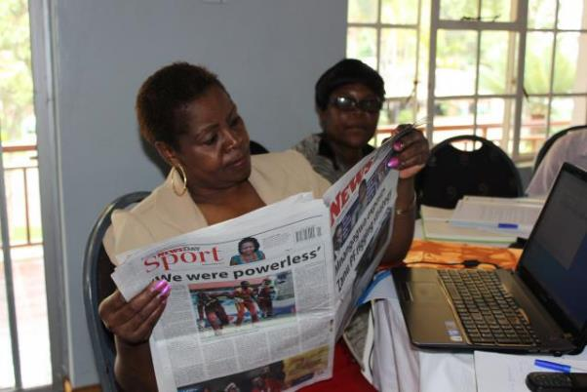

ITEM | DESCRIPTION
Time allocated | One hour
Learning outcomes | Through this section the participants will:  - Understand what tenders are.  - How small business can benefit from tenders but that they need to not rely on them as the only source of business.  - Tendering is hard, and many things need to be considered.  - Where you can look for tenders.
Preparation | Facilitators should be familiar with local tendering policies and find some examples to show participants.
Session type | Lecture, discussion and group work.

Definitions
Tendering: Is the process of offering to carry out work or to supply goods to a private company or government department on the basis of meeting certain requirements needed to fulfil the work or supplying of goods.
Tender process: The process that a government or private companies carry out to request companies to bid to provide goods or services on a competitive basis to get the best or cheapest company to supply goods or do a job.
Procurement: Is the buying of goods or services from an external service provider.
Affirmative procurement: Is a policy which is practiced by some governments and firms that allocates quotas of procurement opportunities to communities which have not had a fair share in the past such as women and in the case of South Africa, black owned businesses.
Compliance: This is the process of obeying external regulatory requirements and or policies within a company.

2.11.1 Case study
Alicia has been a dressmaker for a number of years. She has been running a very small business, making clothes from her home and selling them to neighbours and at the local market. She heard that the government had a new policy for procurement and was given at least 50% of tenders to women.
Alicia found out from her local council where she find out which tenders were available and when. They told her to look in the newspaper every Saturday. Alicia started to buy the paper every week. On the third week she found a tender to make school uniforms and track suits for a primary school of 400 children in the nearest large town. Alicia worked out how much it would cost her to make the items. This included costs for materials, travel, transport, and extra sewing machine and 2 more seamstresses for 2 weeks. She would have to borrow money from her family to buy the sewing machine and the materials. She would only do this if she got the tender. The 2 staff she would pay when she got paid for delivering the goods.

She checked the price of buying school uniforms from the shops in town and found out that she could make 15% profit and still be competitive. The income would allow her to pay back the family and still have enough money to put some aside for the next tender she would apply for. She decided to apply for the tender.

Exercise 2.11.1 Allow for small groups to answer based on the case study above.

What did Alicia do to make tendering a potentially good idea to grow her business? Give at least 2 ideas.

Fact sheet
A TENDER MAY BE ADVERTISED IN A NEWSPAPER LOOK LIKE THIS
RFP NUMBER: | GL/2012/00015
DESCRIPTION: | REQUEST FOR PROPOSALS FOR THE APPOINTMENT OF A SERVICE PROVIDER TO PROVIDE CLEANING SERVICES TO GENDER LINKS OFFICES IN JOHANNESBURG.
PUBLISH DATE: | 02 February 2019
VALIDIY PERIOD: | 20 days from the closing date
CLOSING DATE: | 2 MARCH 2019
CLOSING TIME: | 11:00 AM Late bids will not be accepted.
COMPULSORY BRIEFING SESSION | Briefing to be held at 10 am on the 7 February 2019.  (This is often a requirement)
BID RESPONSES MUST BE HAND DELIVERED TO: | Gender Links Head Office  Derrick Avenue,
ATTENTION: | Ms Fikile
NB: Bidders must ensure that they sign the register at the reception when delivering their bids.
BIDDER NAME: Mozambique Rural Women’s Trading Company

Issues to think about if you want to tender for business:
- You need to decide if you are ready to meet what the tender requires:
- Do you have enough staff?
- Do you have enough equipment to do the job?
- Can you afford what it will cost to increase your staff and equipment and survive until the first payment comes in?
- Can your business survive for the time it takes for the tender to be awarded?
- Do you have enough work to carry you through – always remember that there is no guarantee that you will get the tender and that you can’t therefore rely on this one opportunity?
- If you have enough work already, can you meet the needs of the tender?
- Tenders are very specific and if you don’t deliver in terms of the requirements you may have to pay penalties, so it is very important that you have the right resources to do the work or provide the goods.
- To be considered for a tender a business needs to be:
  - Compliant with the laws and regulations of a country e.g. department of labour, local government trading permits etc.
  - Registered as a business in that country
  - Have a bank account and good history with the bank
  - Have a good credit history
  - Be registered with the tax department and be up to date with tax payments
  - Have the right skills and equipment or is able to buy in these things into the business for the tender
  - Would you need to borrow money to meet the tender needs – can you afford to borrow? The cost of capital needs to be added to the price of yur tender submission.
- Businesses can often work together on a tender and this will be stated in the tender document with all the rules that apply for this arrangement. The company that is the primary bidder takes all the risk and so must be sure of the people they choose to work with.
- You need to have enough time to prepare the tender proposal accurately and in full. It is always important to provide all the information even if you think it isn’t important. If you don’t then they will probably disqualify your bid.
- Tenders always ask for a lot of supporting documents and you need to have these in good time and up to date e.g.:
- A tax clearance certificate
- Company registration papers
- Proof of bank accounts
- Vat registration details
- Any other information that they ask for
- Recently certified copies of original documents
  - You need to know how to price properly! A tender proposal needs to be priced properly if you want to make profit on the tender. This is sometimes difficult because you won’t know what other firms are charging. But it is important to price at the rate that supports your own business. Getting tender and losing money is a waste of time.
  - The simplest way to price remembers is to work out your costs and then add a margin. The bigger the business and the bigger the tender, the more complex this gets. If you can’t work out the pricing then you could ask for help with the financials and figures.
- Tenders can be simple or very complicated.
  - Simple tender can be once off to supply pens, flash drives or computers. You would build in the costs:
  - of the products,
  - of getting the products to you
  - of delivering the products
  - More complicated tenders will need more complicated pricing.

What this means is that many people will apply for the same tender. It is very risky to base your business on hoping for tenders. You need to broaden your approach to your business. Some tenders are too small to keep a business running and getting one tender now and again won’t sustain your business. A business needs to spread its risk by not relying on only one customer or source of income.

  - FUNDING A BUSINESS

ITEM | DESCRIPTION
Time allocated | One hour
Learning  Outcomes | Through this section the participants will:  - Understand different ways to fund a business.  - Understand different types of funding.  - Will have some idea of how much information they have about available funding.
Preparation | Do some research on country or local based options available; in government, private sector and NGOs. Summarise the terms and conditions of the funding options so that you can share this with the participants.
Session type | Lecture, discussion and group work.

Notes to facilitators: This session is important in order to inform participants of types of finance that can be available to businesses and where these fit into the market; especially in terms of meeting the needs of the target group. It is important to ask the women if they are aware of any sources of funding that they could approach.

Key definitions for discussion include:
- Debt: This is money you have borrowed and need to pay back
- Credit: Credit is an amount of money approved for you to spend if you qualify. The use of this money can be specified for example to buy a car or to buy things for a business
- Credit means that you can take something home and own it because it has been paid for by the credit provider e.g. credit card. This debt still must be paid and you will need to pay extra as interest will be charged on the loan. If you don’t pay the money you owe then you can get a bad credit record or have goods taken back by the shop.
- Revolving credit: This is form of credit that gives you a pre-approved a lump sum which you can use to buy things. You only pay back the amounts you have spent. Once you pay you can re-use the credit. A common use of this is a store card. You buy clothes and take them home and then pay the amount off.
- Interest: Interest is an extra amount that you pay for money that you borrow
- Savings: This is money that you can put aside either for personal needs such as school uniforms or for the business so that you can build the business.
- Working capital: This is money that a business needs to pay everyday expenses. When a business starts up it doesn’t generate enough money to meet all its expenses.
- Bridging finance: This is an amount of money that you may need to borrow to cover the expenses of an order until you get paid. For example you get a tender from government to supply 100 computers. You only have enough money to buy 10. You would need to borrow money for the other 90. This funding is usually short term and needs to be paid in full when the contract is finished.
- Micro finance is money lent in very small amounts, usually to groups of people who stand security for each other.

Case study 2.12.1
Mary runs a printing business with her husband. They live in a small town where there are not a lot of shops. For printing ink and paper, they need to travel one hundred kilometres to the nearest large town. They have a large order for a local hotel to design and print brochures, but they only have enough money to do 10% of the job. They travel to the nearest big town and buy what they can. They deliver these pamphlets and asked to be paid. They use this money to travel back to the big town to carry on doing another 20% of the order. This they repeat until they have completed the order.

Exercise 2.12.1: Facilitator breaks group into groups of four to answer the question based on above case study. Ask the question – does this business need funding and why?
How would this business benefit from borrowing money?

Be familiar with the various banking products described in the manual to discuss with the participants and include the role of interest in these transactions.

What is interest? A fee paid for the use of another party's money. To the borrower it is the cost of borrowing the money, to the lender the income from lending the money. It is a rate which is charged or paid for the use of money. In other words we buy and sell money like any other commodity.
Why do we pay more interest for the money that we borrow? At its very core, a bank borrows money at lower interest rates and lends them out at higher interest rates. Banks make money by borrowing depositor’s money at a lower rate than they sell money onto someone else.

Exercise 2.12.2: Finding funding?
Invite the group to share information they have about any sources of funding that they may know about, what those options offer and whether they suit the needs of local women. Invite women to share their own experiences with raising funds for their business. Put the input on the flip charts and collate the responses to answer the following questions and include in the workshop report.
- Are there sources of funding that the women are aware of?
- What types of funds are available?
- Are women able to source these funds?
- What difficulties have they encountered when seeking finance for their businesses from these sources?
- If they have raised funding?
- What amounts were available e.g. between 500 and 1000 of local currency?
- Did the money help their businesses?
- In what ways did it help?

Be familiar with the reasons accessing funding is more difficult for women and why this is a gender issue and discuss this with the group.
Access to finance for business can be difficult for both men and women. Women however find it more difficult for a range of reasons, mainly because they are women. This includes the idea that women don’t have enough time to run a business because of family responsibilities.

Women often work from home and for a long time this was not considered to be a real business. Traditional sources of business finance such as banks may require that a women’s application be co-signed by a husband or a father which undermines women’s independence and can lead to conflict, if the men do not want the woman to access credit for the business.

Women’s businesses often start out small and small loans are not attractive to banks. The clear majority of women are in micro or very small businesses. The primary source of finance for these women is micro finance. The emphasis on micro finance as a source of business finance has meant that very little effort has been made by countries and the financial services sector to develop products and services more suitable for women and which can close the gap between micro finance and traditional sources of finance such as banks so that they can grow.

These barriers have meant that the main sources of funding for women in business include:
- Savings
- Borrowing from friends and family
- Micro finance
- Credit cards
- Banks when their businesses are growing
Ask the group what impact this will have on women in business and discuss why access to capital is important but not necessarily the fix for everything?

Why do businesses need to borrow money?
For most people in business, they assume that borrowing money will make their business a success. This is not always the case. Sometimes people need to run their business properly and to manage their finances rather than borrow money. This is why you need a cash flow.
For some businesses the money you raise from your own resources won’t be enough. You may need money for equipment or a vehicle or working capital or bridging finance.

Close the session with these thoughts: Borrowing money to run your business can be a big help but it is important to remember that:
- You should only borrow when you really need it.
- Don’t borrow for things you don’t really need but want.
- Borrowed money is expensive as interest is charged.
- Borrowed money must be paid back whether you can afford it or not.
- You may be able to solve your problem by running your business smarter.

http://www.guilamuir.com/what-is-a-trainer-what-is-a-facilitator/
http://www.lse.ac.uk/genderInstitute/about/resourcesNailaKabeer/kabeerNoMagicBullets.pdf
http://siteresources.worldbank.org/EXTGENDER/Resources/FemaleEntrepreneurshipResourcePoint041112.pdf
http://medep.org.np/index.php?page=page&id=12
http://www.imow.org/economica/projects/story?key=4108
http://dealbook.nytimes.com/2014/04/01/tap-to-pay-not-so-much-in-the-u-s/?_php=true&_type=blogs&_r=0
http://madamenoire.com/114425/10-obvious-and-not-so-obvious-ways-to-save-money/8/

