


EMPOWERING WOMEN, END VIOLENCE
COMPUTER BASICS TRAINING MANUAL

MODULE THREE


Partly adapted from: GCF learn free website
http://www.gcflearnfree.org/computerbasics

MODULE THREE BASIC COMPUTER SKILLS FOR ENTREPRENEURS

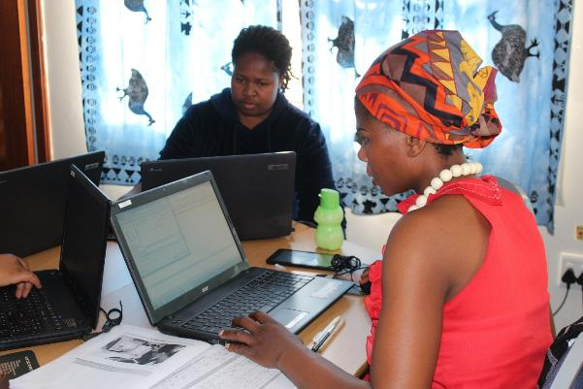

This module will provide participants with the basic knowledge needed to:
- Understand the hardware and software elements of a computer
- Entry level use Microsoft Word and Excel
- Creating a Gmail account
- Using the Internet

3.1 HOW DOES A COMPUTER WORK

This is an introduction on how a computer works and the basic components of a computer.
A computer is an electronic device that can store, recover and process information. You can use a computer to type documents, send email, and browse the internet. You can also use it to do accounting, presentations, games, and more.

All computers consist of two basic parts:
- Hardware is any part of your computer that has a physical structure, such as the computer monitor or keyboard.
- Software is any set of instructions that tells the hardware what to do.

Computers come in different shapes and sizes.
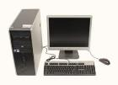 | Many people use desktop computers at work, home, school, or the library.  They can’t be carried around easily and usually stay in one place.
 | Laptops are more portable than desktop computers, allowing you to carry and to use them almost anywhere.  They have everything that the desktop does but is all in one place.
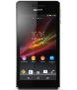 | Today, there lots of everyday devices that are basically specialised computers, even though we don't always think of them as computers think of them as computers. Even cell phones (smartphones) can be used as computers. You can use kind of phone to transfer money, send messages and work on the Internet.

What is an operating system? All computers have a “brain” and this is called the operating system and this runs a computer. It manages the computer's memory, processes, and all of its software and hardware. Without an operating system, a computer won’t work.
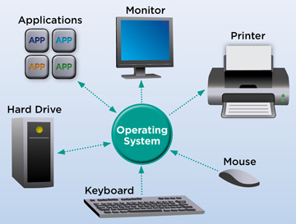
Computer operation system. Picture source: http://www.webopedia.com/TERM/O/operating_system.html

Booting is the process that occurs when you press the power button to turn your computer on. Once the operating system has started up, it manages all the software and hardware on the computer.

What is an application?
You may have heard people talking about using an application or an app. But what exactly does that mean? An application (or app) is a type of software that allows you to perform specific tasks.
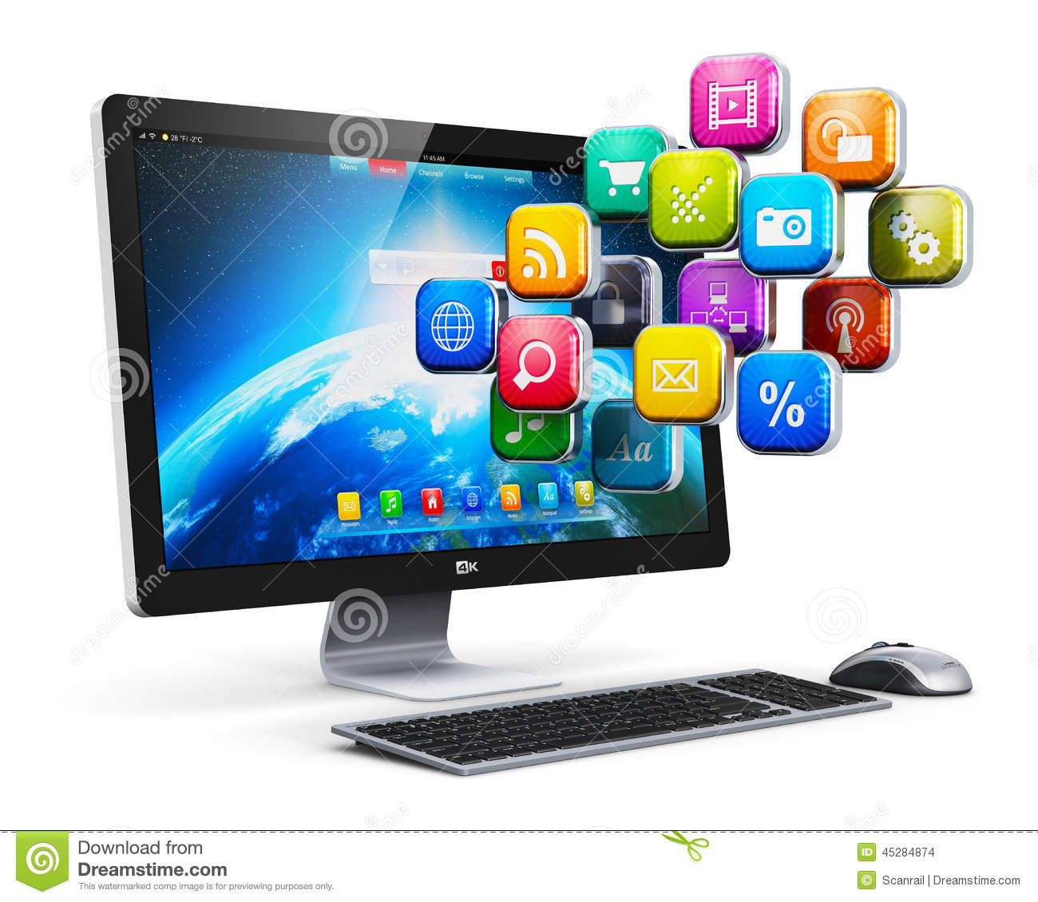2

App is a very common term for an application, especially for simple applications that can be downloaded cheaply or even for free. Many apps are also available for mobile devices.

Types of desktop applications
There are countless desktop applications out there, and they fall into many different categories. Below are just a few types of applications that you might use:
- Word processors: A word processor allows you to write a letter, design a flyer, and create many other kinds of documents. The most well-known word processor is Microsoft Word.
- Web Browsers: A web browser is the tool that you use to access the World Wide Web. Examples of browsers include Internet Explorer, Firefox, and Google Chrome.
- Games: There are many different games that you can play on a computer.

Basic components of a computer

A Key board

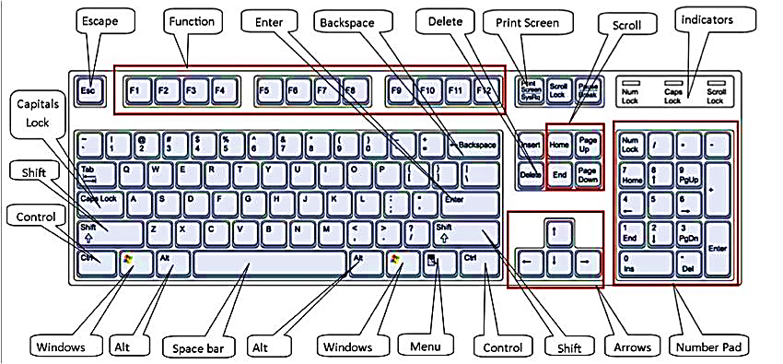

A mouse

This is a way to control what the computer does

With a desktop computer a separate mouse is attached to the computer. A mouse needs to be always be used on a flat surface and must face the computer. | 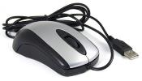
On a laptop the mouse is built into the computer. This type of mouse is controlled with a finger moving where the mouse needs to be on the screen. You can use both types when you use a laptop. | 

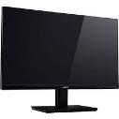
A monitor or screen.

Every computer has a screen. A desktop computer has a separate screen and a laptop this is built in.

3.2 USING A COMPUTER TO CREATE DOCUMENTS

Using the computer to create a document

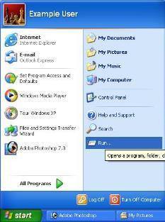
On the computer you can create a new document or work on an existing document which you have already saved. First you need to start the computer using the start button.

Everyone sets up their computer in different ways and this can be confusing when not every screen looks the same. This is because people set up the computer for their own needs.

When you start up the screen will change and show you different options to use on your computer. You will find icons for opening documents, accessing the internet or email, finding all the programmes that are on the computer; amongst other applications.

The most common way of creating a word document is to use Microsoft Word.

Microsoft Word 2010
Word 2010 is a word processor that allows you to create various types of documents such as letters, papers, flyers, faxes and more.

The Ribbon contains all the commands you'll need in order to do common tasks. It contains multiple tabs, each with several groups of commands.

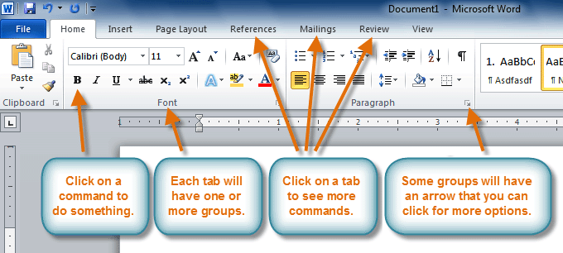

Creating and Opening Documents

Word files are called documents. Whenever you start a new project in Word, you'll need to create a new document, which can either be blank or from a template. There are many different options that you can find and use to make documents look smarter or more interesting. These templates can be changed to suit your own needs.

They include templates for pamphlets, letters and business cards.
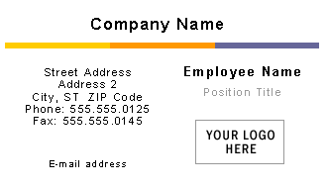

You'll also need to know how to open an existing document which have already worked on. You can save a document you have worked on to keep working on them late.

To Create a New, Blank Document:
- Click the File tab.
- Select New.
- Select Blank document under Available Templates. It will be highlighted by default.
- Click Create. A new, blank document appears in the Word window.

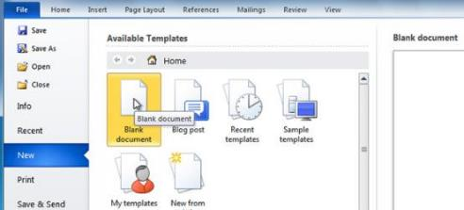

To Open an Existing Document:
- Click the File tab.
- Select Open. The Open dialog box appears.
- Select your document and then click Open.

Microsoft Word also allows you to copy and paste text from;
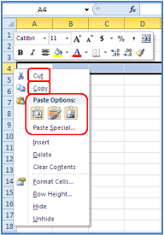
- Different places in the same document
- Between different documents that you are working on
- From other documents that allow you to copy information such as from the Internet

To Copy and Paste Text:
- Select the text you wish to copy.
- Click the Copy command on the Home tab. You can also right-click your document and select Copy.
- Place your insertion point where you wish the text to appear.
- Click the Paste command on the Home tab. The text will appear.

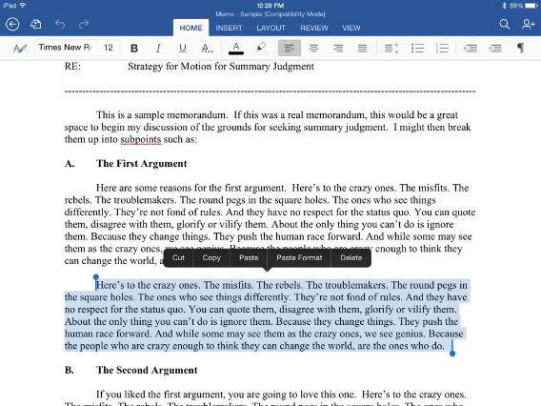

3.3 USING MICROSOFT EXCEL TO MANAGE FIGURES AND FINANCE MANAGEMENT

Excel 2010


Excel 2010 is a spreadsheet application in the Microsoft 2010 Office Suite. Excel allows you to store, manipulate and analyze data in organized workbooks for home and business tasks. New innovations in Excel 2010 include the enhanced data viewing features of Sparklines and Slicers.

Introduction

Working with Excel Environment
The Ribbon is where you will find the commands you need to do common tasks in Excel.

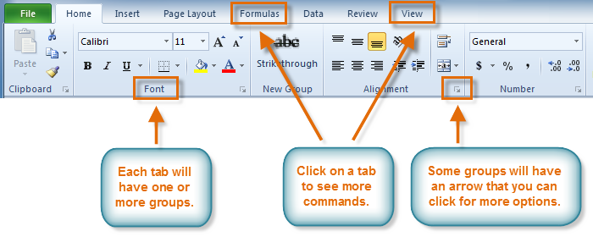

Creating and Opening Workbooks
Excel files are called workbooks. Each workbook holds one or more worksheets (also known as "spreadsheets").

To Create a New, Blank Workbook:
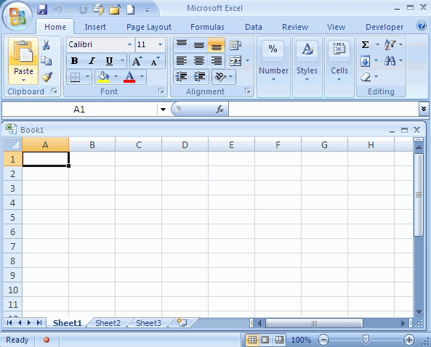
- Click the File Tab. Select New.
- Select Blank workbook under Available Templates. It will be highlighted by default.
- Click Create. A new, blank workbook appears in the Excel window. Creating a new workbook
- To save time, you can create your document from a template, which you can select under Available Templates. We will talk more about this in a later lesson.

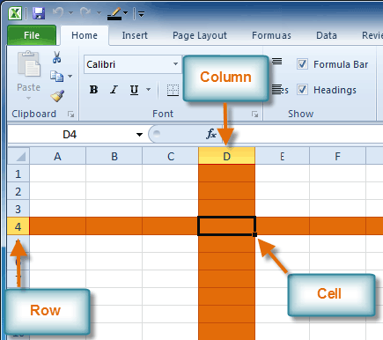
To Open an Existing Workbook:
- Click the File tab.
- Select Open. The Open dialog box appears.

Opening a workbook
Select your desired workbook and then click Open.
You will need to know the basic ways you can work with cells and cell content in Excel to be able to use it to calculate, analyse, and organize data. Cells are the basic building blocks of a worksheet. Cells can contain a variety of content such as text, formatting attributes, formulas, and functions. To work with cells, you'll need to know how to select them; insert content; and delete cells and cell content.
Each rectangle in a worksheet is called a cell. A cell is the intersection of a row and a column.

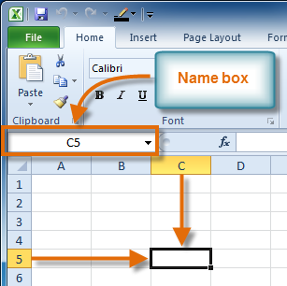
Each cell has a name, or a cell address based on which column and row it intersects.

The cell address of a selected cell appears in the Name box. Here you can see that C5 is selected.

Simple Formulas in Excel 2010
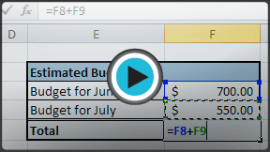
A formula is an equation that performs a calculation. Like a calculator, Excel can execute formulas that add, subtract, multiply, and divide.

Creating Simple Formulas
Excel uses standard operators for equations, such as a plus sign for addition (+), a minus sign for subtraction (-), an asterisk for multiplication (*), a forward slash for division (/), and a caret (^) for exponents.The key thing to remember when writing formulas for Excel is that all formulas must begin with an equal sign (=). This is because the cell contains, or is equal to, the formula and its value.

Creating Formulas with Cell References
When a formula contains a cell address, it is called a cell reference. Creating a formula with cell references is useful because you can update data in your worksheet without having to rewrite the values in the formula.

To Create a Formula Using Cell References:
- Select the cell where the answer will appear (B3, for example).

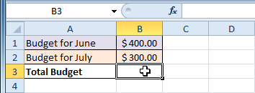
Selecting cell B3
- Type the equal sign (=).
- Type the cell address that contains the first number in the equation (B1, for example).
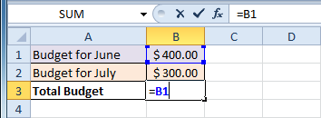
- Type the operator you need for your formula. For example, type the addition sign (+).
- Type the cell address that contains the second number in the equation (B2, for example).
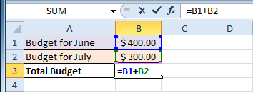
Entering a formula in B3
- Press Enter. The formula will be calculated and the value will be displayed in the cell.
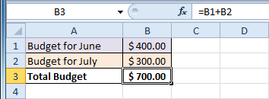
Result in B3
If you change a value in either B1 or B2, the total will automatically recalculate.
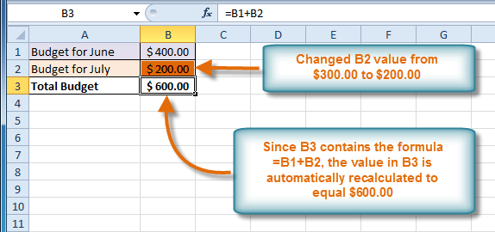

You may be familiar with common functions like sum, average, product or count, but there are hundreds of functions in Excel, even for things like formatting text, referencing cells, calculating financial rates, analyzing statistics, and more.

In this lesson, you will learn the basics of inserting common functions into your worksheet by utilizing the AutoSum and Insert Functions commands. You will also become familiar with how to search and find various functions, including exploring Excel's Functions Library.

To Create a Basic Function in Excel:
- Select the cell where the answer will appear (F15, for example)
- Type the equal sign (=) and enter the function name (SUM, for example).
- Enter the cells for the argument inside the parenthesis.
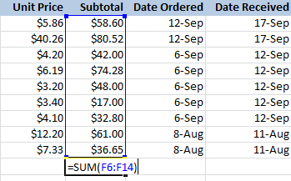
- Press Enter and the result will appear.

You can manage stock on Excel
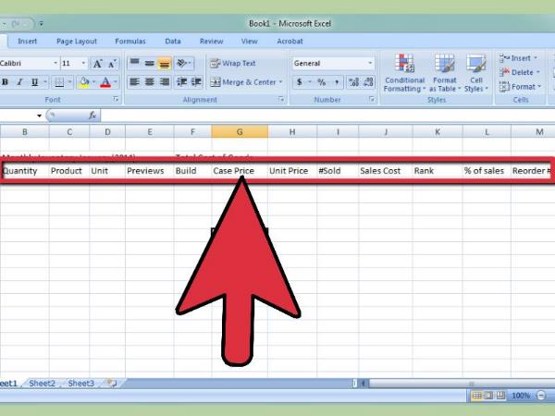
Source: http://www.wikihow.com/Create-an-Inventory-List-in-Excel#/Image:Create-an-Inventory-List-in-Excel-Step-3-Version-3.jpg

You can do your cash flow on Excel

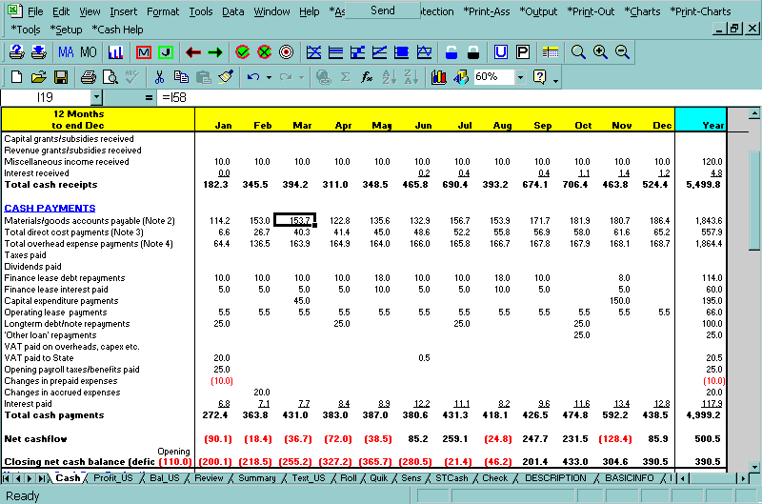
Source: http://www.planware.org/cashshot.htm

Now use the cash flow projections in your entrepreneurship manual (on page 53) to create cash flow projections in Excel.

Start-up finance can also be done on Excel
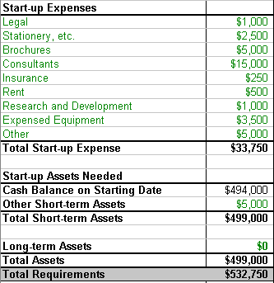
Using Excel to do you’re budgeting, forecasting and to manage your cash flow will make managing your finances easier before and after you start a business.
Use the start-up finance example in your manual to create a template in Excel.
You can also do simple calculations on Excel like your monthly income and expenses in an easy way like the example in your entrepreneurship manual which you can create in Excel.
Template for managing monthly expenses that can guide you and be created in Excel.
EXPENSES IN THE BUSINESS |  | INCOME IN THE BUSINESS
ITEM | COST | ITEM | AMOUNT
Rent |  | Sales
Water and electricity |  | Other
Owners salary
Wages for employees
Transport
Insurance
Telephone/faxes/email
Cleaning
Loan repayments
Stock
Other
TOTAL |  | TOTAL

3.4 Email Basics

Are you interested in communicating online with friends, family and colleagues? The topics in Email Basics will teach you the essentials of email, in addition to other popular ways to communicate online in today's world.

Gmail is a popular, web-based email service provided by Google. Learn the basics of how to compose, send and respond to emails.

Introduction

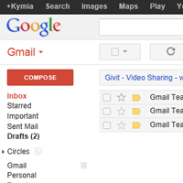
Gmail (also called Google Mail) is a free email service provided by Google. In many ways Gmail is like any other email service: you can send and receive emails, block spam, create an address book, and do other basic email tasks. But it also has some more unique features that help to make it one of the most popular email services on the web. First you need to create a Google account.

Google Accounts
Creating a Google Account will be needed to access Gmail because this email service is one of the many services offered by Google to registered users. Signing up for a Google Account is free and easy, and naming your new Gmail address will be a part of the sign up process. This means whenever you're signed in to Gmail, you are automatically signed in to your Google Account. You'll be able to easily access other Google services like Google Docs, Calendar, YouTube, and more. Creating a Google Account also means that you'll be a part of Google+, Google's social networking service.

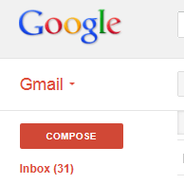
Gmail has a wide range of features, ranging from standard features that all email services have (such as the ability to send and receive emails.

Get to Know the Gmail Interface
When you're working with Gmail, you'll mostly be using the main Gmail interface. This window contains your inbox, and it allows you to navigate to your contacts, Mail settings, and more. Also, if you use other Google services such as YouTube or Calendar, you'll be able to access them from the top of the Gmail window.

Setting up a Gmail account is easy. You will begin by creating a Google Account and during the quick sign-up process you will choose your Gmail account name. In this lesson, we'll show you how to set up your Google Account for Gmail, add and edit contacts, and edit your mail settings.

Setting Up a Gmail Account
To create a Gmail (Google Mail) address, you'll first need to create a Google Account. Gmail will redirect you to the Google Account sign up page. You'll need to provide some basic information like your name, birthday, gender, and location. You will also need to choose a name for your new Gmail address. Once you create an account, you'll be able to start adding contacts and adjusting your mail settings.
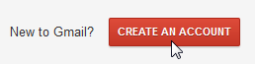
To Create an Account:
- Go to www.gmail.com.
- Click Create an Account.

- Gmail will redirect you to the Create a new Google Account window.
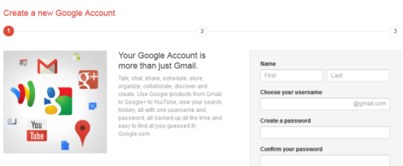
You will now need to fill out a form with your information. Type your first name and last name.
- Type the Google username you want to use. This will become your Gmail email address. Google checks the availability of the username to make sure that name hasn't already been taken.
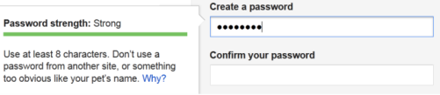
- Type your desired password. Just like with any online service, it's important to choose a strong password - in other words, one that is difficult for someone to guess. When you type your desired password, Gmail will tell you whether it is strong enough, and if it's not strong enough you can modify it. For more information, check out Passwords: The First Step to Safety in our Internet Safety tutorial.
- Enter your birthday month, day, and year. Select your gender.
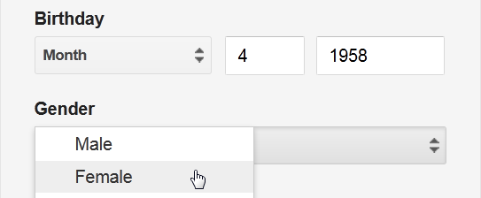

- Review the Terms of Service and Privacy Policy and click on the box to accept.
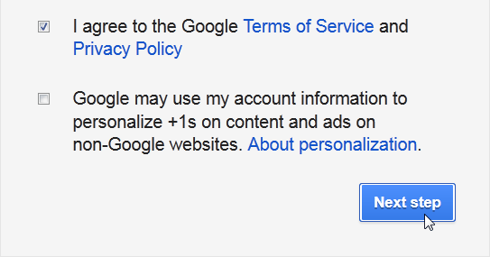
- Review the About personalization and click the box if you would like to participate in Google +1 content and ads. We will leave the box empty. Click Next step to continue.
- The Create your profile page will appear. Google welcome page will appear. This page will help explain the basics of your Google account and remind you of your Gmail address and Google username.

Signing in to Your Account
When you first create your account, you will be automatically signed in. Most of the time, however, you'll need to sign in to your account, and then sign out when you're done with it. Signing out is especially important if you're using a shared computer (for example, at a library or office), because it prevents other people from viewing your emails.

To Sign in:
- Go to www.gmail.com.
- Type your username (your email address) and password, and then click Sign in.
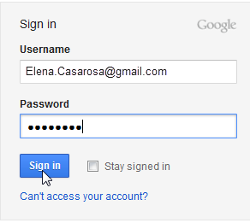

To Sign out:
- In the top-right corner of the page, click your name and select Sign out.

Now that you've created a Gmail account, you can start sending email messages. Writing an email can be as simple as just typing a message, or you can use text formatting, attachments, and a signature to customize your message.

Sending Email
When you write an email, you'll be using the compose window. This is where you'll add the email address of the recipient(s), the subject, and the body of the email, which is the message itself. You'll also be able to add various types of text formatting as well as one or more attachments. If you want, you can even create a signature that will be added to the end of every email you send.
Watch the video to learn how to compose and send an email.

The Compose Window
Click the buttons in the interactive below to learn about the different parts of the compose window.

To Send an Email:
- In the left menu pane click the Compose button.
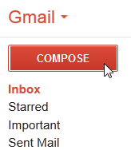
Composing a new email
The compose window will appear in the lower-right corner of the page.
In the Body field, type your message. When you're done, click Send.
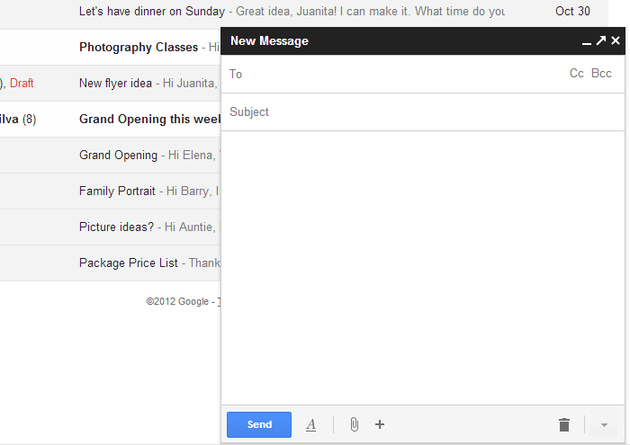

3.5 Browsing the web

Introduction
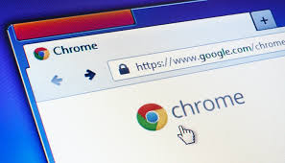
It's possible to think of the internet as the world's biggest library - but instead of books, its shelves contain billions of individual web pages. Imagine being in such a vast library. It would take forever to find what you were looking for! Every library has an index to help you track down the book you want. The internet has something similar in the form of 'search engines'.
Search engines are special websites that have indexed billions of pages - and make it easy for you to find a website or page in an instant. Popular search engines include Google, Yahoo!, and Firefox.
To get to a search engine you just need to go to your browser's address bar and type in the address of the search engine website, or you can use the search box that's usually found in the top right-hand corner of a browser.
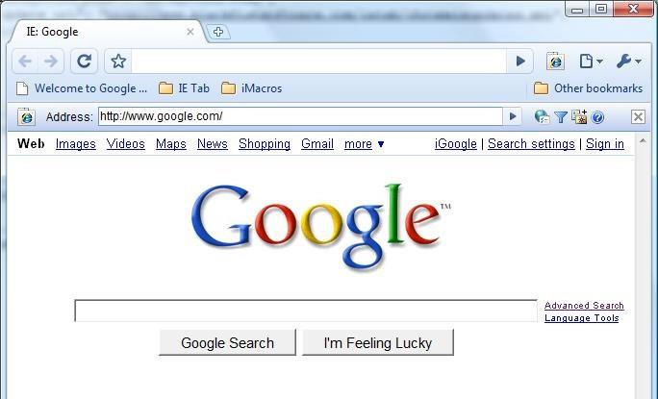
Using key words to find what you want
If you wanted to search shops shopping centres in Johannesburg, you could type Shopping centres in Johannesburg into the search box and then either press 'Enter', or click on 'Search' or the search symbol (which can be a magnifying glass).

You'll get a list of the most popular web pages that contain the words you typed in.
You could search again using more key words. So instead of just Shopping centres in Johannesburg, you could add the word shoes. Now your search results should give you pages of shops that sell shoes. If you know what the website address is then you can type this in the space next to Address. For example type http:/www.genderlinks.org.za.

There are two arrow symbols at the top of your browser window - one pointing left (which is the back icon) and the other pointing right (which is the forward icon).

If you want to go back to a previous page, you can click or tap on the back icon. Similarly, you can use the forward icon to go forwards.

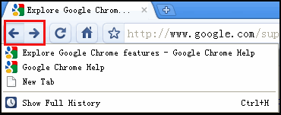
You may also want to reload the same page - for example, if it's a breaking news story that is being regularly updated.

Some browsers refer to this function as 'refreshing' a page. Depending on your browser, the symbol for 'reload' or 'refresh' may appear as a circular arrow or arrows.

How can you use the Internet for your business? Adapted from http://smallbusiness.chron.com/benefits-businesses-using-internet-322.html

The Internet has allowed emerging businesses to increase both visibility and revenue (income), and the ability to reach more people than ever before.

Before the Internet a new business would need to rely on advertising locally, printing pamphlets or putting notices in people’s letter boxes. The Internet has given business an opportunity to reach many more people and customers.

Source: http://moviecom.tv/tag/internet-marketing-requires/

The World Wide Web operates 24 hours a day, seven days a week. Businesses that sell ready-made products benefit most from this advantage. By creating an Internet store, these entrepreneurs have the ability to maintain a virtual retail shop that never closes, affording the owner the possibility of literally making money in their sleep. Opening and maintaining an online store costs much less than setting up a physical shop.

The Internet makes it easy to stay in contact with your customers via email and online networking tools such as discussion boards, chat rooms, and social networking sites like Facebook.

Using Internet communication tools effectively, you can keep up a continuous dialogue with customers and prospects. You can send special offers and announcements to existing customers via email and keep customers aware of new products or services.
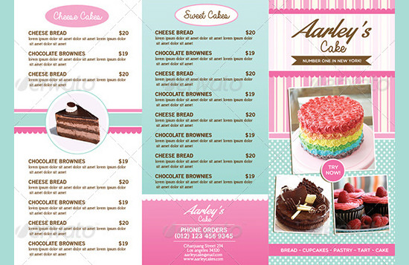
Source: https://www.template.net/design-templates/menu/bakery-menu-template/

A website can be colourful and show off products, allow people ot order and pay online and to ask questions about the business.

Browsing the Internet
There are several options for how we browse and navigate through web pages. Traditionally, we click on links to go to new web pages. We may use the Navigation Buttons to navigate back and forth between pages. However, as we further our browsing, sometimes our computer desktop becomes cluttered with new windows and our navigation can become tedious.

Browsing with Tabs
If you are doing more extensive browsing and perhaps want to switch between pages or have more than one page open at a time, then you may consider browsing with tabs. This option keeps your open pages organized and easily accessible, especially with the new Tab Groups feature that color-codes your related pages and arranges them next to each other.
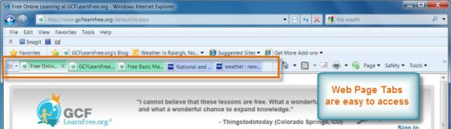Browser Tabs
You can open pages in tabs while still remaining in the same window. Then you may navigate through the tabs at the top of the page to select and view the web pages you desire.

To Open a New Tab:
- Locate and click on New Tab.
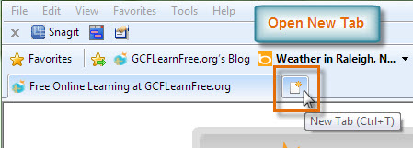
Opening a New Tab
- The What do you want to do next? page will appear with several options you may choose from. Otherwise, you can enter a new address or search to open the page you desire in a new tab.
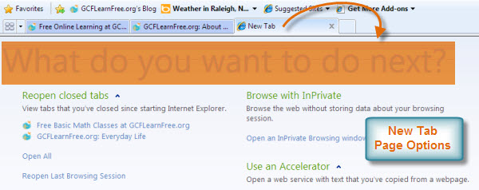New Tab Page Options
To make navigation easier, you can preview your tabs by clicking on the Quick Tabs button and then selecting the tab you desire.
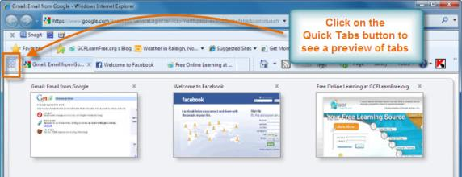Quick Tabs Preview

Tab Groups
In order to use Tab Groups, you will need to open a new page by right-clicking on the desired link and selecting Open in New Tab.
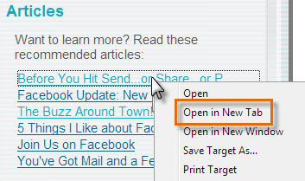
Open in New Tab
Related pages will be grouped and color-coded for easier access. You may see a list of the tabs by clicking on the Tab List drop-down button.
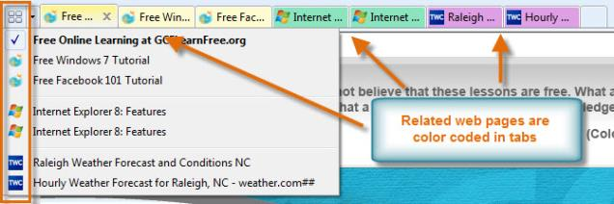Tab Groups
Some links are coded to open in a new window and this option may be fine. However, sometimes having a lot of open windows on your desktop can get a bit confusing, so you may want to get into the habit of selecting Open in New Tab when clicking on links.
Internet Explorer 8 Toolbars
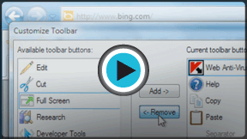
Toolbars allow for one-click access to the menus, functions and features of the web browser. Once you understand the Internet Explorer Toolbars, your browsing experience will become more convenient and even tailored to your specific needs. For example, you can place your favorite websites in the Favorites Bar for faster, one-click access.
In this video, you will learn about the various toolbars and how they can be customized to suit your needs.

The toolbar menu
The Favorites Bar, Command Bar and Status Bar are all standard toolbars in Internet Explorer. Review the interactive below to learn about the various toolbars and their convenience and function.

Customize toolbars
Now that you have a better understanding of the toolbars, you may choose to customize them to suit your needs. You may hide toolbars, rearrange them in the browser or change the look of the icons. You can even add, remove or reorder toolbar buttons.

Toolbar Menu and View Options
Right-click in the toolbar area to access the Toolbar Menu. Click on the box to the left of each Toolbar to hide or show it in the browser.
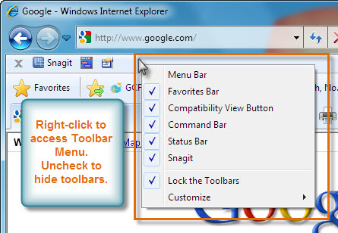
Toolbar Menu
If you want to rearrange the placement and view of toolbars, uncheck the Lock the Toolbar option. You can then click on the dotted line to adjust the view of the toolbar. You can also click and drag toolbars to adjust their placement in the browser.
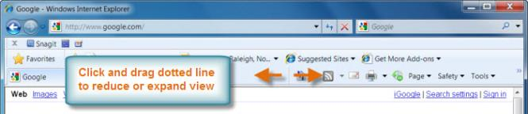Reduce or Expand Toolbars

Customise toolbar
There are several options for customizing the view of the buttons, icons and text in the toolbar. Select Customize from the Toolbar Menu and adjust the settings as desired.
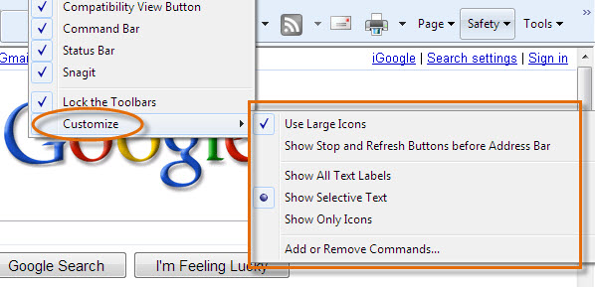Customize Toolbar Options

To Add or Remove Commands:
- Click on Add or Remove Commands... from the Customize options.
- As desired, select a Toolbar Button and then click on Add or Remove.
- Click on Move Up or Move Down to change the order of the icons in the Command bar.
- Click on Close when finished.
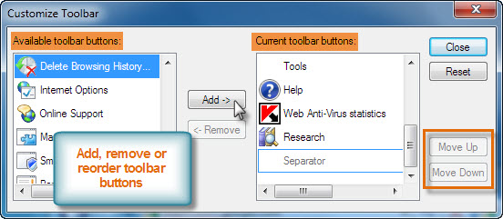Customize Toolbar

Customize your home page
You may wish to change Internet Explorer's default home page to a page that you desire. Click on Tools in the Menu Bar and select Internet Options.
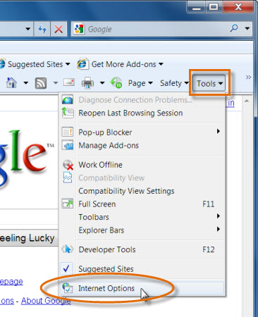
Access Internet Options
Type the URL address of the web page you want to be your home page. You may add more than one address and Internet Explorer will open them as home page tabs. For example, you may wish to check your email and your Facebook page on a regular basis, so it may be convenient to add each of the sites as your home page tabs.

Google Chrome as an Internet Browser (adapted from https://www.howtogeek.com/287721/the-complete-guide-to-mastering-tabs-in-google-chrome/

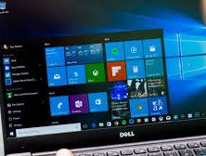
Google Chrome is the most resent browser developed by Google. This has many new features and the screens you might see when opening Chrome can include:
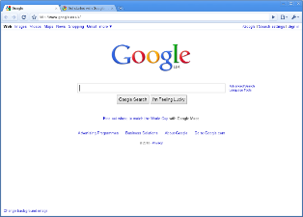

How to Open, Pin, and Close Tabs
To open a new tab on Chrome, click the New Tab button. To close a tab, click the X on each tab on Windows. If you want to reorder tabs, you can click and drag them around to fit your needs.

Similarly, if you want a tab to open in a new window, drag it out of the current browser window, and drop it elsewhere on your desktop. Right-click on any open tab and check out the options available to you.

Closing tabs is easy, as we discussed, but if you have a lot of tabs open and you don’t want to close every single tab one by one, you can right-click on the one you want to keep and choose “Close Other Tabs”.

https://www.dreamstime.com/stock-illustration-computer-applications-internet-concept-creative-abstract-web-software-business-communication-technology-desktop-pc-cloud-image45284874
https://www.digitalunite.com/sites/default/files/images/keyboard850.jpg
https://www.google.com/search?q=microsoft+2010+cut+and+paste&client=firefox-b&dcr=0&source=lnms&tbm=isch&sa=X&ved=0ahUKEwidrrGtm4fZAhVpCMAKHdakBKoQ_AUICigB&biw=1525&bih=730#imgrc=lIZpizh4JnPiBM:
http://articles.bplans.co.uk/starting-a-business/estimating-realistic-start-up-costs-2/358

