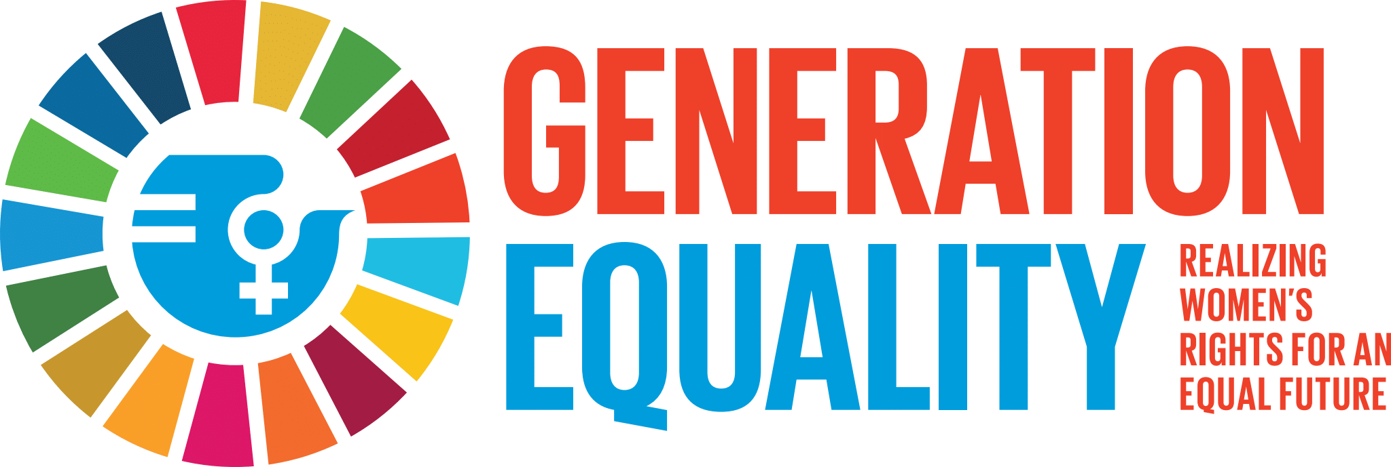

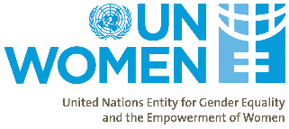


Programme for the
Young Women’s Entrepreneurship Challenge Awards
22 September 2021
11h00 - 13h00 South Africa Time
12h00 – 14h00 Uganda and Kenya Time
Join Zoom Meeting
https://genderlinks-org-za.zoom.us/j/88631419652

Time(South Africa) | Time(Kenya & Uganda) | Item | Who
INTRODUCTION
11h00 – 11h10 | 12h00 – 12h10 | Welcome and introduction of dignitaries, background to the awards | Anna Mutavati, Country Representative, UNWomen, Kenya
11h100 – 11h15 | 12h100 – 12h15 | Messages of solidarity - Business partners | Kaylash Naidoo- Anglo Gold Ashante - Chairperson of the SA WEPs Community of Practice
11h100 – 11h15 | 12h100 – 12h15 | Messages of solidarity - Business partners | Nichole Solomon- WEP Representative –United Nations Global Compact
11h15 – 11h20 | 12h15 – 12h20 | Messages of solidarity – Civil Society partners | Colleen Lowe Morna, Special Advisor –Sustainability Hub, Gender Links
11h20 – 11h30 | 12h20 – 12h30 | Key note address: Generation Equality | Anne Githuku-Shongwe, Representative for UN Women's South Africa Multi-Country Office, UN Women
KENYA | KENYA
11h30 – 11h35 | 12h30 – 12h35 | Poem | Dissi Obanda –Advocate of the High Court of Kenya and an entrepreneur
11h35 - 11h40 | 12h35 - 12h40 | A word from the judges | Mary Thuo Founder and CEO Cityscape Trends Services
11h40 - 11h45 | 12h40 - 12h45 | Awards announcements- Kenya | Infographic
11h45 – 11h55 | 12h45 – 12h55 | Short speeches by the winners | Shanice Kativi Wainana ; Sheila Koech and Ciru Kiiru
UGANDA | UGANDA
11h55 – 12h00 | 12h55 – 13h00 | Poem | Amasha Georgina Tendo
12h00- 12h05 | 13h00- 13h05 | A word from the judges | Agnes Kisembo ; Elizabeth Mushabe  Ms. Barbara Mirembe  UN Women Uganda
12h05-12h10 | 13h05-13h10 | Awards announcements- Uganda | Infographic
12h10 – 12h20 | 13h10 – 13h20 | Speeches by the winners | Laura Nakigozi Octavia; Nnassuna Mirembe and Sandra Letiyo
SOUTH AFRICA | SOUTH AFRICA
12h20 - 12h55 | 13h20 - 13h55 | Poem | Thandeka Radebe South African Poet
12h25 – 12h30 | 13h25 – 13h30 | A word from the judges | Infographic
12h30 – 12h35 | 13h30 – 13h35 | Awards announcements- South Africa
12h35 – 12h45 | 13h35 – 13h45 | Speeches by the winners | Moeletsi Taiwe; Yolanda Dyantyi; Keletso Kgalema;Lesley-Anne Ramontsoe
12h45 – 12h55 | 13h45 – 13h55 | Closing remarks & Vote of thanks | Dr.Okech Benson-Uganda Officer In Charge
12h55 – 13h00 | 13h55 – 14h00 | We are the world, we are the children | All – Zoom sing along

