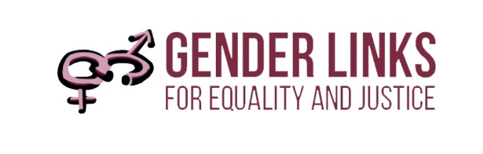

Discussion Paper
Southern African Expert Mission to Zimbabwe on Gender and Elections
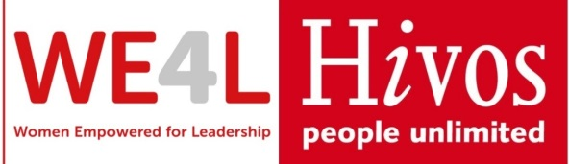
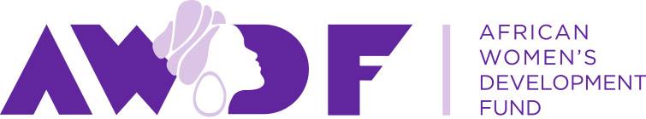
Synopsis
This paper sets out key issues and options for the increased representation of women in politics in Zimbabwe following the 2018 elections that witnessed a decline in women’s political representation at national and local level. The matter is of critical importance given:
- The provisions of Article 17 of the Constitution for women’s equal and effective representation in all areas of decision-making;
- The fact that the 30% quota for women at national level is expiring in 2023.
- The fact that there are presently no special measures in place for women at the local level.

These facts present both a threat and an opportunity – to debate electoral systems and quotas, both in relation to gender equality and to democratic practise more broadly. SADC abounds with examples of every possible combination of electoral system and quotas. The table below summarises key learning from SADC countries that will be elaborated in the paper:

Table one: Summary of key learning from SADC on Gender and Elections
ELECTORAL SYSTEM | QUOTA | EXAMPLE | PROS | CONS
FPTP | Voluntary | Zambia, Botswana | Accountability, party ownership | Slow results for women
 | Gender neutral | Mauritius | Wide acceptance | Only delivers results if there is corresponding advocacy
 | Reserved seats | Lesotho local | Guarantees the quota; women can still | May be seen as discriminatory against men
Mixed | PR women only | Zimbabwe national, Tanzania, Lesotho local | Guarantees the quota; does not infringe the rights of male candidates | Women who come in on PR may be seen as “token”
 | Quota for women in PR seats | Lesotho national | Ensures maximum advantage for women in PR seats | Does not deliver good overall results, if FPTP is 50% or more
 | Voluntary | South Africa local | Party ownership and buy-in | Women do better in PR than FPTP seats although this is improving
PR | Legislated | Namibia local | Delivers excellent results | Zimbabwe may not change its entire system in the time available. In Namibia some feel that PR is not best system at the local level due to the need for accountability.
 | Voluntary | Namibia national | Party ownership of the zebra system | Women’s representation is at the whim of parties
Commitments to gender parity in decision-making
SDG Target 5.5 seeks to “ensure women’s full and effective participation and equal opportunities for leadership at all levels of decision-making in political, economic and public life,” and Target 5c calls upon states to “adopt and strengthen sound policies and enforceable legislation for the promotion of gender equality and the empowerment of all women and girls at all levels.”

The updated 2030 SADC Protocol on Gender and Development, Article 12. 1, states that: “State parties shall ensure equal and effective representation by women in decision-making in the political, public and private sectors, including the use of special measures.”

Key provisions on gender and elections in the 2013 Zimbabwe Constitution include:
- The State must promote full gender balance in Zimbabwean society particularly with regard to promoting the full participation of women in all spheres of Zimbabwean society on the basis of equality with men and to take legislative and other measures to ensure that both women and men are equally represented in all institutions and agencies of government at every level; and that women should constitute at least half of members of all Commissions and other elected and appointed governmental bodies and that the State must take positive measures to rectify gender discrimination and imbalances resulting from past practices and policies. (Section 17)
- For the next two lives of the National Assembly (commencing in 2013), an additional sixty women shall be elected under a party-list system of proportional representation based on votes cast for political party candidates (Section 124)
- The State must ensure that all international conventions, treaties and agreements to which Zimbabwe is a party are incorporated into domestic law. (Section 34)

Women’s political representation at different levels of governance in Zimbabwe

Figure 1: Summary of Women’s Political Participation in Zimbabwe 2008-2018

The graph tracks women’s participation in decision-making in Zimbabwe over the last three elections. Following the adoption of the new Constitution in 2013, the proportion of women in the national assembly increased from 14% to 32% and in the Senate from 33% to 48%, resulting in an overall representation of 34% women. In the 2018 elections, this proportion reduced to 31%.

The PR quota for women at national level will expire in 2023, raising concerns that even the limited gains made at the national level will be lost. Furthermore, despite the provisions of Article 17, there is no quota for women at the local level. The proportion of women at this level has receded with each election – from 18% in 2008; to 16% in 2013 to 14% in 2018.

Electoral systems and quotas
By way of background there are two main types of electoral systems:
- In the Proportional Representation (PR), or “list system,” citizens vote for parties that are allocated seats in parliament according to the percentage of vote they receive. Individual candidates get in according to where they sit on the list. In an open list system, voters determine where candidates sit on the list. In a closed list system, the party determines where candidates sit on the list, although this is usually based on democratic nomination processes within the party.
- In the constituency, or “First Past the Post” (FPTP) system, citizens vote not just for the party, but also for the candidate who represents the party in a geographically defined constituency. Thus, a party can garner a significant percentage of the votes, but still have no representative in parliament, because in this system “the winner takes all.”

Electoral systems are a subject of debate in every country. There is no perfect system. Even mixed systems, that attempt to capture the best of both worlds, are open to debate. These debates may be summarised as follows:

Table 2: Gender and Electoral systems
SYSTEM | ADVANTAGES | DISADVANTAGES | GENDER CONSIDERATIONS
FPTP | Good for accountability | Winner takes all is not good for inclusion | Women especially excluded – lack funds and networks to succeed
PR | Good for inclusion | Weak on accountability – vote for a party, not a candidate | If political parties commit to include women equally in lists (especially the “zebra system” coined in Namibia) this results in a rapid increase in women’s representation.
Mixed | Includes the best of both worlds | PR candidates are regarded as token because they have not been involved in the rough and tumble of FPTP politics | If the PR candidates happen to be all or mostly women (e.g. the quota at national level in Zimbabwe) this adds to the notion of tokenism
Source: Gender Links 2019

There is overwhelming evidence internationally to suggest that women stand a better chance of being elected under the PR (and especially the closed list PR system) as opposed to the constituency electoral system. In a PR system voters choose based on the party and its policies, rather than on a particular individual. This works in favour of women – at least as far as getting their foot in the door – because of socialised prejudices against women in politics. The chance of women being elected is even higher when the PR system works in concert with a quota.

There are two types of quotas:
- Voluntary quotas are those adopted by political parties; these may be in any political system.
- Constitutional or legislated quotas are prescribed by the Constitution or law in any political system. They are often temporary in nature.

Electoral system | Overall % Women | With quota % women | Without quota % Women
FPTP | 13% | 15% | 13%
PR | 38% | 38% | 36%
MIXED | 34% | 37% | 23%
OVERALL | 26% | 38% | 16%
Table 2: Electoral systems and quotas in SADC – what the numbers say?
Source: Gender Links 2018
The table shows that:
- At 38%, countries with quotas have a far higher representation of women than those without quotas (16%).
- Consistent with global trends, countries with the PR system (38%) have a much higher representation of women than the FPTP (16%).
- Women’s representation in the mixed system (34%) is more than double the FPTP system.
- Quotas used in combination with the PR system (38%) and mixed system (37%) result in the highest representation of women.
- Women comprise 37% of parliamentarians in countries with a mixed system and quota, compared to 23% in countries with a mixed system and no quota.

Table 3 plots electoral systems and quotas at local and national levels against women’s political representation in each country. They are ranked in descending order according to women’s representation at national level. Overall, the chart demonstrates the strong correlation between electoral systems, quotas and women’s political representation. Specific observations include:

Table 3: Electoral systems, quotas and women’s political participation in SADC
Country | Electoral system N | Quota national | % women national | Electoral system L | Quota local | % women local
South Africa | PR | Voluntary | 46% | Mixed | Voluntary | 41%
Mozambique | PR | Voluntary | 40% | PR | Voluntary | 36%
Tanzania | Mixed | Constitutional 30% | 37% | Mixed | Constitutional 30% | 34%
Namibia | PR | Voluntary | 36% | PR | Law -30% | 48%
Zimbabwe | Mixed | Constitutional- 30% | 31% | FPTP | No | 14%
Angola | PR | Voluntary | 30% | PR | Voluntary | NA
Lesotho | Mixed | Law-30% PR seats | 23% | Mixed | Law -30% | 40%
Seychelles | FPTP | No | 21% | FPTP | No | N/A
Madagascar | FPTP | No | 20% | FPTP | No | 8%
Zambia | FPTP | Voluntary | 18% | FPTP | Voluntary | 9%
Malawi | FPTP | No | 17% | FPTP | No | 12%
eSwatini | FPTP | Yes – Constitutional | 15% | FPTP | Yes- Constitutional | 14%
Mauritius | FPTP | No | 12% | FPTP | Law -30% | 27%
Botswana | FPTP | No | 10% | FPTP | No | 19%
DRC | FPTP | No | 8% | FPTP | No | NA
Source: Gender Links, 2018

- Nine out of the 15 SADC countries have either a Constitutional or legislated quota, or voluntary party quota, in place. All of these except one (Mauritius local government, and ESwatini) have a PR system.
- All countries except one that have over 36% women in local government and parliament have a PR (or in the case of local government in South Africa, mixed) electoral system. In all four countries (South Africa, Mozambique, Namibia and Angola) ruling parties have adopted voluntary party quotas. In Namibia, the electoral law also prescribes a 30% quota for women in local government.
- Countries with a mixed system coupled with Constitutional or legislated quotas come after those with a PR system in terms of performance. Lesotho has always had a mixed system at the national level. The country adopted a mixed system at the local level so that 30% of seats can be reserved for women and distributed on a PR basis (in addition to the seats contested on FPTP basis). Lesotho now has a quota for PR seats at the national level, but these are not reserved solely for women. The Lesotho formula at local level drew on the experience of Tanzania that has now also been emulated at the national level in Zimbabwe. In all these examples, countries have adopted a mixed system to get around the rigidities of the FPTP system when it comes to increasing women’s political representation. The difference between women’s representation at the local level in Zimbabwe (16%) where there is a FPTP system and no quota, and national (32%) where there is a mixed system and quota is a stark reminder of the key role played by electoral systems and quotas in determining women’s political representation.
- Constitutional or legislated quotas in a FPTP system do not work well unless accompanied by enforcement mechanisms: The reason for this is that unless women are fielded in seats where they are likely to win, the numbers make little difference. The classic example of this is ESwatini, where despite the 30% Constitutional quota, women’s representation at local and national level has remained lower than 20%. A new law passed in May 2018 aims to give effect to the Constitutional quota. Mauritius managed to increase the proportion of women in local government from 6% to 27% in the 2015 elections through a strong advocacy campaign that accompanied the adoption of a gender neutral quota.
- The lowest representation of women is in the eight countries with a FPTP system. Within this category, Madagascar comes after Seychelles, following the increase in women’s political representation from 6% to 21% in the recent elections. These elections showed that it is possible to increase women’s representation in FPTP countries through strategic Fifty/Fifty campaigns, but still a challenge to go beyond around 20% without a quota.

OPTIONS FOR ZIMBABWE TO CONSIDER

- FIRST PAST THE POST OPTIONS

FPTP, no quotas:
The largest number of examples in the SADC region is of countries with a FPTP system and no legislated quota, though periodically voluntary party quotas. The results from SADC show that this is a non-starter if gender parity is to be achieved by 2030:

FPTP politics is still hostile for women in Zambia
Zambia is one of the eight countries in SADC that has a FPTP system with no quotas, resulting in low levels of women’s representation at both national and local level. The increase of women’s representation from 6% to 8% at the local level and 13% to 18% at the national level after the 2016 elections showed that rapid increases in women’s political representation are not likely in the FPTP system, particularly when they are not accompanied by any kind of special measures. The Zambia National Women’s League (ZNWL) commented: “Radical measures have to be put in place to ensure that the country’s leadership truly reflects the population it represents. To let the country change its attitude towards women’s representation on its own is not an option as this can take several years to achieve.”

FPTP and party quotas –Gearing up for elections in Botswana
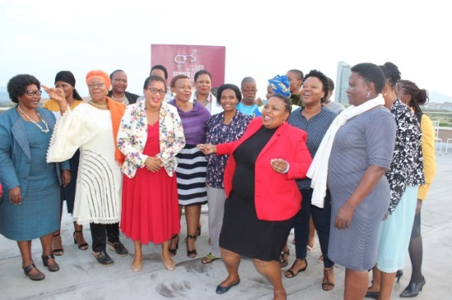
Ahead of the 2019 general election, the women’s movement has launched a 50/50 campaign to promote the equal and effective participation of Batswana women in political decision-making. Botswana, which celebrated its fiftieth anniversary in 2016, has had a FPTP electoral system since independence. The only quotas in the country are voluntary political party quotas that for the most part have not been observed.
At 20% women’s representation, the ruling Botswana Democratic Party (BDP) is far from reaching the target. Though the Botswana National Front (BNF) has a 30% quota, it has not actively implemented it. The Botswana Congress Party (BCP) has a quota of 30% and this has contributed to 44% women’s representation within the party leadership. Other parties like the Botswana Movement for Democracy mention gender equality but have not made efforts to ensure women are equally represented in central committees.
The all-time highest female representation in parliament stood at 18% following the 1999 elections. Since then, it has been a downwards spiral with women’s representation in parliament decreasing from 11% in 2009 to 10% in the 2014 general elections. Local Government representation went slightly up from 18% in 2009 to 19% in 2014. Botswana has never come even half way to achieving the gender parity target at local or national levels.

The general public perceptions of women in politics are that women are not confident to stand for leadership positions especially in politics. There is very limited voter education to mobilise the population to vote for women. Political education is still very weak especially for ordinary Batswana.

FPTP and Constitutional quota with no enforcement mechanism
ESwatini is the smallest Southern African nation and is one of the world’s few remaining absolute monarchies. In eSwatini the Westminster electoral model was replaced by the tinkhundla system to facilitate the practice of both traditional and the western styles of government in 1978. Political parties are not allowed to contest. Instead, individuals are elected to parliament from 55 constituencies known as “Tinkhundla.”

The constituencies are sub-divided into about 350 chiefdoms in the four regions nationwide. In the primary elections voters choose candidates from their chiefdoms who then contest the secondary elections and compete against other candidates in their constituency for a seat in parliament.

The Constitution of eSwatini (2006) provides that if after a general election the female membership does not meet the required 30%, the house shall elect not more than four additional women by region. This provision has not been observed.

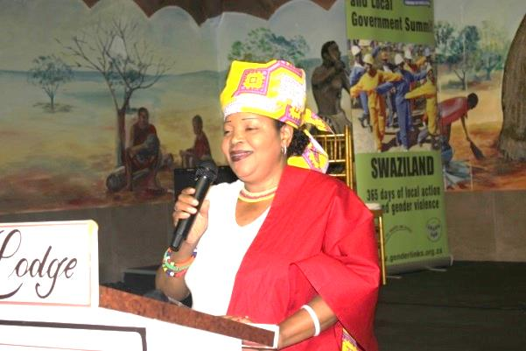
The Women’s Caucus in parliament set out to draft a bill that would ensure that the Constitutional provisions are observed in the 2018 elections. The Election of Women Members in the House of Assembly Bill was finally passed by Senators on 31 May 2018. The Act provides for “the election of the women members to the House of Assembly where, after any general election, it appears that the female members of Parliament will not constitute less thirty percent of the total membership of Parliament.” This gives effect to section 86 (1) in the ESwatini Constitution which states that: “Where at the first meeting of the house after any general election it appears that female members of Parliament will not constitute at least 30 per cent of the total membership of Parliament, then, and only then, the provision of this section shall apply.”
FPTP, reserved candidacy and a gender neutral quota –the Mauritius local government experience: Mauritius is the only SADC country that has not signed the SADC Gender Protocol. One of the island’s objections to the Protocol is Article 5 – affirmative action, now referred to as “special measures” in the Post 2015 Protocol in an effort to be more inclusive. Ironically, in 2013, Mauritius adopted a gender neutral quota for local government that led to the level of women’s representation increasing four fold, to 27%. Although all elections in Mauritius are held primarily on a FPTP basis, public education and awareness helped to ensure that women candidates fielded in the elections won.



Local elections December 2013 women’s representation increases from 6.4 to 26%.
Constitutional amendment removes main obstacle to the SADC Protocol being signed.
Minister of Local Government attends 2013 SADC Protocol@Work Summit, agrees to host Malagasy winners on a study tour ahead of the Madagascar election to share Mauritian model.
Prime Minister promises a White Paper on Electoral Reform to make provision for gender fairness in National election – expected July 2013.

Lobbying and advocacy: Soon after the 2010 General Elections, the Director of Gender Links Mauritius requested an appointment with the newly elected Minister of Local Government Herve Aimee to shared GL’s concern about the low representation of women in local government. She shared GL’s research, At the Coalface, Gender in Local Government in Southern Africa that includes case material on Mauritius. This research shows that women’s presence is necessary in local government for improving responsiveness and the quality of service delivery.

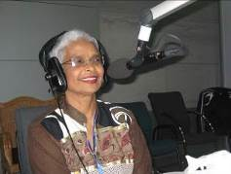
Use of the media: Virahsawmy followed up the meeting with a widely-publicised article on the GL Opinion and Commentary Service on the low percentage of women in local government. In his keynote address at the opening of the Gender Justice and Local Government Summit in 2012, Aimee reflected on how “the article came at a crucial time, as there was some grumbling going on with regard to the participation of women as contained in the new law. Some people said that it would be difficult to get so many candidates while others wondered whether the measures were constitutional. Aimee went further, writing an article of his own for the service, in which he commented: “The new Act will facilitate women's participation at local government level and further facilitate progression at national level.”

Strategic friends and allies: During the campaign, Mauritius appointed its first women Vice-President after four decades of independence. Talking to the media soon after her nomination Vice President Monique Oh San Bellepeau said “The Prime Minister believes in the capacity of women and wants women to go forward.”

On International Women’s Day 2011 in front of hundreds of women at the Grand Baie Convention Centre the Prime Minister Dr. Navin Ramgoolam broke new ground when he declared: “I think that finally we have to put a quota system.” He publicly thanked Virahsawmy for her work in encouraging women to join politics.

Debate and discussion: On 28 May 2011, Gender Links organised a debate on the quota for women in local government elections. Parliamentarians of the Labour Party, the MSM and the PMSD participated in the debate. Former Minister of Gender Equality, Child Development and Family Welfare, Sheila Bappoo (now Minister of Social Security) talked about the impending electoral reforms for local government to make space for women but did not officially commit herself.

Strategy and tactics – a gender neutral quota: Four months after the debate, the New Local Government Bill 2011 which marked a revolutionary step in the history of Mauritius went to Parliament. Government amended the Constitution in to allow for a gender-neutral quota to quell potential opposition and backlash. The Local Government Act requires at least 30% of either sex to be candidates on all party lists. Minister Louis Herve Aimee declared:

“2012 was a landmark year with regard to the advancement of women in politics in my country. When I presented the Bill in the National Assembly, there was very little objection from any quarter, be it religious or social, and certainly not political, as the opposition voted with the government in Parliament to ensure that a Constitutional amendment, brought by the Prime Minister, was passed at the same time as the main legislation, guaranteeing the changes. This was necessary to ensure that any potential legal challenge to the changes could be dealt with swiftly, and positively, by the Supreme Court, should the need arise.”

Finding women candidates: Gender activists took to the streets to find women candidates. Barriers cited by women included financial, family, lack of confidence and multiple roles. Conducting campaigns at night; lack of transport as well as some women being illiterate were also major constraints. GL reached across all parties to give substance to the 30% women candidate provision.

Customising content: From 2010 to 2012, Gender Links embarked on a series of training programmes on Media Literacy and Leadership Skills for Women in Politics. Although this is a module in the Centre of Excellence Process Gender Links Mauritius developed its own training manual using case studies, statistics and electoral system from Mauritius. At the end of the workshops participants gave mock radio and television interviews. They designed the campaigns on a series of issues including gender based violence, health care and heal centres, poverty, unemployment, youth and social problems. They used the issues in the campaigns to design their electoral manifestoes as well as leaflets.

Adapting content to local realities: One locality, Grand Port/Savanne took the training even further by organising a mock council meeting so that women trained had in-depth knowledge on Council meetings, its challenges and how a Council is run – from Standing orders, the Agenda, the debates, budget and what items can be brought to the Council. In Triolet, councillors talked about the tensions between the private and the public on the election trail.

Profile and participation: Ministers and gender activists financed workshops in six localities of Mauritius. Ministers and high level officials opened the workshops and committed themselves to make space for women, to encourage them to stand as candidates in the local elections. Councillors also helped by engaging with participants on how Councils work.
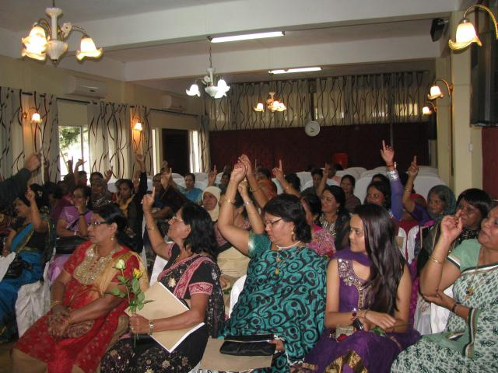
Delivering results: When elections came in December 2012, women won 36% of the seats in the municipal, and 26% in village elections to give an overall proportion of 26% - four times the previous level. Women’s representation in local government has continued to increase, and currently stands at about 30%.

Recommendations of the Zimbabwe local government Study Visit to Mauritius
In June 2015, GL and UN Women organised a study visit by the Ministry of Local Government to Mauritius to study how the island had succeeded in increasing women’s representation in a FPTP system. The team made the following recommendations:

- That the Ministry of Local Government, Public Works and National Housing approach the Zimbabwe Electoral Commission with a view to include a gender neutral clause in the Electoral Act. The percentage required by the Constitution is 50% but it may be prudent to attain this incrementally.
- That the Ministry of Local Government, Public Works and National Housing engage with ZEC to include a “literacy” qualification for councillors.
- That the Ministry of Local Government, Public Works and National Housing include the shorten term of office for the mayor/chairperson in the Local Government Act. It is felt that a two and a half year term [30 months] would be useful.
- That the Ministry of Local Government, Public Works and National Housing request ZEC to consider the registration of political parties as part of its function to ensure that the gender quota system was adhered to.

FPTP and reserved seats – Lesotho’ first local government quota
There is only one instance in SADC of reserved seats being tried in a FPTP system. The theory behind this is that the only way to guarantee the outcome of quotas in FPTP is to reserve certain seats to be contested by women only. These seats then rotate until all constituencies have had a turn at “women candidates only” elections. The system was used in the first local government elections in Lesotho and then abandoned.

The model that Lesotho opted for is similar to that chosen in India where the 74th Constitutional Amendment requires that 33 percent of the seats in the local elected bodies in the towns and country side (the panchayats) are reserved for women. Gender quotas are combined with reserved seats for scheduled casts as part of a rotation system, according to which it is decided in advance which category will be allowed to contest for the seats in the different wards. Article 180 (1) (b) of the Uganda constitution similarly stipulates that one-third of each local government council shall be reserved for women.

The Lesotho Government Elections Amendment Act 2004 provided for one third of the seats to be reserved for women in rotation, for three successive elections. This means that over the period each constituency would be reserved for women once.

Rethabile Pholo, Public relations co-ordinator of Lesotho’s Independent Electoral Commission (IEC) recalled that “We faced a lot of discontent, especially from the men. A lot of them used highly derogatory language to describe the elections. Many women (like the mayor of Maseru) were insulted.” Although women came in at a massive 58% of the total (30% in the reserved seats and 28% in the openly contested seats) many of the opposition parties cried foul. An independent team of observers deployed by the Commonwealth Secretariat concluded that:

A cloud of uncertainty prevailed over the backdrop of the Local Government Elections, with a clear breakdown of consensus and communication among critical stakeholders in the electoral process. Consequently we identified shortcomings in the conduct of critical processes leading up to the elections, such as delimitation of constituencies, the conduct of the voter registration update and voter education. We however commend the overall conduct of the polling day activities, which were carried out in a peaceful atmosphere and in a transparent manner, in accordance with the law.

Chief Tsepo Molefe made history by challenging Lesotho’s legislated 30 percent quota for women in local government. Molefe had wanted to stand, he said, because members of the community put pressure on him to do so as “they felt I could help with the development of this area.” He is proud of the fact that these same community members raised the money for his court case and supported him through the High Court challenge. He got no support from NGOs even though many expressed similar disquiet about the quota in the run up to the elections. Although the high court ruled against Molefe on the grounds that “positive discrimination” is permitted to address historical imbalances, the general discontent led to Lesotho looking for a different approach (see mixed systems).

- MIXED SYSTEMS OPTIONS

Mixed system and quota – Lesotho’s second and third local government elections
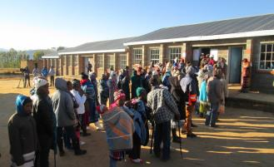
Following a challenge in the High Court, Lesotho opted for the “Tanzania model” (later adopted also in Zimbabwe at the national level). In this mixed system, 30% of council seats are allocated for women only to parties in proportion to their percentage of the vote in the elections, i.e. on a PR basis. In 2011, in addition to these PR seats women won 19% of the FPTP seats; a lower percentage than before, possibly because the first system had been so unpopular. At 49% women still came close to gender parity in Lesotho.

Local government elections due in October 2016 were postponed to September 2017 as the date clashed with Lesotho’s 50 years of independence. The elections were held in one municipal council, 11 urban councils and 64 community councils in all the ten districts of the country. In all, 1394 Councillors were elected in the September 2017 polls (FPTP seats, special PR seats for women and elected chiefs). Of these 555 were women: 40% of the total. The table summarises women’s representation in Lesotho at the local level:

 | 2005 | 2011 | 2017
% women | 58% | 49% | 40%
System | FTPT with reserved | FPTP with 30% women’s seats on PR | FPTP with 30% women’s seats on PR

There is no doubt that the system that delivered the best results for women were the reserved seats in the FPTP. However, the system since introduced has wider acceptance. What is important is for women who come in on the quota to gain the confidence to run in the openly contested seats to make up the 20% that would lead to gender parity.

Quota for PR seats only in the mixed system.
Lesotho has a mixed system at the national level. It has a quota for women at national that only applies to the PR seats. Lesotho experienced a 2% drop in women’s representation in parliament from 25% in 2015 to 23% in 2017.

The Lesotho parliament comprises 120 seats. Eighty are filled on a First Past the Post (FPTP) basis while the remaining 40 seats are distributed among parties on Proportional Representation (PR) system. Women won 19 of the 40 seats (48%) allocated under the PR system. Women only won 8 of the 69 seats under the FPTP system (12%).

The overall 2% drop in women's participation underscores the need for all political parties in Lesotho to review their party constitutions and include quotas. As women fare much better in PR elections than constituency ones, the options are to either increase the total number of PR seats or to reserve the PR seats for women exclusively as done at the local government level.

Mixed system and voluntary quotas – local government in South Africa

South Africa has a mixed electoral system at the local level, but with no legislated quota. The mixed PR and FPTP system is designed to harness the best of both electoral systems, with the PR system more friendly to women and minorities and the FPTP enhancing individual accountability. The only party that has voluntarily adopted a quota at all levels of governance in its party manifesto is the ruling African National Congress (ANC). The 2016 local elections witnessed a slight increase in women’s representation at the local level from 38% to 41% as a result of the mixed electoral system. In 2016, women came through strongly on party proportional representation lists (48%) but remained static at 33% on ward lists, bringing South Africa back to the 2006 position (41%) but still nine percentage points less than the 50% target to achieve gender parity al the local level. What is interesting is that over time, the proportion of women in the ward or FPTP seats has been increasing:

Year | % Women Ward | % Women PR | % Women overall
1995 | 11% | 28% | 19%
2000 | 17% | 38% | 29%
2006 | 37% | 42% | 40%
2011 | 33% | 43% | 38%
2016 | 33% | 48% | 41%

- PR SYSTEMS OPTIONS

PR and quota – Namibia’s experience
Countries with a Proportional Representation (PR) system such as Namibia are exemplary at national and local levels. As a result of the ruling South West Africa Peoples (SWAPO) 50% zebra quota, the representation of women in the national assembly in Namibia shot up from 26% to 46% in 2014, but the overall figure is diluted to 36% because of a weaker showing in the upper house. Local elections in November 2015 saw an increase in women’s participation from 42% to 48%, testament to the impact of the legislated 30% quota for women in local government, combined with SWAPO’s voluntary 50% quota.

Although Namibia’s national and local elections are held on PR basis, its regional elections are held on a FPTP basis. Since independence in 1990, this has resulted in a sharp divergence between women’s representation at local and national level, and in the regional council. This divergence is a poignant reminder of the impact of electoral systems and quotas on women’s political participation. After the commendable increase in women’s representation in parliament (from 26% to 36% in both houses in 2014) and in local government (from 42% to 48%) Namibia continues to lag behind at the regional level, with still no evidence of remedial action being taken.

These facts explain why SWAPO MP Eunice Iipinge introduced a motion in parliament for a legislated quota to cover all spheres of governance.

Making the case for a legislated quota in Namibia’s PR Parliament
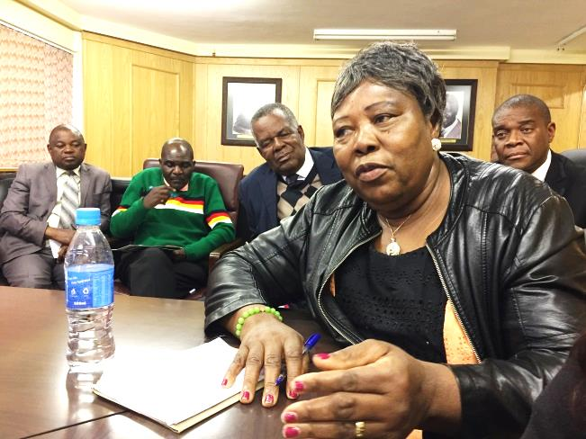
“The SWAPO Party has amended its Constitution to provide for 50 :50 representations on all its structures with the intention to have a half/half representation and participation of women and men at all levels of the Party that includes the Party lists for National and Local authorities’ elections. SWAPO Party is the only Political Party to have done so and has the majority women in this house. To illustrate this point here are the figures: SWAPO Party 43, Popular Democratic Movement 2, Republican Party 1 and Rally for Democracy and Progress 1 which is totalling to 47 women members of National Assembly out of 104 members.
This brings me to the question; how do we ensure gender parity in a democratic system of governance? How do we bring the other political parties on board? It is my proposal that uniformity in policy will bring us closer to fully attaining the gender parity that is required and necessary for an inclusive society. The opposition parties do not have similar policies which means that even when the SWAPO Party implements its 50:50 policy, the imbalance will remain because Parliament includes other political parties which may not have the half/half gender policy. The SWAPO policy cannot be imposed on other political parties, but this House can amend the necessary legislation to ensure that at all elections, all political party lists are aimed at reaching the highest possible equality in representation between men and women in line with the commitments we made in the Maputo Protocol.” – Excerpt from the motion by Hon Eunice Iipinge, Secretary of the SWAPO Women’s Council and SWAPO MP, 26 June 2019

Conclusions
Zimbabwe will need to decide, among others:
- What electoral system work best, at national and local level.
- What quota works best, at national and local level?
- Whether to lobby for the extension of the existing Constitutional quota, or to opt for a new system.
- If these provisions should be by Constitutional amendment, or electoral laws.
- The package of strategies that will be needed – legislative, advocacy and others to bring about change.

We commend:
- The strategic thinking has gone into the options.
- The fact that gender parity is now a non negotiable
- The high level of buy in from political parties: no longer a matter of why but how.
- The recognition that local government needs to be at the fore.
- The recognition of urgency – despite the fact that elections are four years away.
- The Zimbabwe Gender Commission for seizing the moment and mainstreaming this matter into electoral reform debates currently underway.

For more information on the comparative global data on quotas for women in politics see www.idea.int/quota.
Lowe-Morna, 1996.
A law was passed in Swaziland in June 2018 to give effect to the Constitutional quota.
https://womeninleadership.hivos.org/an-analysis-of-zambias-sixteen-councillor-by-elections-in-2018/
Ibid
Karam, A and Ballington, J ed (2005) Women in Parliament: Beyond Numbers, IDEA, p 148.
Commonwealth Report on the Conduct of Local Elections in Lesotho (2005) p 19

