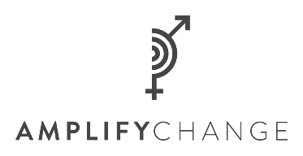
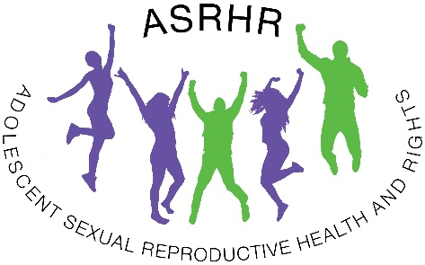
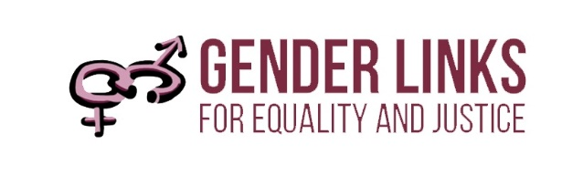

ADOLESCENT SEXUAL REPRODUCTIVE HEALTH AND RIGHTS (ASRHR) CHECKLIST
Purpose and scope
This checklist measures the level of preparedness in SADC countries to respond to the specific Adolescent Sexual Reproductive Health and Rights (ASRHR) needs of their citizens in line with regional and global commitments that enable access to SRHR services. The checklist is adapted from
- WHO Guidelines for Adolescent Sexual and Reproductive Health and Rights (2018);
- A review of the 100 SRHR indicators analysed in the 2021 #VoiceandChoice Barometer;
- The Adolescent SRHR rapid response questionnaire and assessment report; and the updated mapping of ASRHR laws and policies used by Gender Links (GL) to promote best practices on ASRHR in the SADC region.

The checklist covers the legal and policies frameworks, health, social and other service delivery issues that need to be addressed to increase the uptake, equity, efficiency and quality of ASRHR services especially in light of the Covid-19 pandemic. Annex A, shows extracts of policies or guidelines used to support the development of this checklist.

Please use the checklist to assess the current situation on ASRHR in your country. Tick ‘Yes’ or ‘No’ as applicable and add comments to explain the selection.
CRITERIA | YES | NO | COMMENTS
ASRHR legal and Policy Framework
- There is a specific (stand-alone) ASRHR policy and or guidelines that supports a rights-based framework for ASRHR and is aligned with regional and international commitments on ASRHR.
- ASRHR laws and policies allow adolescents and young people to access SRH services without third party authorisation.
- ASRHR legislation and policies are current, and capture adolescents evolving needs.
- Abortion laws and policies enable adolescents to obtain safe abortion services than create situations that lead adolescents to seek unsafe abortions.
Access to ASRHR services
- All health facilities offer free services and there are no other barriers to ensure equitable access to health-care services, including the full package of SRHR interventions as defined by the International Conference on Population and Development (ICPD).
- Health facilities address the range of social, economic, cultural and systemic challenges so that all adolescents and young people have universal access to quality health-care services across their life cycle.
- Health facilities are within 10km of adolescent homes.
- Health facilities offer services that are convenient to adolescent s and young people including after school hours and during weekends.
- Health system ensures the presence of peer counsellors in all health facilities as a component of youth friendly services.
- Health facilities ensure young people are treated without parental consent.
- Health system ensures young people are treated with respect.
- Health system ensures that health workers spend sufficient time with young people.
- Health system ensures that mental health assessments are part of sexual and reproductive health services accessible to adolescents.
- Health system ensures that health workers make follow up visits for adolescent reproductive health and care.
- ASRHR services are responsive to the needs of adolescents and young people especially during and are provided in a non-judgmental, confidential and private environment, in times and locations that are convenient for adolescents and young people including providing disability and respectful care to persons with disabilities.
- There are provisions for social protections as well as economic support for Adolescents as a pathway to reducing ASRHR risks.
Comprehensive Sexual Education (CSE)
- There are interventions for both in and out of school adolescents to provide access to good quality, comprehensive, age-appropriate, scientifically accurate life skills-based comprehensive sexuality education (CSE), to increase contraceptive use among adolescents.
- Government and other stakeholders offer interventions that combine curriculum-based sexuality education with contraceptive promotion to adolescents, in order to reduce teenage pregnancy rates.
- There are strategies within school settings at all levels (from ECD to universities) to ensure provision of CSE and other SRHR services in line with WHO guidelines on Covid-19.
- There are strategies in place to build community support for CSE and to identify and address factors at regional, national, community and individual levels that could contribute to resistance or backlash or stall CSE implementation progress.
Contraception
- There are strategies that are aimed at decreasing the unmet need for contraception among adolescents including formulating laws and policies to increase adolescent access to contraceptive information and services, including emergency contraceptives.
- There is access to a mix of contraceptive methods for and adolescents with special provisions in place for increased access during Covid-19 pandemic period.
- There is provision for tailored and age-appropriate family planning information, counselling and contraceptive services or referrals to adolescent-friendly service providers.
- Health service delivery ensures that the adolescent’s confidentiality is respected and facilitates without parental consent their access to and use of contraceptive information and services.
- There are interventions to reduce the financial cost of contraceptives to adolescents.
Teenage Pregnancy
- There are strategies in place to reduce the adolescent fertility rate (births per 1000 women, 15–19 years of age).
- There are interventions to promote an open culture and ease of parental communication around sexual issues with adolescents.
- Schools unconditionally protect pregnant learners right to remain in school during and after the pregnancy.
Maternal Health
- Health system does not compromise quality of antenatal care to young mothers compared to older mothers.
- Health system provides adequate information and suitable environment to enable young women to request and receive a pregnancy test.
- To reduce the high levels of maternal mortality amongst young mothers, there are strategies including promoting birth and emergency preparedness in antenatal care strategies for pregnant adolescents in household, community and health facility settings.
- There are efforts to ensure the availability of and access to adolescent friendly antenatal, intrapartum and postnatal care, including basic emergency obstetric care and comprehensive emergency obstetric care.
- There are efforts to ensure that adolescent young women can request and receive help with breast feeding.
Menstrual health
- There is provision of free menstrual ware to both in and out of school girls including those in hard to reach areas, the disabled and vulnerable to Covid-19 pandemic.
- There are systems in place (e.g. removal of Value Added Tax (VAT) and other taxes on menstrual ware) to ensure the provision of sustainable and cost-effective sanitary pads to adolescent girls.
- Adolescent girls and young women can request and receive sanitary pads.
- Menstrual hygiene management is an integral component in the country’s WASH programming to ensure access to basic sanitation.
- Government prioritises investment in clean water and sanitation.
Safe Abortion
- Every woman who is legally eligible has access to timely and safe abortion care.
- There are no age restrictions for adolescents wishing to access safe abortion care
- There are national guidelines for pre and post abortion care for adolescents, including during the Covid-19 pandemic period.
- Contraception is included in post abortion care during the Covid-19 pandemic period.
- Ensure adolescents have access to post-abortion care as a life-saving medical intervention, regardless of whether the abortion or attempted abortion was legal.
- There are strategies to identify and overcome barriers to the provision of safe abortion services for adolescent girls.
- Ensure that abortion services are non-judgemental, free of coercion, and respect adolescents’ informed and voluntary decision-making, autonomy, confidentiality and privacy to terminate an unwanted, mistimed or unplanned pregnancy.
HIV and AIDS
- There is provision of CSE, promotion and distribution of condoms, HIV testing and counselling services, pre-exposure prophylaxis (PreP), voluntary medical male circumcision for risk reduction, harm reduction for people who inject drugs, and targeted prevention programmes for young sex workers and other key populations at high risk of HIV acquisition.
- Health workers ensure that such ASRHR and HIV services are free, confidential, adolescent-responsive and non-discriminatory.
- Health system ensures that care and treatment of STIs is part of sexual and reproductive health services, and is accessible to adolescents, regardless of marital status.
- Adolescents are informed on risky sexual behaviours, such as early sexual debut, intergenerational sex and multiple concurrent partners to ensure comprehensive knowledge of HIV and AIDS.
- Health sector response has strategies to reduce HIV prevalence especially among young women aged 15-24 years.
- Cervical cancer screening, STI treatments and HIV and AIDS services are available especially during Covid-19 pandemic lockdowns.
- There is inclusion of HPV vaccine included in essential health services by the local health facilities especially for girls aged 9-13 years.
Harmful practices
- Health-sector response is complemented with community-based and multisectoral interventions that tackle harmful gender norms and attitudes that justify or condone violence against women and girls.
- There are programmes to increase educational opportunities for girls through formal and non-formal channels, and life skills training in order to delay marriage until 18 years of age.
- There are interventions to encourage political leaders, planners and community and religious leaders to formulate and enforce laws and policies to prohibit marriage of girls before 18 years of age.
- All stakeholders, at the community, national, levels, play an active role in the prevention of Female Genital Mutilation (FGM) and child marriage including other emerging harmful practices.
- There are systems to ensure that hhealth-care providers receive information regarding different types of FGM and the associated immediate and long-term health risks so that they can contribute to preventing FGM and prevent the medicalization of FGM (performance of FGM by health-care providers).
Minimum age of marriage
- The country’s minimum legal age to marriage for girls and boys conforms with the SADC Model Law on Child Marriages.
- The country’s minimum legal age to consent to sex for girls and boys conforms with the SADC SRHR guidelines.
- There are sufficient measures in place to ensure that legal prohibitions on early marriage are enforced in line with SADC Model Law on Child marriages.
Sexual and Gender Based violence (SGBV)
- The government and stakeholders implement programmes aimed at developing self-esteem, life skills in communication and negotiation for adolescent girls and young women.
- Country promotes gender-transformative approaches that engage men and boys to critically assess gender norms and behaviours that relate to sexual coercion and violence.
- Support and care for adolescent girls who experience IPV and sexual violence is integrated into sexual and reproductive health, HIV, mental health and adolescent health programmes and services.
- There are sufficient measures in place to ensure compliance with provisions in the SADC GBV Model Law.
- There is provision to strengthen sexual harassment laws in the country including protecting adolescents from sextortion at tertiary institutions of learning.
- The government and legal practitioners offer accessible, affordable and specialised services, including legal aid, to survivors of GBV including adolescents in the country.
- Facilitate uptake of SGBV services through raising public awareness of the signs, symptoms and health consequences of IPV and sexual abuse, and the need to reduce stigma and to seek timely care.

Annex A: Extracts of best practices on ASRHR practices in SADC
Extract 1: Access to contraception including emergency contraception
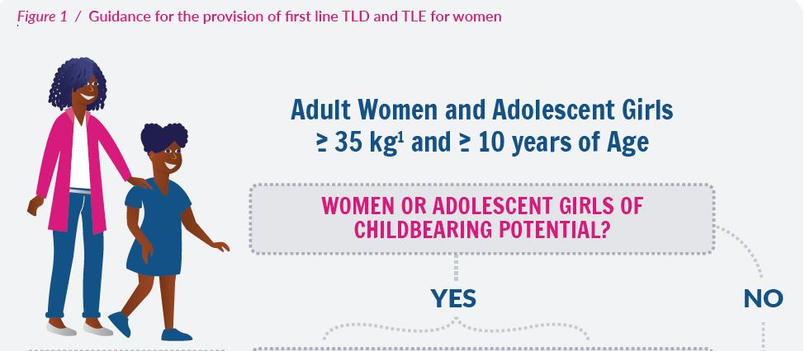
Source: National Contraception Clinical Guidelines 2019, South Africa, pg14.

Extract 2: Emergency Contraception
Relatively effective if used within 120 hours (5 days) after unprotected sex, but the sooner the more effective.
• For many young people, sexual activity can be sporadic, unplanned, and possibly non-consensual. It is important for young people to know about, and have easy access to, emergency contraception.
• Useful after contraceptive accidents, such as condom breakage or missed pills.
• Emergency contraception is not recommended as a regular contraceptive method and does not protect against the transmission of STIs and HIV.
• Condom use should be actively promoted.

Source: National Contraception Clinical Guidelines 2019, South Africa.

Extract 3: Unrestricted Abortion
South Africa: No age restriction at which a child may choose to terminate her pregnancy. Termination of Pregnancy Act 92 of 1996. Sections 1, 5(2) and 5(3). Read with section 129(1) of the Children’s Act 38 of 2005;
Source: National Contraception Clinical Guidelines 2019, South Africa. Pg41

Extract 4: Re-entry policies for Teenage pregnancies
Some governments have focused on tackling these barriers, as well as the root causes of teenage pregnancies and school dropouts, for example by:
- Providing social and financial support for adolescent mothers, as in South Africa;
- Providing girls with a choice of access to morning or evening shifts, as in Zambia;
- Providing school-based counselling services for pregnant girls and adolescent mothers, as in Malawi; and
- Facilitating access to sexual and reproductive health services, including comprehensive sexuality education at school and in the community, as in Ivory Coast, and access to a range of contraceptive methods, and in South Africa, safe and legal abortion.
Despite these positive steps by some African countries, a significant number still impose laws and policies that directly discriminate against pregnant girls and adolescent mothers in education. For example, Equatorial Guinea, Sierra Leone, and Tanzania expel pregnant girls from school and deny adolescent mothers the right to study in public schools. In most cases, such policies end a girl’s chances of ever going back to school, and expose her and her children to child marriage, hardship, and abuse. In practice, girls are expelled, but not the boys responsible for the pregnancy where they are also in school.
Source: Human Rights Watch, https://www.hrw.org/report/2018/06/14/leave-no-girl-behind-africa/discrimination-education-against-pregnant-girls-and, accessed 10 September 2021.

Extract 5: Economic empowerment of Adolescents
Solution pathway 1: Economic empowerment of families, adolescents and young people will lead to reduced school drop outs and harmful behaviours that increase vulnerability to ASRH risks among young people and adolescents.
Household and youth poverty leads to a variety of challenges that lend themselves to increasing the vulnerability of adolescents to sexual and reproductive health risks. For example, the MICS (2014), DHS (2010) and Census (2012) show that girls in poorer families are likely to drop out of school which increases their risk of either getting married or railing pregnant. The Zimbabwe Youth Investment Case of 2015, found that high unemployment among youths and subsequent idleness was contributing to increasing cases or drug, substance and alcohol abuse among adolescents and young people. Such practices increase the risk of young people participating in unsafe sexual practices which exposes them to STDs, HIV and unwanted pregnancies. The same report also ﬁnds that due to youth poverty, an increasing number of adolescent girls and young women were getting enrolled
in commercial sex work especially in poor urban locations. This again increases their vulnerability to sexual and reproductive health infections and adolescent pregnancies. Addressing both youth and family poverty will contribute to keeping more adolescents in school and thus avoid risky behaviour such as drug and substance abuse which increase vulnerability or adolescents and young people. Youth poverty also undermines access of adolescents and young people to ASRH services such as treatment of STDs, HIV testing, contraceptives and condoms for STI prevention.
Source: National Adolescent Sexual and Reproductive Health Strategy II, pg. xiv, 2016-2020.

Extract 6: Retention of learners in schools
6.4.2 Retention in School
The learners’ right to education during and after their pregnancy is guaranteed by the South African Constitution and guided by the African Charter on the Rights of the Child, which states in article 11(6) that ‘State Parties to the Charter shall take all appropriate measures to ensure that children who become pregnant before completing their education shall have an opportunity to continue with their education on the basis of their individual ability’. The basis on which the pregnant learner may be reintegrated into the basic education system after delivery will depend on medical advice and the point in the calendar year when she left the school for delivery. This reintegration process and its timing is detailed in the Policy Implementation Plan and guided by other relevant DBE policies and protocols. The retention or promotion of the learner, during and after pregnancy, will be guided by the National Policy on the Programme and Promotion requirements of the NCS Grade R-12 and Circular E22 of 2016 on progression in Grades 10-12.

In this context however the Policy on the Prevention and Management of Learner Pregnancy is clear that schools will allow the pregnant learner to remain in school during and after pregnancy. To facilitate the application of these rights, learners who are over six months pregnant will be required to submit a medical certificate indicating the status of their pregnancy and estimated delivery date. In addition, the pregnant learner will be asked to provide medical reports to her appointed teacher or school principal certifying that it is safe for her to continue with her schooling if she wishes to stay in school beyond 30 weeks (8 months) of pregnancy. If the learner does not provide this information and fails to provide an explanation, she may be asked to take a leave of absence until medical proof is provided. Medical information provided by the learner to the principal shall be strictly confidential to protect the learner’s right to privacy.
Source: South Africa Draft Pregnancy Policy 2017

Extract 6: Ensure access to disability inclusive services
Barriers that women, girls, and gender non-conforming persons with disabilities face to available, accessible, acceptable, and quality SRH information, goods, and services have been identified and addressed
- Guidance has been provided to SRH facilities on how to ensure that SRH facilities and equipment are physically accessible, services and goods are economically accessible, patients are provided with information in accessible formats, and sign language interpreters or other trained support people are provided.
- A nationwide accessibility audit has been conducted to assess the full range of accessibility measures in SRH facilities.
  - An action plan has been put in place to address gaps in accessibility.
- SRH providers and staff are required to undergo training on human rights, particularly gender and disability rights, including as part of medical education. This training includes:
  - Information to counter the incorrect assumption that persons with disabilities are asexual or incapable of making healthcare decisions.
  - Information on the diversity of disability and on providing respectful care to persons with disabilities.
Source: UNFPA (2021) COVID-19, Gender, and Disability Checklist: Preventing and Addressing Gender-Based Violence against Women, Girls, and Gender Non-Conforming Persons with Disabilities during the COVID-19 Pandemic, https://www.unfpa.org/resources/covid-19-gender-and-disability-checklist-preventing-and-addressing-gender-based-violence, accessed 11 July 2021.

Adapted from rrecommendations in the ASRHR Regional Rapid assessment report
Adapted from WHO Recommendations for Adolescent Sexual and Reproductive Health and Rights (2018) https://www.who.int/reproductivehealth/publications/adolescent-srhr-who-recommendations/en/ accessed 12 September, 2021.
Ibid
Adapted from recommendations in the ASRHR Regional Rapid assessment report
Adapted from indicators in the ASRHR Regional Rapid assessment tool
ibid
ibid
ibid
ibid
Adapted from indicators in the ASRHR Regional Rapid assessment tool
Adapted from indicators in the ASRHR Regional Rapid assessment tool
Adapted from UNFPA (2021) COVID-19, Gender, and Disability Checklist: Preventing and Addressing Gender-Based Violence against Women, Girls, and Gender Non-Conforming Persons with Disabilities during the COVID-19 Pandemic, https://www.unfpa.org/resources/covid-19-gender-and-disability-checklist-preventing-and-addressing-gender-based-violence, accessed 11 July 2021.
Adapted from Zimbabwe National Adolescent Sexual and Reproductive Health Strategy II, 2016-2020.
Ibid
Ibid
Adapted from SADC SRHR Strategy 2019-2030
Adapted from recommendations in the Audit of SRHR Laws and Policies in SADC 2021
Adapted from WHO Guidelines for Adolescent Sexual and Reproductive Health and Rights (2018)
Adapted from indicators in the ASRHR Regional Rapid assessment tool
Ibid
2021 SADC Voice and Choice Barometer recommendations
Adapted from indicators in the ASRHR Regional Rapid assessment tool
Ibid
Adapted from the South African National Contraception Clinical Guidelines 2019.
SADC SRHR Checklist
Adapted from WHO Guidelines for Adolescent Sexual and Reproductive Health and Rights (2018)
Adapted from HIV Chapter, 2021 SADC Voice and Choice Barometer.
Adapted from WHO Guidelines for Adolescent Sexual and Reproductive Health and Rights (2018)
Ibid
Ibid
Ibid
Ibid
Ibid
Ibid
Ibid

