
CONCEPT NOTE
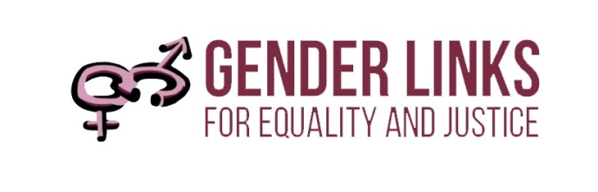
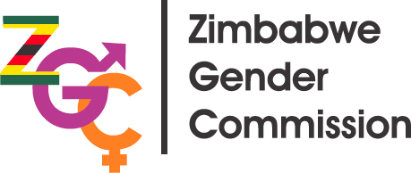
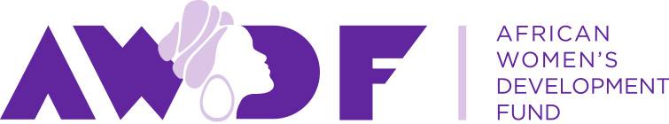
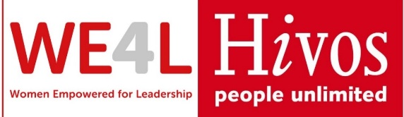

GENDER AND ELECTIONS
SADC EXPERT MISSION TO ZIMBABWE 26-29 JUNE 2019

Synopsis
This concept note concerns a SADC Expert Mission to Zimbabwe to hold consultations on enhancing women’s political participation at national and local level at the invitation of the Zimbabwe Gender Commission (ZGC), with support from UN Women Zimbabwe, Gender Links and the African Women’s Development Fund. The mission follows strategic engagements by the Commission with key stakeholders following the 2018 elections that witnessed a decline in women’s participation both at national and local level, at the very moment when all countries in the region seek to close the gender gap in line with the Post 2015 SADC Protocol on Gender and Development. SADC abounds with examples of different combinations of electoral systems and quotas that have led to greater inclusion. The expert team is drawn from Lesotho, Mauritius, Namibia and South Africa, each of which has interesting and relevant experiences to share. The mission (see Annex A) will comprise two days of bilateral meetings with relevant institutions and a half day stakeholder consultation on 28 June (see Annex B).

Objectives
- To share experiences of electoral systems and gender quotas in the SADC region.
- To examine possible options for Zimbabwe to increase women’s representation and participation at both national and local level.
- To identify opportunities for legislative and policy reform well ahead of the 2023 elections.
- To offer ongoing technical backstopping and support as needed.

Background
One of the key targets in the SADC Protocol on Gender and Development is 50% women’s representation in all areas of decision-making by 2030. The updated 2030 SADC Protocol on Gender and Development, Article 12. 1, states that: “State parties shall ensure equal and effective representation by women in decision-making in the political, public and private sectors, including the use of special measures.” The graph tracks women’s participation in decision-making in Zimbabwe over the last three elections. Following the adoption of the new Constitution in 2013, the proportion of women in the national assembly increased from 14% to 32% and in the Senate from 33% to 48%, resulting in an overall representation of 34% women. In the 2018 elections, this proportion reduced to 31%.

Women’s political representation at different levels of governance

Constitutional provisions
Key provisions on gender and elections in the 2013 Constitution include:

- The State must promote full gender balance in Zimbabwean society particularly with regard to promoting the full participation of women in all spheres of Zimbabwean society on the basis of equality with men and to take legislative and other measures to ensure that both women and men are equally represented in all institutions and agencies of government at every level; and that women should constitute at least half of members of all Commissions and other elected and appointed governmental bodies and that the State must take positive measures to rectify gender discrimination and imbalances resulting from past practices and policies. (Section 17)

- For the next two lives of the National Assembly (commencing in 2013), an additional sixty women shall be elected under a party-list system of proportional representation based on votes cast for political party candidates (Section 124)

- The State must ensure that all international conventions, treaties and agreements to which Zimbabwe is a party are incorporated into domestic law. (Section 34)

As can be seen from these provisions, the PR quota for women at national level will expire in 2023, raising concerns that even the limited gains made at the national level will be lost. Furthermore, despite the provisions of Article 17, there is no quota for women at the local level. The proportion of women at this level has receded with each election – from 18% in 2008; to 16% in 2013 to 14% in 2018.

SADC experience

The 2018 SADC Gender Barometer shows that:
- Performance continues to be mixed in different areas of political decision-making.
- Only South Africa achieved over 40% in parliament, cabinet and local government.
- Only eight countries have exceeded the 30% mark in one or more areas including South Africa (parliament, cabinet and local government); Mozambique (parliament, cabinet and local government); Tanzania (parliament, cabinet and local government); Angola (parliament); Namibia (parliament, local government); Zimbabwe (parliament), Lesotho (local government) and Seychelles (cabinet).

Electoral systems and women’s representation in SADC parliaments
Electoral system | Overall % Women | With quota % women | Without quota % W
FPTP | 13% | 15% | 13%
PR | 38% | 38% | 36%
MIXED | 34% | 37% | 23%
OVERALL | 26% | 38% | 16%
Source: Gender Links 2018

The table shows that:
- At 38%, countries with quotas have a far higher representation of women than those without quotas (16%).
- Consistent with global trends, countries with the PR system (38%) have a much higher representation of women than the FPTP (16%).
- Women’s representation in the mixed system (34%) is more than double the FPTP system.
- Quotas used in combination with the PR system (38%) and mixed system (37%) result in the highest representation of women.
- Women comprise 37% of parliamentarians in countries with a mixed system and quota, compared to 23% in countries with a mixed system and no quota.

Rationale for the mission

Country | Electoral system – national | Quota – national | % women national | Electoral system – local | Quota – local | % women local
Zimbabwe | Mixed | Constitutional- 30% | 31% | FPTP | No | 14%
Lesotho | Mixed | Law-30% PR | 23% | Mixed | Law -30% | 40%
Mauritius | FPTP (mixed) | No | 12% | FPTP | Law -30% women or men | 27%
Namibia | PR | Voluntary | 36% | PR | Law -30% | 48%

The table sets out the rationale for the countries represented in the Expert Mission.
- Lesotho has a quota at the local level, similar to the one pertaining at national in Zimbabwe (women and men contest FPTP seats; 30% seats distributed on a PR basis). This formula has not been fully applied at national level, where there is a 30% quota only for PR seats in a mixed system. Zimbabwe may wish to consider a mixed electoral system at national and or local level in 2023 for reasons other than gender, and consider what kind of gender quota would work best. The Lesotho example shows best case scenario.
- Mauritius runs its elections largely on a FPTP basis. It is the only country in SADC that has implemented a gender neutral quota in a purely FPTP system (local elections) but accompanied this with strong advocacy. If Zimbabwe should decide to retain the FPTP system, the Mauritius example is very relevant. The absence of a quota at national level, where women represent 12% of MPs is equally instructive.
- In Namibia, elections at both national and local level are on a PR basis. When combined with a legislated quota (local) this produces amazing results for women. There are arguments for and against the PR system, including in Namibia. A motion is being introduced in parliament to legislate quotas at national and local level.

Programme at a glance

DATE | ACTIVITY
25 June | Expert Team Arrives in Zimbabwe
26 June | Bilateral meetings – Zimbabwe Gender Commission
27 June | Bilateral meetings – Political parties
28 June – am | Stakeholder working meeting, including with the Zimbabwe Electoral Commission
28 June – pm | Wrap up and conclusion

Outputs
- Relevant papers, presentations, policies and laws to help inform the processes in Zimbabwe.

Outcomes
- A clear roadmap or strategy for lobbying and advocacy to increase women’s political representation and participation at both the local and national level.

Annex A: Expert Team
Rethabile Pholo, GL Board Member, is former Chief Technical Officer and Public Relations Officer of Independent Electoral Commission (IEC) of Lesotho where he engineered the quota for women in local government. Through his knowledge and experience with Lesotho and the Southern African Development Community (SADC) electoral processes and laws, Pholo has wealth of information, networks with governments and politicians.

Tania Diolle, former Lecturer at the University of Mauritius, conducted research on the Mauritius electoral system including the gender neutral quota. She has written a paper on the subject. She resigned at the University to stand as candidate for the local elections. She is now a consultant on CSR and the electoral system.

Eunice Iipinge: is a SWAPO MP in Namibia, gender activist and author. She is a long- time advocate of gender quotas in politics, and has practical experience with SWAPO’s “zebra” voluntary party quota in Namibia. She is presently introducing a motion in the Namibia parliament for voluntary quotas for be legislated at national and local level.

Colleen Lowe Morna is CEO of Gender Links, and a former Chief of Operations, Commonwealth Observer Mission to South Africa. She is editor-in-chief of the annual Southern African Gender Protocol Barometer and authors the Gender and Governance Chapter. She has contributed to a book on quotas by International Ideas, published by the University of Stockholm, and is chief author of the Commonwealth’s Gender and Elections Checklist. Colleen has edited several GL publications on gender and elections, including several country policy briefs on the 50/50 campaign.

Annex B: Draft Programme for Consultative Meeting 28 June

TIME | AGENDA ITEM | WHO | REFERENCE
8.30 – 9.00 | Registration | All
9.00 :09:15 | Welcome Remarks | ZGC
9.15 – 10.15 | Panel presentation |  | Moderator
 | Regional | CLM | Power point
 | Lesotho | RP | Power point
 | Mauritius | TD | Power point
 | Namibia | EI | Power point
10.15 – 10.45 | Discussion |  | Moderator?
10.30 -11.00 | TEA
11.00 -12.00 | Group work | All | Discussion paper
 | National options
 | Local Options
12.00 -12.30 | Report back
12.30 -13.00 | Wrap up and closure

