

INSTITUTIONAL EFFECTIVENESS STRATEGY 2026-2030

OVERVIEW


Institutional effectiveness at Gender Links depends on strong leadership, skilled staff, sound governance, and sustainable financial management. As the organisation enters a period of leadership transition and operates within a decentralised organisational model across the Southern African region, strengthening institutional systems becomes critical to maintaining organisational stability and programme impact.

Gender Links has adopted an agile organisational structure that allows country offices to operate with a degree of autonomy while remaining aligned to the strategic direction of the Regional hub. Within this structure, Human Resources and Financial Management form the backbone of organisational effectiveness, ensuring that the organisation has the people, systems, and financial resources required to deliver results.

The Human Resources function focuses on developing a motivated, skilled, and resilient workforce capable of delivering high-impact programmes. This includes strengthening leadership capacity, improving performance management systems, promoting staff wellbeing, and ensuring transparent and fair employment practices.

The Finance function ensures that Gender Links maintains strong financial governance, transparency, and sustainability. The finance department is led by a Chief Financial Officer (CFO) who is part of the senior management team and actively participates in organisational strategy and decision making. The department includes finance professionals at both regional and country office levels who ensure effective financial management across the organisation.
Between 2020 and 2025, Gender Links secured approximately €18.87 million from 38 diverse donors, demonstrating strong donor confidence in the organisation’s programmes and governance. At the same time, the organisation has expanded internally generated income streams through GL Services.

While these achievements demonstrate strong institutional foundations, Gender Links recognises the need to further strengthen leadership succession planning, staff development, financial sustainability, digital systems, and organisational culture.

This Institutional Effectiveness Strategy therefore focuses on strengthening the organisation’s human resources, financial management, and systems to ensure long-term sustainability and impact.

HUMAN RESOURCES

GOALS


Goal 1: Leadership Sustainability
Ensure a smooth leadership transition while maintaining strong governance, institutional memory, and organisational stability.

Goal 2: Policies and Organisational Structure
Strengthen institutional policies, procedures, and systems to support transparent governance, effective performance management, and accountability.

Goal 3: Staff Capacity Building
Develop a knowledgeable, skilled, and motivated team capable of delivering high-impact programmes.

Goal 4: Performance Management and Organisational Culture
Promote a high-performance organisational culture focused on accountability, collaboration, and results.

Goal 5: Talent Retention and Staff Wellbeing
Retain institutional knowledge while promoting staff wellbeing, resilience, and career development.

Goal 6: Technology and Systems
Improve operational efficiency through digital systems for finance, HR, monitoring and evaluation, and donor management.

Goal 7: Financial Sustainability and Strategic Financial Management
Ensure that Gender Links maintains strong financial sustainability through diversified funding, effective financial management, and responsible stewardship of resources.
The Chart below shows the Gender Links Organisational Structure for 2026/2026
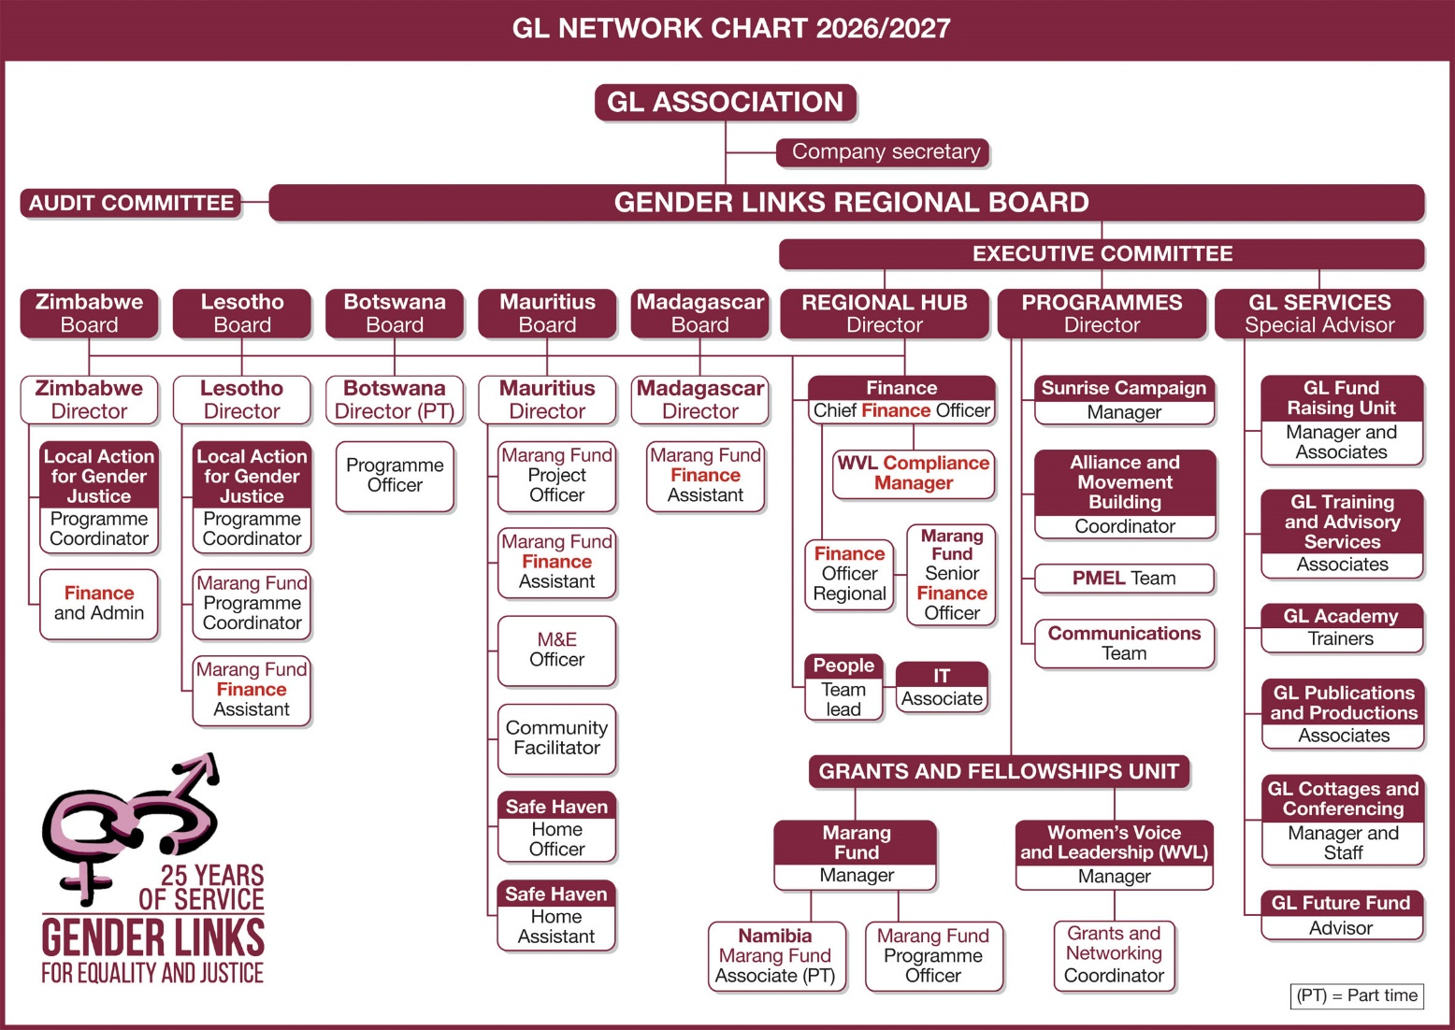
Gender Links is a regional organisation registered and headquartered in Johannesburg, South Africa with branch offices in Botswana, Eswatini, Lesotho, Madagascar, Mauritius, Mozambique, Namibia, Zambia and Zimbabwe. Mozambique serves as GL’s Lusophone base, and Madagascar as GL’s Francophone base. The Botswana office serves both as a country office and liaison office with the SADC Secretariat. Each country office where GL has an office has a Board member from that country, who oversees the operations of that particular office and provides financial and governance oversight. In the other six SADC countries, GL works through partner organisations.
Every GL office has a Country Director that has a dual reporting line to both the Country Board Chair for statutory matters and to the Director of the GL Regional Hub for day to day operational issues. All country Directors have a first line human resources management responsibility for staff in their own offices and for raising funds that keep their offices sustainable.

SPECIFIC OBJECTIVES

Leadership Sustainability
- Implement a clear and operational leadership succession plan.
- Monitor the shared leadership model of co-directors.
- Strengthen country director leadership and ownership of country offices.
- Identify and promote internal talent into leadership positions.

Policies and Organisational Structure
- Develop transparent organisational structures and clear job descriptions.
- Strengthen HR policies including safeguarding, SEAH, and anti-bullying policies.
- Improve performance management systems.
- Conduct biannual staff skills gap assessments.

Staff Capacity Building
- Strengthen staff expertise in:
  - Governance and compliance
  - Monitoring and evaluation
  - Resource mobilisation
  - Human resources management
  - Digital communication and innovation
- Develop leadership training and mentorship programmes.
- Implement onboarding programmes for new staff.

Performance Management and Culture
- Strengthen the performance management system.
- Link performance to recognition and incentives.
- Introduce staff engagement and feedback surveys.
- Promote cross-departmental learning.

Talent Retention and Staff Wellbeing
- Introduce retention incentives and career pathways.
- Develop staff wellness programmes.
- Strengthen knowledge management systems.
- Promote team collaboration across countries.

Technology and Systems
- Improve use of digital systems for:
  - Finance –Evolution Online state of the art system
  - Human Resources –ESS Human Resources
  - Monitoring and evaluation –Alchemer for survey gizmo reports
  - Donor management systems –Good Grants systems.

WHAT WE HAVE ACHIEVED
The Gender Links Agile organisational model
- Established a regional organisational structure with Regional Hub in Johannesburg and country offices across the SADC region.
- Implemented an agile staffing model, including:
  - Fixed-term contracts
  - Pay-by-results contracts
  - Short-term contracts
  - Consultancy contracts.
Contracting models
To build a more agile organisation in an uncertain funding environment GL has instituted different contracting models.

GL Division | Staff | Associates | Total | Women | Men | Of whom identify as LGBTIQ
GL Regional hub | 3 | 4 | 7 | 4 | 3 | 0
GL Programmes (including Grants and Fellowships) | 10 | 4 | 14 | 12 | 2 | 3
GL Services | 1 | 4 | 5 | 4 | 1
GL Country Offices
Botswana | 1 | 1 | 2 | 2
Lesotho | 4 |  | 4 | 3 | 1 | 1
Mauritius | 5 |  | 5 | 4 | 1 | 1
Madagascar | 2 |  | 2 | 1 | 1
Zimbabwe | 3 | 1 | 4 | 3 | 1
GL Project sites
Namibia |  | 1 | 1 | 1 | 0
Zambia |  | 1 | 1 | 0 | 1
Mozambique |  | 1 | 1 | 1
Malawi |  | 2 | 2 | 2
Tanzania |  | 1 | 1 | 1
Sub total | 29 | 20 | 49 | 38 | 11 | 5
% | 59% | 41% |  | 78% | 22% | 10%
GL Cottages | 14 |  | 14 | 7 | 7
Total | 43 | 20 | 63 | 45 | 18 | 5
This table shows the various categories of Gender Links Human Resources and breakdown of the diverse gender for each of these categories. In the year 2026, Gender Links has 59% full time staff and 41% Associates. Of these, 78% are women, 22% men and 10% diverse.
Fixed term staff contract
Employees contracted for a specific period of time or to do a specific job subject to availability of donor funding. These staff work an average of 21.67 days a month, inclusive of holidays.

Pay by results contract
Employees paid a day rate against work actually performed.
This rate is computed as Cost to Company divided by 220 working days. This mode is suited to staff whose income is partly or mostly derived from consultancy work, and in circumstances of uncertain funding. These staff:
- May not invoice more than the number of working days in each month.
- May not invoice more than 220 working days in a year unless circumstances demand, and as otherwise agreed with the immediate Supervisor.
- May not invoice for annual leave, sick leave, study leave and family responsibility leave as this is included in their daily rate.
- Daily rate may be increased by a maximum of 5% on an annual basis consistent with inflation, budget and as authorized by the Board.

Consultancy contracts
Independent companies or individuals who:
- Provide an ongoing service at an agreed rate per service/ day or per hour, and this is billed monthly against a job card and according to the actual service delivered.
- Undertake a specific task against an agreed Terms of Reference with work plan stating task, timeframe, rate and deliverable.

Gender Links successfully built a diverse workforce:
  - 78% women
  - 22% men
  - 10% gender diverse.

Retained strong institutional memory, with:
  - 46% of staff serving more than 10 years.
- GL Staff Retention
Length of Service | Average | More than ten years | Three years to ten years | Less than three years
 | 7,71 | 13 | 6 | 9

The table above shows a breakdown of the length of service for 28 of the Gender Links full time staff. Out of 28 staff, 13 staff members (46%) have been with the organisation for more than 10 years and 6 staff members (21%) have worked for GL for 3-9years. The average length of service at Gender Links is above 7 years, which is very commendable.

Staff Capacity building
- Gender Links staff have gone through very intense capacity building including academy sessions on fundraising, diversity training and testing of GL integrity policies before the issuing of new staff contracts each year.
Strengthening of Organisational Policies
- GL further improved recruitment policies to ensure safer recruitment practices. In addition, Human resources Policies were strengthened to address gaps identified in performance management and contractual terms.

Timeous Human Resources planning, contracts & remuneration
- With efficient systems in place, HR Budgets were done timeously and this made it possible to communicate staff contracts status in time with all relevant staff.
- Staff job descriptions and performance agreements were done in time
- Salaries benchmarking exercise conducted with industry specialists Averile Ryder reflecting that GL salaries were mostly in line with market

Recruitment of Director of Programmes –GL successfully filled the position of Director of Programmes as recommended by the Board

WHAT WE HAVE LEARNT
- Painful HR lessons: Gender Links has learnt from its past mistakes regarding challenges that arise because of poor HR practices such as delays in issuing staff contracts and lack of timeous communication when contracts are ending.
- Succession challenges: Leadership transitions require structured succession planning to ensure stability. This is applicable at all levels across the organisation.
- At executive level, Gender Links has learnt that Institutional Memory of a long serving executive member cannot be replaced overnight. This will require a gradual phased approach as the incoming leadership settles in to ensure no disruptions
- With Gender Links lean staff structures, losing one staff member within an office causes quite some significant pressure on other staff members and may affect deliverables.
- Flexible contracting forms: Flexible staffing models are necessary in uncertain donor funding environments. Mixed combination of staff and consultants
- Institutional sustainability depends on:
  - Strong governance
  - Skilled staff
  - Availability of funding to keep core staff
  - Clear systems and policies.
- Staff motivation improves when performance is recognised and rewarded.
- Staff capacity Building: Continuous skills development and training is necessary to maintain programme impact.
- Staff wellbeing is critical when working in emotionally demanding social justice environments. GL has responded to this by ensuring that staff get wellness training sessions.
- The importance of thorough Interview processes: GL has learnt that its very important top put in place robust processes for the recruitment and selection of new staff. Most candidates interviewed were very grateful for the thorough interviews and personal feedback given, whether or not they got the job.

WHAT WE WILL DO

Leadership and succession management
- Implement a gradual leadership transition model- GL will put in place a succession plan that is fully operational and practical at all levels
- Strengthen the shared leadership structure and ensure it is reviewed bi-annually.
- Identify, groom and develop internal leadership pipelines.
- Leadership and Governance course required for Senior Management in conjunction with GL Academy training
- Team building exercise to be conducted for Senior staff

Governance and Policy development
- Strengthen HR policies and governance frameworks
- Conduct regular policy reviews through Board committees.
- Maintain transparent organisational structures.
- Create separate I.T Policy and workshop with staff

Staff Development
- Conduct regular skills audits.
- Implement annual training plans.
- Provide staff training and mentorship programmes.
- Support staff professional development and study leave.

Performance and Culture
- Strengthen performance appraisal systems.
- Introduce staff engagement surveys.
- Encourage peer recognition and cross-department learning.

Staff Retention and Wellbeing
- Develop staff wellness programmes.
- Promote work-life balance and flexible working.
- Implement knowledge management systems to protect institutional memory.
- Promote holistic well-being of staff
- Prevent burnout, stress, and compassion fatigue
- Foster a supportive and inclusive workplace culture
- Strengthen staff resilience and productivity
- Integrate self-care as a leadership and organisational value
Building Institutional Strength
- Monitor the Shared Leadership Model of Co-Directors to make sure that its working effectively, with the right delivery of results
- Provide country directors with the necessary support to encourage growth and ownership of their country offices
- Recognise Internal talent for key roles, acknowledging of change in job content
- Engage in Frequent Organizational culture evaluation and assessments to monitor progress continually, in the key result areas
- Outsource specialist skills where needed for sustainable solutions and ensure effective delivery
- Compliance and governance: Good governance pillar
- Monitoring & evaluation: Results and communications for change pillar
- Resource mobilisation: Sustainability, Financial Management pillar
- Human Resources management: People power pillar

Enhancing Digital Systems
- Improve operational efficiency through digital systems.
- Implement integrated digital systems for finance, HR, M&E, and donor management.
- Put in place Human resources systems that align with Finance –Enhanced People 300
- Digital communication –Innovation and I.T skills
- Ensure all staff build capacity on Monday.com and standardise across Gender Links
- Encourage better and more efficient use of SharePoint
- Maximise Utilizing AI in Evo Online Financial systems
- Efficient use of Co-Pilot and Outlook
Retention & Institutional Memory
- Introduce retention incentives (career progression pathways)
- Develop wellbeing strategy
- Implement knowledge management system

HOW WE WILL MEASURE CHANGE

Leadership Sustainability
- Fully operational succession transition
- Continuous reduction of assistance from SPA
- At least 50% of leadership roles filled internally.
- Staff retention rate above 85%.

Policies and Governance
- 100% staff with signed contracts and job descriptions.
- HR policies approved and regularly reviewed by the Board.
- Performance reviews completed twice per year.

Capacity Building
- At least one training per staff member annually.
- Leadership pipeline identified.
- 10% of junior roles filled by interns.

Performance Management
- 100% Self-funded country offices
- 100% performance review completion each semester.
- Staff satisfaction above 70% in surveys.

Talent Retention and Wellbeing
- Staff turnover below 15%.
- Documented Standard Operating Procedures for core functions.

Technology and Systems
- Digital systems implemented for:
  - HR : Sage People 300 system that integrates with Finance
  - Finance: 100% usage of all finance systems with evidence of monthly internal audit checklists
  - Monitoring and evaluation -More advanced M & E Systems and tools for measuring impact
  - Donor management – Improved system that are able to source grant opportunities
Human Resources ratios indicators
- No of staff; at Regional Hub and in country offices and levels of qualification
- Proportion of staff to associates becomes an even more important indicator than before, as associates generally provide a high level of skills.
- Average length of service and age of staff.
- Proportion of HR costs to the budget overall.
- Proportion of support to programme staff.
- Proportion of budget spent on capacity building

SOUND FINANCIAL MANAGEMENT

GOALS
The finance department’s main goals are to:

- Ensure financial sustainability and stability
- Provide accurate financial reporting and compliance
- Support strategic decision-making with financial insights
- Optimize cost management and revenue performance
- Strengthen risk management and internal controls

SPECIFIC OBJECTIVES

Financial Sustainability and Strategic Financial Management
- Diversify the organisation’s funding base.
- Strengthen unrestricted income streams through GL Services.
- Improve financial forecasting and budgeting systems.
- Strengthen liquidity management and institutional reserves.
- Improve grant management and financial monitoring systems.
- Support country offices to strengthen financial sustainability.
Governance & Compliance
- Continue to build on existing financial policies & procedures manuals
- Enforce the use of the Evo-Online accounting software by all branches
- Establish internal controls and monitor them monthly through the internal Audit checklists
- Ensure that GL Conducts Institutional annual external audits timeously, that result in unqualified Audits
- Make sure countries utilise branch accounting and reconcile their Trial balances monthly
- Align all Financial procedures to approved Financial policies
- Keep statutory payments updated and regularise VAT in all GL offices where applicable

Revenue Diversification and Business Development
- Maintain a Gender Links Leadership and Opportunities unit where funding prospects are brought in and discussed
- Develop a fundraising strategy that is implemented fully and yielding results
- Diversify income sources (grants, individuals, corporate)
- Build donor database
- Develop proposal calendars for Unit
- Maintain strict rules for Operations Reserve

Build Financial Resilience
- Establish reserve policy & Build 3 months operating reserve
- Ensure that operational reserves are created by managing costs under 5%

WHAT WE HAVE ACHIEVED
Gender Links has built strong institutional systems that support organisational effectiveness and programme delivery.
Key achievements include:
- Establishment of a decentralised financial architecture with branch accounting
- Strengthening of Finance policies, systems and procedures to improve efficiency and accountability.
- Establishment of a professional finance department led by a Chief Financial Officer who has Finance officers in countries with a dotted reporting line to the CFO.
- Successful mobilisation of approximately €18.87 million from 38 diverse donors over the past five years.
- Expansion of internally generated income through GL Services.
- Implementation of hybrid accounting systems aligned with international financial reporting standards.
- Improvement in financial systems and reporting mechanisms.
- Unqualified Audits

MAIN SOURCES OF DONOR INCOME OVER THE PAST 5 YEARS

WHAT WE HAVE LEARNT
Gender Links has learnt several important lessons regarding institutional sustainability.
- Diversified funding sources are necessary to reduce financial risk.
- Unrestricted income streams are essential to support core organisational functions.
- Strong financial governance and transparent reporting systems increase donor confidence.
- Good Financial systems create efficiency and accurate reports especially when used correctly
- Lack of funding directly affects Human Resources as contracts cannot be done for staff where there is insufficient funding
- Significant shifts in exchange rates can adversely impact HR budgeting processes especially with funds received in foreign currency
- Poor tracking of VAT and statutory compliance has serious reparcations with regards to funds accountability and liquidity
- Diligent management of operational costs is fundamental for building reserves
- Setting realistic targets for long term loans/investments is key because this sets the organisation up for failure when these commitments are not met
- Staff need to be flexible to take on different kinds of work and shift to different contracting models as budgets dictate and as mutually agreed.
- Salaries must be funded by donors or clients through market-related costing of time

WHAT WE WILL DO

Strengthening Financial Sustainability
- Diversify funding sources.
- Expand GL Services and other income-generating initiatives.
- Develop multi-year financial forecasts.
- Strengthen organisational reserves.
- Improve financial planning and grant management systems.
- Support country offices to strengthen financial sustainability.

HOW WE WILL MEASURE CHANGE

Sound Financial Management
- 100% clean audit reports, produced in time before end of July each year.
- Monthly trial balances and age analyses for all branches.
- Budget variances maintained below 10%.
- Diversified donor income streams.
- Annual revenue growth targets achieved.
- Three to six months organisational reserves maintained.
- Strong donor retention rates.
- Diversified donor income streams to reduce risks, no single donor to constitute more than 40% of budget
- Aim for 20% increase in revenue annually
- 15% of revenue to be set aside for GL Future Fund annually
- Minimum 7% operations budget
- All countries to be financially self -sustaining
- Monthly financial reporting at MANCO, with Fund Accountability Statements balancing per Unit
- Maintain Budget variances at less than 10% or as guided by donor contracts
- Utilise approved budgets that have gone through Audit Committee

