
RESULTS FOR CHANGE

For more than two decades, Gender Links (GL) has sought not only to advance gender equality but also to make change visible. Through advocacy, research, training, and partnerships across Southern Africa, GL has developed a strong tradition of tracking progress, documenting lived experiences, and using evidence to inform policy and practice. As the organisation enters the 2026–2030 strategic period, Monitoring, Evaluation and Learning (MEL) will remain central to this commitment.

Building on the Results for Change framework, GL will adopt a more explicitly feminist and participatory approach to MEL. This approach recognises that meaningful change cannot be measured only through outputs and numbers. It must also capture shifts in power relations, social norms, and agency, particularly among women, girls, and marginalised groups. Inspired by initiatives such as the Women of the South Speak Out (WOSSO) programme, the new MEL framework places lived experience at the centre of evidence generation while strengthening transparency, accountability, and learning across the organisation and its partners.

Goal
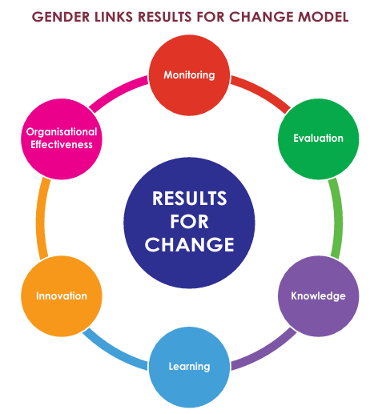
To strengthen evidence-driven advocacy and programming by embedding a feminist Monitoring, Evaluation and Learning system that captures transformative change, centres lived experiences, and enhances accountability and learning across Gender Links and its partners.

Specific Objectives
- Strengthen the quality, credibility, and accessibility of quantitative and qualitative data that informs GL programmes and advocacy.
- Embed feminist MEL principles that centre the lived experiences and voices of women, girls, and marginalised communities.
- Strengthen accountability to donors, partners, and communities through transparent reporting and accessible knowledge sharing.
- Institutionalise learning loops that enable continuous reflection, adaptation, and improvement across programmes.
- Build the capacity of partners, local councils, and communities to generate, analyse, and use data for decision-making and advocacy.
- Position Gender Links as a regional leader in feminist Monitoring, Evaluation and Learning practice.

What We Have Achieved
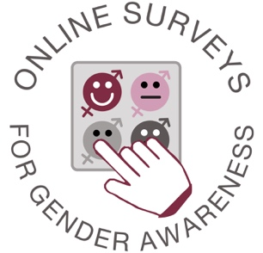
Key achievements include:
- Development of 135 online surveys through the Alchemer platform and 91 reports through Google Data Studio, enabling systematic collection and analysis of programme data.
- Establishment of digital monitoring systems that allow participants to complete surveys and evaluations via smartphones, tablets, or computers, with real-time results and analysis.
- Implementation of quantitative outcome measurement tools, including:
  - Gender Attitudes Quiz
  - Citizen Score Card measuring public perceptions of government performance on gender equality
  - SADC Protocol on Gender and Development Knowledge Quiz
- Routine use of event evaluation tools to assess programme quality and identify areas for improvement.
- Collection of cost-saving and in-kind contribution data, strengthening transparency and demonstrating value for money.
- Use of digital tools to support major research initiatives such as the Gender Progress Score (GPS) and the Gender and Media Progress Study.
- Increased transparency and accountability through real-time dashboards and evidence-based reporting to donors and partners.
- Growing investment in data visualisation and multimedia reporting, making research findings more accessible to diverse audiences.

Through these efforts, GL has strengthened its ability to provide credible evidence to stakeholders while improving programme design and performance.


What We Have Learned
Experience over the past strategy period has generated several important lessons:
- Evidence must go beyond outputs to capture deeper changes in attitudes, norms, and power relations.
- Lived experiences and qualitative stories are essential to complement quantitative indicators and understand real-world impacts.
- Participatory approaches strengthen ownership of data and improve the relevance of monitoring systems.
- Digital tools increase efficiency and transparency, but must be complemented with face-to-face engagement to avoid excluding communities with limited digital access.
- Intersectional data disaggregation, by gender, age, disability, geography, and other markers, is essential to understanding inequality.
- Learning spaces and peer exchange among partners and activists are often more effective for building capacity than traditional training alone.
- MEL is most effective when integrated throughout programme cycles rather than treated as a reporting requirement.

What We Will Do (2026–2030)
During the 2026–2030 strategy period, Gender Links will strengthen its Results for Change framework through a feminist MEL approach that prioritises participation, learning, and accountability.

Key priorities include:
Strengthening Feminist Monitoring and Evaluation
- Integrate feminist principles into MEL practices, ensuring inclusive participation and intersectional analysis.
- Combine quantitative indicators with qualitative methodologies such as “I Stories”, participatory video, and Most Significant Change approaches.

Enhancing Digital Data Systems
- Expand the use of digital data collection platforms such as Alchemer and interactive dashboards.
- Develop accessible community dashboards allowing councils, partners, and citizens to track gender indicators in real time.

Strengthening Participatory Research
- Engage communities, activists, and partners as co-researchers, not merely respondents.
- Encourage local actors to define their own indicators of change through participatory Theory of Change processes.

Embedding Learning Loops
- Institutionalise reflection processes through annual learning reviews, regional summits, and programme reflection sessions.
- Strengthen peer-to-peer learning spaces where partners, activists, and fellows exchange experiences and strategies.

Tracking Long-Term Change
- Introduce longitudinal monitoring systems, following fellows, programme participants, and councils over time to measure sustained impact.

Building Capacity Across the Network
- Train GL staff, country offices, partners, and local councils in feminist MEL methodologies and digital tools.
- Establish country offices as learning nodes responsible for contextualised evidence generation.

Strengthening Knowledge Dissemination
- Expand multimedia reporting, including dashboards, infographics, podcasts, and interactive reports.
- Continue publishing key knowledge products such as the #VoiceandChoice Barometer and thematic research reports.

How We Will Measure Change
Gender Links will measure progress using a combination of quantitative indicators, qualitative evidence, and participatory evaluation methods.

Key indicators will include:
Institutional and Programme Indicators
- Number of MEL tools, surveys, and dashboards implemented across programmes.
- Percentage of programme indicators disaggregated by sex, gender identity, age, disability, and other intersectional factors.
- Number of partners and councils trained in MEL tools and methodologies.
- Number of research publications, policy briefs, and multimedia knowledge products produced.

Outcome Indicators
- Evidence of programme adaptations based on MEL findings.
- Increased use of MEL data by partners, councils, and communities for decision-making and advocacy.
- Documented changes in gender attitudes, social norms, and institutional practices.

Qualitative Indicators
- Personal narratives and case studies demonstrating shifts in agency, voice, and decision-making power among women and marginalised groups.
- Stories of policy influence and institutional change resulting from GL advocacy and research.

Accountability Indicators
- Transparent reporting through platforms such as IATI, public dashboards, and open-access reports.
- Evidence of community engagement in evaluation and feedback processes.

Through these measures, Gender Links will ensure that MEL not only tracks progress but actively contributes to transformative change, strengthening feminist movements and gender justice across Southern Africa.

