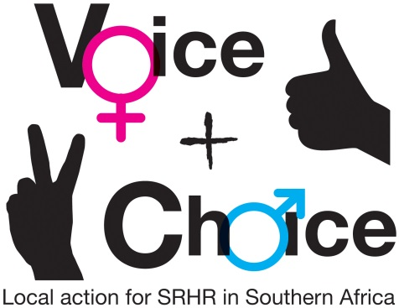
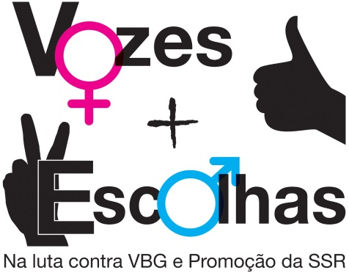
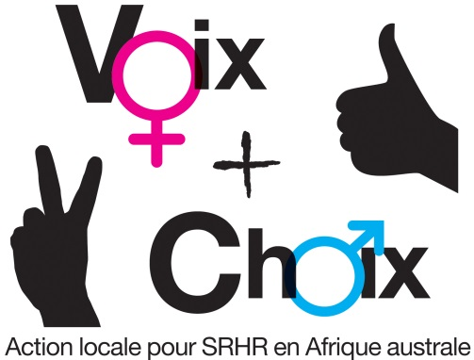

ALLIANCE SEXUAL AND REPRODUCTIVE HEALTH AND RIGHTS (SRHR) ADVOCACY AND COMMUNICATION MODULE

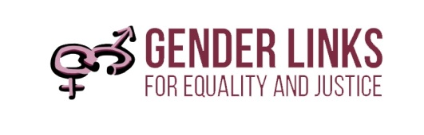
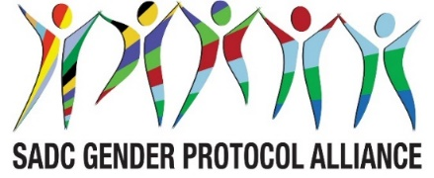
PARTNER LOGO

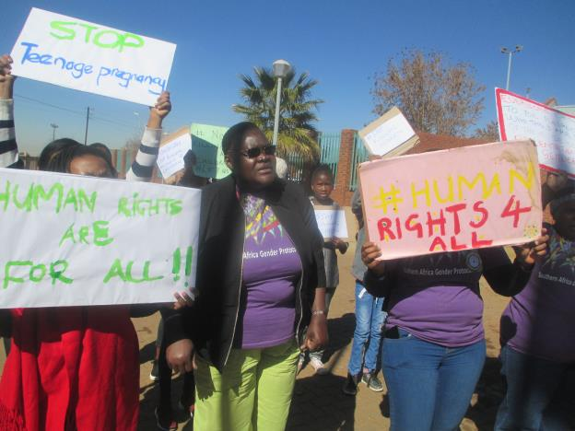

Introduction
Women and men’s sexual and reproductive health and rights (SRHR) are fundamental for promoting development, fighting poverty and, ultimately, for achieving the Sustainable Development Goals (SDGs) attaining the targets of the Agenda 2030 SADC Protocol on Gender and Development. Sexual and reproductive health is a human right which is essential to good health and human development.


Objectives
- To undertakes rigorous advocacy planning (including policy mapping, audience analysis, decision-making pathways in order to structure and target advocacy activities logically) for SRHR policy change.
- To lobby for progressive national SRHR policies in countries that do not have these and mount campaigns on pertinent issues such as:
- Menstrual health
- Access to SRHR services
- Teenage pregnancies
- Safe abortion.
- Ending gender violence
- Harmful practices, including child marriages
- Sexual diversity.
Description
Alliance SRHR clusters will develop a Sexual and Reproductive Health and Rights (SRHR) plan with advocacy and communication initiatives.

Target group
- SRHR organisations working at national and local level.
- Alliance partners.
- Government partners.

Key outputs
- Mapping of organisations working on SRHR in all SADC countries.
- SRHR campaigns in 16 countries that include new media, community dramas and other communication methods.
- An audit SRHR laws and policies in 16 countries.
- An Alliance M and E campaigns plan that is monitored each month, and results shared with each

Key outcomes
- Evidence-based SRHR communication strategies in all SADC countries.
- Youth and gender friendly SRHR services in all countries
- Strong GBV and HIV campaigns in all countries.
- Emerging trends on the resurgence of HIV and AIDS especially among young women analysed. Advocacy tool by the SRHR cluster to develop campaigns against so called “Blessors” - older men having transactional sex with younger women.
- Strong menstrual health campaigns in all countries with at least five countries providing free sanitary ware in schools.
- Safe abortion campaigns in all countries; progress towards choice of termination of pregnancy legislation in at least three countries.
- Progress towards decriminalisation of LGBTI in at least three countries and evidence of changing attitudes.

Key accompanying documents
- This module is accompanied by a SRHR strategic communications toolkit that provides information about the different SRHR thematic areas, with suggested hashtags and links.
- Power point presentations by working groups at the August 2018 meeting of the Alliance
- A campaigns and advocacy planning framework
- Monitoring and evaluation plan and tools.

WORKSHOP DOCUMENTS
English: http://genderlinks.org.za/what-we-do/sadc-gender-protocol/advocacy/alliance-srhr-meetings/
French: http://genderlinks.org.za/what-we-do/sadc-gender-protocol/advocacy/alliance-srhr-meetings/reunions-de-la-srhr/
Portuguese: http://genderlinks.org.za/what-we-do/sadc-gender-protocol/advocacy/alliance-srhr-meetings/reunioes-da-alianca-srhr/
MONITORING AND EVALUATION
English: http://genderlinks.org.za/what-we-do/sadc-gender-protocol/advocacy/alliance-srhr-me/
French: http://genderlinks.org.za/what-we-do/sadc-gender-protocol/advocacy/alliance-srhr-me/alliance-srhr-se/
Portuguese: http://genderlinks.org.za/what-we-do/sadc-gender-protocol/advocacy/alliance-srhr-me/alianca-srhr-me/

Activity: Conducting an audit of SRHR related laws and policies

- Start the session with a group of experts presenting on the key SRHR related policies and regulations based on the audit conducted.
- Below is a summary of SRHR policies in the SADC region.
- In November 2018 SADC Health Ministers will adopt an SRHR strategy for the region 2019 – 2030 (see background documents in the web link).
- Have a discussion in plenary. How recent is your country SRHR policy? Is it being reviewed? How can civil society organisations contribute to developing/updating/popularising a comprehensive SRHR policy?

Country | Policies/Guidelines | Year
SRHR policies
Adopted more ore than five years old
Namibia | National Policy for Reproductive Health | 2001
Mauritius | National Sexual and Reproductive Health Policy | 2007
Lesotho | National Reproductive Health Policy | 2008
Zambia | National Reproductive Health Policy | 2008
Malawi | National Reproductive Health and Rights Policy | 2009
Zimbabwe | National Adolescent Sexual and Reproductive Health Strategy | 2010 - 2015
Mozambique | National Sexual and Reproductive Health Policy | 2011
Seychelles | Reproductive Health Policy for Seychelles | 2012
Five years or less
eSwatini | National Policy on Sexual and Reproductive Health | 2013
Madagascar | Reproductive Health and Family Planning Law | 2017
South Africa | Sexual and Reproductive Health and Rights: Fulfilling our Commitments and “National Adolescent Sexual and Reproductive Health and Rights Framework Strategy” | 2014 - 2019
SRHR Guidelines
Botswana | Policy guidelines and service standards for sexual and reproductive health | 2015
Tanzania | SRHR guidelines and National Adolescent Reproductive Health Strategy | 2011 – 2015
No SRHR policy or guidelines
Angola | Included in the Constitution | 1975
DRC | Included in the Constitution | 2011

Activity: Prioritising campaigns
- Share some slides from the campaigns tool kit.
- What are the most important SRHR issues for your country?
- Please choose no more than four priority themes.

Fact sheet

This workshop is a follow up to a regional Alliance SRHR planning held in August 2018 in Johannesburg. During the meeting country delegations identified the key SRHR priorities. Botswana, Malawi and Zambia identified all SRHR concerns as key priorities. It will be important to rationalise these so that the Alliance SRHR cluster can focus on the most important priorities. Gender based violence (GBV) remains a key SRHR priority across the SADC region. Nine out of 15 countries chose GBV as their top priority.

COUNTRY/ CAMPAIGN | Ang | Bots | DRC | Les | Mada | Mal | Mau | Moz | Nam | Sey | SA | eSwa | Tan | Zam | Zim
Menstrual health
Maternal health
Comprehensive sexual education and services
Teenage pregnancies
Choice of termination of pregnancy
HIV and AIDS
Child marriages
GBV
Sexual diversity

Activity: Broken Telephones
Participants stand in a circle. A message is whispered into one person’s ear and this should be whispered on to the rest. The last person should say what message they finally received. This should be compared to the original message. Try to find out where and how the message broke down?

What is communication?
Communication is conveying a message from one party to the other in the most effective way possible. The way in which the effectiveness of the message is measured is by the feedback that is received.

Communication is the process of sending and receiving messages through verbal or nonverbal means, including speech, or oral communication; writing and graphical representations (such as infographics, maps, and charts); and signs, signals, and behaviour. More simply, communication is said to be "the creation and exchange of meaning."

The communication process
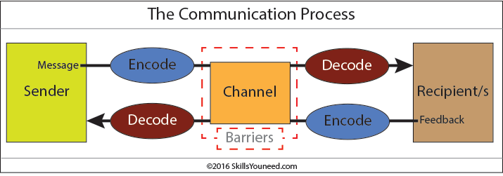
A message or communication is sent by the sender through a communication channel to a receiver, or to multiple receivers.
The sender must encode the message (the information being conveyed) into a form that is appropriate to the communication channel, and the receiver(s) then decodes the message to understand its meaning and significance.

Misunderstanding can occur at any stage of the communication process.
Effective communication involves minimising potential misunderstanding and overcoming any barriers to communication at each stage in the communication process.

An effective communicator understands their audience, chooses an appropriate communication channel, hones their message to this channel and encodes the message to reduce misunderstanding by the receiver(s).

They will also seek out feedback from the receiver(s) as to how the message is understood and attempt to correct any misunderstanding or confusion as soon as possible.
Receivers can use techniques such as Clarification and Reflection as effective ways to ensure that the message sent has been understood correctly.

Senders and receivers are of course vital in communication. In face-to-face communication the roles of the sender and receiver are not distinct as both parties communicate with each other, even if in very subtle ways such as through eye-contact (or lack of) and general body language.

There are many other subtle ways that we communicate (perhaps even unintentionally) with others, for example the tone of our voice can give clues to our mood or emotional state, whilst hand signals or gestures can add to a spoken message.

In written communication the sender and receiver are more distinct. Until recent times, relatively few writers and publishers were very powerful when it came to communicating the written word. Today we can all write and publish our ideas online, which has led to an explosion of information and communication possibilities

Communication Channels
Communication theory states that communication involves a sender and a receiver (or receivers) conveying information through a communication channel.

Communication Channels is the term given to the way in which we communicate. There are multiple communication channels available to us today, for example face-to-face conversations, telephone calls, text messages, email, the Internet (including social media such as Facebook and Twitter), radio and TV, written letters, brochures and reports to name just a few.
- Spoken or Verbal Communication: face-to-face, telephone, radio or television and other media.
- Non-Verbal Communication: body language, gestures, how we dress or act - even our scent.
- Written Communication: letters, e-mails, books, magazines, the Internet or via other media.
- Visualisations: graphs and charts, maps, logos and other visualizations can communicate messages.

Choosing an appropriate communication channel is vital for effective communication as each communication channel has different strengths and weaknesses.

For example, broadcasting news of an upcoming event via a written letter might convey the message clearly to one or two individuals but will not be a time or cost effective way to broadcast the message to a large number of people. On the other hand, conveying complex, technical information is better done via a printed document than via a spoken message since the receiver is able to assimilate the information at their own pace and revisit items that they do not fully understand.

Written communication is also useful as a way of recording what has been said, for example taking minutes in a meeting.

Encoding Messages
All messages must be encoded into a form that can be conveyed by the communication channel chosen for the message.
We all do this every day when transferring abstract thoughts into spoken words or a written form. However, other communication channels require different forms of encoding, e.g. text written for a report will not work well if broadcast via a radio programme, and the short, abbreviated text used in text messages would be inappropriate if sent via a letter.

Complex data may be best communicated using a graph or chart or other visualisation.
Effective communicators encode their messages with their intended audience in mind as well as the communication channel. This involves an appropriate use of language, conveying the information simply and clearly, anticipating and eliminating likely causes of confusion and misunderstanding, and knowing the receivers’ experience in decoding other similar communications. Successful encoding of messages is a vital skill in effective communication.

Decoding Messages
Once received, the receiver/s need to decode the message. Successful decoding is also a vital communication skill.
People will decode and understand messages in different ways based upon any Barriers to Communication which might be present, their experience and understanding of the context of the message, their psychological state, and the time and place of receipt as well as many other potential factors.
Understanding how the message will be decoded, and anticipating as many of the potential sources of misunderstanding as possible, is the art of a successful communicator.

Feedback
Receivers of messages are likely to provide feedback on how they have understood the messages through both verbal and non-verbal reactions.
Effective communicators pay close attention to this feedback as it the only way to assess whether the message has been understood as intended, and it allows any confusion to be corrected. Bear in mind that the extent and form of feedback will vary according to the communication channel used: for example feedback during a face-to-face or telephone conversation will be immediate and direct, whilst feedback to messages conveyed via TV or radio will be indirect and may be delayed, or even conveyed through other media such as the Internet.
Different approaches to communication
Now think of some of the techniques that you can use to relay information to others. If you think of communication as an umbrella, what are some of the different forms of communication that you would find under it? What are the differences between those forms of communication?

Activity: Give one example of when you would most likely use each one of these approaches in the campaigns.

APPROACH | COMMENT | EXAMPLE
Advocacy | Believing in and vigorously conveying a message, but often on behalf of others
Campaigning | Also vigorous, but may be for yourself (e.g. in politics)
Lobbying | Targeting the receivers of the message, using personal as opposed to mass communications.
Networking | Linking with many like-minded people, not necessarily trying to convince them of your point of view, but benefiting in direct and indirect ways from associating with them.

All these are forms of communication that you are likely to use in one way or the other in your communication strategies.

A medium is the channel through which communication is sent. Types of channels include radio, TV, newspapers, magazines, video, film, compact disk or CD, e-mail, websites, newsgroups, posters, pamphlets, stickers, meetings, and new forms of social media. Media refers to the multiple ways humans use to communicate with each other.

Activity: Think about the different kind of media in relation to the campaigns you have chosen. When would you most likely use each? Please give specific examples.

MEDIA | EXAMPLES | ADVANTAGES | DISADVANTAGES
Letter box | Posters, pamphlets, stickers
Personal | Face-to-face
Traditional | Song, drama, poems, dancing
Mainstream | Radio, television, newspapers, magazines
Community | The above, but with a specific community focus
New media | Internet, e-mail, electronic discussion forum, Facebook, Twitter, Instagram, LinkedIn

Fact sheet: Defining media and what are the different types of media?
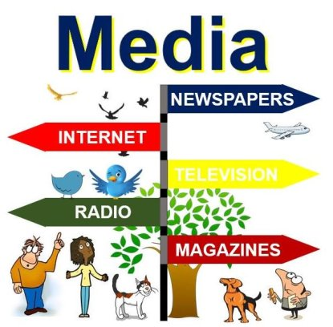
The term media, which is the plural of medium, refers to the communication channels through which we disseminate news, music, movies, education, promotional messages and other data. It includes physical and online newspapers and magazines, television, radio, billboards, telephone, the Internet, fax and billboards.

It describes the various ways through which we communicate in society. Because it refers to all means of communication, everything ranging from a telephone call to the evening news on television can be called media.

When talking about reaching a very large number of people we say mass media. Local media refers to, for example, your local newspaper, or local/regional TV/radio channels.

We used to get all our news and entertainment via TV, radio, newspapers and magazines. Today the Internet is gradually taking over. Print newspapers are struggling as hundreds of millions of people each year switch to news sources online.

Media can be broken down into two main categories: broadcast and print. The Internet has also emerged as a major player, as a rapidly-growing number of people globally get their news, movies, etc. online.
Print Media includes all types of publications, including newspapers, journals, magazines, books and reports. It is the oldest type, and despite suffering since the emergence of the Internet, is still used by a major proportion of the population.

Broadcast Media refers to radio and TV, which came onto the scene at the beginning and middle of the 20th century respectively. Most people still get their news from TV and radio broadcasts – however, experts predict that it will not be long before online sources take over.

The Internet – specifically websites and blogs – are rapidly emerging as viable and major channels of communication as more and more people seek news, entertainment and educational material online.

Virtually every part of the Internet has become a medium of communication – most free email services have little boxes that display ads and other messages.

Social media is a collective of online communication channels where communities interact, share content and collaborate. Websites and apps dedicated to social networking, microblogging, forums, social bookmarking, wikis and social curation are examples of some types of social media. The most famous social networking companies are Facebook, Twitter, Google+ and Instagram.

Social media

Activity: Google the name of your country and a key word from your campaign that comes up – eg Mauritius, safe abortion. Who else is interested in this campaign? How and where is this interest reflected online?


Facebook is a social networking Web site that allows people to communicate with their friends and exchange information. In May 2007 Facebook launched the Facebook Platform which provides a framework for developers to create applications that interact with core Facebook features

How to create the visibility?
- Paid Ads to reach larger audience
- Sponsored Posts / short videos/ infographics to showcase work
- Raise awareness on your events, by creating event on Facebook event section.

Getting people to engage by:
- Share a post, photo, video, article or infographic from your page
- Tag, email or sign a letter to encourage or thank a public figure
- Post about your cause to inform your networks.
- Share a personal story related to your cause.
Twitter is an example of a micro-blogging service. Twitter can be used in a variety of ways including sharing brief information with users and providing support for one’s peers and other networks. Twitter isn’t about friending—it’s about following. You can follow people you know personally, or artists or projects you’re a fan of.


Once you create your account, Twitter offers a kind of set-up wizard to help you get started. If you’re into wizards, follow the steps. It’ll suggest some accounts to follow to get you started based on your interests

How to create the visibility?
Twitter will continue to offer suggestions for who to follow as you use it. These suggestions will appear in your feed if you’re using the app, or on the side of the screen if you’re using the website
- Infuse personality in your profile.
- Keep Adding people.
- Learn the habit of using Hashtags: Hashtags are best used for adding to a larger conversation. For example if you’re Tweeting about the Sustainable Development Goals, use the hashtag #SDGs to add to the conversation.
- Sponsored Posts / short videos/ infographics to showcase work

Getting people to engage by:
- Tweeting consistently.
- Creating tweets that stand out.
- Share a post, photo, video, article or infographic from your page
- Connecting people
- Post about your cause to inform your followers and their followers.
- Share a personal story related to your cause.


LinkedIn is a social networking site designed specifically for the business community. The goal of the site is to allow registered members to establish and document networks of people they know and trust professionally.

Linked in Profiles are where first impressions are formed, where potential employers, partners and other users silently answer the question. “Can I see myself working with this person?” – Business LinkedIn 2018.

How to create the visibility?
- Infuse professionalism in your profile
- Follow relevant individuals
- Use Sponsored Posts / short videos/ infographics to showcase work

Getting people to engage by:
- Engage with connections.
- Share a post, photo, video, article or infographic from your page
- Introduce your content with a personal note.

Activity: Selecting relevant messages, targets, slogans and hashtags linked to the Barometer. Look at twitter hashtags and twitter handles in your country and across the region.

The 2018 Barometer launched the Voice and Choice Campaign. There are several relevant dates across the year (see documents on the web link: Communications general/key dates throughout the year). Go through these dates and messages to determine which might be most relevant to the campaign. Who will be targeted for the activity? Ensure that the SADC key populations including men having sex with men (MSM), sex workers, transgender persons, people who are using drugs (PWUD) and people in prisons are part of your target populations. Have a look at the Alliance Twitter Handles also available on this web link. Look at regional, your country, partner countries, individual and organizational. Which of these might be useful for the campaign?

Fact sheet: Effective messaging

The main objective of a communications strategy is to move beyond raising awareness, to making people change their behaviour. For example, it is not enough to put out information that HIV/AIDS is transmitted mainly through sexual intercourse. Prevention depends on a behaviour change: either not having sex or practicing safe sex.

To achieve this, a combination of communication approaches is needed. We know from advertising that if a message is packaged attractively and repeated often enough, it begins to stick in the mind. It may even cause you to stop buying your old soap and buy the new one advertised all the time. This change of brands is the result of clear and catchy messages. You can also write them for your campaign. These words are an important part of the branding of the campaign, and will be contained in materials that you develop and have full control over such as posters, stickers, pamphlets, billboards etc.

You will then try to spread all this information as widely as possible. You can either buy television time, or radio spots or erect billboards. Buying airtime or newspaper space is very expensive. You can also make your campaign so interesting that you attract radio, television and newspaper coverage. This is free, but you have limited control over what they will write, how long the articles will be, and if they will write anything at all. Letter- box media that you develop, and coverage by the mass media form important background communication. Your posters and pamphlets, along with media coverage, raise awareness. This generates knowledge.

Changing attitudes, let alone practices may require much more foreground or one-on-one communication. This form of communication is effective because it is inter-active. But it is expensive. Think how many people there are in your country and how much it would cost to reach each one of them face to face! Such communication should be as targeted as much as possible to those who won’t like the messages you are trying to plant. They might not change overnight because it takes a long time to change habits. This may not even be achieved just by one campaign as illustrated in the diagram below:

DEVELOP YOUR CAMPAIGN PLAN USING THE TEMPLATE PROVIDED!
DEVELOP A MONITORING AND EVALUATION PLAN USING THE TEMPLATE PROVIDED!
The documents are available on the web link provided at the beginning of this module.

Activity: Developing a campaign plan
- Divide into three to four groups, depending on the number of themes chosen. Refer to the campaigns planning framework.
- Each group will be responsible for one thematic area.
- One of the themes should be lobbying for policy development/review/ updating/implementation.
- Each group should look at the key messages/target/ slogans/hashtags for their theme.
- Each group should develop an action plan for their theme.
- Use the SRHR Strategic Communications Toolkit for reference. Please take note of all the significant dates during the year and utilise those in your planning.
- The plan is divided into the following categories:

Category | What you need to do?
Strategic objectives | See the high level outcomes and customise these to your country
Specific objectives | Cascade the high level objectives into specific objectives
Activities | List all the actions that will be taken to implement the plan. Please note that a number of generic activities have been listed. These need to be customised to your context. Please remove any lines that are unnecessary.
Partners | Who will the Alliance cluster work with to implement the plan?
Time frame | When will the activity be implemented by?
Outputs | What are the tangible outputs?
Resources | What financial/ human or other resources will be required? How will these be accessed?

- As part of the feedback each group must present their plan.
Activity: Developing a Monitoring, Evaluation and Results framework that will be used for tracking
- Use the framework provided to develop an MERF framework for the campaign.
- Record progress using the online tools, as well as the reporting framework.
- A half year report in February 2019 will be used to assess progress.
- All Alliance networks will report progress against their MERF in August 2019.

https://marketbusinessnews.com/financial-glossary/media-definition-meaning/
Getting smart: Strategic communications for activists, edited by Colleen Lowe Morna and Lene Overland, Gender Links and Women’s Media Watch

