CENTRES OF EXCELLENCE STAGE THREE WORKSHOP

Country: Namibia
District: Omusati regional
Date: 17-19 Sept 2014
Venue: Omusati regional Council

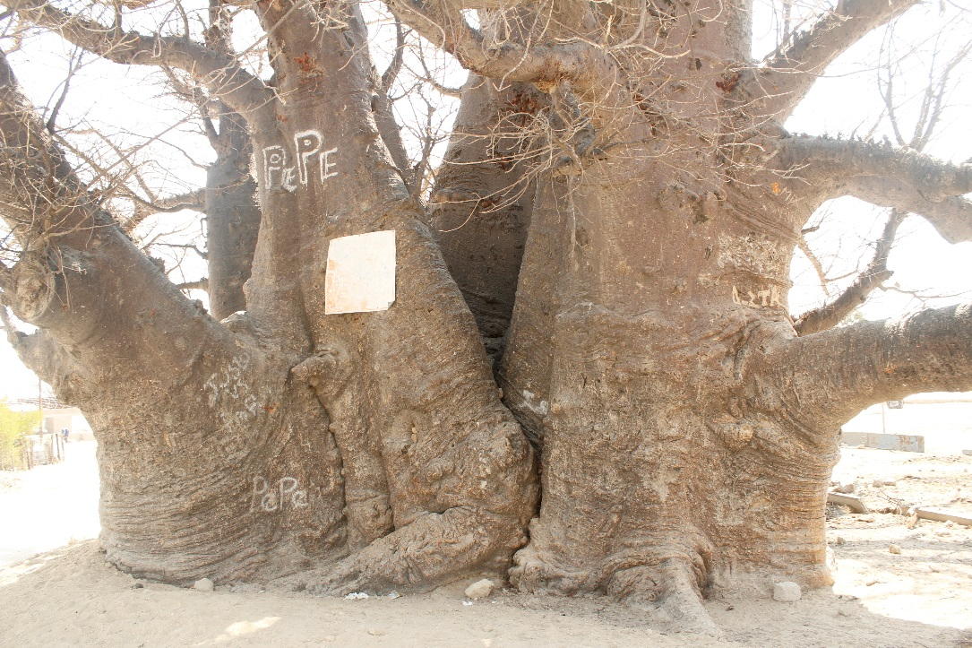
Figure 1Boabab tree. Elders meet here to discuss pertinent issues of the commnity



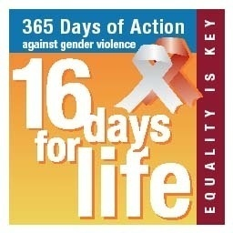



PARTNERS IN LOCAL GOVERNANCE and GBV

Table of Contents

Executive Summary

Background

Process and activities

Outcomes

Way Forward

Annexes

- A - Programme
- B – Participants’ list
- C – Gender action plan
- D – Summative workshop evaluation

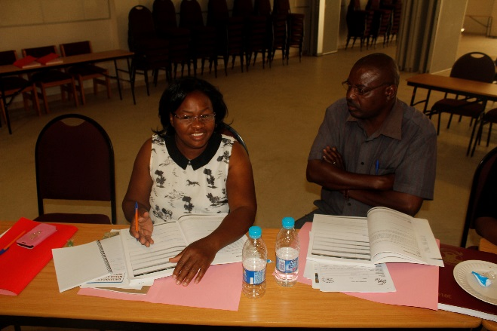
Figure 2Participants draw up AP
Executive Summary
This is a report on the proceedings of the Centres of Excellence for Gender Mainstreaming in Local Government stages 4&5 held at the town of Outapi from 17-19 September 2014.
It was attended by 24 participant,20 women and 4 men. The council and senior managers were well presented.

The purpose of the programme was to;
- Build participants understanding around key gender concepts
Figure 3Councl Finance Manager Helela, Thomas in white dress
- To empower participants around personal empowerment
- Build capacity around issues of gender, democracy and good governance
- Look at what makes good leaders through looking at transformative leadership
- Look at key concepts like gender policy and planning concepts
- Assist participants in understanding the importance and synergies around gender, the economy and budgets
- Develop a Local Gender Action Plan
- Develop a Local 365 Day Gender Violence Action Plan
- Popularise the SADC Protocol on Gender and Development.
- Establish communication strategies for the GBV action plans.
- Inform councils about the collection of good practices for addressing GBV at the local level and in the Gender Justice and Local Government Summit.
- Assist councils in seeing the importance of making IT and the media work for them
- And empowering women leaders around the Media Literacy tools.

See the full workshop programme attached at Annex A.

Over the three days, the workshop was attended by a range of council officials, councillors and Non Governmental organisations representatives; in total 28participants (10men and 18 women); see Annex B for the full workshop participants list.

The Draft Arandis Council Gender Action Plan that the participants produced is attached at Annex C.

The Draft Arandis Council Gender Based Violence Action Plan that the participants produced is attached at Annex D.

The GBV messages/slogans/posters and calendar are attached at Annex E.

The participants evaluated the workshop as having been an enlightening workshop. A summarised version of the evaluation forms is attached at the end of this report as Annex F.

Background
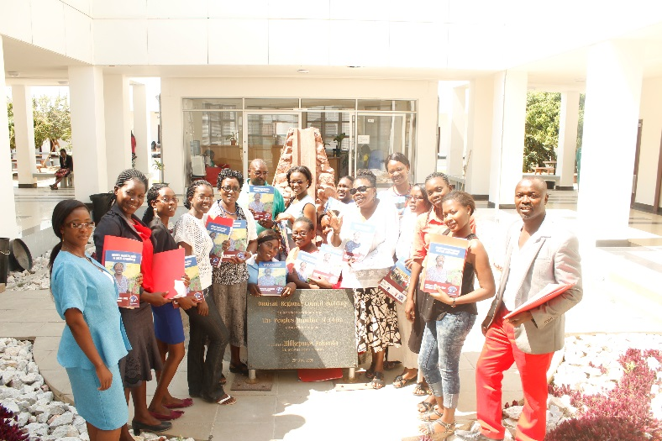
In 203, GL undertook the first comprehensive study of the impact of women in politics in Southern Africa. One of the key findings of “Ringing up the Changes, Gender in Politics in Southern Africa” was that local government is a sadly neglected area of the gender and governance discourse. Taking heed of this finding, GL conducted ground-breaking research in 2006/2007, At the Coalface, Gender and Local Government covering South Africa, Lesotho, Mauritius and Namibia. A key finding of this study was that few practical steps have been taken to mainstream gender in this tier of government or to build the capacity of councillors to lead this process. The study has since been extended to nine countries. In terms of process, once the research reports have been written up, GL hosts launch and strategy workshops in the respective countries with key stakeholders and partners, ideally the local government associations of that particular country to map out a way forward of how to roll out the strategy and host Gender and GBV action plan workshops.
Figure 4Outapi workshop group photo

The launches are then followed by Gender and GBV action plan workshops that are held at a provincial, regional or district, level to ensure that all councils have gender action plans. In 2009, GL embarked on a study in Zimbabwe on women’s representation and participation in local government to assess the conditions necessary to increase the representation of women in local government in Southern Africa, and to ensure their effective participation. In March 2010 GL convened the first Gender Justice and Local Government Summit and Awards to gather evidence of institutional and individual initiatives to empower women and end gender violence. The recommendations of this event informed the need for councils to become Centres of Excellence for Gender Mainstreaming in Local Government to ensure that Councils have the necessary and support to address issues of gender across all spheres.

Process and activities
The 3day training was aimed at introducing key gender concept, gender governance, gender economic, gender budgeting, and four New COEs Modules to participants. They are Conflict management/Resolution, Care work and HIV and AIDs, Local Economic Development and Gender, Climate Change and Sustainable development in local governance. These are considered to be key areas Local Authorities need to work on and provide those services needed to assist communities in this regards. Most of the participants were pro-active and participatory.

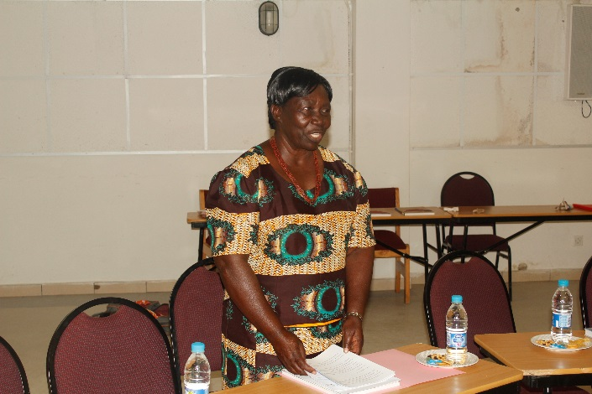
Welcome and openingThe welcome was done by the Hon deputy Mayor Hon Johanna Indongo who also at the same briefed the workshop about a workshop she attended on Women in Polices she added in the Oshana region. The deputy Mayor says, it was one of the most important gatherings she has attended where all political parties were represented leading to the upcoming election on November 28, 2014. These are the national, regional and Presidential elections. The deputy Mayor Hon Johanna Indonga welcomed all participants saying she feels honored and pleased to welcome all to Outapi the centre of culture and heritage, as well as to this inspiring occasion, of the gender mainstreaming in local government, institutions and civil society, whereby delegates will discuss gender issues in Institutions and the challenges thereafter. The Mayor Indongo told the workshop that she was very proud indeed of the participants presence, as it is a clear indication and testimony of desire and willingness to achieve the implementation of this project that is seeking to help local, National government, institutions and civil society to achieve the 28 target of the SADC protocol of which Namibia is a signatory. Says the Mayor ‘gender issue has been at the centre of a debates and discussions as councils are trying to balance the playing table to be equal regardless of gender’. Hon Indongo says In the past some careers were forbidden to men only. Furthermore there were also many opportunities for men as they were seen as superior unlike women. This she stressed has led to formation of different institutions and organizations to tackle the gender issues and see how men and women can be seen as equal. Oflate the deputy Mayor says, women nowadays have proved to excel in all careers just like men if not better than men. Said the Mayor, ‘I hope this workshop will address serious issues to empower women to be better leaders in their work place and communities’. She urged participants with the following words, ‘let’s get engaged in the discussions, share ideas and experiences. As the saying goes ‘together we can make it, in isolation we can fall’ she concluded.
Figure 5Outapi dep Mayor

odules
These Modules were strategically design to suit the needs of the Council, community and stake holders at towns or village levels. The workshop kicked off with Gender key concept. Role play was given before explanations were sought on what is sex and Gender. Participants were given small placards on which certain roles performed by women and men had to be swapped. The intra-changeable roles were also highlighted. Other Modules such and gender and Governance, Planning Action plans Conflict resolution/management, HIV and Aids and care work, Local Economic Development and Climate Change are some of these Moguls for facilitation.

Key gender concepts
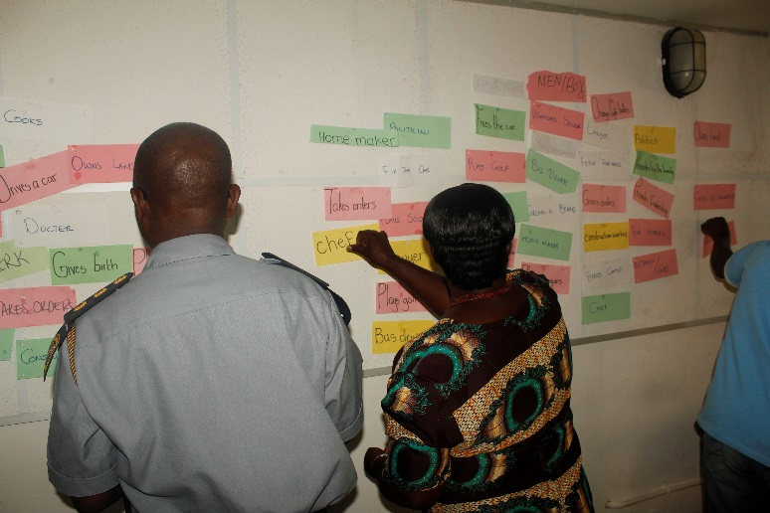
This Module was an introduction for participants to have a better understanding of all COE Modules/stages. The Module was meant to broaden the understanding of the participants in Sex, gender and stereotypes issues. Each participant was given cards with different roles, activities and occupations. These cards were place on the wall in categories like a Politician, Home maker, Manager, Model, Chef, Hairdresser, Bus driver, Teacher, Construction worker, Secretary, Doctor, Engineer, President, Clerk, Lawyer, gives birth, grows a beard, menstruates and breastfeeds. These roles were debated and re-swapped to intra-changeable gender roles. Majority agreed with the way these roles were changed but had reservations on playing with guns, doles and bus driver as they have not seen a female driver in this role. For the better understanding of gender and its concept the facilitator brought to attention of the participants the below phrases.
Figure 6Inspector of Police, Likius Helao and Hon dep Mayor hon Indongo

Gender concepts | Meaning as per the facilitator s explanation
Gender | Refers to socially or culturally constructed ideologies on what it means to be a girl/woman or boy/man. Not universal, changeable.
Sex | Universal biological differences between a girl/boy and woman/man.
Gender discrimination | Unfair treatment which is based on a person’s sex.
Gender equality | Equal rights, equal access to opportunity for full realization of potentials.
Gender equity | Fairness, just treatment for all, equal recognition and appreciation.
Gender planning | Gender sensitive planning, taking various gender needs into consideration whilst planning.
Gender mainstreaming | A process of taking gender needs into account whilst planning, during the development of policies, acts etc.

_{Gender and governance.}
The objectives of this module are to understand, the links between gender and governance. The Module also investigate why there are few women in decision-making, the economic/finance and in Cultural/Traditional power sharing. In groups participants were looking at these barriers and reported back in plenary.

Barriers to women’s emancipation at various levels of participation:
Political
- Politics is a demanding exercise, thus some women stay out of politics. They have development no interest in any subject related to politics. Some political parties have also contributed to this as all positions are reserved for men
- -Fear of Criticism and discrimination
- Women Are just followers
- Cultural Perception that women are home-makers
- Not allowed by partners to participate in any political affairs
- No motivation of Leadship roles to lead with Low Self Esteem
Economical
- Lack of information on economic affairs of the country. There is no access as well
- Fear of the unknown. They are not sure if these is the right direction to move to access information to emancipate them
- Lack of Self Confidence
- -Lack of Support from immediate family members and partners/husbands

Religious
- -The bible prohibit women to be the leadership positions of the church .It can be proven on the old testament which states that no women wrote the bible and -No women will become a priest or prophet
- Women are not allowed to participate in congregation, for example in the Muslim religion women are not allowed to conduct prayers only men.
- No Women can become Bishop
Media
- The Media are always negative towards women in society
- Not supportive against women’s empowerment drive
- They do not report on positves issues concerning women’s rights
- Negative women’s portrayer is not good for society and children
Culture
- Woman are brought up to be seen and not to be heard even on issues that concerns them
- Women are brought up to take orders and not to give orders
- Woman are Culturally/traditionally expected to be submissive to man
- Culturally woman are considered to be weak than man
- Man are expected to make decisions being the head of house but not a woman.
The opinion of the workshop participants were that government, political parties even at private domains implement the 50/50 gender parity in their Institutions. This will allow equal opportunity for women in power sharing.
The other concern is how communities can assist women in their leadership roles.

What do Communities Expect from their leaders? | How Can Communities Contribute to good leadership,what role can they play? | What are the problem associated with leadership?
1.Lead by example | Community need to understand the leadership role | Abusive with power
2.Service Delivery | Community member should be interested and actively participate in decision making | Unhealthy Competition
3.Transparency | Community members need to understand Gender roles | Selfishness
4.Fairness/No Favoritism | Effective Communoications Between the leaders and community members | Keeping up a good standard image
5.Involvement/Inclusive |  | Lack of communication
6.Participary Leadership |  | Lack of Coordination
7.Approachable leader |  | Corruption
8.Open Door policy
9.Mentor
10.Flexible
11.Able to Listen

_{Conflict Resolution}
The aims was for participants better understand the role each one can play in making conflict a manageable issue.
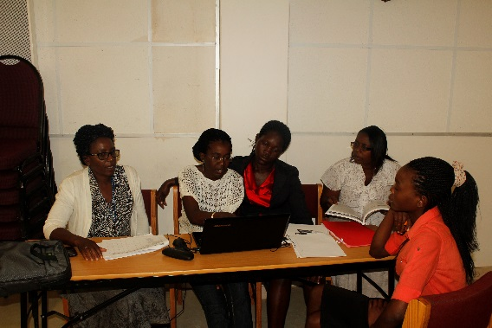
Participants were asked to debate in groups various conflicts found in society. In plenary groups had same views on conflict and how to manage it. They talked of community vis community, church vis church, council vis clients/community, in war zones between warring forces, family vis family and many others. This time around the facilitator’s conflict was based on the councillors vis councillors with different political parties members and their role in the chambers. Participants were asked who these councillors represent in the chambers. Many though they represent their political parties and those that gave them mandate to represent them in the Council. But some say, they need to represent all residents in the town regardless of even those who did not vote for them. When these happens to be conflict in chambers on issues of community, they, Councillors should stand together and resolve amicably this issue as they represent the residents of the town participants agree. Councils should take note that some small political related issues will derail much sought developments for the people’. Here they are of the opinion that sometimes politicians must and should listen to the genuine demand and needs of the ordinary people on the ground they stressed.They echoed that some conflict in some parts of the world have caused lots of destruction in billion and human lives not spared. ‘Women and children are the main victims and survivals in this regard. Participants feel that the town’s residents must minimised possible conflicts and look for ways of solving them. Participants have adviced that women need to be trained in negotiating skills to help limit conflicts where ever they happen. ‘It was learned during the workshop that women are peace makers’ and can apply their minds positively to conflict resolution and management discourse’.
Figure 7Dep Mayor Hon Johana Indongo and Inpector of the Police Likius Helao swapping gender roles

Some councillors some say, do not listen to the voice of women when implementing projects thus causing more conflicts and division in community like the case in point of the Local Economic Development Projects where women are selling their produce. This trading zone is erected at areas where women cannot access buyers. It is situated in remote areas. They stressed that most of these women finds themselves close to big shopping centres, like OX Bazar and Shoprite or Service Stations. ‘Says One women Police are not always friendly towards this kind of trading’. Another women lamented police are only there to protect big businesses ‘at the expense of poor women traders’. These are types of the conflicts most women at the town are familiar with and wanted government to intervene.

Participants urged all Councillors to treat all residents of the town equal without favour. Participants have commended that it is election year and need to see the town’s development on the agenda of the Council.

Gender the Economy and Budget.
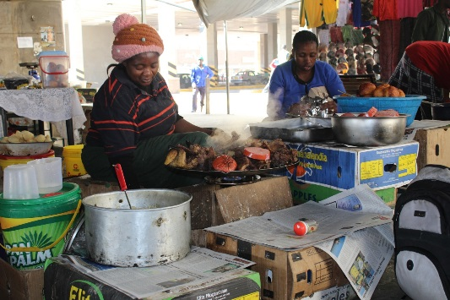
This module aims to explore key concepts such as gender budgeting and gender disaggregated data. It also deals with various types of institutional mechanisms for promoting gender equality, their advantages and disadvantages and how they form part of a Gender Management Systems (GMS). For the council and residents of Outapi this module was never heard of. Even Councillors and senior staff present did participate for the first time in such a workshop addressing these burning issues. They are of the opinion that a special workshop need to be arrange to facilitate this module only. They say this Module is at an advance stage and staff and selected stakeholders should be invited for this Module. A request was made for this Module to be facilitated at a later stage to which the facilitator agreed to. But the workshop continued with Gender Budgeting. Finance staff of the from stake holders and staff told the meeting that the council has not embarked on such a specific project but will in future deal with it when funds are available.
Figure 8Women trading with LED project

Gender policy and planning concepts
This Module was more of a participatory nature. Participants were given exercises to do in groups on practical and strategic gender needs, gender blind, gender neutral and gender aware policies, gender mainstreaming and sex disaggregated data. At this stage definitions of practical and strategic needs where given for better understanding of the concept. Participants especially women needed this training at their levels of business. They say, their planning skills need to be sharpened especially in identifying modern skills for making business planning methods.

Making Care work Count:
This Module was meant to broader the understanding of participants in health related issues especially care and HIV and AIDS keeping in mind the gender dimension of this matter. It also looks at possible strategies to address the pandemic at the town of Outapi. The residents of the town especially the Ministry of Helth has to raise wareness campaigns to reduce new infection. The Module will address issues of care givers and their renumerations according to the Community Home Based Care Policy of vernment. This document was done with Genderlinks assistance which the Facilitator spearheaded in Namibia. This CHBC policy in SADC region has been hailed as one of the outstanding documents that are gender awareness. According to information provided by GL, Namibia has implemented this policy frame works.

Amongst the participants, two women and some volunteers from the Ministry Health and Social Services attended the workshop. They briefed the audience that, the region is facing mammoth task to reduce the HIV Aids infection in the region. But the Ministry tring its best to roll out programme on HIV and AIDS, although rural areas are facing access to some of the health clinics there are mobile clinics introduced in rural areas.
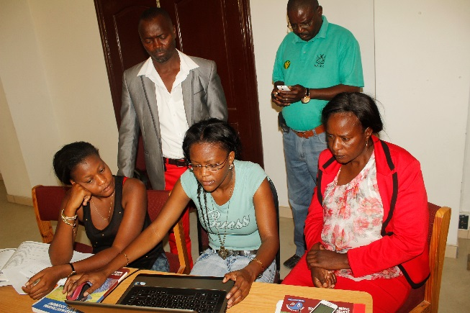
The most disappointing matter is that mosre training need to rake place for the care givers in terms of HIV and AIDS roll out in communities.Although the Ministry of Health and Social Services has decentralized its services to regions and rural areas, access still remains a challenge. The workshop learnt that the absence of some care givers at the town is compromising some of the important service delibery for chronic diseases. The facilitator further dealt the issue of a Policy to address pertinent issues of Care and HIV&AIDS. The CBHC is meant to assist care givers and their Organisations to assist government in implementing this Policy. Its gives more powers and privileges to society to take ownership of taking care of people infected and affected. Some of the care givers in the workshop wanted to know from the Ministry Health staff if they can access these forms to facilitate in the community. But the answer was, they also have not seen this form and the regional office does not have any. They promised to investigate and inform the community about it. It is a fact that all regions where GenderLinks Namibia had similar workshops, these are the same complaints raised. The issue that caregivers do not know, is a serious matter that needs to be investigated throughout the country.
Figure 9Group work planning AP
Figure 10Group work on AP

Gender and Local Economic Development:
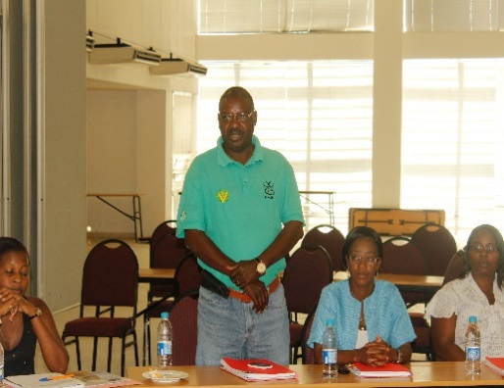
The ‘White Paper’ of the Ministry of Local Government Housing and Rural Development has drew up this Policy guidelines for councils in their implementation frameworks for LED implementations. The Outapi town Council has a Strategy that lacks implementation. The deputy Mayor says this workshop came at a time to assist with the implementation mode. The Council has trading zones for women at the town. But some say these were established without their consent. The women in the workshop alluded that they were not consulted when these trading zones where erected. ‘If they were asked, they would have advice the council to place these zones where they can make lots of money’. The facilitator visited these trading zones and can admit indeed that the complaints raised by these women were valid. Some of erections are empty as many women have relocated to town Centers where they can access possible clients. That being the case it is believe, the LED initiatives at the town will remain ‘ghost zones’. The Council has appointed a senior LED Manager, a female to oversee this project. But much need still to be done to see women accessing and embracing this initiatives.

Gender Climate Change and Sustainable Development:
This Module is aimed at strengthening frame works existing in Councils or towns and how GenderLinks can assist in this regards. The Module also raises pertinent issues regarding gender and sustainable development. It also inform Councils and stake holders and community to come up with strategies to address climatical conditions at their towns. The facilitator kicked off with the overview of the subject under discussing. These were the issues that matters during the workshop deliberations.

- What is climate change?
- Linkages of climate change on food security, health, migrations, town development and the effect on education sector.
- What can town council perhaps do to be ready in case natural disasters?
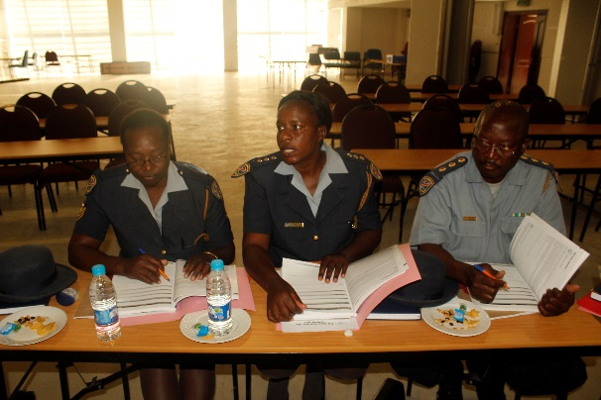
These town’s residents knew more about Climate Change. But the missing links were how to link this to gender and sustainable development. Food security was another issue that participants were also keen to deal with. Most of this town is more of a rural setups as most of the residents are located far away from urban areas. They mostly depend on crop production and cattle and small stock farming. This town being situated at flood prone areas it makes crop production an farming a biggest challenge.’ The workshop was told majority of women and children in some parts will face food shortage. Some School are also disrupted and learners are kept out of schools for months. Many wanted to know the Council’s role during climate Change. A senior manager told the meeting that Council is doing its best to make sure residents are assisted this period and some are relocated to safer grounds. The workshop learned ‘Emergency relief food productions’ are provided to all affected persons. Awareness raising is given on ‘water diseases and other health’ issues says the Council manager. Facilitator told the residents that council needs to plan for targeted groups as their needs are not the same. They should plan for women, children, old people, men, people with disability and those with serious health matters like people leaving with HIV/AIDS. The facilitator further says that a special budget for Climate Change needs a relook.
Figure 11Police and Army in consultation on work Plan

Gender Based Violence:
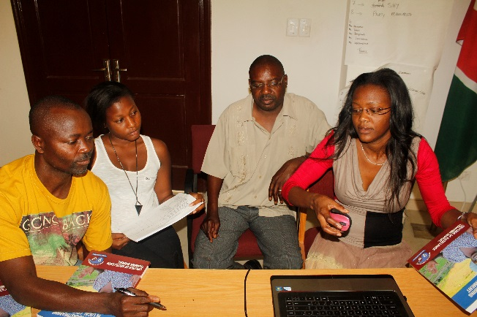
Gender Based Violence is sky-rocketing at this town. But the country itself is struggling with strategies to address the pandemic. The country held so far a National Conference under the Prime Minister’s office in July 2014 to map strategies for implementation. Women and children are not spared from gang rape, murder and constant abuse.Workshop participants expressed similar view as that of the facilitator who wanted to see a speedy solution to the killing of defense less women and children countrywide. Many expressed their views and urged government to bring back the ‘death penalty’ and stiffer penalties to all perpetrators of gender based violence. ‘Death penalty ‘has been out lawed since 1990 when the country attained independence.
Figure 12Police aand Army caucus on AP

Output
Outapi town Council has a draft combined COE Action Plan and a Gender Champion and a Gender focal person to assist with implementation.

Challenges
- Action Plan draw up very difficult
- Simplify or translate Manual
- The Omusati Regional Council not attending the workshop, Why?
- The hired projector aeem not operational, thus professionalism compromised
- The workshop wanted to see all counciloors at the workshop
Way forward
- All departments in the Omusati region need training on Gender mainstreaming
- All workshops should be represent 50/50 representation
- Transport to be provided to those who come from a far
- As gender mainstreaming is a new concept participants need ‘Certificates’
Outcomes
- The Council has now a COE Gender Action Plan in place for activity implementation
- That Councillors and stakeholders, including Non-Governmental organisations are aware of Actions plans.
- That the Council and stake holders work together in the implementation of the Action Plan.
- That the Council and stakeholders to participate in the 2015/16 National and Regional gender justice and Local Government Summit
- Gender built into policy and practise at local level, and that councils identified the need to have gender built into policy and practise at local level with the assistance from GL.

Closing remarks
The closing remarks were done by a senior staff o of the council who urged all present to help Council implement the Action Plan. He thanked GL Namibia for bringing the most needed skills like Gender Mainstreaming, something new to residents.

Annex A:
PROGRAMME
STAGE FOUR: INCEPTION WORKSHOP

DAY/TIME | ACTIVITY | TIME | WHO
DAY ONE:
8:00 – 8:30 | Registration | 30 min
8:30 – 8:45 | Opening | 15 min
8:45 – 9:00 | Introductions and objectives  Expectations from participants  To develop guidelines of participation  Eyes and Ears | 15 min
Key gender concepts
9:00 – 10:30 | Sex and gender | 1 hr 30 min
10:30 – 11.00 | TEA
11.00-13.00 | Group work on stereotypes | 2 hours
 | Report back
Gender, governance and transformative leadership
14.00- 15.30 | Access, participation, transformative leadership  Group work (role plays) | 1 hr 30 min
 | Report back
15.30 -16.00 | TEA
12:15 – 13:00 | At the Coalface DVD  Plenary discussions | 1 hr
13:00 – 14:00 | LUNCH
Conflict resolution
1400 – 15:30 | What is conflict?  Conflict at the local level  Role paly  Feedback | 1 hr 30 min
1530-15.15 | TEA
16.00 – 17.30 | Resolving conflict | 1 hour
17.30- | CLOSURE | 30 min

DRAFT PROGRAMME
STAGE FIVE: ACTION PLANNING WORKSHOP (3.5 DAYS)
DAY/TIME | ACTIVITY | TIME | WHO
DAY ONE:
8:00 – 8:30 | Registration | 30 min
8:30 – 8:45 | Opening | 15 min
8:45 – 9:00 | Introductions and objectives  Expectations from participants  Developing guidelines for participation  Eyes and Ears | 15 min
Gender policy and planning concepts
9:00 – 10:45 | Practical and strategic needs  Gender mainstreaming  Gender blind and gender aware policies | 1 hr 45 min
10:45 – 11.00 | TEA
11.00 – 12.00 | Gender disaggregated data | 2 hours
12.00-13.00 | Gender budgeting
Gender and the economy
12.00 – 13.00 | The unwaged work of women
13:00 – 14:00 | LUNCH
14:00 – 15:30 | Care work | 1 hr 30 min
15:30 – 15:45 | TEA
15:45 – 16:45 | Care work continues | 1 hour
DAY TWO:
8:00 – 8:30 | Reflections, Eyes and ears
Local Economic Development
8:30 – 10:45 | Gender and local economic development  Strategies for local economic development | 2 hrs 15 min
10:45 – 11:00 | TEA
Sustainable Development (Climate Change)
11:00 – 13:00 | Definitions / background  Impact of climate change on gender | 2 hours
13:00 – 14:00 | LUNCH
Gender Based Violence
14:00 – 15:30 | Key GBV provisions in the SADC Protocol on Gender and Development  GBV as a key service delivery issue | 1 hr 30 min
15:30 – 15:45 | TEA
15:45 – 16:45 | GBV continues | 1 hour
16:45 | CLOSURE
DAY THREE:
8:00 – 8:30 | Reflections, Eyes and ears
Developing a Gender Action plan
8:30 – 9.30 | Exercise: Key gender issues in local government | 2 hours
9.30- 10.30 | Developing a gender and GBV action plan
10:30 – 10:45 | TEA
10:45 – 13:00 | Developing a gender and GBV action plan | 2 hrs 15 min
13:00 – 14:00 | LUNCH
14:00 – 15:30 | Developing a gender and GBV action plan | 1 hr 30 min
15:30 – 15:45 | TEA
Prioritizing the action plans
15:45 – 16:45 | Prioritizing the action plans | 1 hour
16:45 | CLOSURE
DAY FOUR
8.30-10.30 | Review of action plan | 2 hours
10.30-11.00 | TEA
11.00 -12.00 | Agreement on gender task team to finalize plan | 1 hour
12.00-13.00 | Closure, way forward and agreement on how the plan is to be adopted | 1 hour

Particpants registrationPartner Strategic meeting
Safari and Conference
Country: Namibia
Date:29-30 September 2014

NAME | Sex  M/F | ORGANISATION / MUNICIPALITY | DESIGNATION | PHONE | FAX | E MAIL | Signature
Pinehas Shetunyenga | M | OTC | Assistant Acc | 0812725906 | 251128 | shetunyenga@outapitc
Christofina Shanyata | F | OTC | Receptionist | 0812837073 | 251128 | schristophine@yahoo.com
Hilya Amukwelele | F | MYNSSC | RYO | 065-251076 | 251135 | Monikamichael13 @yahoo.com
Likius Helao | M | NAMPOL | INSPECTOR | 065-251853
Emma Taapopi  Shimhanda Aili | F | NAMPOL | INSPECTOR | 065-253505 |  | Taapopi @gmail.com
ShimandaAili | F | NAMPOL | SGT |  | 065-251550
Aipinge Renate | F | CDC | counsellor | 065-251661 | 065- 251616 | aipingerenate@gmail.com
Shaanika Helena | F | Nampol | SGT | 065-25150 | 251862
Martha Jeremia | F | Ministry of Youth | receptnist | 065-251076 |  | marthandatulilwapo@gmail.com
Helena Thomas | F | Outapi Town Council | Senior Manager officer | 065-251191 | 065-251128 | Thomas@outapitc.org.na
Tushelde nghilinganye | F | MOHSS Outapi | NNRRS | 065-251021 | 065-251020
Emma Sheehama | F | Ministry of youth | Nappa | 065-251076 | 065-251135 | Ndapandulasheehama.com
Aune -Sarra | F | Nappa | CBRHA | 065-251076 | 065-251135 | auneimata@gmail.com
Naemi Ndaningie | F | Outapi/MGWSSC | CBRHA | 065-251076 | 065-251135 | naomitapola@gmail.com
Michael shinyata | M | Outapi town council | Cleansing officer | 065-251191 | 252228 | mashinyata@yahoo.co.uk
Melila simon | F | WAD | Computer officer admin trainer | 081316585 | 065-250340 | simonmelly@yahoo.com
Andowa Generosa | F | Outapi tc | Local councillor | 065-25109
J .Haindongo | F | Outapi | Local Authority | 0811274522 | 251059 | haindongo@yahoo.co.uk
J.JSwartbooi | M |  |  | 0817169389

COE GENDER PLANNING FRAMEWORK FOR LOCAL COUNCILS

The fields to be completed are:
- Why - What is the objective; starting point, answer the questions?
- What is the indicator –How will progress towards achievement of this target be measured; for example percentage increase in women’s representation.
- What is the action – What needs to be done for the target to be achieved?
- Who –Which department/s unit/s is responsible of the action?
- When – What is the timeframe in which this action should be completed?
- Budget – What financial resources are required for this action to be completed?

STRATEGIC OBJECTIVE/ OUTCOME | BASELINE | SADC PROTOCOL TARGET - 2015 | INDICATORS | ACTIONS | OUTPUT | WHO | TIME FRAME | BUDGET
GENDER POLICY FRAMEWORK
Increase council’s level of awareness around national, regional, international commitments that the country has made especially the SADC Protocol on Gender and Development and the National Gender Policy | What is the current level of awareness? | Laws and policies are accompanied by public awareness campaigns to demonstrate link between equal representation participation of men and women to democracy, good governance and citizen participation. | No | We want to do the workshop on national, regional and global gender instrument to raise awareness | Awareness raise on gender | Council, regional council, civil society | 2014 - 2015 | N$20 000
Ensure that there is there is a gender policy in the council and it is implemented. | Has a gender policy framework been drafted and approved. | Laws and policies put in place to enable women to have equal opportunities with men to participate | None | We strategise the policy to be implemented | Draft the strategized policy | Council, regional council, civil society | 2014 - 2015 | N$ 50 000
Gender issues are given a high political profile by the Council and has a political champion |  |  | None | Appoint gender focal persons and champions | Appointed gender focal persons and champions | Council, regional council, civil society, stakeholder | 2014 - 2015 | N$ 15 000
GOVERNANCE
Representation
To increase the representation of women councillors in the next elections to ensure that the SADC target of 50% women in local government is achieved by 2015. | What is the % of women councillors in the municipality? | At least fifty percent of decision-making positions in public and private sectors are held by women; affirmative action measures in effect. | Yes | Initiate women to take part in decisions making in public and private sector. | Acceptance of 50/50 implementation in place | Council, regional council, civil society, stakeholder | 2014 - 2015 | N$ 35 000
To ensure that women are equally represented in leadership positions in the Council. | What proportion of women councillors are there in leadership positions in Council, e.g. as chairs of committees? | Policies, strategies, and programmes for building capacity of women to participate effectively through leadership and gender sensitivity training and mentoring. | Yes | Awareness campaigns to build capacity of women to participate in leadership and gender sensitivity training and mentoring. | Implementation of Awareness programmes | Council, regional council, civil society, stakeholder | 2014 - 2015 | N$ 20 000
To educate communities and raise awareness about the importance of women’s equal representation in local councils | Has there been a 50/50 campaign or any other awareness raising on women’s equal participation? | Legislative measures and public awareness campaigns to emphasise that women’s representation and participation are an important component of democracy and good governance. | Yes | Educate communities and raise awareness about the importance of women’s equal representation in local councils | Equal participation of men and women in representation of local council | Council, regional council, civil society, stakeholder | 2014 - 2015 | N$ 20 000
Political participation
To increase participation by women because their concerns are often sidelined or overshadowed by political party concerns. | Is there a multi party women’s caucus? | Policies, strategies and programmes for the establishment and strengthening of structures to enhance gender mainstreaming. | Yes | Increase participation of women Policies, strategies and programmes for the establishment and strengthening of structures to enhance gender mainstreaming. | Establishment of women’s participation Policies, strategies and programmes related to women’s empowerment. | Council, regional council, civil society, stakeholder | 2014 - 2015 | N$ 40 000
 | Has any networking been done with other women’s caucuses? |  | Yes | participation of women Policies, strategies and programmes for the establishment and strengthening of structures to enhance gender mainstreaming | women’s participation Policies, strategies and programmes related to women’s empowerment. | Council, regional council, civil society, stakeholder | 2014 - 2015 | N$ 40 000
To empower women councillors to advocate for gender equality | Has there been a skills audit? What kinds of skills exist? | Policies, strategies and programmes for building the capacity of women to participate effectively through leadership and gender sensitivity training and mentoring. | Yes | Advocate gender equality throughout educating women on Policies, strategies and programmes for building their gender participation capacity | Implementation of gender equality education | Council, regional council, civil society, stakeholder | 2014 - 2015 | N$ 500 000
To empower women councillors to advocate for gender equality | What training has already been done? |  | Yes | Gender main streaming and local government | Implementation of gender planning framework | Council, regional council, civil society, stakeholder | 2014 - 2015 | N$ 200 000
To empower men on gender issues and mobilise their support. | What training has already been done – how many men participated? | Ensure the inclusion of men in all gender related activities, including gender training and community mobilisation. | Yes | Educate all men to understand that women are part of decision making | Participation of women in decision makings at all levels | Council, regional council, civil society, stakeholder | 2014 - 2015 | N$ 300 000
To empower men on gender issues and mobilise their support. | Have any dialogues with male Cllrs been held? |  | Yes | Mobilise the awareness regarding women participation in decision making | Participation of women in decision makings at all levels | Council, regional council, civil society, stakeholder | 2014 - 2015 | N$ 20 000
Public participation
To ensure that women and men participate equally in local government and community matters | What is the representation of women and men in ward committees? | At least 50 percent of decision-making positions in public and private sectors are held by women; affirmative action measures in effect. | Yes | Create the campaign awareness to ensure that women and men are all participating equally in decision making at all levels | 50/50 policy implementation | Council, regional council, civil society, stakeholder | 2014 - 2015 | N$ 25 000
 | Are there gender disaggregated statistics on the consultative meetings? | Women and men participate equally in all governance structures. | Yes | Consult gender statistical officer on the gender related issues | Gender based statistic | Council, regional council, civil society, stakeholder | 2014 - 2015 | N$ 45 000
 | Have any workshops been conducted with men’s groups? | Ensure the inclusion of men in all gender related activities, including gender training and community mobilisation. | Yes | Educate how important are women in local government and community | Understand and accept the importance of women in local government and community | Council, regional council, civil society, stakeholder | 2014 - 2015 | N$ 50 000
PLANNING
To ensure that targeted planning and service delivery takes place in the council women are consulted equally in policy-making processes. | Is the Council’s strategic plan gender aware? |  | None | We are going to have a workshop to mobilizing women in policy | Woman included policy making frame | Council  Civil  Society  MGECW | 2014-2015 | 30-000
To ensure that women are consulted about their needs when drawing up Council plans. | Has the gender desk been involved in the strategic planning process? Have the views of women and men been taken into account in the plan? | Equal participation of women and men in policy formulation and implementation of economic policies. | None | We raise awareness of and training to consult women | Women included | Council  Civil  Society  MGECW | 2014-2015 | 30000
MAINSTREAMING GENDER INTO EXISTING PROGRAMMES
Local economic development – The economy and job creation
To facilitate access to equal employment opportunities | Is there gender disaggregated data on jobs created through Council activities? | Equal opportunity: ensure that women and men have an equal chance to participate in and implement economic decisions and policies. | None | We raise awareness the available job opportunities in the market | Women and men have equal employment opportunity | Councils  Civil  society | 2014-2015 | 30000
To provide gender aware support to the informal sector | How gender aware is council assistance to the informal sector? | Trade and informal sector: adopt policies and enact laws, which ensure equal access, benefits and opportunities for women and men in trade and entrepreneurship; take into account the contribution of women in the formal and informal sectors. | No | The council need to come up with gender sensitive policy | Draft policy | Regional council and Town council | 0n-going | 30000
To ensure that women and men have equal access to financial resources | Does the Council have any financial schemes or influence over any financial schemes to assist LED? Are these gender aware? | Policies and laws that determine access to, control of, and benefit from productive resources by women in order to ensure that women have equal access and rights to credit, capital, mortgages, security and training as men. | None | We make information available on where to find financial assistance | Women and men have equally access to financial resources | Regional Council and  Financial institutions | 2014-2015 | 30000
To ensure that women and men have equal access to new technologies for improving the efficiency of their enterprises. | Does the Council have any technology schemes or influence over any technology schemes to assist LED? Are these gender aware? | Ensure that women and men have access to modern, appropriate and affordable technology and support services. | None | We train them on the importance and how to use modern technology | Everyone will be able to use the new technology | Regional council and ministry ICT | 2014 | 30000
Procurement
To ensure that women benefit equally from the procurement processes which they have historically been excluded from. | What proportion of Council tenders over the last year went to women? Is there a policy and or point system in place to redress gaps? | Women benefit equally from economic opportunities, including those created through public procurement policies. | None | We draft gender sensitive procurement policy | Procurement policy in place | Regional council | 2014-2015 | 30000
CLIMATE CHANGE AND SUSTAINABLE DEVELOPMENT
Ensure that the council understand the effects of climate change and they address the effects through instilling measures to address the negative impact of climate change | Has there been a gender aware audit done of climate change and its effects and or likely effects? | Laws and policies: review all policies and laws that determine whether women can access, control, and benefit from, productive resources. | No | We need to train councils on possible measures on how to combat the effect of climate change | They will be able address negative impact of climate change | Geologist | 0n-going | 30000
To involve women, as key stewards of the environment, in environmental preservation | Are women involved in drawing up policies and plans for “going green” | Equal participation of women and men in policy formulation and implementation of economic policies. | No | We must involve women in drawing up policies on environmental preservation | Women involved | Regional council and ministry of Environmental and Tourism | 2014-2015 | 30000
To involve women in projects and green business ventures, e.g. waste management. | Are there any green business ventures? | Women benefit equally from economic opportunities, including those created through public procurement policies. | No | We organise a workshop on green business project | Women will participate in green business ventures | Regional council and ministry of environmental and tourism | 2014-2015 | 30000
To take into account the needs of women in emergencies and disasters | How gender aware are existing disaster management plans? | Policy measures to ease the burden of the multiple roles played by women. |  | we train women on emergencies and disasters | Committee established in which serve | Regional council | 2014-2015 | 30000
INFRASTRUCTURE
Housing
To promote the equal rights of women to land tenure | What proportion of stands (ERF’s) are owned by women? | Collect and analyse baseline data against which progress in achieving targets will be monitored. | Few women | We review existing land policy to be gender sensitive | Women will own land | Councils and ministry of land | 2014-2015 | 30000
 | Do any policies exist to ensure women’s access to land tenure? | Laws and policies: review all policies and laws that determine whether women can access, control, and benefit from, productive resources. Especially with regard to  - Water and property rights;  - Land tenure; |  | Changing the housing policy
To women’s equal access to housing. | What kind of consultation process exists in residential design? | Laws and policies: review all policies and laws that determine whether women can access, control, and benefit from, productive resources.
Water, sanitation and electricity
To ensure that women, who are disproportionately affected by inadequate service delivery, are provided with affordable access to basic services | What services are currently being provided and at what cost? | Laws and policies: Review all policies and laws that determine whether women can access, control, and benefit from, productive resources. Especially with regard to Water and property rights. | None | The council should come up with hygienic sanitation projects | Deliver adequate services | council | 2014-2015 | 30000
 | What kind of consultation process has there been in the past? |  | None | The council should come up with hygienic sanitation projects | Deliver adequate services | council | 2014-2015 | 30000
 | What is the current state of service delivery? |  | Every week | Deliver adequate services | Deliver Adequate services | council | 2014-2015 | 30000
HEALTH
Ensure health facilities are accessible to women | How many mobile clinics are there currently? Which communities do these clinics service? | Legislative frameworks, policies, programmes and services to enhance gender sensitive, appropriate and affordable quality health care. | Very few | Mobile clinic should regularly visit community | Women will have more access to affordable quality health services | Ministry of health | 2014-2015 | 30000
HIV AND AIDS AND CARE WORK
Prevention
To establish the gendered dimensions of HIV/AIDS and to raise awareness on the pandemic in the Council. | Does the Council have gender disaggregated data on HIV and AIDS? | Collect and analyse baseline data against which progress in achieving targets will be monitored. | yes | It should be put into practice | People would be aware | council | 2014-2015 | 30000
To run gender- aware prevention campaigns | Do prevention campaigns emphasise differences in power relations between women and men? | Develop gender sensitive strategies to prevent new infections. | yes | Prevention campaign should emphasis power between men and women | All people should be aware | council | 2014-2015 | 40000
 | Do prevention campaigns emphasise the dangers of multiple concurrent partners? |  | yes | The campaign should emphasis the danger of multiple concurrent partners | People should be aware | Council, ministry of health | 2014-2015 | 40000
 | Is the female condom available? If so where? |  | yes | Female condoms are available at c linics | Women use female condoms | Clinics , hospital | 2014-2015 | 250000
To ensure that messages of generational sex and multiple partners are addressed | How has the municipality participated in awareness campaigns in the past?  Has the municipality actively participated and promote the 16 Days Campaign in the past? | Programmes take account of the unequal status of women, the particular vulnerability of the girl child as well as harmful practices and biological factors that result in women constituting the majority of those infected and affected by HIV and AIDS. |  | By mobilise the community to participated in 16 GBV Campaign | The community will be active | council | 2014-2015 | 40000
To raise awareness that there is an increased risk of contracting HIV/AIDS as a result of sexual assault. | Are there any awareness campaigns in the Council on the link between gender violence, HIV and AIDS? | Information on services available to survivors of gender based violence AND Laws on gender based violence provide for the comprehensive testing, treatment and care of survivors of sexual offences, which shall include preventing the onset of sexually transmitted infections. | Yes | There is awareness campaign in the council on the link between gender vilolence hand Hiv and Aids | People will be educated and aware | council | On-going | 500000
To educate women who are not aware of the need to avail themselves of Post Exposure Prophylaxis (PEP) and emergency contraception in the event of a sexual assault. | Is PEP readily available at all health facilities? If not, at how many facilities is it available? | Ready access to post exposure prophylaxis at all health facilities to reduce the risk of contracting HIV. |  | Yes but there are few facilities available
To educate women and men on voluntary counselling and testing which is a powerful tool for preventing the spread of HIV/AIDS. | What is the % of men and women who go for VCT? | Collect and analyse baseline data against which progress in achieving targets will be monitored. | yes | A lot of men go to vtc than women | Women should take such an opportunity to go to vtc | council | On-going | 200000
Treatment
To address unequal access to treatment; especially inhibitions by men to accessing treatment | What proportion of women compared to men access free treatment? | Collect and analyse baseline data against which progress in achieving targets will be monitored. |  | Both access free treatments | So that they can become better
Care
Ensure that the council addresses the gendered dimensions of care work | What proportion of care givers in the community are women? | Policies and programmes to ensure appropriate recognition of the work carried out by care givers, the majority of whom are women, the allocation of resources and the psychological support for care givers as well as promote the involvement of men in the care and support of people living with HIV and AIDS.
 | Do care givers receive any remuneration |  |  | Yes they receive remuneration | So that can be encourage to work
 | What support do care givers receive |  |  | They receive all kind of support
 | Do care givers receive training? What kind? |  |  | Yes care giver give training
 | Are there any efforts to involve men in care work? |  | yes | A lot of men involve in heath care
Social development
To make community and sporting facilities more accessible to women and girls and ensure that they benefit equally from such facilities. | What kind of work is/ has been done with women’s groups? | Collect and analyse baseline data against which progress in achieving targets will be monitored. | None | Provide more facilities | Women have access to sport facilities | Council and ministry of youth and sport | 2014-2015 | 50-000
 | Are there any awareness programmes or training materials covering parenting responsibilities? If there are, are they gender sensitive? |  |  | Introduce training for men women on parenting | Parent responsible | Ministry of Gender | 2014-2015 | 30000
GENDER SPECIFIC PROGRAMMES
FLAGSHIP PROJECT - ENDING GENDER BASED VIOLENCE
Prevention
To contribute to the SADC Gender Protocol target of halving gender violence by 2015. | What are the current statistics on GBV in the municipality? | Collect and analyse baseline data against which progress in achieving targets will be monitored. | high | To create awareness through workshop | Reduce GBV |  | 2014-2015 | On-going
  MGECW and ministry of safety and security
 |  | Integrated approaches, including cross sector structures installation with the aim of reducing current levels of gender based violence, by half by 2015.
Public awareness campaigns
To educate communities to challenge and eradicate gender based violence. | How has the municipality participated in awareness campaigns in the past?  Has the municipality actively participated and promote the 16 Days Campaign in the past? | Introduce and support gender sensitisation and public awareness programmes aimed at changing behaviour and eradicating GBV in all sectors of society. | Yes | Introduce awareness campaigns that educates community on how to eradicate gender based violence | awareness campaigns conducted on gender based violence | Council, regional council, civil society, stakeholder | 2014 - 2015 | N$ 300 000
 |  | Ensure the inclusion of men in all gender related activities including gender training and community mobilisation. | Yes | Train and community mobilise men in all gender related activities for men to understand that women are part of decision making in public | Men’s understanding of all gender related activities | Council, regional council, civil society, stakeholder | 2014 - 2015 | N$ 15 000
Response
To implement actions that are effective in responding to GBV in your council | What is the state of street lighting in the municipality? | Accessible, effective and responsive police, prosecutorial, health, social welfare and other service to redress cases of gender based violence. | Yes | Ensure that all the street are installed with effective street lights to eradicate GBV that are mostly occurring during night time | Street light | Council, regional council, civil society, stakeholder | 2014 - 2015
 |  |  |  |  |  |  |  | N$ 30 000
 | Are any of the police stations within the municipality equipped (private room, female officers etc) to deal with cases of GBV? | Specialised facilities, including support mechanisms for survivors of gender based violence. | yes | GBV survivors to conduct community awareness and educate the community to speak out GBV related issues to the responsive body | Community members are educated on speaking out the GBV related matters | Council, regional council, civil society, stakeholder | 2014 - 2015 | N$ 60 000
 |  | Community sensitisation programmes regarding available services and resources for survivors of gender based violence. | Yes | Ensure the programmes regarding available services and resources must be accessible to survivors of gender based violence | The availability of programmes and resources to gender based violence survivors | Council, regional council, civil society, stakeholder | 2014 - 2015 | N$ 50 000
 |  | Establish special counselling services, legal and police units to provide dedicated and sensitive services to survivors of gender-based violence. | Yes | Innovate the establishment of special counselling services, legal and police units to provide dedicated and sensitive services to survivors of gender-based violence. | Good understanding in occurrence GBV related matters | Council, regional council, civil society, stakeholder | 2014 - 2015 | N$ 65 000
Support
To implement a plan and actions that supports survivors of GBV | How many places of safety and care are there within the municipality? | Provide specialised facilities, including support mechanisms for survivors of gender-based violence. |  | Monitoring and evaluation mechanisms in place | Achievement will be measured | Chief executive officer | 2014-2015 | 30000
 | How many counselling facilities are there within the municipality? |  | yes | Through report | Achievement will be measured | Chief executive | 2014-2015 | 300000
 | What publications and information exists on where to get help, and how is this being disseminated currently? |  | yes | Strengthen works representation by unions | Representation of works by unions | Chief executive | 2014-2015 | 30000
Coordination
To ensure that efforts to address GBV are conducted in a coordinated manner | Is there a multi sector committee for addressing GBV in the local council? | Integrated approaches, including cross sector structures with the aim of reducing current levels of gender based violence, by half by 2015. | Affirmative action plan | Affirmative action to be strengthen at all levels | Equal opportunity to recruitment process and selection Human resource | Human resource Pr actioner at all institution | 2014-2015 | 250000
Budget allocation
To ensure that Councils commit budget and resources to addressing GBV | Is there a budget line for addressing GBV in the Council? |  | 50/50 representation | Affirmative action to be strengthen at all levels | Equal opportunity to recruitment process and selection | Council ,civil society and MGECW | 2014-2015 | 40000
Monitoring and evaluation
To ensure that efforts to address GBV are monitored and evaluated |  | Collect and analyse baseline data against which progress in achieving targets will be monitored. |  | Strengthen the existing gender policy | No employment discrimination | Council ,civil society and MGECW | 2014-2015 | 250000
Best practices
To showcase best practices to end GBV
EMPLOYMENT PRACTICES AND ENVIRONMENT
To increase the representation of women employed in the council. | What steps have been taken to prioritise gender equity in performance plans? | At least 50% of decision-making positions in the public and private sectors are held by women including the use of affirmative action measures. | None | Review the employment policy to engender it | 50/50 representation at all levels | Councils ,MGECW and civil society | 2014-2015 | 30000
 | What are the current gender statistics of employees in the municipality? What % men and women occupy management positions – what is the breakdown per department? | Review, amend and enact laws and policies that ensure women and men have equal access to wage employment in all sectors of the economy. |  | 70% male representation 30% woman | Review the employment policy to engender it | 50/50 representation at all levels | Councils ,MGECW and civil society | 3000
 | Who is responsible for ensuring that targets are met? Is this included in their contract? |  | Chief executive officer
 | Has any work been done in this area?
 | Have the unions been approached?
Selection and recruitment
To ensure that the recruitment and selection process offers equal opportunity to women. | What kind of employment equity plan is in existence? | Affirmative action measures with particular reference to women in order to eliminate all barriers that prevent them from participating meaningfully in all spheres of life and create a conducive environment for such participation.
 | What are the targets for ensuring women’s equal representation at all levels? |  |  | Affirmative action to be strengthen at all levels | Equal opportunity to recruitment process and selection | Equal opportunity to recruitment process and selection | 2014-2015 | 40000
 | Has gender been incorporated into policies and processes? | Eradication of occupational segregation and all forms of employment discrimination. | yes | Strengthen the existing gender policy | No employment discrimination | Council ,civil society and MGECW | 2014-2015 | 250000
 | Are women and men paid equally for the work they do? | Equal pay for equal work and equal remuneration for jobs of equal value for women and men; and | yes | We maintain equal payment mechanisms in workplace | Equal payment for women and men | Council ,civil society and MGECW | 2014-2015 | 150000
 | What is the policy on maternity leave? | Enact and enforce legislative measures prohibiting the dismissal or denial of recruitment on the grounds of pregnancy or maternity leave. | Labour act | Educate raise awareness on labour act | Full understanding of the labour act | Ministry of labour, council | 2014-2014 | 35000
Capacity building
To ensure that training is done to educate all employees and community groups on gender | What training has already been done? | Ensure equal participation of women and men in decision making by outing in place policies, strategies and programmes for the establishment and strengthening of structures to enhance gender mainstreaming. | yes | To carry out training for employees and community group on gender matters | equal participation of women and men in decision making by outing in place policies, strategies and programmes to strengthening structures | Council, regional council, civil society, stakeholder | 2014/2015 | N$ 30.000.00
Work conditions and environment
To facilitate women’s equal participation in the workplace by providing support for parents because parenting responsibilities have continue to be the main responsibility of women. | What childcare facilities are currently available? | Provide protection benefits for women and men during maternity and paternity leave. | No | Provide protection place for childcare at workplace | Women and men are benefit on the program | Council, regional council, civil society, stakeholder | 2014/2015 | N$3.500.000
 | Is there any such arrangement currently? | Conduct time use studies by 2015 and adopt policy measures to ease the burden of the multiple roles played by women. | No | Money to be allocated for such arrangement to put program on place | Plan is done for that arrangement program | Council, regional council, civil society, stakeholder | 2014/2015 | N$ 60 000
 | Has this issue ever been addressed? How? |  | yes | Meeting are carried out for allocating of capital for the project | Consultation has made | Council, regional council, civil society, stakeholder | 2014/2015 | N$ 20000
 | Are there any such programmes? |  | yes | Facilitate women and men in participating on supporting childcare at workplace | Programme strategized | Council, regional council, civil society, stakeholder | 2014/2015 | N$ 100 000
 | What crèche facilities exist? |  | No | Implement the programme to be in place | The programme implementation is strategized | Council, regional council, civil society, stakeholder | 2014/2015 | N$ 400 000
Address issues of sexual harassment in the council. | Is there a sexual harassment policy in existence? | Enact legislative provisions adopt and implement policies, strategies and programmes that define and prohibit sexual harassment in all spheres, and provide deterrent sanctions for perpetrators of sexual harassment. | Yes | Implement harsh policies, strategies and programmes that define and prohibit sexual harassment in all spheres, and provide deterrent sanctions for perpetrators of sexual harassment. | The policies, strategies and programmes implementation is strategized | Council, regional council, civil society, stakeholder | 2014/2015 | N$ 35 000
Address issues of sexual harassment in the council. | What kind of safety measures are in place currently? |  | Yes | Educate community members on how to report sexual harassment related issues to the nearest police stations | Education to the community members was implemented | Council, regional council, civil society, stakeholder | 2014/2015 | N$ 44 000
GENDER MANAGEMENT SYSTEM
Gender structures
To establish structures that constitute the gender machinery and to ensure that they have the authority to carry out their work and to obtain the commitment of all managers. | Has any work been done in the establishment of structures? | Establish and strengthen structures to enhance gender mainstreaming. | none | We mainstream gender policies and guide line in all department | Policies are implementing | MGECW | On-going | 60-000
 | Is there a committee in Council responsible for gender? |  | yes | Gender focal person need to be introduce to the community | Gender focal person known by residents | MGECW | On-going | 80-000
 | Has a gender technical task team: comprising the GFP has been formed?
 | Have gender focal points been established in all departments? Have TOR been drafted? |  | yes | Gender foal point need to be drafted on all department | GFP established TOF has drafted | MGECW | On-going | 150000
 | Has a gender specialist been recruited? |  | No | Specialist need to be recruited | Specialist has been recruit | MGECU | On-going | 1000-000
 | Has gender been written into the performance agreements of senior managers and GFP? |  | No | Need to be written into the performance agreement of the senior managers and GFP | Gender has been written | MGECW | On-going | 90000
 | Is the GMS known, has it been publicised? |  | No | GMS need to be publicised | GMS has publicised | MGECW | On-going | 70000
Budget, monitoring and evaluation
To make use of gender disaggregated data for monitoring and evaluation to ensure that gender equality is being strived for. | Does sex disaggregated data exist? Is it applied? | Ensure gender sensitive and responsive budgeting at the micro and macro levels, including tracking, monitoring and evaluation. | No | We want disaggregated monitoring and evaluation | Disaggregated has been monitoring and evaluated | MGECW | On-going | 90000
To ensure that resources are being allocated to gender priorities. | Are there direct or budget allocations for advancing gender equality? | Ensure that all national and local budgets sufficiently represent the needs of women and men; assessment of all spending should reflect how resources have been allocated to all gender groups. | No | Is need to be em powered | Budget allocted | MGECW | On-going | 60000
 | Do women and men benefit equally from budget allocations? |  | No | Woman and man needed to benefit equally. | Benefit equal | MGECW | On-going | 60-000

WORKSHOP EVALUATION FORM
Event: Outapi stage 4&5
Date:

Administration information
Sex | Male Female
Country
City/ Town/ Village
Age Group | 12 - 17 | 18 -30 | 31- 40 |  | 41 - 50 |  | 51 – 60 |  | 60 +
Education level | Primary School | Secondary School |  | Tertiary |  | Vocational |  | Adult literacy

Please score the following 1-10 where 1= very poor; 10 – excellent
 | SCORE OUT OF TEN
1. PROGRAMME DESIGN | 76
2. PROGRAMME CONTENT | 86
3. DOCUMENTATION | 81
4. FACILITATION | 72
5. GROUP WORK | 82
6. OUTPUTS | 68
7. OUTCOMES AND FOLLOW UP PLANS | 66
8. LEARNING OPPORTUNITY | 78
9. NETWORKING OPPORTUNITY | 76
10. ADMINISTRATIVE ARRANGEMENTS | 75

- Which session did you find most useful? Why?
- Gender and governance and conflict resolution
- Gender policy and planning concepts because it is good that even women can be part of planning and policy.

- Group work on stereotypes.
- The last one because it was move practical
- Gender based violence and conflict
- All session were all useful since we have learnt a lot in all session
- Day three: We were discussing and gave our input
- Gender concept, deepening understanding
- All , as they concern my work
- Gender because I have learnt that everyone should be treated the same no matter what
- GBV session, because it reality existing in community
- Sex and Gender, I came to understand the difference between the two clearly
- Gender and the economy because women should be considered when it comes to economy
- Difference between sex and Gender
- Gender policy and planning concepts because I learned a lot on the difference between practical and strategic needs
- Gender based violence because I learnt a lot of mechanism of how to solve this through group discussion.
- Gender, governance and transformative leadership because I learnt how to governance and how to be a good leader.

- Which session did you find least useful? Why?
- SADC protocol on gender and development because less information was communicated to us
- All session were good
- Conflict resolution, because conflict are always happening unexpected
- Strategic local economic
- Stereotypes because a stereotype is something that cannot be changed people will still stereotype other people.
- Adaption of action plan, it hard to come up with action plan due different common understand of individuals
- Gender and economic because woman is not mostly considered to be leaders and I do not know how long it will take for this to change.
- Conflict resolution, need more details
- All were useful
- The first session as I was not really aware of what the workshop was all about
- Conflict resolution, I did not understand the topic in relation to gender
- Participation and transformation

- How will you apply what you have gained from this engagement?
- Engage in activities concerning gender issue
- I will educate and empower my clients with the knowledge I have gained
- I will try to help our local government in Gender mainstreaming
- I will educate and empower my clients with the knowledge I have gained
- Engage in activities concerning gender issues
- To educate a community member on how to report sexual harassment related issues to the nearest police office.
- To give feedback to my fellow colleagues
- By raising awareness in my community that gender based violence is not a solution to any problem.

- Any other comment

- It was very important workshop we learnt a lot.
- The workshop was very informative
- More workshop of this nature needed
- Need another training comprehensively every year
- Need another workshop
- Workshop should be repeated, follow up should be done for implementation sake
- More workshops should be conducted
- To have more training on GBV
- I am grateful about this engagement and I urge the organization to

